

K&M Tire

SOP General Ledger
5/26/2026

Table of Contents
1. K&M Tire 1
2. Office Manual Introduction 4
3. Overview 5
3.1 Conventions 5
3.2 Cautions & Warnings 5
4. Organizational Chart & Contacts 6
4.1 Organizational Chart 6
4.2 3CX – Phone System 6
4.3 Location Contact List 6
5. Department Summary 7
6. K&M Tire Intranet, File Server and Software 8
6.1 K&M Tire Intranet 8
6.2 F-Drive 8
6.3 PC Desktop 8
6.4 One Drive 9
6.5 WISE – Warehouse Management Software 9
6.6 MaddenCo 9
6.7 Dayforce 9
7. MaddenCo General Ledger Basics 10
7.1 Input Journal Entry / ** Making Unbalanced Journal Entry 10
Making unbalanced journal entries – MUST HAVE AUTHORITY TO DO SO 10
7.2 Upload Journal Entry 11
7.2.1 Upload Journal Entry – Full SOP with Screenshots 11
7.3 General Ledger Re-class (Moves) 13
7.4 Update Journal Entry 13
7.5 Journal Entry Hold/Release 14
7.6 General Ledger Inquiry/Balance Inquiries 14
7.7 Audit Inquiry by Reference # 15
7.8 Trial Balance Inquiry 15
8. GL Maintenance 16
8.1 Creating New General Ledger # 16
8.2 GL Account Maintenance 17
8.3 Update Financial Reports 18
8.4 Changing or Adding Sales Tax Rates 19
8.5 Updating Recurring Entries 20
8.5.1 Bad Debt Recurring Entry 21
8.5.2 CAT Tax Recurring Entry 22
8.5.3 Insurance Recurring Entry 23
8.5.4 Property Tax Recurring Entry 28
8.5.5 Depreciation & Amortization entry 30
8.6 General Ledger Error Log & Correcting Unbalanced GL 34
9. Daily Procedures 38
9.1 Daily Bank Reconciling 38
9.1.1 Wells Fargo (If Applicable): 38
9.1.2 First Financial - Cash: 40
9.1.3 Chase AR Ending 0982: 41
9.1.4 PNC AP Daily Banking 44
9.1.5 PNC AR Daily Banking 46
9.1.6 Mobile Deposit Discrepancy Emails 51
9.1.7 Line of Credit 52
9.1.8 Consolidated Daily Bank Balances 52
9.2 Update Inventory Cost Change 52
10. Weekly Procedures 54
10.1 Non-Stock Balancing (Same as month-end; keeping up with it weekly) 54
10.2 Weekly Payroll Journal Entry 56
10.3 Adjustment Tracking – Account 1110 Audit 57
10.4 Weekly Sending AR Discrepancies 58
10.5 Weekly Sending Non-AP Withdraw Listing to President 60
11. Monthly Procedures 62
11.1 Bill My Tire Place Contracted Accounting Services 62
11.2 Best One Health Insurance Billing Allocation 63
11.2.1 Prepaid Expenses 65
11.3 Fixed Assets 66
11.3.1 Reconcile Balance Sheet Account 1610 Construction in Progress for all locations weekly, to begin: 66
11.3.2 Update the Asset Activity spreadsheet F:\Accounts Payable\Shared\Lists\ASSETS “Asset Activity.xlsx” 67
11.3.3 Send Asset Activity to M&Z (Dave Estupinan) monthly (unless there have been no changes) to receive an updated Depreciation Schedule 67
11.3.4 Reconcile 1610 Monthly 68
11.3.5 Reconcile 1630, 1650, 1670, 1690 monthly 69
11.3.6 Reconcile 1640, 1660, 1680, 1700 monthly 70
11.3.7 Review All Assets (before year end, but can be done quarterly or biannually) 71
11.4 Travelers Tracer Payment 71
11.4.1 Validate amount billed from Travelers 72
11.4.2 Process & Initiate ACH within 24 hours of receipt 72
11.5 WEX Fleet Allocation 73
11.6 PR Allocation 74
11.6.1 Open the previous months worksheet and save it as the current month you are working on. 74
11.6.2 Run Current Month AC – Correct Sales and COGS Report: 74
11.6.3 Verify PR Allocation Spreadsheet: 75
11.6.4 Tie Out Each Route in the Sales Summary: 75
11.6.5 Validation and Entry: 78
11.6.6 Journal Entry Creation: 79
11.7 Tribune Billing – Monthly Process 79
11.7.1 Summary of Invoices between K&M and Tribune 79
11.7.2 Create new file for invoicing (done monthly) 80
11.7.3 K&M to Tribune Trucking Invoice 80
11.7.4 K&M to Tribune Bill (Truck NBV) 81
11.7.5 Tribune to K&M Bill 81
11.7.6 Review Totals & Send Invoices 82
11.8 Inventory Adjustment Tracking – Acct 3900 Audit 82
11.9 Send GL 3900 Balances to VP of Operations 82
12. General Ledger Account Reconciliations 83
12.1 GL 1000 - Cash on Hand 83
12.2 GL 1010 thru 1019 – Cash in Bank 83
12.3 GL 1020 – Cash Coming In 83
12.4 GL 1070 – Volume Bonus 84
12.5 GL 1110 – Adjust Credits from Vendors 85
12.6 GL 1140 – Net State CR Due From Vendors 86
12.7 GL 1160 – Co-Op Advertising Credits Due 88
12.8 GL 1200 & 1230 – Accounts Receivable 88
12.9 GL 1220 – Inventory In Transit, Inter-Co 90
12.10 GL 1290 – Reserve For Bad Debt 91
12.11 GL 1300 – Inventory 92
12.12 GL 1301 – Goodyear Pending Inventory 94
12.13 GL 1310 – Containers Pending 96
12.14 GL 1390 – Security Deposits 96
12.15 GL 1400 – Prepaids Insurance 97
12.16 GL 1405 – Prepaid Workers Comp 98
12.17 GL 1410 – Prepaid Federal Income Tax 99
12.18 GL 1420 – Prepaid Expense 100
12.19 GL 1440 – Tri-Energy Stock Payment 102
12.20 GL 1480 – FCSS Investment 104
12.21 GL 1510 Pending Nonstock/DS Banking 105
12.22 GL 1530 Returns to Vendor AP 105
12.23 GL 1530-1-1 – Returns to Vendor-NAB 105
12.24 GL 1540 – Employee Loans Receivables 107
12.25 GL 1550-1-0 – AP Pass Thru 110
12.26 GL 1550-1-1 – AR Pass Thru 110
12.27 GL 1560 – Employee Loan Pass Thru 112
12.28 GL 1580 – Marketing Promo & Pass Thru 115
12.29 Fixed Asset Accounts 117
12.30 GL 2010 – Note Payable 118
12.31 GL 2030 – Accrued Delivery Fees 119
12.32 GL 2300 – Accounts Payable 119
12.33 GL 2320 Purchase Pending 121
12.34 GL 2370 – Inventory Value Overstated 125
12.35 GL 2400 – FICA Payable ER 127
12.36 GL 2450 – 401K W/H 127
12.37 GL 2455 – 401K Employer Match 128
12.38 GL 2460 – HSA 129
12.39 GL 2470 – Child Support W/H 129
12.40 GL 2480 – Garnishment/Bankruptcy W/H 129
12.41 General Ledger Account 2490 Union Dues 130
12.42 General Ledger Account 2500 Sales Tax Payable 136
12.43 General Ledger Account 2510 Tire Tax Payable 137
12.44 General Ledger Account 2515-1-1 CAT Tax 138
12.44.1 General Ledger Account 2620 Accrued State & City Income Tax 140
12.44.2 General Ledger Account 2640 Accrued State & City Income Tax 140
12.44.3 General Ledger Account 2660 Accrued Property Tax 140
12.44.4 See property tax procedure for the process with the 2660 rec. 140
12.44.5 General Ledger Account 2710 Accrued Salaries 140
12.44.6 General Ledger Account 2740 Accrued Dividends 140
12.44.7 General Ledger Account 2750 Accrued PTO 140
12.45 General Ledger Account 2810 Federal & FICA W/H EE 140
12.46 General Ledger Account 2860 United Way 140
12.47 GL 2950 - Capital Stock/Shares 142
12.48 GL - No Activity Reconciliations 142
12.49 Miscellaneous GL Notes/Information 142
12.49.1 Direct Ship 142
13. End of Month Procedures- Day 1 144
13.1 Run Reports – make sure all updated 144
13.2 Saving Reports 154
13.3 Correct GP 154
13.4 Correcting Sales & Cost of Goods Sold (COGS) for Sold Transfers 155
13.5 Post standard journal entries (recurring entries) for K&M Tire 157
13.6 Reconcile Vendor Accounts Receivables 157
13.7 Correct Direct Ship: difference should be what we paid verses what we charged 158
13.8 Allocate 4080-1-1. F:/Accounting/Shared/Month End/EOM Entries 2026/4080 Extension Changes_YYYY. 158
13.9 Check for any inventory adjustments that are on hold 159
13.10 Check “Receivers on Hold” 159
13.11 AR Analysis 159
13.12 AR Analysis 160
14. End of Month Procedures- Day 2 161
14.1.1 Customer Cash Discounts EOM Entry#1 161
14.1.2 Vendor Cash Discounts EOM entry #2 161
14.1.3 Adjustments EOM Entry#3 162
14.1.4 Accounts Receivable – Accounts 1200 & 1230 EOM Entry#4 163
14.1.5 Inventory – Account 1300 EOM Entry#5 164
14.1.6 Accounts Payable- Account 2300 EOM Entry#6 165
14.1.7 Inside/Outside Sales Wage Allocation EOM Entry#7 166
14.1.8 Freight Billed to Vendors EOM Entry#8 167
14.1.9 Freight EOM Entry#9 168
14.1.10 PR (Purchase Resale) – accounts 1120 & 4120 EOM Entry#10 168
14.1.11 Inter-Co Inventory – account 1220 EOM Entry#11 169
14.1.12 Intercompany Transfer Calculation 170
14.1.13 Non-Stock Adjustment Entry 171
14.1.14 Service Charges – Account 3980 EOM Entry#12 173
14.1.15 EOM Net Income Entry Location 50 (complete after loc 50 has been reviewed) 174
14.1.16 Corporate Income & Expense Allocation EOM Entry 174
14.1.17 Run & Review Financial Statements 176
14.1.18 FINAL PROCEDURES To Do by 15th (After Cheryl’s Review): 179
14.2 Summary Financials 180
14.3 Operations Income Statement 181
14.4 Warehouse Bonus Analysis 181
14.4.1 Warehouse Reports 181
14.4.2 Complete the current month data tab 184
14.4.3 Calculating Terms 185
14.4.4 Calculating Active Employees 186
14.4.5 Calculating Wages 186
14.4.6 Calculating Hours 187
14.4.7 Calculating OT Wages 187
14.4.8 Net Income & Temp Labor 188
14.4.9 Total Tires Shipped 188
14.4.10 To review $ Tires Shipped on the Intranet: 189
14.4.11 $ Tires Shipped Manual Equation 189
14.4.12 Sales Summary 189
14.4.13 Finalizing the Bonus 190
14.4.14 Sending to Managers 190
14.4.15 Adding a new location to Workbook 191
14.5 Property Tax Procedures 191
14.5.1 ASSESMENTS/APPEALS: 192
14.6 Five Star Insurance Reimbursements 193
14.6.1 GL 1401-1-1 General Liability – Pass Thru 194
14.6.2 GL 1402-1-1 Auto – Pass Thru 194
14.6.3 GL 1403-1-1 Credit Risk – Pass Thru 194
14.6.4 GL 1406-1-1 Workers Comp – Pass Thru 196
14.6.5 Quarterly Five Star Loss Run Report 196
14.6.6 Supporting details for Loss Run report 198
15. Quarterly Closing Procedures 199
15.1 Bank Covenants 199
15.1.1 Bank Covenant Calculations 199
15.1.2 Bank Covenant Tracking 199
15.2 Create Equipment & Parts Income Statement 201
15.3 Key Performance Indicators (KPI’s) – Company Playbook 202
16. End of Year Closing Procedures 205
16.1 Update Year End 205
16.1.1 Update Year End – Balance Sheet roll forward 205
16.1.2 Close Prior Year Net Income & Distributions 205
16.2 Calendar Year Update 206
16.3 Reconcile All Balance Sheet Accounts 206
16.4 Profit Sharing 206
17. Tax Filings and Compliances 210
17.1 Sales Tax Reports 210
17.2 Use Tax 219
17.3 State Tire Fee Report 222
17.3.1 Summary 222
17.3.2 OH, NY, & PA Report 222
17.3.3 NE & IL Tire Fee 223
17.3.4 KS Tire Fee 224
17.4 CAT TAX – Commercial Activity Tax – Quarterly Return 225
17.5 Unclaimed Funds 225
17.6 Income Tax Payments 226
17.6.1 Quarterly Income Tax Estimate Payments 226
17.6.2 Annual Income Tax Extension Filing 228
17.7 Property Tax Abatements 231
17.8 Business License Filings/Renewals 231
17.8.1 Annual CSC Worksheets 231
17.8.2 Wisconsin 232
17.8.3 Arkansas 232
17.8.4 Kansas 233
17.8.5 Michigan 233
17.8.6 Texas 233
17.8.7 New York 233
17.9 Form 8752 234
17.10 Form 05-158 Texas Franchise Tax Report 234
17.11 Form 8802 Application for United States Residency Certification 235
17.12 Form 200 – Oklahoma Annual Franchise Tax Return 236
18. Miscellaneous Additional Responsibilities 238
18.1 S-Corporation Distribution Payments 238
18.2 US Census Bureau Quarterly Financial Report 238
18.3 Preparing 1099’s 239
18.4 Energy Benchmarking Compliance Review 246
18.5 Supply Suppliers with Audited Financial Reports 246
18.6 Trademark Registration Maintenance – currently managed by the President 246
18.7 Attorney Invoice Approvals 247
18.8 Annual Capital Expenditures Survey 247
18.9 GL Reclass Entries 247
18.10 Annual Business Survey 247
18.11 Annual Zurcher Best One Analysis – Benchmarking 248
18.12 ACH/Wire Approvals 253
19. New Location Procedures 255
19.1.1 GENERAL LEDGER: 255
19.1.2 Auto Reports: 259
19.1.3 Edit Existing Auto Reports: 262
19.1.4 Tire Dealer Menu & Misc: 264
19.2 Transfer Hops: Location to Location Transfer Grid 272
20. Frequently Asked Questions 276
21. Other 277

List of Figures
No table of figures entries found.

List of Tables
No table of figures entries found.

K&M Tire




K&M Tire US Footprint
Click on the below link to see the footprint map
http://kmtire.com/km-cgi/distmap

Office Manual Introduction
This manual is intended to aide in the training of the K&M Tire Accounting team by providing step by step detail of the processes.
Provide link & path of where to find up-to-date version
ADD PRIVACY AND/OR SECURITY CONSIDERATIONS HERE.

Overview

Conventions
- This document provides screen prints and corresponding narrative to describe how to use the Maddenco, WISE and K&M Intranet, known as “company systems”
- When an action is required on the part of the reader, it is indicated by a line beginning with the word “Action:” For example:
- Action: Click on OK.
- Fields or buttons to be acted upon are indicated in bold italics in the Action statement; links to be acted upon are indicated as links in underlined blue text in the Action statement.
- Note: The term ‘user’ is used throughout this document to refer to a person who requires and/or has acquired access to the company systems.

Cautions & Warnings
- This manual does not supersede any safety or company policy.

Organizational Chart & Contacts

Organizational Chart
- https://login.paylocity.com/Escher/Escher_WebUI/views/employeeportal/employeePortalOrgChart.aspx?area=home&view=coOrgChart
  - *Replace link with Dayforce Org Chart once available

3CX – Phone System
- F:\SOP\Administrative Assistant\Pending Approval\3CX - Phone Instructions.pptx

Location Contact List
- F:\Administrative Assistants\Public\Location Cheat Sheet.xlsx

Department Summary
- K&M fiscal year is Oct. 1 through Sept. 30 each year
- The General Ledger Department is responsible for ensuring accuracy of financial reporting to internal and external stakeholders, sales tax returns/audits, insurance including workers compensation audits, CAT tax, Tire tax, proper GL balances, proper GL reconciliations and anything relating to balance reconciliations.
- K&M’s ERP system is MaddenCo but several departments use other software that integrates into MaddenCo. This software includes WISE, Dayforce, Blue Ridge, Pro Ship, etc.
- K&M is required annually to have audited financials.
- Forvis performs K&M’s annual audit of financials and 401K.
- M&Z provides K&M’s updated depreciation schedule and provides our Federal and State tax returns.
- CSC provides our state business filings.
- PNC is our primary lender and banking partner.

K&M Tire Intranet, File Server and Software
- If you may need information pertaining to your department you have access to our very own Intranet and hard drive.
- The K&M Tire Intranet is a hub that provides our team with programs and tools that are necessary for our everyday functions for each department.
- Our hard drive we have named the File Server (F :) is a resource located in your PC folder on your desktop. The F-Drive contains a public and shared files per department.

K&M Tire Intranet
- http://intranet.kmtire.local/index.php?area=home
- Some of the many functions our own Intranet provides for our staff include:
- Well-established reports & resources that each of our departments use day to day.
- Under every department is a list of employees with their photo, email and phone number to help you remember faces and their titles.

F-Drive
- Located under “This PC” there is a network drive named File Server (F :). Within this drive are public and shared files for every department. It is also where you will be able to locate many resources such as Benefit forms located F:\Human Resources\Public\Benefits. All final versions of company related documents should end up being stored on the F Drive.

PC Desktop
- Only use your desktop to save documents for one-time needs, personal use, or documents in progress.

One Drive
- One drive can be used for working documents that are in progress or updated frequently between multiple users. These documents must end up being saved on the F Drive once progress is done and the file is considered complete.

WISE – Warehouse Management Software
- WISE is the system used for inventory receiving, put-away, cross-docking, product location, picking, shipping, outbound documentation, and more. WISE tracks inventory from the moment it is received, directing the put-away process to best utilize available space and eliminating guesswork during order picking by directing pickers to strategic retrieval locations

MaddenCo
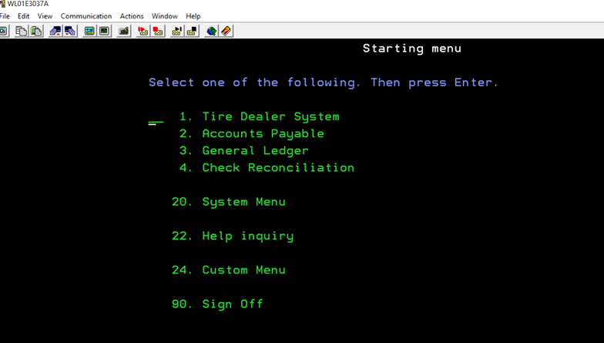
- MaddenCo is our ERP system and inventory tracking system, that is integrated with our accounts payable and general ledger software. It is a tire dealer system software with national account interfaces to many of the leading rubber vendors.

Dayforce
- Dayforce is a cloud-based Human Capital Management (HCM) platform covering the full suite of HCM software, including payroll, tax filing, benefits, HR, talent intelligence, workforce management, and recruiting technology.

MaddenCo General Ledger Basics
Menu Options 2 and 3 on the G/L Start Menu

Input Journal Entry / ** Making Unbalanced Journal Entry
Purpose: To provide step-by-step instructions for entering and updating general ledger journal entries in Madden Co, including both balanced and unbalanced entries.
Note: Unbalanced Journal Entries are only made if an out-of-balance appears on the Error Log (details on Error Log process in section 8.9 below). Admin emails out the error long and Controller sends to A/R to research the cause of the imbalance. Typically, it occurs when something does not flow correctly from the intranet to MaddenCo for Accounts Receivable (A/R). If AR cannot identify, the Controller is to research and identify reason being for out of balance.
- Go to Madden Co
  - 3 General Ledger (enter)
  - 2 Input & Update Menu (enter)
  - 1 Work with Outstanding JE’s (enter) (This is where the general ledger entry will be entered)
  - F6 Create New
  - F2 Get Reference #
  - Year/Period = Add 3 months to period making the change (K&M Only! – Fiscal Year period)
    - Example – June 2026 = input 2026/09
  - Tab down to put in a description
    - Reason for entry Example – EOM Inv. Reconciliation
  - (Enter)
  - Enter in account, location, and values
  - Continue entering until all accounts and amounts are entered
  - F3 to exit

Making unbalanced journal entries – MUST HAVE AUTHORITY TO DO SO
- This should only be done to correct one sided issues such as items highlighted on the Error Log or AR items posted to a GL Account for a location that does not exist, as those go to 99999
- Follow all steps above
- It will let you know that the entry is out of balance, F12
- At the work with outstanding Journal Entries screen, it will say Out of Bal
- Enter “@” on the Opt entry line and hit enter.

Upload Journal Entry

Upload Journal Entry – Full SOP with Screenshots
Journal entries can be uploaded to the general ledger to save time. The upload template is saved in excel at F:\Accounting\Shared\General Ledger\Journal Entry Upload\”JEUPLOAD”. The file cannot contain header rows and must be saved as a CSV file.
- Below is a sample JE Upload file. The columns and formats are as follows:
  - Column A – Account number. This must be a valid account in the General Ledger Account Master file. (4 digit)
  - Column B – Division. This must be a valid division number (LOC #) in the General Ledger Account Master file. (1 or 2 digit)
  - Column C – Department. This must be a valid department number in the General Ledger Account Master file. (0 or 1 if positing to corporate)
  - Column D – Debit Amount. If you want to post a debit transaction to the above GL Account, enter the amount in this column. The amount can be up to 9 digits before the decimal and 2 digits after the decimal. The largest value that can be keyed is 999,999,999.99 and the format should exclude commas.
  - Column E - Credit Amount. If you want to post a credit transaction to the above GL Account, enter the amount in this column. The amount can be up to 9 digits before the decimal and 2 digits after the decimal. The largest value that can be keyed is 999,999,999.99 and the format should exclude commas.
  - Column F – Description. This field can be left blank. This is the same description line that is available from within the Journal Entry input per line item. It can only be 50 characters and if longer will be truncated when the file is uploaded.
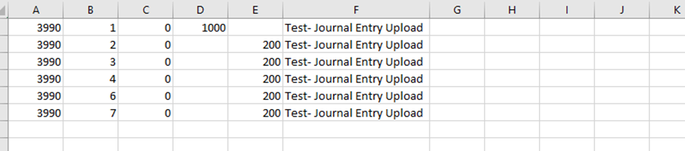
- Open F:\Accounting\Shared\General Ledger\Journal Entry Upload\JEUPLOAD.CSV and clear out all contents in the spreadsheet
- Replace with JE formatted for upload [GL Acct, Loc, Dept, Debit, Credit]
- Verify no negative numbers and save the excel sheet
- Go to F:\Accounting\Shared\General Ledger\Journal Entry Upload\JOURNAL ENTRY UPLOAD.dtt and click transfer data to IBM (this will automatically send the entry to Madden Co)
- Go to Madden Co to post the entry
  - 3 General ledger
  - 2 Input & Update Menu
  - 10 Create Journal from PC File
  - F2 to get a reference number
  - In year/period put three months out from month reconciling. (Example: reconciling 9/2025 you would be 2025/12)
  - Put it in the description of the EOM of the entry (EOM AJE FOR SERVICE CHARGES)
  - In File Name to Post put JEUPLOAD and hit enter
  - Work with Outstanding JE’s
  - Locate entry, review for accuracy and place a 2 on the entry to put into ready status
  - Ensure the entry is correct
- Sample:
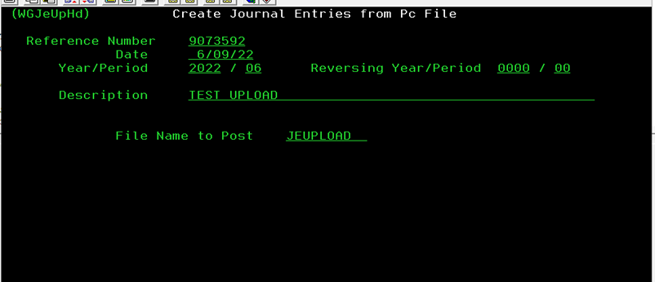
  - F3 back
  - Work with Outstanding JE’s
  - Entry will be on hold, check it by placing a 2 to Edit or 6 to Release
  - It must be released or it will not be posted.
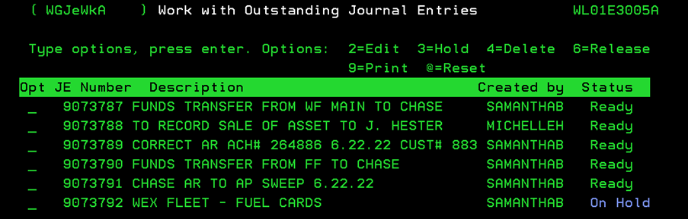

General Ledger Re-class (Moves)
Overview: If it’s determined that an expense has been posted to an account in error or a Re-class of any account, a GL move will be necessary. These entries should be approved by the Controller.
Errors can be found through account balancing or check run review or various methods. Once the error is found, proceed as follows.
- Research entry
  - Recurring entry
  - Review past entries to confirm accuracy.
  - Do all entries need moved or just this one?
- Individual/Miscellaneous entry.
  - Review charges and compare to GL list of accounts
  - Confirm correct account with Controller to get approval of move.
  - Controller must initial correct account
- Make note of re-class required on original document, date & initial
- Make a copy of original document to provide the Controller with support to make JE to re-class expense
- File original document in appropriate file
- Make any necessary notes to use correct GL for like transactions going forward.
  - Example: Andersen inv#40432765 was originally posted to 5050-1 and should have been posted to 5570-1
- If the move was needed due to account balancing, confirm with controller before posting

Update Journal Entry
Allows you to update entries in real time instead of waiting until the update late at night. This should only be used if it is needed, so you can run financials, as an example.
MAKE SURE THAT ANY ENTRY THAT YOU DON’T NEED OR WANT TO UPDATE ARE PUT ON HOLD (SEE 6.5 – Journal Entry Hold/Release)
Note: if an entry is in use, it won’t update. This means someone is in the entry or someone was in it and didn’t probably exit before closing the Maddenco session. Only reset if you are certain someone isn’t in the entry. To reset put a @ on the line and hit enter. You must have permission/access in Maddenco or it won’t reset.
Steps to update JE’s during the day:
- Start Menu
- 3 General Ledger (enter)
- 2 Input & Update Menu (enter)
- 2 Update journal entries
- (Enter)
- Put report on Hold? Y for yes.

Journal Entry Hold/Release
This allows you to put a journal entry on hold, so it does not get updated upon either a manual JE Update and/or during the normal nightly update.
Important Note: Once an entry is on hold you can run the update JE’s and all JE’s not on hold will update. You must release the JE’s on hold or they will not update during the nightly update.
- Start Menu
- 3 General Ledger (enter)
- 2 Input & Update Menu (enter)
- 1 Work with outstanding Jes (enter)
- Place a 3 (3=Hold) in the Opt column (enter)
- To Release, put a 6 in the OPT column

General Ledger Inquiry/Balance Inquiries
To pull up and review the GL detail of a GL number:
- Starting menu
- 3 General Ledger (enter)
- 3 Inquiry Menu (enter)
- 1 Balance Inquiry (enter)
  - Enter the Store Number to be Used or (normally used) enter 000 for all stores
  - Enter the 4-digit account number and store number (if you chose 000 in a. otherwise that field is auto populated for you)
  - (enter)
- Each fiscal period is listed that has activity. You can put a 5 in the Opt column to display the detail for that month. You can tab to the top and change YR.
- Within the monthly detail you can also use a 5 to display detail or a 6 to display by reference # detail
- If you entered 6 to display reference detail you could press F14 to see additional detail if the entry came from something other than a JE entry.

Audit Inquiry by Reference #
When provided a reference #, you can inquire into the ledger.
- Starting menu
- 3 General Ledger (enter)
- 3 Inquiry Menu (enter)
- 2 Audit Inquiry by Reference #
- Input the reference number (enter)
All the GL #’s are listed as part of that reference #. To inquire on a specific account entry, put a 5 in the Opt column to display the detail.

Trial Balance Inquiry
You can pull up a trail balance inquiry at any time for any YR or Period. This is especially useful to view balances on a GL across several locations.
- Starting menu
- 3 General Ledger (enter)
- 3 Inquiry Menu (enter)
- 3 Trial Balance Inquiry (enter)
- Enter store room or leave 000 for all
- “Start at G/L #” Enter the account, location (if you chose 000 in 5, otherwise that field is auto populated for you)

GL Maintenance

Creating New General Ledger #
Before any creation of a new GL, it must first be approved by the CFO with prior approval from the President.
- Starting menu
- 3 General Ledger (enter)
- 1 Maintenance Menu (enter)
- 2 GL Account Maintenance (enter)
- All stores
- Include heading and subtotal accounts? Y (This shows headers and sub accounts)
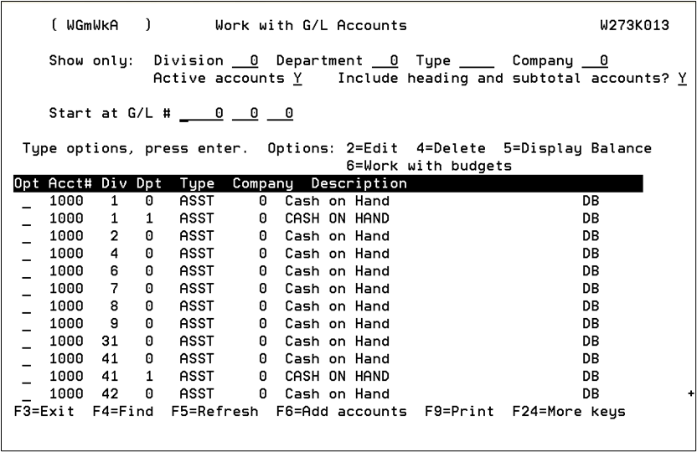
- What kind of account is needed? – Asset, Liability, Equity, Income, or Expense
  - Put a “2” in front of a similar account and print the screen so you know what the account should look like.
- F6 = Add Accounts
  - Type in Account Number/Division/Department (Dept 1 only for Corporate GL #)
  - Type in Long Description
  - Give Short Name – same as long description if it fits
  - Account DB or Credit (F4 for menu)
- Asset (1000) = DB
- Liability (2000) = CR
- Equity (2990) = CR
- Income (3000 & 4000) = CR
- Expenses (5000) = DB
  - Account Type (F4 for menu)
- Asset = ASST
- Liability = LIBL
- Equity = EQTY
- Income = INCM
- Expenses = EXPS
  - Mark account active
**Important Note: When adding GL’s, unless it’s an account for a division of 1 (like 408-1-100) always add for all K&M locations.
Make sure to do for all active locations for K&M Tire and Heading GL (Account Type = SUB1 –loc 0 0).
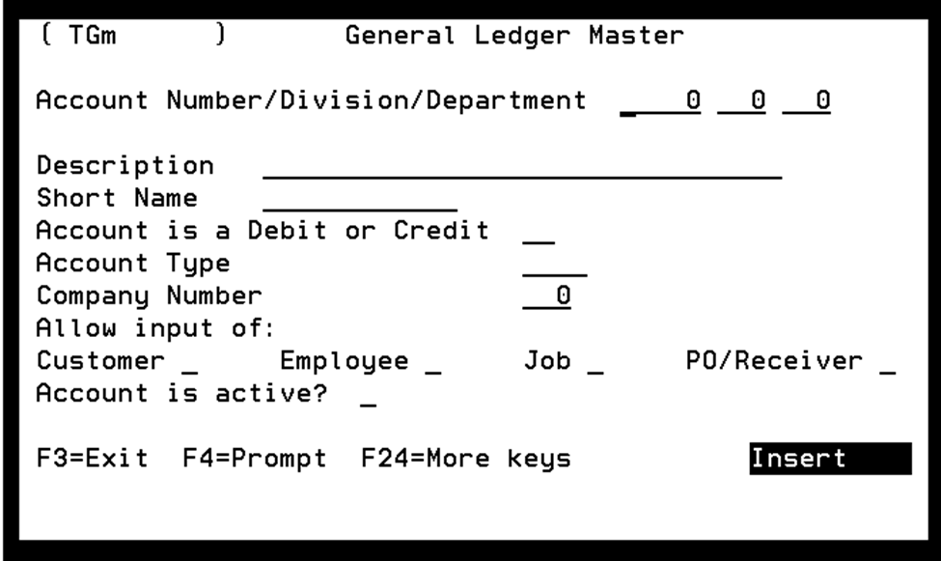

GL Account Maintenance
- Starting menu
- 3 General Ledger (enter)
- 1 Maintenance Menu (enter)
- 2 G/L Account Maintenance (enter)
- Enter the store number or leave blank for all stores
- Either type in the account at “Start at G/L #” or scroll down the to G/L account you would like to work with
- 2 to edit
- General Ledger Master profile is displayed
- Make appropriate changes and hit enter to complete. The history of the account name is not kept. The only reference of an old account name/structure is how it displayed on prior month’s financial statements.

Update Financial Reports
Follow these steps if adding a single GL #: If adding a new location refer to section 7.3.1.
Important Note: This should only be completed by a Controller or Level 3 accountant.
You must add the new GL# to the financial reports or they will be out of balance because they won’t include the new GL.
- 3 General Ledger (enter)
- 1 Maintenance Menu (enter)
- 3 Report Format Maintenance (enter)
- Enter through all stores
- Search for report needing updated, Ex. INC30 (or most current)
- 2 to Edit
- (Enter)
- Find similar account and locations new account needs added, print screen of similar (unless it’s a division of 1, GL should be added to all locations)
  - Add new- F6
  - Add new sequence number to keep in order
  - Add the GL Number
  - Do not change anything else- (Enter)
- Update the Consolidated Totals
  - Add new- F6 if new account does not fall within an already existing row
  - Copy similar accounts, will need to copy both associated rows.
  - Ex. Seq# 41,940 & 41,950 both would need opened, print screen and copied with the new account’s details and a new sequence number
- No change needed if already falls within an existing row
  - Ex. 4085-1-230 is already included in the below Seq# 42,060 & 42,070.
- F3 to exit “Work with report format” Screen
- Re-sequence the Updated statement
- place an 8 beside the updated statement
- (enter)
- start at sequence number 10 incremented by 10
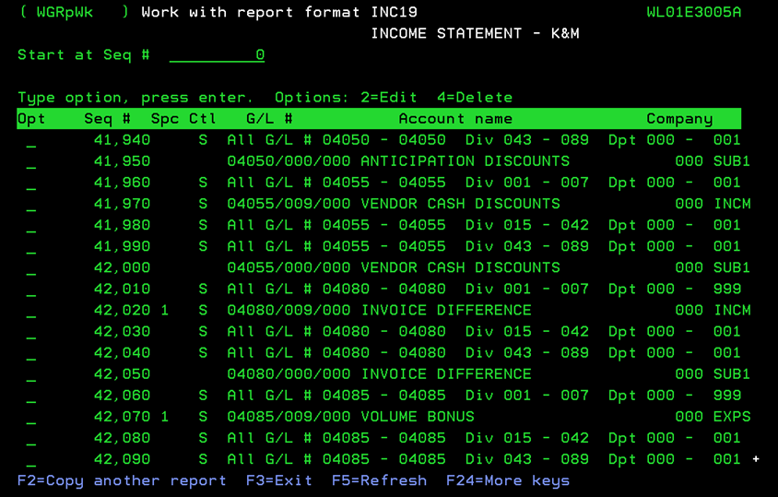
- (enter)

Changing or Adding Sales Tax Rates
Purpose: To outline the process for updating or adding a sales tax rate / authority in Madden Co
- Twice a year, in January and July, the controller or accountant responsible for sales tax should research current tax rates to see if any states or localities we collect in have changed their rate.
  - We check the state tax rate as well as local rate, because either could change independently of the other
  - We verify this twice a year because most states change their rate on either January 1st or July 1st if changes are implemented
  - To research, visit the state’s department of revenue website as both the state and any local rates are available to view on the state DOR’s website.
- Confirm with Controller the Jurisdiction and Rate that we are updating or adding.
  - Due to complexity of Sales Tax, all updates must be approved by Controller prior to entering and reviewed by Controller after entering.
- To Update an Existing Sales Tax Rate:
  - Navigate through the following menu path in Madden Co:
    - 1 Tire Dealer System
    - 6 File Maintenance Menu
    - 7 Sales Tax File Maintenance
  - Locate the correct state:
    - Search for the state.
    - Select 2 to Edit.
  - Make the necessary change to the tax rate:
    - Example: If the rate is currently .07000 (7%) and it needs to be updated to 7.25%, change the value to .07250.
  - Notify Controller Update has been made and is ready for review.
- To Add a New Sales Tax Rate:
  - Navigate through:
    - 1 Tire Dealer System
    - 6 File Maintenance Menu
    - 7 Sales Tax File Maintenance
- Press F6 to add a new entry.
- Enter the state code on the Tax Code State line.
  - If you're unsure of the tax code, press F4 on that field, then select using 1.
- Enter the next available taxing authority number for that state.
  - Example: If the highest authority for IA is 00004, use 00005.

- On the next screen:
  - In the Description, enter a clear description like “IA [City] Tax” or “IA Combined Tax” as shown above.
  - In the Tax Percent field, enter the sales tax rate (e.g., .07000 for 7%).
  - Set Tax FET to N.
- Leave all other fields as default or blank and press Enter to save.
- Notify Controller addition has been entered and is ready for Controller to review.

Updating Recurring Entries
The purpose of this SOP is to outline the process for calculating, proposing, approving, and posting the monthly recurring entries. Calculating these entries correctly is critical to ensuring accurately monthly financial statements and avoiding large swings in net income at year-end. All recurring entries must be presented to and approved by President at the beginning of each fiscal year. We strive for consistency in recurring entries. Updates are only made quarterly, and any quarterly changes must also be approved by President.
NOTE: All Recurring Entry amounts are rounded to the nearest $10. This makes it easy to visually catch anything posted to these accounts that was not part of the monthly recurring entry.

Bad Debt Recurring Entry
The purpose of this entry is to accrue for bad debts that either do not qualify for credit risk insurance reimbursement, or are in excess of coverage limits.
- This entry will be a credit to 1290-1-1, and a debit to 5980-Location.
- Allocation of this entry is based upon the following
  - 75% based upon sales
  - 25% based upon last 3-yr average of bad debts by location
- Open prior-year spreadsheet, make a copy and roll spreadsheet forward to current year.
  - File Path: "F:\Accounting\Shared\Month End\Recurring Entry\FY 20XX\FINAL & APPROVED - Bad Debt Recurring Entry - Per XX thru Per XX.20XX.xlsx"
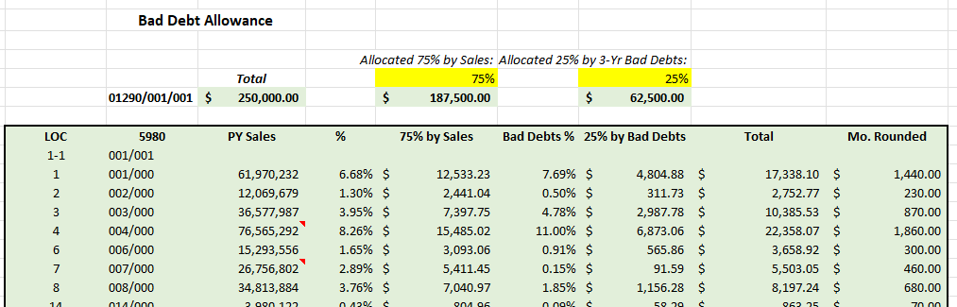
- Update the Sales Column
  - NOTE: if there are any new locations that were added mid-year, or any locations that were consolidated, the Sales figure for that location will need to be adjusted to be annualized based on increase.
    - If annualizing, add a note in that cell explaining how calculation was computed and any assumptions made when annualizing.
- Update the Last 3 years Bad debts tab
  - Request most recent fiscal year bad debts by location from C&C Manager
  - This list should include bad debts written off to 1290 and 1403.
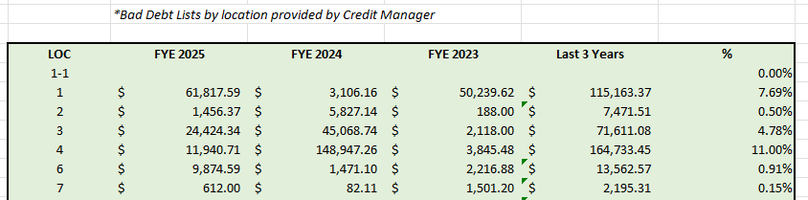
  - Verify all formulas are correct after updating, and bad debts percentage is correctly flowing back to Bad Debt Entry tab
- Review the total amount of entry.
  - In above example, upon review the average bad debt expense for the prior four fiscal years was roughly $750,000. We have up to $500,000 coverage through credit risk insurance, so it was determined to set the bad debt 1290 accrual at $250,000 annually for fiscal year in example.
  - If the total annual amount of accrual appears it may need to be adjusted, provide recommendation to President, CFO, and EVP with support to show why proposed amount might make better sense.
- Create a tab showing prior year monthly entry beside current year entry
  - Add notes explaining any noticeable changes.
- The Bad Debt Entry is now ready to be submitted to President for approval

CAT Tax Recurring Entry
The purpose of this entry is to accrue for CAT Tax evenly over 12 months, even though the cash payments for CAT tax are only made once each quarter.
- This entry will be a credit to 2515-1-1 and a debit to 5750-Location.
- Allocation of this entry is based upon the following
  - Total sales by location delivered within the state of Ohio
- Open prior-year spreadsheet, make a copy and roll spreadsheet forward to current year.
  - File Path: "F:\Accounting\Shared\Month End\Recurring Entry\FY 20XX\FINAL & APPROVED - CAT Tax Recurring Entry - Per XX thru Per XX.20XX.xlsx"
- Request Report Sales Analysis report from CFO containing Sales by Route, by location, by State
  - We use this report, because we’re looking at sales delivered by Ohio warehouse to customers within the State of Ohio. Starting with this report by route helps us get the sales in the right location even if they were transferred in and the invoice was generated out of another hub.
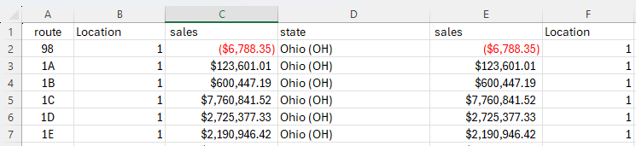
  - Review data to make sure everything appears correct and as expected
  - Copy this report into your working Cat Tax Recurring Entry excel file
- In CAT Tax Recurring Entry tab, update pivot table so it’s pulling from most recent year sales
  - 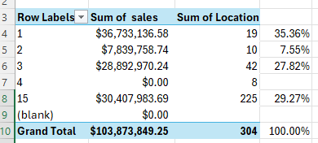
- Review current year Exemption to see if there have been any changes to the excluded amount
- Verify all formulas are flowing through correctly and the proposed allocation appears correct
- Create a tab showing prior year monthly entry beside current year entry
  - Add notes explaining any noticeable changes.
- The CAT Tax Entry is now ready to be submitted to President for approval.

Insurance Recurring Entry
- Open prior-year spreadsheet, make a copy and roll spreadsheet forward to current year.
  - File Path: “F:\Accounting\Shared\Month End\Recurring Entry\FY 20XX\FINAL & APPROVED - Insurance Recurring Entry - Per XX thru Per XX.20XX.xlsx"
- First, update the 20XX Allocation Summary Tab with Travelers and Five star insurance policies for the coming year.
  - This tab is critical because it ensures we allocate 100% of the know premiums, and we will later use this to reconcile our monthly entries back to the total premiums for the coming year
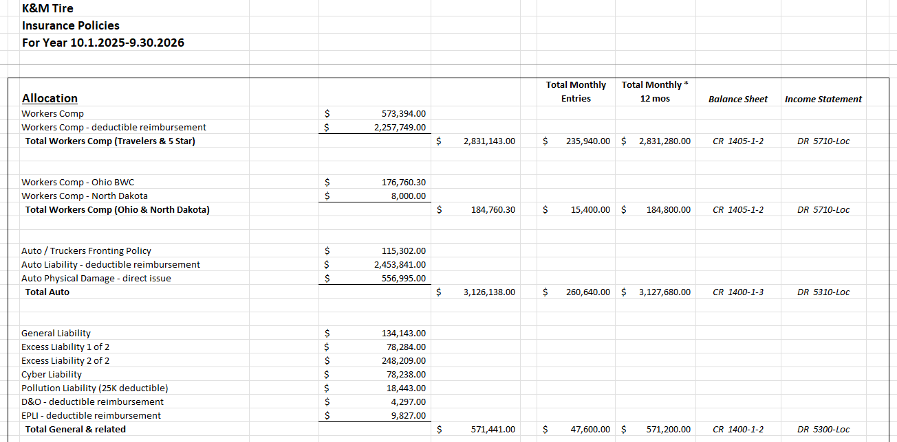
- Next, begin updating each tab to calculate accrual for current year
Workers Comp Insurance Entry
- This entry is a Credit to 1405-1-2 and a debit to 5710-Loc
- Workers Comp
  - Allocation is based upon (for locations other than Ohio & ND)
    - 75% Allocated by Payroll (5690+5700 wages)
    - 25% Allocated by Claims, (Average of Prior 3 years + 80 of Reserves)
    - See below screenshots as examples:
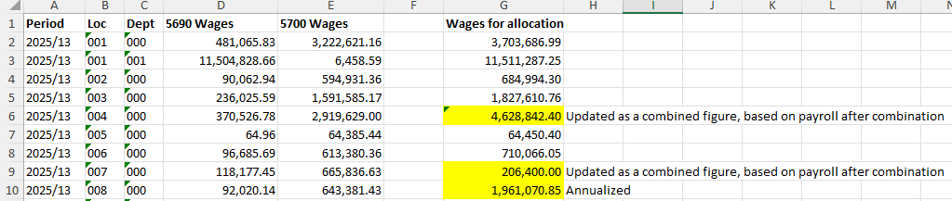
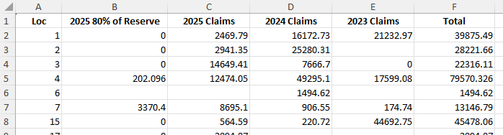
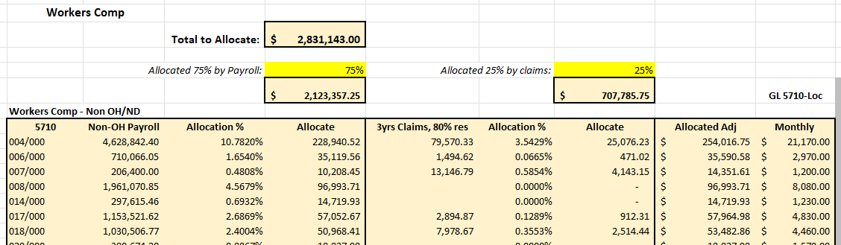
- For Ohio, allocation is based up Payroll by location with Category (Drivers/Wholesale/Sales/Office) and W/C rate applied.
- For ND, we base accrual off last year’s actual amount paid
- After updating,
  - Analyze spreadsheet to make sure all formulas flowing through as expected
  - Analyze entry to make sure everything is correct
- Create a tab showing prior year monthly entry beside current year entry
  - Add notes explaining any noticeable changes.
- The Workers Comp portion of Insurance entry is now ready to be submitted to President for approval.
Auto Insurance Entry
- This entry is a credit to 1400-1-3 and a debit to 5310-Loc
- Auto Entry allocation based upon
  - 75% is based on number of vehicles by location
    - Cars & Pickups receive a flat charge of $1,000 per vehicle
    - Remainder is allocated based on the number of delivery vehicles
      - For 9.30.2026 accrual, this was $3,777.76 per delivery vehicle
  - 25% is based upon claims
    - Prior 3 years claims plus 80% of CY Claims reserve
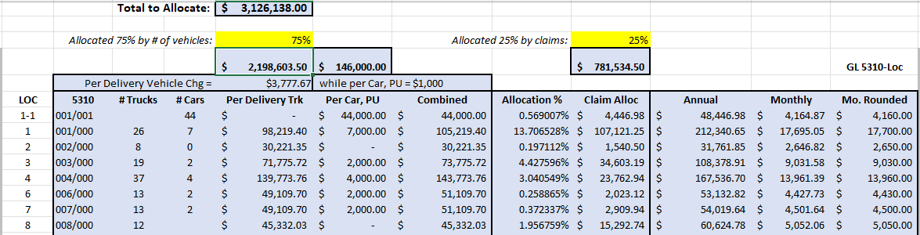
  - Vehicle list should be requested from logistics. When reviewing, exclude any vehicles highlighted red or noted as being out-of-commission or held-for-sale. These should be excluded from calculation
- Create a tab showing prior year monthly entry beside current year entry
  - Add notes explaining any noticeable changes.
- The Auto Insurance portion of Insurance entry is now ready to be submitted to President for approval.
General and Excess Liability Entry
- This entry is a credit to 1400-1-2 and a debit to 5300-Loc
- Allocation of General and Excess Liability entry is based upon Prior Year sales
  - Be sure to annualize for any location added mid-year or consolidations
  - Remove any locations that have been closed
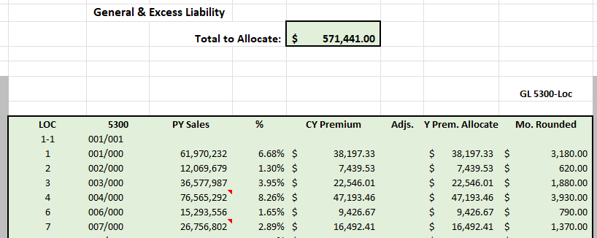
- Create a tab showing prior year monthly entry beside current year entry
  - Add notes explaining any noticeable changes.
- The Workers Comp portion of Insurance entry is now ready to be submitted to President for approval.
Credit Risk Entry
- This entry is a credit to 1400-1-4 and a debit to 5980-Loc
  - Per GAAP, insurance expense for credit risk would be posted to an insurance expense account and not a bad debt expense account. On our annual audited financial statements, FORVIS renames our Bad Debt expense line as “Credit Loss” expense, allowing for us to post both the Bad debt and the Credit Premium expense into this same account.
- Allocation of Credit Loss expense mirrors allocation of G/L 1290 Bad Debt accrual as outlined earlier in this SOP.
  - We post these as two separate entries so we can reconcile each individually
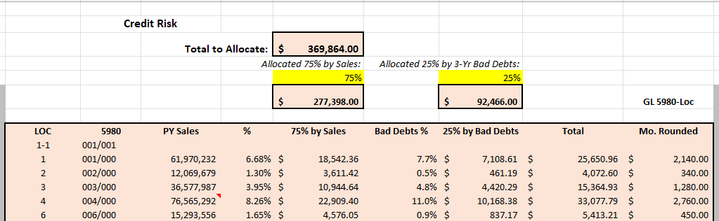

Property Insurance Expense
- This entry is a credit to 1400-1-2 and a debit to 5300-Loc
- Allocation is based on Statement of Values as used by Travelers to calculate premiums
- Copy in current year statement of values as starting point for calculation
  - When updating, make sure you start with the FINAL Statement of Values as used by Travelers.
  - If rates are not listed, email Hylant to request the exact rates by category (Building / Stock / Property of Others)
  - Review PY to see if any adjustments were made, which may need to be repeated in current year.
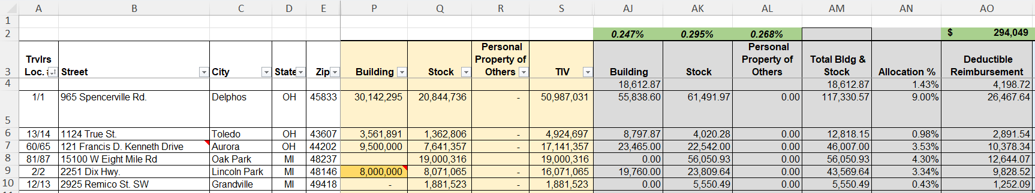
- Verify all formulas are flowing through as expected, and totals tie out.
- Verify all amounts look reasonable and correct
- Create a tab showing prior year monthly entry beside current year entry
  - Add notes explaining any noticeable changes.
- The Property Insurance Entry is now ready to be submitted to President for approval
Insurance Summary
- Return to “20XX Allocation” tab
- Scroll down to the bottom, and verify the total of the Insurance monthly recurring entries x 12 months equals the total cost of insurance
  - There will be a small variation due to rounding entries to nearest $10.
  - See highlighted cells below as example
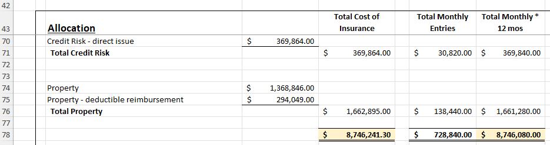

Property Tax Recurring Entry
The purpose of this entry is to accrue for Property Taxes evenly over 12 months, even though the cash payments for Property taxes are only made once or twice each quarter.
- This entry will be a credit to 2660-Loc and a debit to 5760-Loc.
- Open prior-year spreadsheet, make a copy and roll spreadsheet forward to current year.
  - File Path: "F:\Accounting\Shared\Month End\Recurring Entry\FY 20XX\FINAL & APPROVED - Property Taxes Recurring Entry - Per XX thru Per XX.20XX.xlsx"
- Replace PY actual payments tab with updated summary from most recent year-end
  - This can been found in the following folder: F:\Accounting\Shared\Tax\RE and Property Tax\Property tax spreadsheet

- Update the “Taxes” tab
  - Analyze each row, location by location, being mindful of factors which could affect coming year property taxes
  - Review “2660 Accrued Taxes” spreadsheet and related assessments folder to see if there are any swings in assessments
    - "F:\Accounting\Shared\Tax\RE and Property Tax\Property tax spreadsheet\2660 Accrued Taxes - Property - FY 2026.xlsx"
  - Review property tax abatements
    - See if there are any being phased out which would cause an increase
  - Consult with Real Estate Manager and President to see if there are any other expected increased or decreases
    - Possible increases could be do to recent building additions or significant improvements
    - Possible decreases could be due to prior year appeals where we lowered our assessed value
  - When truing up property taxes at year-end, most errors identified in accruals come from locations where we either moved locations or went into a new building and under-accrued the first year.
    - Pay extra attention to new locations and whse moves
- Verify all formulas flowing correctly
- Verify with President the percentage increase we want to anticipate, absent other factors.
  - FYE 9.30.2026, we applied a 5% expected increase to the accrual. We hope it is less, but we accrued 5% increase as buffer
- Create a tab showing prior year monthly entry beside current year entry
  - Add notes explaining any noticeable changes.
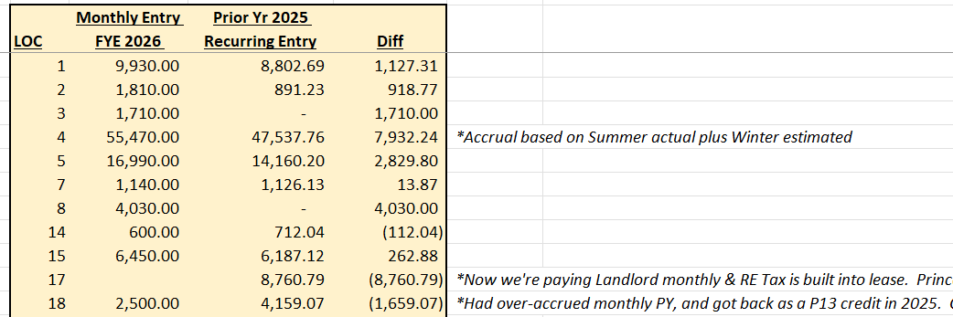
- The Property Tax Entry is now ready to be submitted to President for approval
NOTE: When reviewing where to post a property tax bill, if there is any question the controller should review this spreadsheet to see if we’re accruing for that invoice monthly. Where we get invoiced for property taxes monthly from the landlord as part of a CAM agreement, we post these payments directly to the 5760 expense. When we receive an invoice from a landlord, to the extent we have accrued for it determines if it should be posted to 2660 or 5760 when received. Bills received from landlords annually, we accrue for.

Depreciation & Amortization entry
- Open prior-year spreadsheet, make a copy and roll spreadsheet forward to current year.
  - File Path: "F:\Accounting\Shared\Month End\Recurring Entry\FY 20XX\FINAL & APPROVED - Depr & Amort Recurring Entry - Per XX thru Per XX.20XX.xlsx"
- Request Book Future Depreciation Report
  - At the beginning of each new fiscal year, after all fixed asset additions and disposals have been sent to M&Z for the previous year, email M&Z to request a “Book Future Depreciation Report” for the coming year.
  - Request report in excel format
  - Once received, save report in following file path
    - F:\Accounts Payable\Shared\Lists\ASSETS
  - Verify the date on the report header matches current fiscal year that’s beginning
- Calculate initial Monthly Expense from Report
  - Verify depreciation & amortization expense total for proof
    - Scroll to the bottom of the report and highlight the current year depreciation expense.
    - Insert a formula to divide that amount by 12 months
    - When working the next steps, verify the total by location agrees with the total on the report
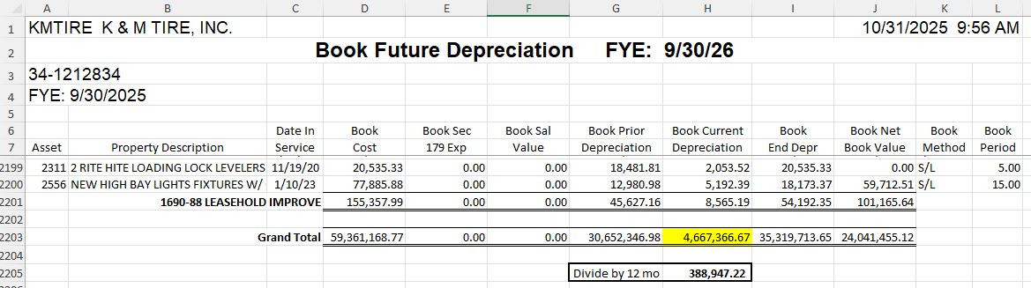
  - Insert Formula to divide current month expense by 12
    - In column N, insert a formula such as follows to take the current expense divided by 12 months.
    - =IF(C11<>"",IF(K11="",(H11/12),0),0)
    - Verify total of Column N matches the monthly depreciation proof calculated above, based on the report total
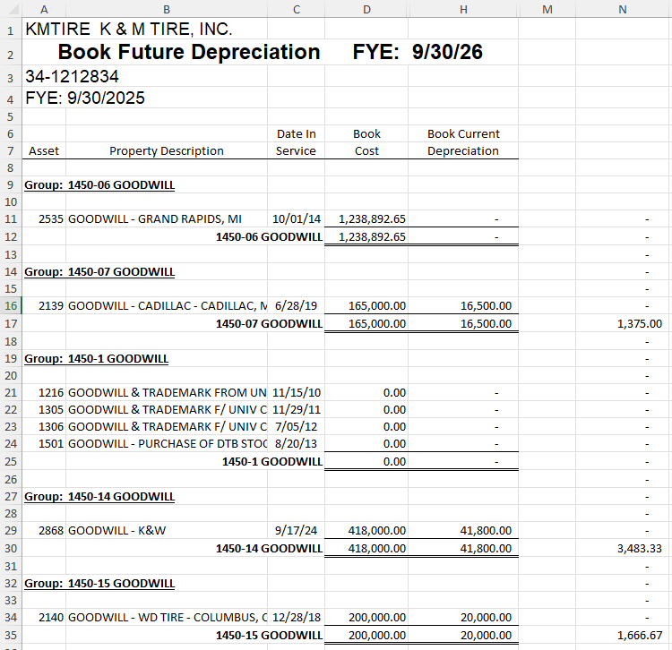
- Copy and paste Column C & Column N values into a new tab.
  - Sort by Column C
Creating Amortization Entry Proposal
- Review locations with amortization expense to verify none have been closed or consolidated.
  - If any locations have been closed or consolidated, their amortization expense will need to be reallocated to the locations where the customers, routes, and sales were transferred.
  - Request this information from Logistics and allocate based on sales history of acquired customers
    - Update our figures used for the recurring entry.
  - Email M&Z with instructions for how to reallocate.
    - For example, when Allentown (L19) was closed & consolidated, the customers and routes were transferred to L18, L14, & L17 as follows:
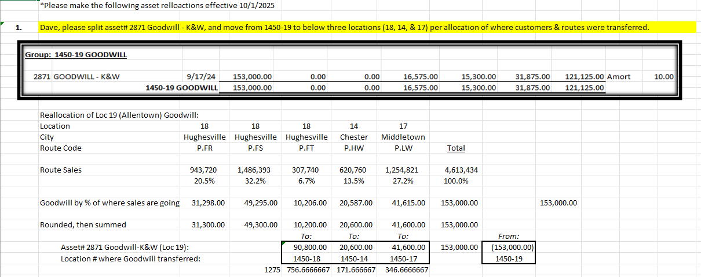
- Create a new excel spreadsheet named “Depreciation & Amortization 01.20XX” and save under the following path:
  - F:\Accounting\Shared\Recurring Entry\FY 20XX
  - Copy the prior year recurring entry into this spreadsheet as a template for current year’s entry.
- Update the Amortization Recurring Entry Template
  - Fill in the current year monthly amounts, rounding UP to the $10 figure
  - NOTE: We round this entry, because this helps us spot items that might be mistakenly posted to the Accumulated or Expense accounts.
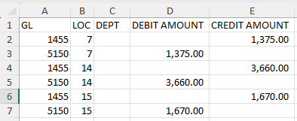
  - Once updated, verify the total agrees with the Amortization expense total from the Depreciation Schedule, after rounding.
  - The Amortization entry proposal is now prepared. We will now move on to the Depreciation Entry.
Creating the Depreciation Entry Proposal
- Update the “Depreciation - Calculation” tab with the current year amounts.
- Begin by updating columns D & E with the totals from the Book Future Depreciation Report.
  - Round amounts to the nearest $10. Round up if in question.
- Next, clear any old formulas out of columns G & H, and begin inserting new formulas adding the total from report, to any proposed monthly additions in column J, that will be identified in following step.

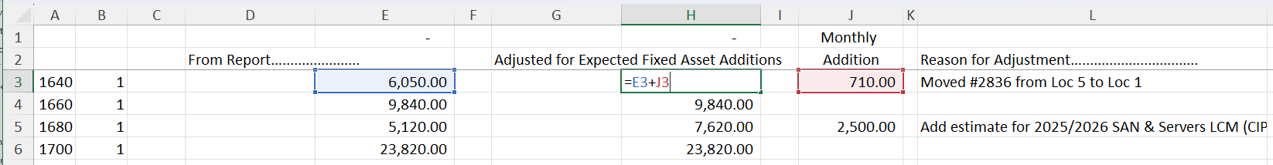
- Next, update Columns J, L, & M to build in a proposed allowance for current year Fixed Asset Additions, not yet on Depreciation Schedule
  - Consult with VP of Real Estate & Facilities and CFO, on known equipment purchases that should be accounted for and built into entry.
  - Ask if there are any current year building additions, remodels, or other large capital expenditures which could result in fixed assets being added to the depreciation schedule.
    - For real estate improvements, clarify if K&M is making expenditure as tenant, or if real estate LLC is making expenditure and increasing rent.
    - Leasehold improvements will be depreciated over the shorter of their useful life or the life remaining on the lease.
    - If warehouse equipment, take total dollar amount divided by 5 years, divided by 2 (which equates to 10% of cost) for straight-line, half-year depreciation method for the year equipment was placed in service.
      - Divide this by 12 months for the monthly increase which is recorded in column J.
        - Round to nearest $10.
      - Note reason for adjustment in Column L.
    - Review the Construction In Progress (CIP) account, 1610.
      - This account is used for any assets that have been purchased, or for which a deposit or amount has been paid, but the asset has not yet been placed into service.
      - Refer to excel file: "F:\Accounts Payable\Shared\Lists\ASSETS\Asset Activity.xlsx"
        - Refer to tab “CIP”
  - Request estimate of coming year server and life-cycle-management large computer hardware expenses from CFO and VP of IT.
    - Computer hardware is depreciated over 5 years
  - Discuss findings with CFO, and inquire if any other locations should receive a small padding for potential fixed asset additions throughout year
  - NOTE: This step is important, because if we miss known fixed asset additions, we will underestimate the deprecation expense and have a negative adjustment at yearend.
- All proposed entries should be rounded to the nearest $10
- Confirm total of column D agrees with Depreciation Expense from Depreciation Schedule after rounding
- Loc 15 should be allocated 100% to 15-0
  - Although there is some corporate computer hardware housed here, Loc 15 has a low rent for the building, so no depreciation is reallocated.
- Create a tab and display Prior Year monthly depreciation expense by location beside current year proposed entry for depreciation expense.
  - Only do this for 5200 G/L, not for Accumulated Depreciation GLs.
  - Use VLOOKUP to pull over amounts from prior year, so they’re listed beside current year.
  - Add a column to the right subtracting prior year from current year to highlight the difference
  - List reason for any noticeable swings.
- Review to make sure you agree with everything as presented
- The Depreciation entry proposal is now ready

General Ledger Error Log & Correcting Unbalanced GL
When an error report is received, it generally indicates that something wasn’t posted correctly to the GL. It is critical to research what happened the day of the error and identify the root cause, to prevent additional errors from happening the following day. In addition to fixing the root cause, in many cases a GL entry or something else is needed to fix the error. Continuous errors that are not getting resolved within 1 week should be brought to the attention of the President, as the indicates problems with a process or control key that aren’t being fixed.
- Accounting>Shared>General Ledger Error Logs for saved examples and more info
- Error log report will be sent from Admin to Controller and VP of Accounting, and then to Accounting if needed.
  - To manually run (do not edit or delete):
    - 1 Tire Dealer System
    - 20 System Menu
    - 7 Work with Error Log
- Descriptions of Errors Log line items:
  - “G/L EOY completed for company”- a EOY rollover has been done, to get balance sheet accounts to carry over from one year to another (this can be done multiple times)
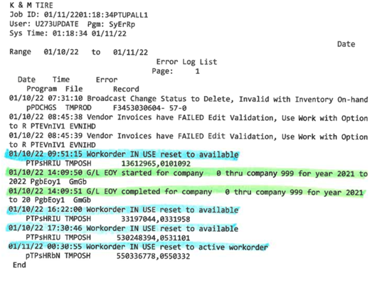
  - “G/L Master record not on file Ref#”- something has posted to an account that doesn’t exist, it will post to 99999-loc and make the GL out of balance.
    - Ex. AR adjustments can only be posted to 1013-1 not 1013-loc, if they post to a location it will go to 99999-loc.
    - This can be fixed by a two-sided entry reversing the amount in 99999 and posting to 1013 or correct account
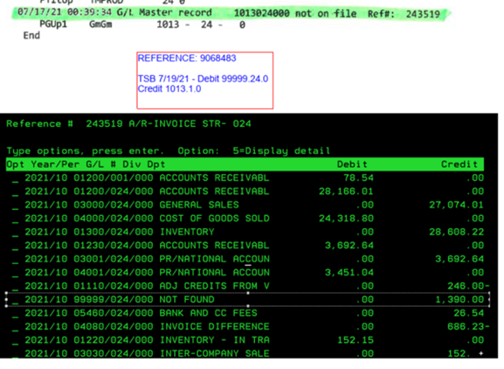
  - Error Report: Control Key Missing or Invalid
    - The Control Key Error GLS3993 is populated when a Direct Ship invoice is created out of loc 50 that includes Tire Tax. When this happens the tire tax is not posted to GL correctly because the control key isn’t set up. We do not want to set it up because customers billed out of store 50 could be from any state and we need to know what state the tire tax needs submitted to.
    - When this error occurs, the tire tax is posted to GL3000-General Sales. The tire tax will need to be moved from GL 3000 to GL 2510. When posting to 2510, post it to the location the customer normally receives deliveries from, which should be located in the same state the tire tax is associated with.
    - Save a copy of the invoice in a folder on the F drive under tire tax for that state. This may be needed in an event of a Tire Tax audit.
    - When review the invoice on the error report and determining the amount of the GL posting, it is the amount on the invoice listed under State Tire
Tax and this should also match the amount on the error report. - this is the amount that needs to be moved.
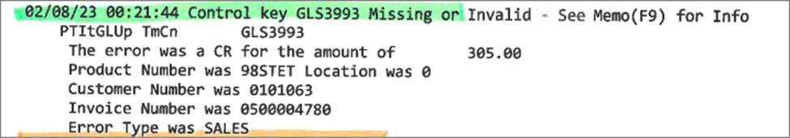

- To move the tire tax from 3000 General Sales to 2510 Tire Tax.
  - 3 General Ledger (enter)
  - 2 Input and Update Menu (enter)
  - Work with outstanding JEs
  - F6 Generate GL Ref Number
  - Update Year/Period and end Description
  - Debit 3000- Loc and Credit 2510-1
- “G/L Company is out of balance last ref#”- this is something in an AR cash receipt posting that will need investigated by the AR Manager and the Controller will need notified to then fix with a one-sided entry.
  - Cash Receipts Edit Register can be used to find the discrepancy (AR will still need to review to correct the customer account):
    - 1 Tire Dealer System
    - 1 AR Menu
    - 3 Cash Receipts
    - Store Number 1
    - Show only date applicable (date from error log, or one day prior)
    - Find the reference number from the error log
    - Exclude processed receipts- N
    - F9 to print
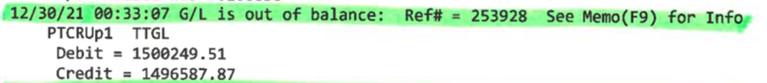
    - Compare ck amount to amount applied

- If the GL is out of balance but it is not listed on an error log these are the next items to check:
  - Check that it is only out of balance in the period you are working with
    - If it is a period that previously balanced and none of the below checks help, you can compare audit reports, trial balances or financial statements to find the difference.
  - Check that the 99999 accounts do not have a balance
  - Check that something was not posted one side to an affiliate (location 90-96) and one side to K&M
    - To do this you can run affiliate balance sheets (3-4-1-4 BAL90, BAL91. BAL94, BAL95, BAL96, BAL98) try calendar month of the month out of balance
    - This could happen by a manual journal entry or AP or AR
  - Check to see if the Trial Balance and Audit Reports balance as they should be out of balance as well

Daily Procedures
The following standard operating procedures are to be completed daily:

Daily Bank Reconciling
The purpose of daily bank reconciling is to reconcile and verify all transactions posting to our bank accounts on a daily basis. Through daily banking we will catch and record items such as sweeps, NSFs and returns, ACH payments made by customers, 5-Star reimbursements, BKT adjustment and VB payments, and auto-withdrawals such as bank service fees, etc.
  - Open K&M Inc. Bank Ledger
  - F:\Accounting\Shared\Banking\Wells Fargo\2025 then click on 1010-1 Bank Ledger

Wells Fargo (If Applicable):
- Pull Wells Fargo Daily Activity: https://wellsoffice.ceo.wellsfargo.com/portal/signon/index.jsp?TYPE=33554433&REALMOID=06-000d71c3-1a65-1ddc-b7b9-f958aa2b0000&GUID=&SMAUTHREASON=0&METHOD=GET&SMAGENTNAME=$SM$wxmc1ecDLapnq6HGl7mpYUdBlXthkgxcPSsA7RoAreov8EM75QYfI7EQwXrlNithd9eOVK1jty0udNc4ugg%2bmzYRcdozfPvGOxjR8AQr5ghuYUP9ZpLuEmudqahrPSUa&TARGET=$SM$https%3a%2f%2fwellsoffice%2ewellsfargo%2ecom%2f
  - While on Wells Fargo check for any alerts/notifications in Communication Center or Fraud Manager- these will show up on home screen
  - Click Reports & Insights then click on Go to Reports & Insights dashboard.
    - Previous Day Composite- click “Run” to pull the report
    - Save as PDF at \\file-a.kmtire.local\File Server\Accounting\Shared\Banking\Wells Fargo\YYYY\Month YYYY
  - To review a different day’s activity, click Reports & Insight and then Transaction Search.
    - In Search For select Account Activity. Pick your date or date range. Then click Search.
- Update Wells Fargo Bank Ledger “1010-1 Bank Ledger- YYYY”. excel F:\Accounting\Shared\Banking\Wells Fargo\YYYY- 1010-1 Bank Ledger
  - Following Previous Day Composite add Credits/Deposits:
    - Type them onto bank ledger with description, entered into MaddenCo date (if applicable by checking the GL account), cleared bank date, deposit in bank amount, reference number if in MaddenCo, and initials or department that made entry
    - If a customer name is listed on the Previous Day Composite it is an ACH
    - If no customer name is listed it is a Warehouse Deposit
    - Ex. “Commercial Deposit”, “Over the Counter Deposit”, “Edeposit in Branch Store”
  - Send listing of ACH’s to Accounts Receivable (wait until all bank accounts are reconciled and send all ACH’s in one email)
    - Subject- “ACH Deposits DD.MM.YYYY” Body- “Good Morning, ACH Deposits clearing the bank(s) on DD/MM/YY:”
    - Copy and paste customer name, dates, & amount from bank ledger under Bank Name
  - Following Previous Day Composite add Debits/Withdraws:
    - Type them onto bank ledger with description, cleared date, withdraw amount
    - If a journal entry needs made (Ex. Client Analysis Service Charge) enter into MaddenCo (copying previous) and add Maddenco date, reference number & initials to bank ledger
  - Carry down (copy and paste) reconciliation in column J-K-L
    - Update date to date you are reconciling, column J
  - Update Closing Balance from report onto the bank ledger column K with first line on Previous Day Composite (Closing Ledger Balance)
    - In column I take =column H of last thing entered – column K. If its zero then it balances
- Reconcile Wells Fargo bank ledger against MaddenCo 1010-1
  - Scroll to bottom of date reconciling & make sure each item is on the bank ledger
  - Highlight anything on the spreadsheet that is in MaddenCo orange
  - Fill in any missing dates/reference numbers/initials
  - Make sure to match up AR debits (ACH’s) and AR credits (NSF/chargebacks)
  - Add the closing ledger balance to Consolidated Daily Bank Balance. F:\Accounting\Shared\Banking\Consolidated Daily Bank Balances.xlsx
  - Follow up weekly
    - Each week on Friday complete the Open Items – AR Discrepancies spreadsheet F:\Accounting\Shared\Banking\\AR Discrepancies - Weekly Update.xlsx
    - Right click on previous tab and copy of move to end. Rename tab with W.E. (means week ending) the Friday date you are doing the report.
    - Change the as of date to the Tuesday date of the week you are doing the report.
    - List any open items with a cleared date of the Tuesday of the week you are in and prior
    - Send report to Controller, AR & CC team leads & their managers, Director of Accounting, and VP of Accounting.
- Weekly (Thursdays) Funds Transfer to PNC AR
  - See banking guide for how to send an ACH out of Wells Fargo
  - Send all but $25,000.00 (have Controller, Director of Accounting, or Sr Project Manager Accounting approve the transfer)
  - Record in bank ledger
  - Make MaddenCo JE (can copy previous)
    - “Funds Transfer from WF to PNC AR”
    - 01016/001/000 Debit
    - 01010/001/000 Credit

First Financial - Cash:
Purpose: To outline Accounting’s process for managing the First Financial bank account including: updating the First Financial Bank ledger, reconciling the account to MaddenCo, and transferring funds to our AR account.
- Access First Financial Online Banking
  - Log into First Financial online banking:
    - First Financial Commercial Banking = https://commercial.bankatfirst.com/dbiqp
- Updating the First Financial Bank Ledger
  - Open our internal First Financial Bank Ledger file for the current year:
    - F:\Accounting\Shared\Banking\First Financial\1012-1 Bank Ledger-20XX.xlsx
  - In First Financial Online Banking First Navigator:
    - Click KM Tire (In Blue) on the homepage.
    - Check the cleared amount for the previous business day. (top of activity)
    - If necessary, adjust the Search Criteria-Date Range to reflect the day being reconciled.
  - Update our internal bank ledger for cleared transactions:
    - Enter the date cleared for all amounts that have been processed.
    - Ensure the Balance column (Column G) matches the running balance in First Navigator.
- Reconciling the First Financial Against MaddenCo 1012-1
  - Compare First Financial transactions with MaddenCo 1012-1 and update the ledger:
    - Fill in any missing details (amounts, reference numbers, and initials).
    - Highlight any discrepancies in orange for further review.
    - Verify that the ending/running balances match.
    - Record any necessary Account Analysis or Tech Care/Discover Settlement monthly entries (use the prior month’s entries as a reference).
    - Update the Consolidated Daily Bank Balances with the closing ledger balance:
    - F:\Accounting\Shared\Banking\Consolidated Daily Bank Balances.xlsx
  - We generally never have discrepancies in this account. If a discrepancy exists that cannot be identified, escalate to the controller for further research.
- Weekly Funds Transfer to PNC AR (Thursdays)
  - Refer to the Banking Guide for instructions on initiating an ACH transfer from First Financial.
  - Transfer all but $25,000.00 (to retain a cash reserve in Delphos if needed)/ (have Controller, Director of Accounting, or Sr Project Manager Accounting approve the transfer)
  - Record the transfer in the bank ledger.
  - Enter the MaddenCo Journal Entry (JE) (copy from a previous entry):
    - Description: Runds Transfer from FF to PNC AR”
    - Debit: 01016/001/000
    - Credit: 01012/001/000

Regions - Cash:
Purpose: To outline Accounting’s process for managing the Regions bank account including: updating the Regions Bank ledger, reconciling the account to MaddenCo, and transferring funds to our AR account.
- Access Regions Online Banking
  - Log into Regions online banking:
    - Regions Online Banking = https://login.regions.com/signin?channel=olb&product=accountoverview
- Updating the Regions Bank Ledger
  - Open our internal Regions Bank Ledger file for the current year:
    - F:\Accounting\Shared\Banking\Regions (1018)\1018-1 Bank Ledger-20XX.xlsx
    - Add all activity to the bank ledger and ensure that column G matches the running balance in Regions
    - Any ACH send to Accounts Receivable in an email with all ACH’s from all banks
- Reconciling the Regions Against MaddenCo 1018-1
  - Compare Regions transactions with MaddenCo 1018-1 and update the ledger:
    - Fill in any missing details (amounts, reference numbers, and initials).
    - Highlight any discrepancies in orange for further review.
    - Verify that the ending/running balances match.
    - Record any necessary Account Analysis or Tech Care/Discover Settlement monthly entries (use the prior month’s entries as a reference).
    - Update the Consolidated Daily Bank Balances with the closing ledger balance:
    - F:\Accounting\Shared\Banking\Consolidated Daily Bank Balances.xlsx
  - We generally never have discrepancies in this account. If a discrepancy exists that cannot be identified, escalate to the controller for further research.
- Weekly Funds Transfer to PNC AR (Thursdays)
  - Refer to the Banking Guide for instructions on initiating an ACH transfer from Regions.
  - Transfer all but $25,000.00 (to retain a cash reserve in Delphos if needed)/ (have Controller, Director of Accounting, or Sr Project Manager Accounting approve the transfer)
  - Record the transfer in the bank ledger.
  - Enter the MaddenCo Journal Entry (JE) (copy from a previous entry):
    - Description: Runds Transfer from Regions to PNC AR”
    - Debit: 01016/001/000
    - Credit: 01018/001/000

Huntington - Cash:
Purpose: To outline Accounting’s process for managing the Huntington bank account including: updating the Huntington Bank ledger, reconciling the account to MaddenCo, and transferring funds to our AR account.
- Access Huntington Online Banking
  - Log into Huntington online banking:
  - https://businessonline.huntington.com/BOLHome/BusinessOnlineLogin.aspx
  - In Huntington’s website follow the below steps to get the report for previous day activity:
    - Click Reports
    - Click Activity Report
    - Change the date range to previous day (weekend change to just Fridays date) and click run report
    - Click print report and save F:\Accounting\Shared\Banking\Huntington\2026\May 2026 as date (ex 5.1.26)
- Updating the Huntington Bank Ledger
  - Open our internal Huntington Bank Ledger file for the current year:
    - F:\Accounting\Shared\Banking\Huntington\1015-1 Bank Ledger-20XX.xlsx
    - Add all activity to the bank ledger and ensure that column H matches the running balance in Huntington
    - Any ACH send to Accounts Receivable in an email with all ACH’s from all banks
- Reconciling the Huntington Against MaddenCo 1015-1
  - Compare Huntington transactions with MaddenCo 1015-1 and update the ledger:
    - Fill in any missing details (amounts, reference numbers, and initials).
    - Highlight any discrepancies in orange for further review.
    - Verify that the ending/running balances match.
    - Record any necessary Account Analysis or Tech Care/Discover Settlement monthly entries (use the prior month’s entries as a reference).
    - Update the Consolidated Daily Bank Balances with the closing ledger balance:
    - F:\Accounting\Shared\Banking\Consolidated Daily Bank Balances.xlsx
  - We generally never have discrepancies in this account. If a discrepancy exists that cannot be identified, escalate to the controller for further research.
- Weekly Funds Transfer to PNC AR (Thursdays)
  - Refer to the Banking Guide for instructions on initiating an ACH transfer from Huntington.
  - Transfer all but $25,000.00 (to retain a cash reserve in Delphos if needed)/ (have Controller, Director of Accounting, or Sr Project Manager Accounting approve the transfer)
  - Record the transfer in the bank ledger.
  - Enter the MaddenCo Journal Entry (JE) (copy from a previous entry):
    - Description: Runds Transfer from Huntington to PNC AR”
    - Debit: 01016/001/000
    - Credit: 01015/001/000

FNB Bank - Cash:
Purpose: To outline Accounting’s process for managing the FNB bank account including: updating the FNB Bank ledger, reconciling the account to MaddenCo, and transferring funds to our AR account.
- Access FNB Online Banking
  - Log into FNB Bank:
  - https://fnbvan.myebanking.net//#/login
  - Look at Recent Transactions on the home page. If there is activity for the previous day click on it.
  - Click the down arrow to download a copy to save F:\Accounting\Shared\Banking\FNB Bank (1019)\May 2026 as date (ex 5.1.26)
- Updating the FNB Bank Ledger
  - Open our internal FNB Bank Ledger file for the current year:
    - F:\Accounting\Shared\Banking\FNB Bank (1019)\1019-1 Bank Ledger-20XX.xlsx
    - Add all activity to the bank ledger and ensure that column G matches the running balance in Huntington
    - Any ACH send to Accounts Receivable in an email with all ACH’s from all banks
- Reconciling the FNB Bank Against MaddenCo 1019-1
  - Compare FNB Bank transactions with MaddenCo 1019-1 and update the ledger:
    - Fill in any missing details (amounts, reference numbers, and initials).
    - Highlight any discrepancies in orange for further review.
    - Verify that the ending/running balances match.
    - Record any necessary Account Analysis or Tech Care/Discover Settlement monthly entries (use the prior month’s entries as a reference).
    - Update the Consolidated Daily Bank Balances with the closing ledger balance:
    - F:\Accounting\Shared\Banking\Consolidated Daily Bank Balances.xlsx
  - We generally never have discrepancies in this account. If a discrepancy exists that cannot be identified, escalate to the controller for further research.
- Weekly Funds Transfer to PNC AR (Thursdays)
  - Refer to the Banking Guide for instructions on initiating an ACH transfer from FNB Bank.
  - Transfer all but $25,000.00 (to retain a cash reserve in Delphos if needed)/ (have Controller, Director of Accounting, or Sr Project Manager Accounting approve the transfer)
  - Record the transfer in the bank ledger.
  - Enter the MaddenCo Journal Entry (JE) (copy from a previous entry):
    - Description: Runds Transfer from FNB to PNC AR”
    - Debit: 01016/001/000
    - Credit: 01019/001/000

Chase AR Ending 0982:
Chase account ending 0982 was K&M Tire’s primary AR account up until we switched to PNC in August of 2024. We keep this account open for deposing cash received by K&M Tire locations that do not have a PNC branch nearby. Periodically, a customer will use an old ACH template and send an ACH to this account instead of PNC. When that happens, we should notify AR so updated ACH instructions can be provided to our customer.
- Log on to: https://access.jpmorgan.com/jpmalogon?TARGET=$SM$https%3a%2f%2ftssportal.jpmorgan.com%2fpp%2fpp%2fWSQ%2flanding%2fclassichome&brand=jpma
  - In box that says reports click “Run Balance and Transaction Report”
  - A new page will pull and click run unless you need to change the date of the reports
  - Print to PDF for easier viewing and save at F:\Accounting\Shared\Banking\JP Morgan Chase\AR\2025\Month
- Update “1013-1 Bank Ledger F:\Accounting\Shared\Banking\JP Morgan Chase\AR\2025
  - ACH’s: put all ACH’s in order on the bank ledger sheet
    - Description on report “EFT CREDIT”
    - Column A will be the Madden Co date once AR puts them in Madden Co.
    - Column B (Description) will say the name of the company the ACH came from. (ex. Alma Tire Service)
    - Column C (cleared date) will be the date it cleared the bank
    - Column D (check#) will be ACH
    - Put the amount in either column E or F depending on whether it is a credit or debit in the bank. (Highlight amount orange once posted in Madden Co
    - Column G will be the ref# out of Madden Co once AR posts it
    - Column H will be the initials of the person that posted it in Madden CO.
    - Check all ACH’s highlighted and see if they have been posted in Madden Co in the correct GL. Add ref# and initial and unhighlight them but highlight dollar amount in orange. (in Madden Co it will be the total of all the ACH’s highlighted)
    - Send listing of ACH’s to Accounts Receivable email (wait until all bank accounts are reconciled and send all ACH’s in one email)
    - Subject- “ACH Deposits 6.16.25” Body- “Good Morning, ACH Deposits clearing the bank(s) on 6/16/25:”
    - Copy and paste customer name, dates, & amount from bank ledger under bank name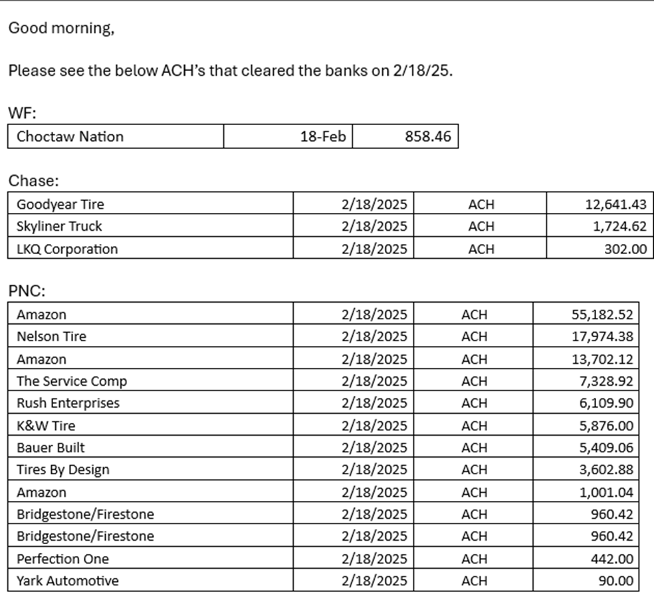
  - Warehouse (cash) Deposits: put all the warehouse deposits together on the general ledger sheet
    - Description on report “ATM Cash Deposit” or “Deposit”
    - Column A will be the Madden Co date once AR puts them in Madden Co.
    - Column B (Description) will say Warehouse Deposit
    - Column C (cleared date) will be the date it cleared the bank
    - Column D (check#) will be the location the cash came from. (if the customer ref starts with 2 digits of one of our location put that number if it starts with random numbers put X)
Ex. 820000006 would be location 82. Ex. 6780042783 would be X
    - Put the amount in either column E or F depending on whether it is a credit or debit in the bank. (highlight amount in orange once in Madden Co)
    - Column G will be the ref# out of Madden Co once AR posts it
    - Column H will be the initials of the person that posted it in Madden CO.
    - Check all warehouse deposits highlighted and see if they have been posted in Madden Co in the correct GL. Add ref# and initial and unhighlight them but highlight dollar amount in orange. (in Madden Co it will be the total of all the warehouse deposits highlighted)
  - Returned Items or Adjustments
    - Put on the ledger. Email AR to see if they know anything about it
    - If AR does not know then email Chase for me information
- Once everything has been added to the ledger make sure the balance matches what the ledger says and put the balance on the consolidated daily bank balance sheet.
- Daily balance review and Funds Transfer to PNC AR
  - Refer to the Banking Guide for instructions on initiating an ACH transfer from Chase
  - Once the balance gets above $150,000 transfer all but $25,000.00 to the PNC AR account. (have Controller, Director of Accounting, or Sr Project Manager Accounting approve the transfer)
  - Record the transfer in the bank ledger.
  - Enter the MaddenCo Journal Entry (JE) (copy from a previous entry):
    - Description: Runds Transfer from FF to PNC AR”
    - Debit: 01016/001/000
    - Credit: 01013/001/000

PNC AP Daily Banking
- Log into PNC (Pinacle) https://www.treasury.pncbank.com/idp/esec/login.ht
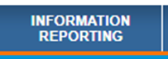
- Click on the tab that says Information Reporting along the top of the page

- Click on Activity Detail on the left-hand side of the page
- Click on the date range and make it the dates that you are doing daily banking for and click continue (Weekends do Friday-Sunday)
- Click on Selected account and choose Accounts Payable and select continue
- Click Run Report off to the right
- Once the report is done click on the three dots off to the right and select PDF
- Open the PDF file and save it at F:\Accounting\Shared\Banking\PNC\PNC AP 1017\YYYY Month as the date (example 4.11.25)
- Open the 1017-1 ledger at F:\Accounting\Shared\Banking\PNC\PNC AP 1017\2026\1017-1 Bank Ledger- 2026.xlsx
- Log into Madden Co
  - 3 General Ledger
  - 3 Inquiry Menu
  - 1 Balance Inquiry
  - Enter through store
  - Put in 1017-1 for the GL account
  - Go to the period you are in and put a 5 on the line
  - Look at everything that was posted in Madden Co from the previous day and highlight it orange on the 1017-1 ledger and put the reference number and initials beside it.
  - Tip- AP will lump multiple items from the ledger together and it will be posted as a lump sum in Madden Co. May have to add things up sometimes on the ledger to get the full amount of the entry
- Open the report you saved from PNC and find all the ACH amounts on the report in the ledger and put the previous date in the cleared date column.
- There may be some ACH’s that will not be on the list that Accounting must do an entry for themselves, you can look at previous entries to know where to post them. If you do not know what to do with any ACH’s ask the Controller. Examples below
  - Wex first one of the month will be posted back into the previous month
  - Account Analysis Charge
  - UPS you will have to put on the ledger and then send a snip it to Account Payable Team Lead and they will make the entry
  - Sweeps from PNC AP to PNC AR
  - Travelers first one in the month will be posted back into the previous month
  - Ohio BWC
  - Madden Co fee
  - Best One insurance will come out of the bank and accounting may have not processed it yet. Keep looking for the entry in Madden CO.
- If there has been an entry for checks in the previous day put a clear date on that as well.
- Move all the items that cleared up to the last thing that cleared the day before.
- Put your sweep last (on the report it says ZBA Credits (Funds transfer from acct)
- Make sure all formulas are calculated right.
- Copy down the below so that it is close to the last thing you put on the ledger
  - Change the date to the day you are doing daily banking for
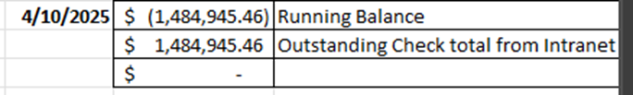
  - In the box beside running balance make sure that it is pulling the amount on the last thing you put on the ledger

- All the items that say checks paid on the PNC report follow the below steps
  - Go to Intranet
  - Outstanding checks report under accounting
  - Select the previous day under date and click run report
  - Double click on the amount so that it filters it from largest check amount to smallest. (That is how PNC’s report runs from top to bottom)


  - Click the little box beside each check on the report to check mark it

  - Once checks are all marked click update records.
  - When it is updated, scroll to the top and click excel
  - This will give you a list of all the remaining outstanding checks.
  - Put the total amount of the outstanding checks on the consolidated daily bank balances excel sheet F:\Accounting\Shared\Bank Ledgers\K&M Inc\Consolidated Daily Bank Balances.xlsx
  - Put the outstanding check amount in the box beside outstanding check total from Intranet
  - If there is no variance it reconciles


- Save the outstanding check list from Intranet here F:\Accounting\Shared\Banking\Outstanding Checks as the date (example 4.11.25)
- Go back to Intranet in the same spot for outstanding checks and click the clear button
- Put the previous day in both from and to and then select run report (this will give you the list of all checks that were cleared)
- Once the report is done click excel save this report here F:\Accounting\Shared\Banking\Outstanding Checks\Cleared Checks as the date (example 4.11.25)

PNC AR Daily Banking
- Log into PNC (Pinacle) https://www.treasury.pncbank.com/idp/esec/login.ht

- Click on the tab that says Information Reporting along the top of the page

- Click on Activity Detail on the left-hand side of the page
- Click on the date range and make it the dates that you are doing daily banking for and click continue (Weekends do Friday-Sunday)
- Click on Selected account and choose Accounts Receivable and select continue
- Click Run Report off to the right
- Once the report is done click on the three dots off to the right and select PDF
- Open the PDF file and save it at F:\Accounting\Shared\Banking\PNC\PNC AR 1016\YYYY Month as the date (example 4.11.25)
- Open the 1016-1 ledger at F:\Accounting\Shared\Banking\PNC\PNC AR 1016\2026\1016-1 Bank Ledger- 2026.xlsx
- Log into Madden Co
  - 3 General Ledger (enter)
  - 3 Inquiry Menu (enter)
  - 1 Balance Inquiry (enter)
  - Enter through store
  - Put in 1016-1 for the GL account
  - Go to the period you are in and put a 5 on the line
  - Look at everything that was posted in Madden Co from the previous day and highlight it orange on the 1016-1 ledger and put the reference number and initials beside it.
  - Mail Checks will be on the ledger and in Madden Co from the previous day but won’t come out of the bank until next day. Make sure the amount is correct and then wait to highlight them orange until you see them come out of the bank.
  - You will need to put all the Transfers and Sweeps that you did for FF, WF, Chase, and PNC that morning on the 1016-1 ledger
- Add all adjustments made to 1016 to the ledger
  - Go to Intranet under AR-Adjustment Report
  - Filter the date range for previous day
  - Check to see if any of the adjustments are already on the ledger, if not add them to the bottom under pending
  - Make sure the amount for all of them matches what is in Madden Co as the below name. Highlight them orange and put the date, ref# and initials in the correct columns.

  - In Madden Co if the description says the below it is for returned checks and ACH debits.
    - If you can’t find the total amount go to Intranet under Sales (SA) – Product History Inquiry
    - In the part number put returnedpnc, click “run report”
    - That will tell you all the amounts that add up to the total for that day

- Open the PDF you pulled from PNC and saved on the F:file. Input all the information from the report onto the ledger.
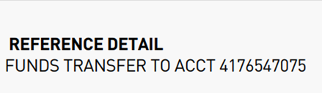
  - The item that says Funds transfer to acct# 4176547075 will be the Sweep from PNC AP

  - Corporate Cash Sweep (Sweep from Loc) is either the pay on loc or draw on loc. Pay on location will be a withdrawal amount and draw on location will be a deposit. (you will need to make an entry for this in Madden Co)

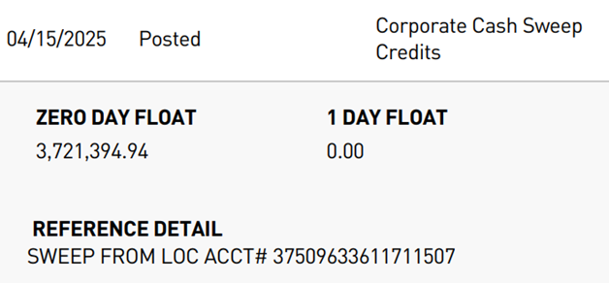

  - The item that looks like the below will be put on the ledger as PNC webpay
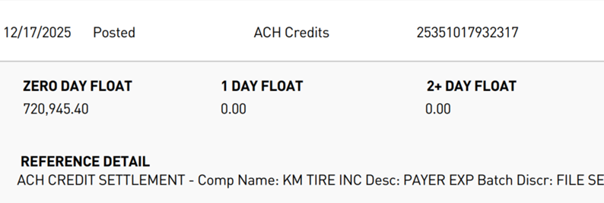

  - The item that looks like the below will be put on the ledger as PNC credit cards
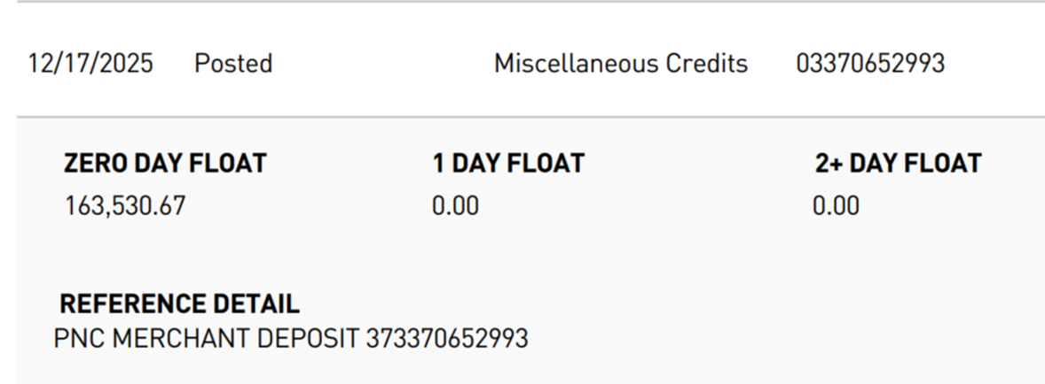

  - Returned Items, ACH debit return, and ACH reversals
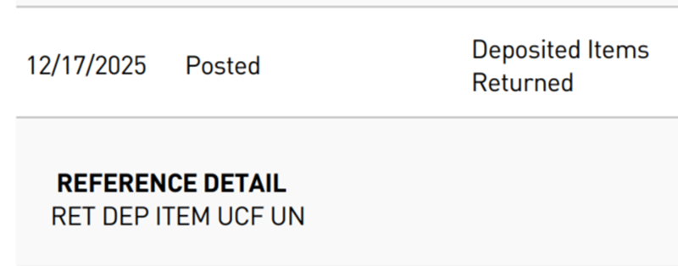
    - Items that say the below are returned items, but they can be redeposited the same day. If they aren’t redeposited follow the steps below to see what they are and put on NSF maintenance in Intranet

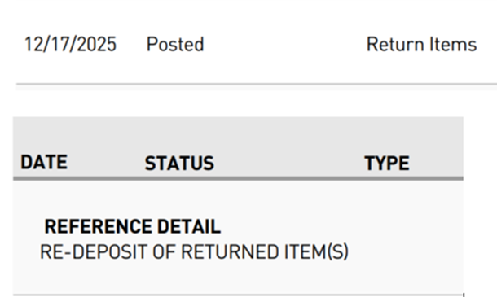

  - Items that say the below are ACH debit returns that need to be put on the ledger including the customer’s name of the ACH being returned and put through NSF maintenance on Intranet: follow the steps below
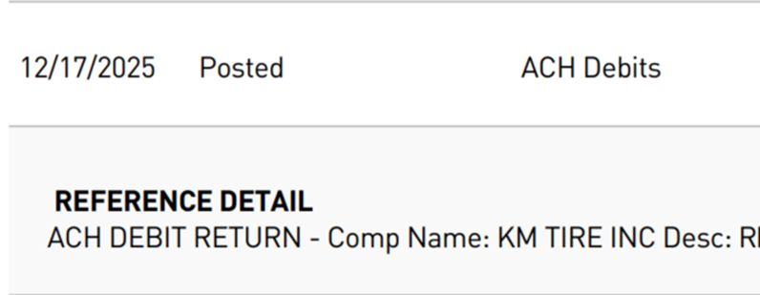

    - Go to PNC website (Pinacle)
    - Click on tab across the top that says “Special Reports”
    - Along the side click on “Returns”
    - Put in the date range or click previous day, click “run report”
    - Go to Intranet: Credit and Collections (CC) – NSF maintenance
    - Add all of them to the NSF maintenance
    - ACH returns no address and in check number put web pay
    - Add the check numbers to the ledger for the returned items
  - Items that say the below are ACH reversals and AR will make the entries for those

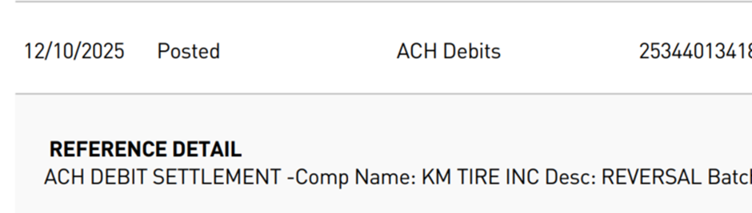
  - Items that say “Lockbox Deposits” need added to the sheet
  - ACH deposits need added to the list and sent to AR with all the other ACH’s from the other banks
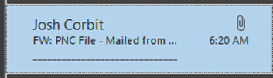
  - One of the detail deposits that says “remote capture” will match the mail checks that AR put on the ledger already in Madden Co the rest that say remote capture will add up to the mobile deposit for that day. See below to get that amount

    - Open the report from the email and put a filter on it
    - In item type filter to show only virtual checks and delete all of them out, unfilter the column
    - In location filter to show only 00 and delete all them out, unfilter the column
    - Highlight all of column I and that will be your mobile deposit total to put on the ledger
    - Save this file F:\Accounting\Shared\Banking\PNC\PNC AR 1016\Month
- The “detail deposits” that don’t say “remote capture” are warehouse deposits taken to the bank and need added to the ledger as “warehouse deposit” with X as the check number
- Some customers still use Worldpay so just put that on the ledger
- If there are items you aren’t sure what they are for look in previous months for the same description and make the entry to where that got posted or ask the Controller.
- Once everything is added to the list, copy the green box in column J from the previous day and put it in column J on the last thing you entered.
- From the report put the closing ledger amount in the green box
- In column K do =and select column I and subtract column J. If there is no variance it balances. If there is a variance, look over everything again to make sure you didn’t mess anything up.
- Put the closing ledger balance on the consolidated daily bank balance sheet saved here F:\Accounting\Shared\Banking\Consolidated Daily Bank Balances.xlsx
- Go to Intranet to AR-Mobile Deposit PNC
  - Put the previous date in both date boxes and click run report
  - Once report is ran click cash receipts export
  - Click save as Excel
  - Open the excel file and filter row tow
  - Filter column E by MOBILEPNC
  - Save here as mobile deposit posted date (example mobile deposit posted 5.12.25) F:\Accounting\Shared\Banking\PNC\PNC AR 1016\Month

Mobile Deposit Discrepancy Emails
- AR will send over emails to accounting for any check that was deposited for the wrong amount, send those in an email to tmcc@pnc.com. (Example on next page)
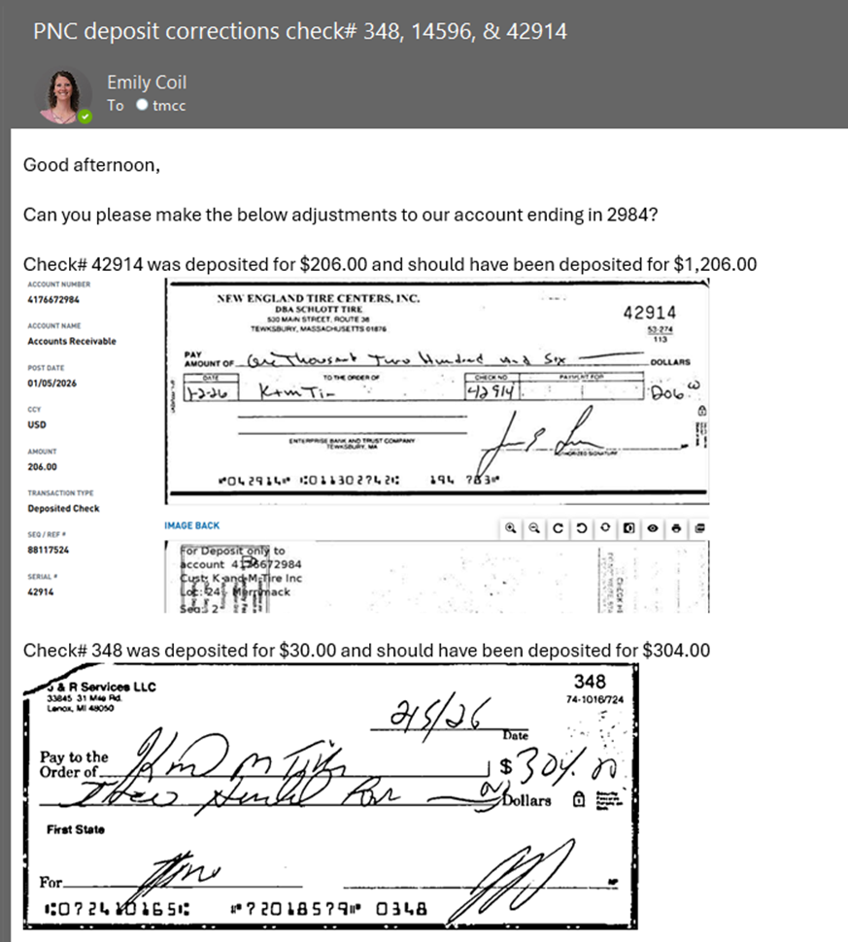

Line of Credit
- Open up Line of Credit spreadsheet F:\Accounting\Shared\Banking\Line of Credit\Line of Credit Tracking.xlsx
  - Put the previous day date in column A
  - In column B put Pay on Line if the amount is a withdrawal (debit) or Draw on Line if the amount is a deposit (credit)
  - Put the amount in the correct column based off Pay or Draw on Line
  - Columns E & F are formulas and will populate themselves
- On the consolidated sheet in column J put =the amount of column E from line of credit spreadsheet minus column I
- On the consolidated sheet in column K drag the formula down. Make sure it matches what is in column F of the line of credit spreadsheet

Consolidated Daily Bank Balances
- Make sure all the balances for each bank are on the consolidated spreadsheet
- Drag down formula in column I
- Once everything is on the spreadsheet send it to Controller, VP of Accounting, Director of Accounting, Accounting Senior Project Manager, Chief Financial Officer, and AR Manager

Update Inventory Cost Change
Purpose: This SOP outlines the process for updating inventory cost changes daily. Since inventory pricing changes daily. Since inventory pricing changes in the inventory module, do not automatically flow to the General Ledger (GL). This process ensures proper tracking and reconciliation. The final adjustment will be recorded in the End-of-Month (EOM) adjusting entry spreadsheet.
- Receive the “Actual Cost Report” Email
  - Look for an email from someone in Purchasing and Pricing with the subject line “Actual Cost Report.”
  - The email will contain an attached file titled “actual cost changes DATE.xlsx.”
- Save the File
  - Save the attached file to the following location:
  - F:\Accounting\Shared\Month End\EOM Entries 2026\Inventory Cost Change\Month YYYY
  - Ensure the file is saved with its original name for consistency and easy reference.
- Extract the total amount
  - Open the saved file.
  - Navigate to the “EXTENDED” sheet within the file.
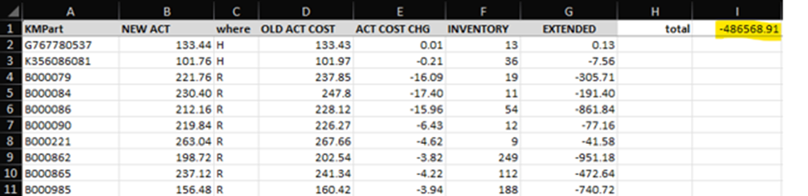
  - Locate the “Total” amount, typically in cell I1 on the far right of the sheet.

- Update the Running Monthly Inventory Cost File
  - Open the “Month YYYY Inventory Cost Change.xlsx” file, located in:
    - F:\Accounting\Shared\Month End\EOM Entries 2026\Inventory Cost Change\Month YYYY
  - Enter the amount extracted from Step 3 into the running monthly file.
    - If the amount is negative, record it as a negative value.
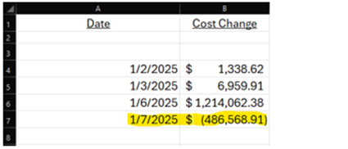
    - If the amount is positive, record it as a positive value.

- Use of this file
  - This Monthly Inventory Cost File is used in our month-end inventory reconciliation.
  - When the month is complete, the total cost change for the month will be recorded in the EOM Adjusting Entries Spreadsheet. This amount will then be entered in the variance column of the EOM AJE FOR INVENTORY journal entry. This process verifies that the monthly variance primarily reflects cost changes that did not transfer from the inventory pricing module to the general ledger. See example below.
  - See SOP 11.8 Inventory Change Entry History.
  - 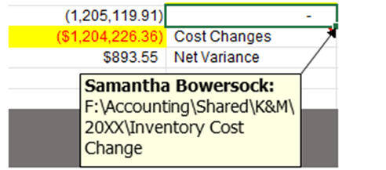

Weekly Procedures
The following standard operating procedures are to be completed weekly:
Copies of invoices that print can be recycled

Non-Stock Balancing (Same as month-end; keeping up with it weekly)
Purpose: This SOP ensures weekly review of non-stock inventory transactions for MaddenCo by balancing Accounts Payable (AP) and Accounts Receivable (AR) entries. The reason we do this weekly is so we can stay on top of researching non-stock AP and AR invoices that have exceeded two weeks in MaddenCo without a corresponding match coming through.
Open Madden Co
- Run a GL Audit Report for all locations out of Madden Co, this is the AP Debit side
  - 3 General Ledger (enter)
  - 4 Reports Menu (enter)
  - 2 Other Reports (enter)
  - 1 Audit Report (enter)
  - Store # = 000
  - Order = 01 (GL /Div/Dept)
  - Year Period = Fiscal Year Period (add 3 months to calendar year)
  - GL Account # = 3910 thru 3910
  - Put report on hold Y
  - Refer to System I Navigator SOP
- Run an invoice history report for all locations out of Madden Co, this is the AR credit side
  - 1 Tire Dealer System (enter)
  - 5 Invoice History Menu (enter)
  - 17 Invoice History Reports (enter)
  - 2 Invoice History Salesman Reports (enter)
  - Store # = 000
  - Order = 01
  - Salesman Type = S
  - Product Class = 60 for High and Low
  - Year/Period = Calendar Year and month
  - Put report on hod Y
  - Refer to System I Navigator SOP
- Open the non-stock excel sheet: F:\Accounting\Shared\Month End\EOM Entries 2026\Non-Stock\Month YYYY\Month YYYY.xlsx If starting a new excel sheet for a new month open the previous month and save as the new month. Make sure you have a new folder for the new month. (Example open February 2026 and save as March 2026 in March file)
  - Each location has its own tab, be sure to review location totals before moving onto the next location (if you can’t find the location it could be hidden)
  - Record each AR invoice, date, and total cost on the AR side but first make sure that there are no AP entries for those invoices already on the sheet. If there is put the AR information on the AR side on that same line if not add it to a new line.

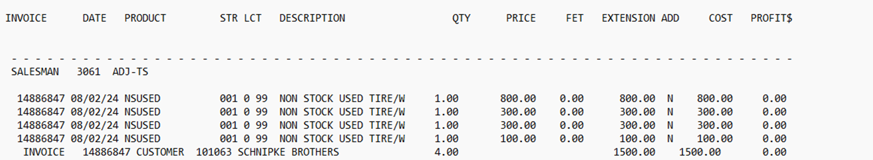

  - Record each AP invoice and dollar amount by finding the same invoice number on the AR side and put the AP information on the AP side. If there is no AR side for the invoice, then add it on a new line. The AP invoices on the report will look like the below.
  - Each AP entry should matchup with an AR entry
  - If there is an amount in the difference column look up the K&M invoice number in Intranet under and see if there is a freight charge on the invoice. If there is put the freight amount in column I. Column J is the Freight we will write off.
  - Review for any duplicate invoice numbers, these will appear as red when entered on the excel sheet
    - If there are duplicates, make a note to review further
- Review any AR invoices that were left open in the previous month, if it is over a week old investigate by following the below steps and then email AP team lead and Product manager for anything you need them to look into or complete.
  - If there is an AR invoice still open and no AP side to match it follow the steps below to investigate.
  - Go to Madden Co
    - 1 Tire Deal System (enter)
    - 4 Inquires Menu (enter)
    - 8 Invoice History Inquiry by Inv (enter)
    - Store # = 000
    - Enter the invoice number then put a 5 on the line beside it to view the invoice
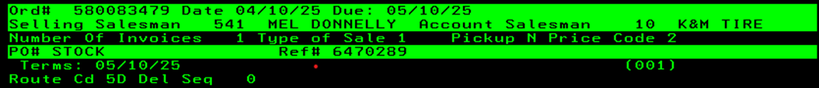
    - Scroll down on the invoice and look for a ref#

    - The ref# should be the AP vendor inv# that goes with the AR invoice.
  - Then go in Madden Co to
    - 2 Accounts Payable (enter)
    - 3 Inquiry Menu (enter)
    - 8 A/P Invoice Inquiry (enter)
    - Enter through store screen
  - Enter the ref# in the invoice line. If the invoice is not in AP, email the AP team lead to ask them to enter it
- Review any AP invoices that are left open and no AR side. If you need help investigating these ask the Controller
- To make sure all the AR side is on the non-stock sheet for the month go to GL account activity on Intranet under accounting. Run a report for the 3910-location to see the account activity. Filter the report to only see A/R invoices. The total amount of those should be everything in the month added to the non-stock sheet.
- To make sure all the AP side is on the non-stock sheet for the month go to GL account activity on Intranet under accounting. Run a report for the 3910-location to see the account activity. Filter the report to only see AP entries no A/R invoices. The total amount of those should be everything in the month added to the non-stock sheet.

Weekly Payroll Journal Entry
Purpose: To establish a standardized process for retrieving, validating, formatting, and preparing weekly payroll journal entry uploads from Dayforce.
The Level 3 Accountant will pull the payroll reports from Dayforce each Wednesday and prepare the payroll journal entries for upload. Backup personnel for this process include the Payroll Manager, Controller, and Director of Accounting.
- Log into Dayforce using assigned credentials.
  - Navigate to the Payroll function.
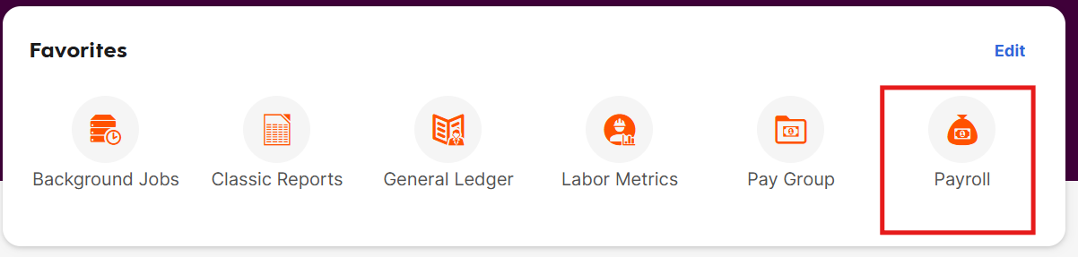
- Select Archived Reports. 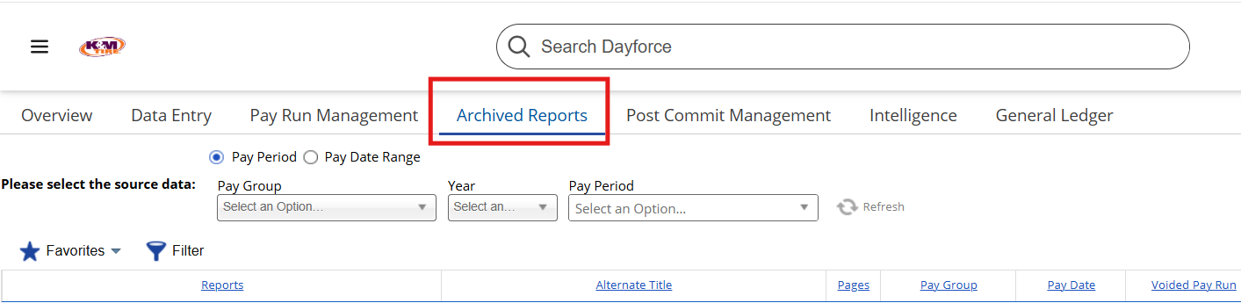
- Complete the following report selections: 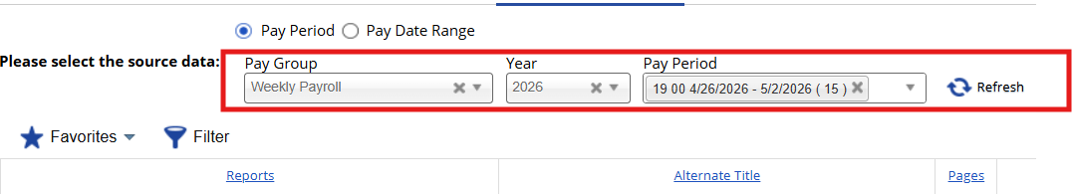
  - Pay Group = Weekly Payroll
  - Payroll Year = Current Payroll Year
  - Pay Period = Current Payroll Period’
  - Standard payroll runs will typically display as:
    - 19 00
    - Additional payroll runs may display as:
      - 19 01
      - 19 02
      - etc.
  - Click Refresh
- Download the following report:
  - GL_Summary_Weekly_Payroll
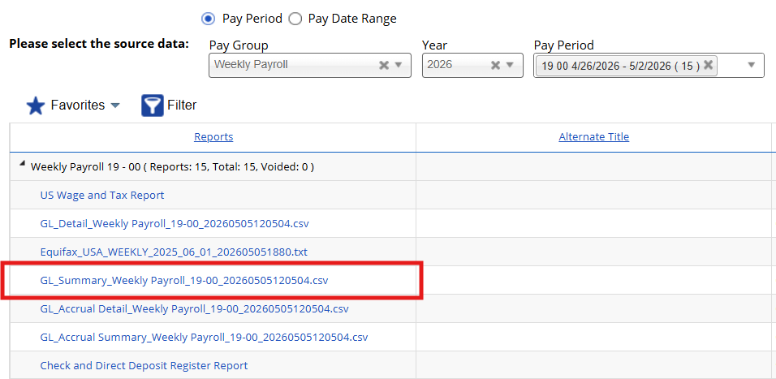
  - Save the report to the designated payroll working folder - F:\Accounting\Shared\Payroll\Payroll Files
- Open the downloaded GL_Summary_Weekly_Payroll file.
  - Filter the report by Account Number.
  - Review for any entries coded to account 99999.
    - If no 99999 accounts exist proceed to the next step.
    - If a 99999 account exists notify:
      - Director of Accounting
      - Payroll Manager
      - Controller
      - Level 3 Accountant
  - Research and correct all invalid GL account coding before proceeding.
- Insert the payroll data into a Pivot Table on a separate worksheet.
  - Build the Pivot Table using the following fields:
    - Account Number = Rows
    - Division = Rows
    - Department = Rows
    - Debit Amount = Values
    - Credit Amount = Values
- Format the Pivot Table.
  - Select the Pivot Table.
  - Go to the Design tab.
  - Update the following settings:
    - Subtotals = Do Not Show Subtotals
    - Report Layout = Show in Tabular Form
    - Repeat Item Labels = Repeat All Item Labels
  - Delete the first two blank rows above the Pivot Table.
- Open the following template:
  - F:\Accounting\Shared\Payroll\Payroll Files\Dayforce Template
  - Copy columns I through M from the Dayforce Template.
  - Paste into columns I through M of the current week payroll file.
  - This process automatically creates:
    - Tax Liability Entry
    - Payroll Garnishment Entry
    - K&M Cares Match Entry
- On Thursday review payroll draws in PNC Financial Services.
  - Access current day banking activity.
  - Locate:
    - Main Payroll Draw
    - Garnishment Draw
  - Input the payroll draw amounts into the payroll file.
    - The following amounts should net to zero:
      - Net Pay
      - Tax Liabilities
      - Garnishments
  - If balances do not net to zero review the following:
    - Verify no 99999 accounts exist within the Pivot Table.
    - Review the Check and Direct Deposit Register report.
    - This report is located in the same Archived Reports location as the GL_Summary_Weekly_Payroll report.
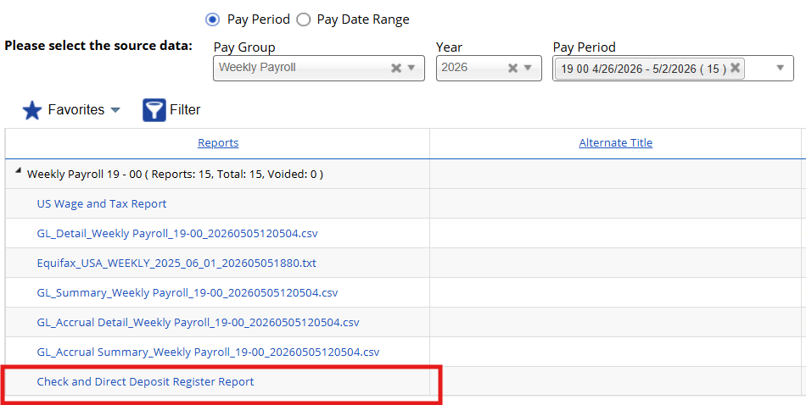

  - If manual checks exist:
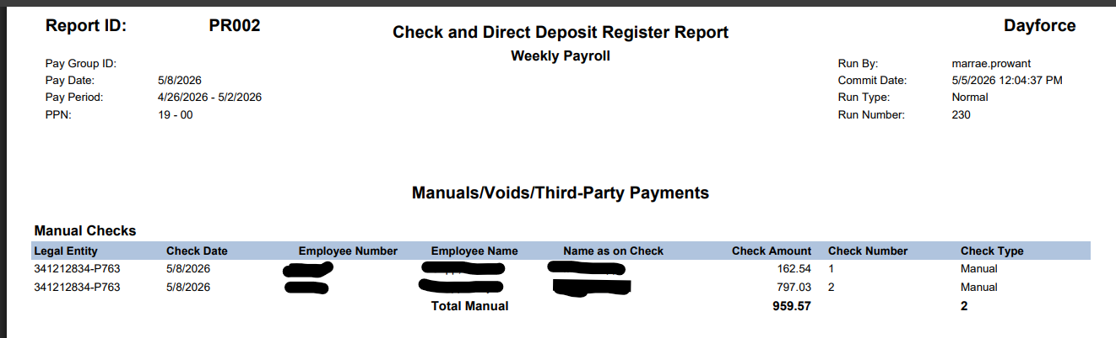
    - Subtract the manual check amount from Net Pay in cell K2.
    - Research the employee’s work location.
    - Post the expense to the appropriate:
      - 5690
      - 5700
      - Offset the entry to account 1017-1.
        - AP already issued and posted the manual check against account 1017.
        - This adjustment prevents duplicate payroll expense postings.
  - Once payroll has been validated follow:
    - SOP 6.2 – Upload Journal Entry
    - Upload:
      - Current month recurring payroll entry
      - Tax liability payment journal entry
      - Paste payroll amounts into columns A through E.
  - Create the K&M Cares Match entry separately from the standard payroll upload.
  - Save all payroll support documentation to:
a. F:\Accounting\Shared\Payroll\Payroll Files
    - Use the approved payroll file naming convention established by Accounting leadership.
- Key controls for this process:
  - All payroll files must be validated prior to upload.
  - No 99999 GL accounts should exist before posting.
  - Manual checks must be adjusted to avoid duplicate expense recognition.
  - Supporting documentation must be retained for audit and reconciliation purposes.
  - K&M Cares Match entries must be uploaded separately from standard payroll entries.
You will receive the Weekly General Ledger Payroll Report and Alerus 401k snip it from the HR Payroll Department.
Purpose: This Standard Operating Procedure (SOP) outlines the process for managing the Weekly General Ledger Payroll Report and Alerus 401k snippets from the HR Payroll Department which are used to create and upload the Weekly Payroll Journal Entry.

Adjustment Tracking – Account 1110 Audit
Every Monday morning the staff accountant will pull the ending balance of each location from the 1110 GL and compare it to each location balance on the NAB – Adjustment Tracker on the Intranet.
- Run and save an open report for the last day of the month
- Adjustments Reconciliation Worksheet: F:\Accounting\Shared\General Ledger\Balance Sheet Reconciliations YYYY\1110 All “Adjustment Reconciliation”
  - Copy and move the template tab to the beginning
  - Record all GL balances in column C labeled “A/C# 1110”
  - NAB Adjustment Tracking Open Report
    - From Date = 1/1/19
    - To Date = Previous Friday (ex. Monday April 20th 2026 pull Friday April 17th 2026)
    - Pulling the previous Friday insures you have the most up-to-date information
    - Location = All
    - Vendor = All
    - Claim Status = Open
    - Run Report
    - Open each location and record the Open Passed Total for each location
    - Since each location must be opened it is quicker to start at the last location and open them by working your way up. This prevents you from having to scroll through each store to get to the next location.
    - At the end of each month run and save an open report in the same folder as above.
- Review the variance for each location, any variance larger than $500 for small stores and $1,000 for large stores needs to be researched. All stores that have a variance less than $500 put ok on their OK/Review line to be filtered out.
- After reviewing filter so that only stores with larger variances are visible
- In order to research a variance, pull each location as an excel
  - Keep the same dates as the original report
  - Select your first location with a variance needing researched
  - Vendor = All
  - Claim Status = Both
  - Run Report
  - Export to Excel
- Reviewing the location excel
  - Custom Sort by column I “Deposited”
  - Newest to Oldest
  - Scroll down past vendor totals
  - Review column L “Variance amounts” for the current month
    - If you add everything for the month it should equal the variance
    - If the total is above the variance this is okay, record the larger amounts that make up the total, this should be anything over $100 - $150. These will be sent to Adjustments for an explanation on why we didn’t receive credit.
    - If the amount is less than the variance, review if anything was carried over from last month that we are waiting on a credit for. If so, add this to the excel amount.
    - If the amount is still less than the variance make sure all amounts are in MaddenCo GL 1110. Check column L first since excel is already sorted correctly, then check column F by sorting by column C.
    - If all amounts are accounted for run a vlookup formula using the previous months Open Report. (Ex. Reconciling April use March’s open report)
    - (=vlookup(open inv#, adj tracking excel column B,1.F)
    - Look for N/A’s that are for the current reconciling month, these should be what you are off by.

Weekly Sending AR Discrepancies
Every Friday:
This SOP will explain how to get the AR discrepancy report. This report lets AR and Credit & Collections know what is either in banking but not in Madden Co or vice versa.
- Open the AR Discrepancy spreadsheet F:\Accounting\Shared\Banking\AR Discrepancies - Weekly Update.xlsx
- Move or copy the last tab and make sure the new tab is moved to the end
  - Right click on the current tab and select move or copy
  - Select create a copy
  - Scroll until you see move to the end
  - Select OK
- Rename tab to W.E MM.DD.YY (will be the date of the Friday you are doing the excel sheet)
- Look at all the bank accounts except the AP ones for anything that is open (will not be highlight orange) from previous Tuesday and prior. (example if Friday 4.18.25 you would look at 4.15.25 and prior)
  - Any warehouse deposits will go under the section that says, “open deposits- cash- not posted in Madden Co” (put bank name in column A)
  - Anything that is posted in Madden Co but has not cleared the banks will go under section “posted in Madden Co, not cleared in bank” (put bank name in column A)
Examples could be mobile deposits that are in Madden Co but not cleared the banks or mail checks.
  - Anything that has cleared the bank but not posted in Madden Co will go under section “deposits/withdraws cleared bank, not posted in Madden Co” (put bank name in column A)
Examples would be returned items, duplicate items, or ACH’s
  - Any notes that you may have for the open items can be put in column J
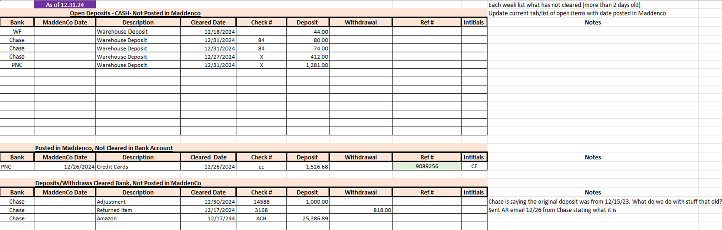
  - See the snip it below for a reference.

- Once everything has been added save the spreadsheet F:\Accounting\Shared\Banking\AR Discrepancies - Weekly Update.xlsx
- Send the spreadsheet to the Credit & Collections Team Lead & Manager, Accounts Receivable Team Lead & Manager, Controller, VP of Accounting, and Director of Accounting.
  - Subject “AR Discrepancies – Weekly Update”
  - Body “Attached are the open items from MM/DD/YY (prior Tuesday) and prior”
  - Attach entire spreadsheet

Weekly Sending Non-AP Withdraw Listing to President
Done Every Friday:
- Update Spreadsheet F:\Accounting\Shared\Banking\”Non AP Withdrawals”.xls
- Create a new tab
  - Right click on the tab and select move or copy, select create a copy, and scroll until you see move to end and click OK
  - Right click on the tab to rename it from dates past Friday to current Thursday
  - Clear all contents on the page except the headers
- Go to the AP bank ledger spreadsheet and put a filter on date cleared only selecting the dates from last Friday to current Thursday
- Filter the initial column to only see initials of people in Accounting or blank.
- Add all of what is on AP ledger sheet to the Non-AP sheet except and Sweeps (the check# column will not be on the Non-Ap sheet)
- Once everything is added save it F:\Accounting\Shared\Bank Ledgers\K&M Inc\Non AP Withdrawals.xlsx
- Send to the President of the company, CFO, VP of Accounting, Controller, Director of Accounting, and AP manager.
  - Subject “Non-AP Withdrawals”
  - Body “Attached are the Non-AP withdraws from MM/DD-MM/DD/YY. Please let us know if you have any questions.”
  - Attach entire spreadsheet
- Example of the spreadsheet below
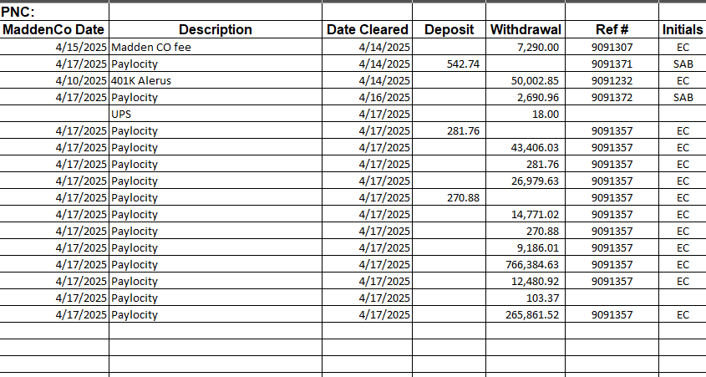

Monthly Procedures

Bill My Tire Place Contracted Accounting Services
- Once final payroll for the month is ran retrieve monthly payroll data for employees performing work on My Tire Place MN, LLC (MTP)
  - Log on to Paylocity **Replace with Dayforce**
  - Under “Reports & Analytics” select “Reporting”
  - On Reporting page with “Report List” selected search for “Payroll Register Data Export YTD”
  - On Payroll Register Data Export YTD parameters selection screen set the following parameters
    - Under the “Output” section in the “Output Type” dropdown box select “Excel 2007+”
    - Under the “Payroll Filters” section select the radio button next to “Process Date From”
    - In the dropdown box next to “Process Date From” choose the first payroll paid during the month being billed
    - In the dropdown box next to “Process Date To” choose the last payroll paid during the month being billed
    - Under the “Standard Filters” section type the last name of the first employee being billed for in both boxes
  - Select “Run”, “Go to Pickup” or select “Stay on Page” if more than one employee
    - If running for more than one employee from step iii above, change the last name to that of the next employee being billed for
  - Once reports show as available click on the Excel icon to open
- Calculate the monthly allocation billing amount
  - Open the prior month’s calculation found at F:\Accounting\Shared\MTP Contract Services Billings\Wage Allocation for MTP YYYY.MM and save as current month
  - Paste the “Payroll Register Data Export”. Excel pulled from Paylocity into “Sheet2”
  - In the employee reports that were ran insert columns as needed to match the format in the “Wage Allocation for MTP YYYY.MM” spreadsheet
    - Note, if any new columns show in the employee payroll register make sure to add them in the calculation spreadsheet and update formulas if necessary
  - Copy and paste only the cells that contain the month’s payroll data (from “Process” to “Total Deductions” for all paychecks) into the appropriate section of the calculation spreadsheet
    - Note, payroll data allocated should be periodically analyzed to determine the appropriate percentage is being used
  - Verify all data pasted correctly and all formulas are correct
- Create invoice for MTP
  - Email A/P team leader or manager to have them create an invoice to MTP coded to account 3995-1-1 for the amount calculated in step 2.
- Submit invoice to MTP A/P for payment

Best One Health Insurance Billing Allocation
Purpose: The purpose of this Standard Operating Procedure (SOP) is to ensure accurate and consistent allocation of monthly Best One Health Insurance billing across all relevant cost centers and general ledger accounts.
- Receive detailed bill around the 15th of each month from the HR Manager – Benefits & Payroll.
- Save both attachments from the email at F:\Accounting\Shared\Best One Insurance\YEAR (naming them both Month YYYY Billing)
- Open Month YYYY Billing excel file that you just saved on the F drive.
  - Go to the tab Full Details. Put a filter on row 1. Filter column H by Health Savings Account
  - Copy and paste all those rows to a new tab on the excel sheet renaming it HSA only
  - Delete those rows off the Full Detail report
  - Un-filter column H and highlight the whole page by clicking on the arrow in the top left-hand corner of the excel sheet
    - 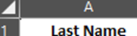
  - Create a pivot table by clicking on ‘Insert’ tab and clicking ‘Pivot Table.’
    - Enter through the auto selection of the pivot table information.
  - Click in the pivot table and select Employee Cost, Employer Cost, and Benefits Location. Make sure each one is in the correct area and says the correct thing.
    - Example on next page:
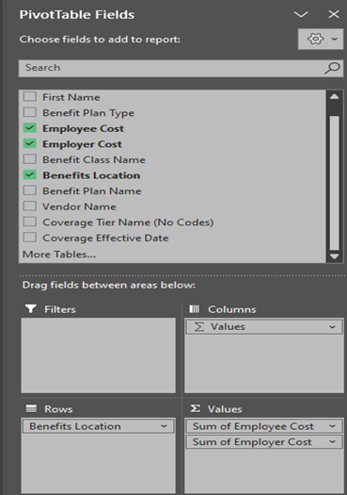
  - In column D outside the pivot table put total in row 3. Beside each location do = select column B, +, select column C and hit enter. This will add the 2 columns together giving the total in column D. Repeat for each location row.
  - Rename the tab PT for pivot table
- Next Open the “Best One Insurance GL Entry” excel sheet F:\Accounting\Shared\Best One Insurance\Best One Insurance GL Entry.xlsx
  - Copy the previous Month/YYYY tab by right clicking select move or copy, select create a copy, scroll down to select move to end of the excel file
  - In Rows 1 and 2 change the month to the current month you are in
  - From the HSA only tab of the Month YYYY Billing excel sheet put the total of column D on the “Best One Insurance GL Entry” in column D beside All HSA.
  - Beside 1017-1 put the total in column D from Totals by location tab off Month YYYY Billing excel sheet
  - Use the PT tab off Month YYYY Billing excel sheet to fill in the rest of the “Best one Insurance GL Entry” sheet
    - KMDELPHOSA is Corporate (5680-1-1)
    - KMDELPHOSW is just Delphos (5680-1)
    - KMMINN & KMSTPAUL need added together
  - After everything is added scroll to the bottom of the “Best One Insurance GL Entry” sheet and see if column F beside DB & CR is zero, if zero everything is good
  - Add the HSA only amount again in the cell that is colored and if the cell below it is zero everything is good
  - Copy columns D&E just from 1017-1 through San Antonio and paste them in columns K&L
  - Make journal entry in MaddenCo in current period by using the JE upload. Refer to SOP 6.2
  - In row 4 put the JE ref#, initials, and date
  - Update K&M Inc. Bank Ledger sheet PNC AP. If it is already on the Bank Ledger sheet just add the Madden Co date, Ref#, initials, and highlight the amount orange.

Prepaid Expenses
Purpose: The prepaid expense account is used to expense over time large invoices that should be either expensed over the life of their contract (such as a 12 or 24 month contract) or large expenses that should be expensed over the remainder of the current fiscal year, to not take the expense hit in one single month. Samsara and Blue Ridge are two examples of invoices we currently expense monthly over the term of the agreement using the 1420-1-1 prepaid expense account.
- Under the following circumstances we review the invoice to consider prepaid expense treatment:
  - Invoices over $20K for a single location
  - Invoices over $150,K for total company
  - When in question, we should consult with CFO, EVP, and President to ensure alignment on prepaid or expense treatment.
- If treating an invoice as prepaid, a copy should be saved at F:\Accounting\Shared\Month End\Recurring Entry\Prepaid Expense Invoices
- To Post monthly prepaid expenses listed on F:\Accounting\Shared\Month End\Recurring Entry “Prepaid Expense Tracker”
  - Locate the correct YYYY tab and find the column with the correct Month & Period
  - The amounts listed below need to be posted to Credit 1420-1-1 and Debit the expense account located in column G
    - If there is no amount listed but was in the prior month- do not post, the expense is complete at that time
  - Copy previous JE description while changing the month
  - Highlight each in Green for done
- When adding a new expenses to the prepaid listing after approved from the invoice copy
  - Add the vendor name in column A
  - Add the date range the contract is covering under “Contract Terms” in column B
  - This might be a longer time frame then what the expense of this invoice covers
  - Ex. 3 year contract and the invoice is for one year so far
  - Add the invoice number in column C
  - Add the total amount of the invoice in column D
  - Add the date range the expense covers in column E “Period Covering”
  - Column F “Holding Account” should always be 1420-1-1
  - Add the account the actual expense should go to in column G
  - Add the amount that should be expensed by month under each months column
    - An invoice being expensed over the remainder of the current fiscal year should be divided by the number of months remaining that it is being expensed over.
    - Ex. a 12 month service contract invoice should be the amount in column D divided by 12 then placed under each of the 12 months based on column E

Fixed Assets
This SOP outlines the process for updating and reconciling the fixed asset and depreciation schedule.

Reconcile Balance Sheet Account 1610 Construction in Progress for all locations weekly, to begin:
- F:\Accounting\Shared\General Ledger\Balance Sheet Reconciliations 2026\1610
- Open “1610 Reconciliation” and start at tab “Month YYYY Detail”
- Pull Detail from Intranet
  - Intranet
  - Accounting
  - GL Account Activity
  - Tab “Account Activity”
  - Select Period/Range
  - Select Fiscal Year and Period needing reconciled
  - Select Account “1610 – Construction in Progress”
  - Select Location “K&M Only (R60)”
  - Click “Run Report”
  - Click “Excel” to export
- Copy all new data onto tab “Month YYYY Detail”
  - Ensure no data is missing or duplicated
  - Look into each entry to see if it is an asset that needs reclassed to GL 1630, 1650, 1670, or 1690.
    - View the invoice copies saved by AP at F:\Accounts Payable\Shared\Lists\ASSETS\Asset Details\FY YYYY
    - Items that are not yet in service or incomplete can be left in 1610 and the status checked monthly until they are ready to reclass
    - Ask the Fleet Acquisition Manager for the status on vehicles and equipment (such as lifts, pickers, trucks, sales cars)
    - Check the F:\Accounting\Shared\General Ledger\Balance Sheet Reconciliations 2026\1610 “Open Project Owners - Shortcut.lnk" for the status and updates on large building improvement projects or email the Facility Manager.
    - Logistics or AR may email about sold assets (they may come across labeled as AR Cash Store)

Update the Asset Activity spreadsheet F:\Accounts Payable\Shared\Lists\ASSETS “Asset Activity.xlsx”
- This should be done whenever there is an asset added, removed or transferred in GL 1610, 1630, 1650, 1670, 1690
  - The tab “Purchases” should only be items in use and in 1630, 1650, 1670, or 1690 that M&Z needs to add to the depreciation schedule
    - These assets should be over $5,000.00 in order to be in use
    - Ex. a lift for $4,000.00 and its battery for $1,000.00 are both needed for the lift to be in use so it is an asset.
  - The tab “Disposals” should be items sold that were listed on the depreciation schedule so M&Z can remove them
    - M&Z will need asset disposed, date disposed, and amount of any sales proceeds to calculate gain or loss on disposal of fixed asset
  - The tab “Transfers” should only be items listed on the depreciation schedule in one location and needing moved to another.
    - The depreciation schedule to and from location should match the MaddenCo GL location to and from.
    - Ex. a truck moved from 1650-3 to 1650-4
  - The tab “CIP” should be the items left in 1610 (not in use or not complete)
    - The total dollar amount on this tab should match the 1610 GL Balance

Send Asset Activity to M&Z (Dave Estupinan) monthly (unless there have been no changes) to receive an updated Depreciation Schedule
- Send the file F:\Accounts Payable\Shared\Lists\ASSETS “Asset Activity.xlsx” after checking it is up to date from the above
- In the same email, also send invoice copies for all new purchases saved by AP at F:\Accounts Payable\Shared\Lists\ASSETS\Asset Details\FY YYYY
- When M&Z responds
  - Save the depreciation schedule at F:\Accounts Payable\Shared\Lists\ASSETS to be used for reconciliations and updating the recurring entry, below
    - If it was sent only in PDF reply and ask for an excel version
  - Post the necessary journal entries calculated and sent by M&Z, after control reviews and approves.
    - Review the journal entries to make sure they make sense
    - Ex. typo of 1540 instead of 1640 or location 3 instead of 33
    - Save the file at F:\Accounts Payable\Shared\Lists\ASSETS\Journal Entries
  - Any other files received and previous depreciation schedules can be put in the folder F:\Accounts Payable\Shared\Lists\ASSETS\Prior Years

Reconcile 1610 Monthly
- F:\Accounting\Shared\General Ledger\Balance Sheet Reconciliations 2026\1610 Ensure the weekly process of updating the tab “Month YYYY Detail” is complete from step 1 above.
- Update all dates in the header and reconciliation at the bottom
- Update the tab “Month YYYY Summary”
  - Under “Reconciling Items” column C it should list each asset still in 1610 by location.
  - Column D is the correlating price of the asset
  - Under “Totals by Loc” column E is the sum of the assets by location
    - This formula will need manually adjusted with any changes
  - Under “GL Balances” column F is the totals by location from Maddenco hard keyed in from the below:
    - Intranet
    - Accounting
    - GL Account Activity
    - Tab “Account Balance”
    - Select Period/Range
    - Select Fiscal Year and Period needing reconciled
    - Select Account “1610 – Construction in Progress”
    - Select Location “K&M Only (R60)”
    - Click “Run Report”
- Under “Variance” column G it should be $0.00
  - Check the formulas first if not $0.00
  - If off by a few cents it can be written off to 3990-1-1
  - Research further by comparing it to the GL detail from step 1.c above
- Under the detail (approx. row 94) ensure that all formulas are pulling, and the variance (in approx. cell G98) is showing $0.00
- Take a snippet from the total at the bottom of the Intranet from completing step 4.d.iv. above and paste onto the bottom of the spreadsheet
  - Ensure again this total ties out with the “GL Balance DATE” (approx. cell F96)

Reconcile 1630, 1650, 1670, 1690 monthly
- F:\Accounting\Shared\General Ledger\Balance Sheet Reconciliations 2026\1630-1700
- Update tab “16X0 Period M.YYYY Details” by pasting in the Intranet GL Activity
  - Intranet
  - Accounting
  - GL Account Activity
  - Tab “Account Activity”
  - Select Period/Range
  - Select Fiscal Year and Period needing reconciled
  - Select Account 1630 or whichever of the four reconciliations is in progress
  - Select Location “K&M Only (R60)”
  - Click “Run Report”
  - Click “Excel” to export
- Update tab “16X0 Period M.YYYY Summary”
  - Column B comes from the Details tab, ensure the locations and amounts pulled correctly
  - Column C “Depreciation Schedule Fixed Asset Balance as of M/YYYY” comes from the most recent excel depreciation schedule saved at F:\Accounts Payable\Shared\Lists\ASSETS
    - It should say “Book Asset Detail Modified” somewhere in the file name
    - Use the totals by GL Account and Location from column F “Book Cost”
  - Column D “New Activity” should include anything completely identified and on the Asset Activity that is just missing from the depreciation schedule due to timing.
  - Column E “Difference” will then be any variances left that need researched
    - Most likely an “AR Cash Store” entry from an employee selling an asset and not letting Accounting know
    - Check emails from Logistics and AR for any information
    - Email Logistics or Fleet Acquisition Manager if nothing else is found on a 1630 or 1650 discrepancy
  - Check that the formulas are correct in rows 51, 53, 55 and 57 and any variances match what is being researched
  - Add snippet of total GL Balance for the accounts reconciling from the Intranet GL Activity to the bottom of the Summary tab

Reconcile 1640, 1660, 1680, 1700 monthly
- F:\Accounting\Shared\General Ledger\Balance Sheet Reconciliations 2026\1630-1700
- All four sheets will need tab “16X0 Period M.YYYY Details” updated from the Intranet GL Activity
  - Intranet
  - Accounting
  - GL Account Activity
  - Tab “Account Activity”
  - Select Period/Range
  - Select Fiscal Year and Period needing reconciled
  - Select Account 1640 or whichever of the four reconciliations is in progress
  - Select Location “K&M Only (R60)”
  - Click “Run Report”
  - Click “Excel” to export
- Update tab “16X0 Period M.YYYY Summary”
  - Column B comes from the Details tab, ensure the locations and amounts pulled correctly
  - Column C “Depreciation Schedule Current Book Depr as of M/YYYY” comes from the most recent excel depreciation schedule saved at F:\Accounts Payable\Shared\Lists\ASSETS
    - It should say “Book Asset Detail Modified” somewhere in the file name
    - Use the totals by GL Account and Location from column L “Book End Depr”
  - Column D “Depr remaining to book in FY2025” is a formula, the difference between column B and C.
  - Column E “Monthly Est Recurring Entry” is column D divided by cell J1.
  - Cell J1 needs updated monthly
    - If calculating the month before the recurring entry has been posted, in order to post the right amount, it should be 12 minus the previous fiscal period.
    - Ex. Nov is 12 minus 1 since only 1 has been posted (Oct)
    - If checking for month end after the recurring entry has been posted it should be 12 minus the fiscal period.
    - Ex, Nov is 12 minus 2 since 2 have been posted (Oct & Nov)
  - Column F “Est Recurring Entry VS Actual Recurring Entry” is column E minus column I.
  - Column I “Actual Recurring Entry” should be pulled from the correlating GL Accounts on the current recurring entry.
    - F:\Accounting\Shared\Month End\Recurring Entry
    - If updating this causes a variance in column F, verify and use to update the recurring entry (section 7 below)
  - Check that formulas are correct in rows 51, 53, 55 and 57 and any variances match what is being researched
  - Add snippet of total GL Balance for the accounts reconciling from the Intranet GL Activity to the bottom of the Summary tab

Review All Assets (before year end, but can be done quarterly or biannually)
- Go through each item on the current depreciation schedule to see if it is still in K&M’s possession, still in use, and if the location listed is still correct
  - For items in 1630 Shop Equipment reach out to the warehouse manager or Fleet Acquisition Manager.
  - For items in 1650 Transportation Equipment use the “Trucks & Trailers” spreadsheet saved at F:\Logistics\Public\Trucks & Trailers
    - There are multiple tabs that each item could be in depending on what it is and if it was sold or not.
    - If an asset is still in use, make sure the location matches.
    - If an asset was sold it will have the details of the sale, such as the amount, date, and who purchased it. This should tie out with an entry in 1650, if not it will need researched further.
  - For items in 1670 Office Equipment reach out to IT. The Warehouse manager may also be able to assist.
  - For items in 1690 Leasehold Improvements reach out to the warehouse manager or Real Estate department.
    - Many assets in 1690 do not need researched.
    - Ex. New roof or loading dock
- When a location is closed or consolidated, any Goodwill associated with that location should be reallocated. To reallocated:
  - If all routes and customers are transferred to another single location, reallocated the goodwill to that location.
  - If customers and routes are transferred to multiple locations, contact logistics to get the routes transferred and the sales dollar volume of each route.
    - Reallocated goodwill based on sales volume reassigned to locations receiving routes.
NOTE: Refer to SOP 7.7.5 Depreciation & Amortization Entry for details on updating fixed asset recurring entries.

Travelers Tracer Payment
Purpose: This SOP outlines the steps for validating, approving, and processing Worker’s Compensation and Auto Liability charges to ensure accuracy, timely payment, and proper financial allocation.
After the Benefit Generalist and Logistics Supervisor review the Worker’s Comp charges and Auto Liability charges respectively, the following steps will be performed. This original SOP derived from Human Resource provided “Travelers Tracer Payment” saved F:\Accounting\Shared\Month End\EOM Entries YYYY\Travelers EOM Entry “Travelers Tracer Payment SOP from HR 04.29.20”

Validate amount billed from Travelers
- We validate the amount billed by Travelers by comparing it to the amounts internally approved for payment for both workers compensation from HR and auto liability from Logistics. If the amount billed by Travelers equals the amounts approved by HR and Logistics, move to Step 2.
- In the rare event of a discrepancy, the Controller will contact Travelers to discuss and resolve any discrepancies.

Process & Initiate ACH within 24 hours of receipt
- Accounting department is responsible for initiating ACH and uses a Travelers ACH template saved on the Banking portal which can be updated with the current Tracer amount due before initiating.
- If the amounts are not approved by Logistics and HR within 24 hours of the notification from Travelers, escalate the request for approval to the Controller, VP of Accounting, and VP of HR, respectively.
- Save working files, Prepare and Post G/L entry
  - Working files will be saved in F:\Accounting\Shared\Month End\EOM Entries YYYY\Travelers EOM Entry\YYYY\MM.YYYY
    - Open the Excel file from the email and save as “Travelers Billing YYYY.MM”
  - Create a pivot table from all data to separate out AL=Auto Liability & WC= Workers Comp by using rows “Line” and “Organization Code” and the value of “Sum of Total”
    - Auto Accident Costs from Loss Date prior to 10/1/21– post total to account 5055-location
    - Workers Comp Costs from Loss Date prior to 10/1/21 – post total to account 5710-location
    - Auto Accident 5 Star (after 10/1/21) – post total to account 1402-1-1
    - Workers Comp 5 Star (after 10/1/21) – post total to account 1406-1-1
  - Verify the breakdown from the HR and Logistics approvals are the same as the pivot table.
  - Create a JE to record in the month of the “Charge Dates” (if received at the beginning of August it will be for July)
    - “Travelers Billing Month YYYY”
    - Credit 01017/001/000 for the total amount
    - Debit the GL’s from the allocation above

WEX Fleet Allocation
The purpose of this SOP is to outline the process for allocating and posting the Wex Fuel bill between locations and between the Sales Fuel 5070 and Truck Fuel 5030 GL accounts.
- Receive and save monthly Bill Details file from Logistics around the 1st of the month at F:\Accounting\Shared\Month End\EOM Entries YYYY\Wex Fleet
- Open “YYYY GL Entry for WEX Fuel.excel”
- Enter the three monthly payment amounts and dates in cells A2-B4 from tab “Payment” in the Bill Details excel.
- Enter the Rebate Adjustment plus Wex Edge Rebate into cell A6 from sheet “Ancillary” in the Bill Details excel.
- Enter the Delivery Trucks amounts in column B from the “BillTrailer” sheet in the Bill Details excel.
- Find Sales fuel allocation
    - Go to sheet “Transaction” in the Bill Details excel and filter to show “Sales” in column C
    - Select all and create pivot table
    - Use fields “DriverFName” and “DriverLName” under Rows
    - Use field Sum of “Net Total” under Values

    - Remove subtotals by highlighting all of them, right click, and click

  - Copy amounts per employee into spreadsheet “YYYY WEX Fuel Breakdown for Salespeople. Excel” saved here F:\Accounting\Shared\Month End\EOM Entries YYYY\Wex Fleet “WEX Fuel Breakdown for Salespeople”
  - Enter the total of each location from the “YYYY WEX Fuel Breakdown for Salespeople. Excel” into column A under sales.
- Check that the cells under total in table in the “YYYY GL entry for WEX Fuel” is green and says “balances” if it is off by a couple cents add to location 1-1. If off by more there may have been a billing adjustment on sheet “Ancillary” of the Bill Details excel. Logistics will normally send details including the location ahead of time, if they do not then ask.
- Make entry “EOM AJE – WEX Fleet Allocation to Locs” from columns K, L, M, N, and O by referring to SOP 6.2
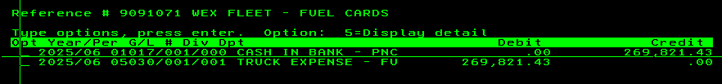
- Make the entry for the last payment of the month in period of closing Ex. March 2026 = 2026/06 (same as the other two entries made during Daily Banking throughout the month). Example below

    - This will be a reconciling item on the bank rec.

PR Allocation
PR allocation purpose is to correct general ledger balances to correctly show the location that delivered the product. This allocation is necessary because a tire that is stocked in one warehouse can be made available and sold to customers delivered out of a different warehouse due to K&M Tire’s nightly transfer system. This step moves the PR sales and cost of sales from the location that shipped it to the location that delivered it. PR is any class 6 customer. Class 6 customers are deliveries made by K&M on behalf of a vendor. Examples of this are car dealer deliveries, secondary supply deliveries, and deliveries to large national chains. On these deliveries K&M is reimbursed for the tire and receives a delivery commission.

Open the previous months worksheet and save it as the current month you are working on.
1. The worksheets are saved: F:\Accounting\Shared\Month End\EOM Entries YYYY\PR Allocation

Run Current Month AC – Correct Sales and COGS Report:
- Access the intranet.
- Go to Accounting, AC – Correct Sales.
- Under Period, click on the calendar and click on the month and year that just ended.
- Click on Run Report
- Export the report to Excel.

Verify PR Allocation Spreadsheet:
      - Ensure the PR allocation spreadsheet aligns with the AC-Correct Sales and COGS report by making sure all the route codes are the same. (Add how to do this . . . Route codes are listed in Column C, compare the file that just ran to the previous months report that you opened in step 1. If the new report shows a new route, add that route to PR allocation sheet by inserting a line in the exact same spot it is located on the report, if there is a route code on the PR allocation sheet but not the report from Intranet remove it from the PR allocation sheet by going to that line and deleting the entire line. Confirm that everything matches, each route listed on the report needs to match by being in the same order and being on the same line.
      - From the report you just ran, Copy columns D - G and paste in column D of PR allocation spreadsheet.

Tie Out Each Route in the Sales Summary:
- Run Sales Summary:
  - Navigate to Madden Co (Tire Dealer System).
  - Select the Sales Menu (Option 2).
  - Choose Monthly Sales Summary (Option 2).
  - Select Sales Summary (Option 1).
- Store Selection:
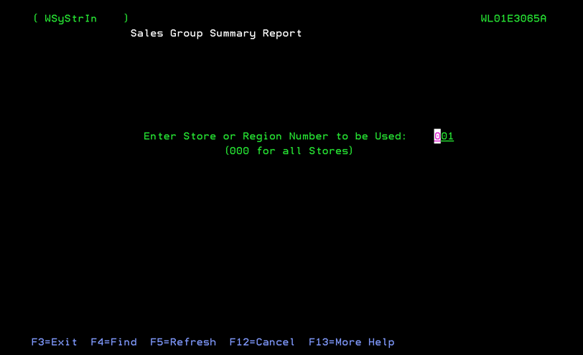
  - Start with the locations in column A of the report. For instance, begin with Store 1. You will Run this report once for each line on the excel report. (approx. 40 times)

- Period Selection:
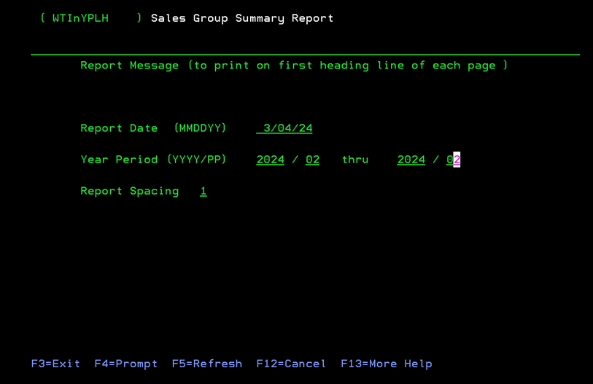
  - Set the period to the current working month. This is a month end entry so if running in March you would pick 2024/02 for February. (e.g., February 2024 would be 2024/02).

- Put CC on first line for Customer Class
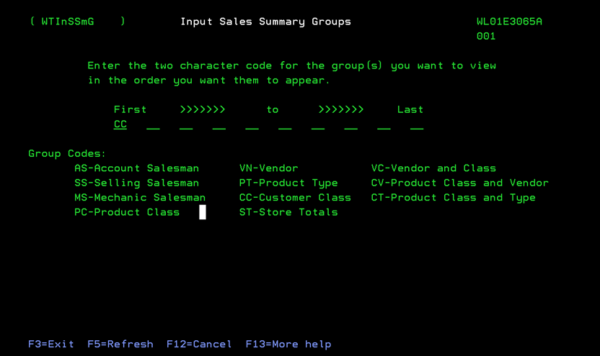
- Next screen = Route Code Entry:
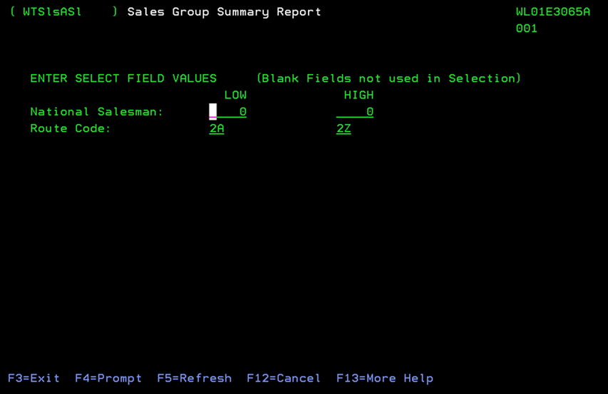

  - Enter the route code from column C of the Excel file.
  - Enter through to next screen
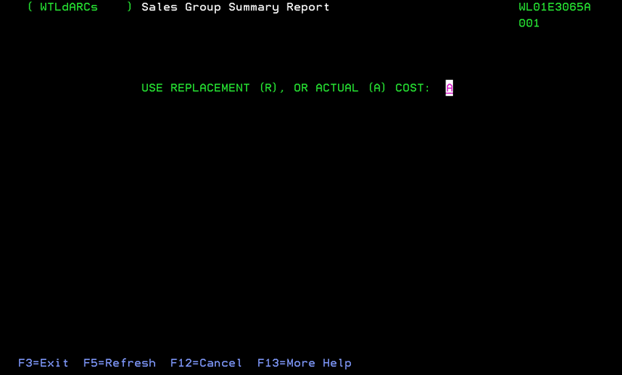
- Cost Selection:

  - Choose A for Actual Cost when prompted.
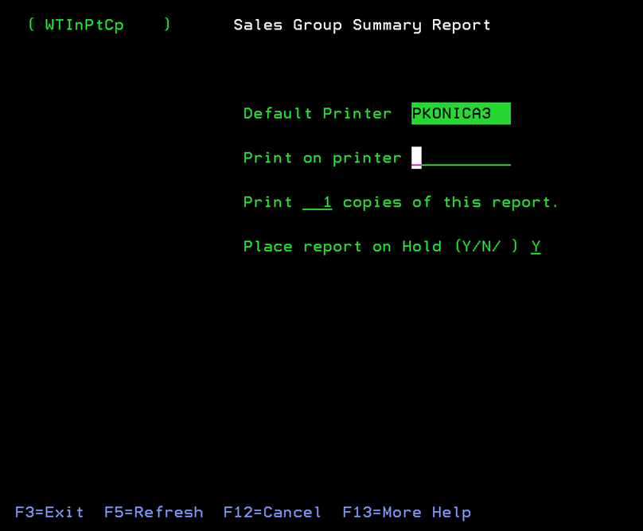
- Viewing the Report:

- Ensure the file has been put on Hold by placing a Y in place report on Hold line.
  - To view the report, open I Navigator and open the report. See the System I Navigator Procedure.

Validation and Entry:
- Complete the PR Allocation excel spreadsheet columns P, Q, and Y using the Sales Summaries from I Navigator.
- Ensure that all $ sales totals from the reports match column E on the PR Allocation Excel spreadsheet
- In column Y enter the class 6 sales for that route from the sales summary.
  - Enter Sales Numbers:
    - Input the $ sales for Class 6 in column Y
  - Calculate COGS:
    - Input the $ profit for Class 6 off the individual route code reports for each line in column P.
    - Input the $ sales for Class 6 off the individual route code reports for each line in column Y.
    - Verify that column Q is a formula taking column Y minus column P.
  - Complete this process for all locations.
  - Save all reports from Madden Co in a new file named month reports (example February reports). Change the name of the reports to the routes. Any duplicate routes use the routes and then the locations it is for. (example JA-JE 1-18)

Journal Entry Creation:
- Copy and Paste the data from columns Q through AE to create a Journal Entry in the necessary JE upload format on the tab “JE”.
  - The GL Account numbers are in Q2 (GL 4000), R2 (GL 4001), U2 (GL 4010), V2 (GL 4011), Y2 (GL 3000), Z2 (GL 3001), AC2 (GL 3011), AD2 (GL 3010)
  - The amounts to Debit or Credit (row 1 specifies DB or CR) are every amount except the totals in columns Q, R, U, V, Y, Z, AC, and AD
  - The locations in the GL for each amount are columns S, W, AA, and AE
- Upload the journal entry into Madden Co using the JEUPLOAD file. Refer to section 6.2 for instructions on Journal Entry Upload.

Tribune Billing – Monthly Process
Background & Purpose: K&M delivers tires to our customers on delivery vehicles operated by Tribune. Tribune is our affiliate For-Hire motor carrier. The structure of this relationship provides cost and sales tax benefits when purchasing and repairing vehicles, but it requires us to document that the vehicles are operated by Tribune through monthly invoicing between K&M and Tribune.

Summary of Invoices between K&M and Tribune
Operating Costs including Fuel, Repairs, Insurance, Wages & Benefits charged to Tribune: This invoice is generated by K&M and given to Tribune monthly to pass delivery vehicle operating costs to Tribune. Because Tribune is the company operating the vehicles, Tribune must be charged for operating invoices paid by K&M on behalf of Tribune. See: K&M to Tribune Trucking Invoice
Vehicles Owed by K&M, Operated by Tribune: This invoice is generated by K&M and given to Tribune with the purpose invoicing Tribune for delivery vehicles owned by K&M Tire and leased to Tribune through the “Affiliated Equipment Lease Agreement” dated April 15th, 2025. See: K&M to Tribune Bill (Truck NBV)
Carrier Operating Expenses charged to K&M: This invoice is generated by Tribune and given to K&M, with the purpose of rebilling K&M for carrier expenses incurred by Tribune while delivering tires for K&M. See: Tribune to K&M Bill
Invoice for Mileage: This invoice is generated by Tribune and given to K&M, with the purpose of charging K&M on a per-mile basis for delivery vehicles operated by Tribune delivering tires for K&M under the “Transportation Agreement” dated April 15th, 2025. Note: This invoice is generated by Logistics and is only mentioned here for context as it is part of the total K&M / Tribune relationship.

Create new file for invoicing (done monthly)
- File path is "F:\Accounting\Shared\Month End\EOM Entries 2026\Tribune Billing"
- Take previous month file and copy and paste it, renaming it to current month (For example, “02.2026 Invoicing Tribune & KM”)
Note: there are three invoices to create each month.

K&M to Tribune Trucking Invoice
- Includes GL Accounts: 5030, 5050, 5310, 5700
- 5030 & 5050 → Pull GL activity details for the current month bill from the intranet using the steps below. (auto-feeds invoice). Plug into the current spreadsheet tab for 5030 & 5050.
  - Go to Intranet under “Accounting” and select “GL Activity”
  - Make sure “account balance” tab is selected
  - Put in the year, period, GL, and K&M only for location and click “Run Report”
  - Click the excel button to convert it to excel
    - Use only the amounts for each location in Period balance
    - All the totals will feed into the invoice
- 5310 5310 → Auto Insurance allocation (from insurance spreadsheet located F:\Accounting\Shared\Insurance Costs)
  - Copy the most recent Insurance and paste it in the tab 5310
  - Make sure cell N37 has the grand total in it and that will feed into the invoice
- Wages (Route Drivers Only):
  - This information comes from Paylocity. (if you do not have access to do this you will have to ask Controller or someone that does)
  - Filter: select billing month
  - Filter: Cost Center 2
  - Route drivers only.
  - Go to Labor Costs → Trends → scroll down → snip totals.
    - **Need to update steps a thru e with Dayforce equivalent**
  - In tab “Wages & Benefits” enter the totals from the report in cell R32 (feeds into the invoice).
  - Benefits total will automatically calculate in cell R21 (feeds into the invoice)
  - The benefits @ 30% in R22 will automatically calculate and feed into the invoice
- Be sure to update the Dates, Invoice Number, and anywhere it says the month on each invoice monthly
  - Typically, the invoice naming mechanism is KT08312025
    - Meaning K&M to Tribune (KT) and then the current EOM date.
  - This bill is billed to 1550-1-0

K&M to Tribune Bill (Truck NBV)
- K&M bills Tribune monthly based on Net Book Value (NBV) of K&M-owned trucks used and leased by Tribune, per Schedule A.
  - Path is F:\Accounting\Shared\K&M\2025\Tribune Billing\KM Trucks Net Book Value 4.15 - Tribune Sch A - 9.23.2025.xls
- Cross-check the excel file with Logistics since trucks may be sold often.
- Put the total of column D from the spreadsheet in invoice in column C.
- Update: Be sure to update the Dates, Invoice Number, and anywhere it says the month on each invoice monthly.
  - Typically, the invoice naming mechanism is KTNBV08312025
  - Meaning K&M to Tribune (KT), NBV for the net book value bill then the current EOM date.
- This invoice is billed against 1550-2-0 as an offset of the mileage expense bill from Tribune Trucking.
  - Make a journal entry for this using the total of all the NBV column D on the spreadsheet going to 1550-2 as a debit.
  - The other side of the entry will go to 5210-location as a credit. (filter the NBV sheet by location to get totals per location)

Tribune to K&M Bill
- Must equal Invoice #1 which feeds to this invoice (K&M to Tribune Trucking).
- Used to bill back the amount fronted by K&M.
- Update: Be sure to update the Dates, Invoice Number, and anywhere it says the month on each invoice monthly.
  - Typically, the invoice naming mechanism is TK08312025
  - Meaning Tribune to K&M(TK) and then the current EOM date.
- This payment received from Tribune is posted to 1550-1-0 to offset the A/P Invoice.

Review Totals & Send Invoices
- Confirm that Tribune to K&M Bill matches the first K&M to Tribune Invoice.
- Double-check all GL pulls, insurance, and wage totals are accurate.
- Send Invoices
  - Tribune to K&M Bill → Email to A/P, cc Miranda, CFO and Controller.
  - K&M to Tribune Bills & Truck NBV → Email to Miranda, cc Controller.

Inventory Adjustment Tracking – Acct 3900 Audit
- When working on financial statement notes at end of month, review each location’s Inventory Variance account to catch any large variances.
- If the net change is significantly larger than the previous month, drill down and review the adjustments for the month to see if there is a single instance that is causing the increase
- If there is a single adjustment causing the change reach out to the warehouse manager, ROM, and also include the VP of Operations on the communication.
- Make note of the reason for the large adjustment on the Financial Statement Review-Notes excel sheet

Send GL 3900 Balances to VP of Operations
Purpose: Sending the detailed report to the VP of Operations allows for a review of the inventory adjustments each location is adjusting in or out of inventory. This allows them to question certain transactions on the general ledger that they may need to investigate further.
Send GL 3900 Balances to VP of Ops
- On or around the first of each month, send the VP of Ops the Account 3900 Balances for the prior month.
  - Intranet
  - Accounting
  - GL Account Activity
  - Ensure it is on tab “Account Balance”
  - Period/Range- set to prior fiscal month
  - Select account 3900 – Inventory Variance
  - Select Location K&M Only (R60)
  - Click Run Report
  - Export to Excel
  - Save and email
    - The saving of the report is strictly for email purposes. It can be deleted from downloads once it has been sent.

General Ledger Account Reconciliations

GL 1000 - Cash on Hand
This GL tracks the Cash on Hand (Petty Cash) at each location. There generally should not be any changes unless a new location is added and petty cash is added at that location.
- To reconcile, in early September, contact AR Manager & Team Lead and request an update of petty cash on hand at each location.
  - AR team will email and call warehouse managers to confirm balances on hand going into September 30th year-end.
- Reconciled balance in MaddenCo at 9.30.XX year-end should match the petty cash detail by location reported back my managers.
  - This should also generally match what was carried forward from the prior year.
  - If there are any entries needed to adjust balances, inquire and notify Controller.

GL 1010 thru 1019 – Cash in Bank
The Cash in Bank GLs track cash deposits and disbursements across K&M’s bank accounts. Our primary AR and AP accounts are with PNC, (AP acct = GL 1017) and (AR acct = GL 1016.) We maintain other accounts in order to have a local bank to deposit cash received where there is not a PNC branch nearby.
- PNC AR and AP accounts are reconciled daily through daily bank.
- Each bank rec should be tied back the bank statement balance on the month-end statement and should clearly identify outstanding checks, deposits in transit, any other reconciliation items, and adjusted bank balance.
- **Placeholder for team to build SOP out further….**

GL 1020 – Cash Coming In
On a daily basis, customer payments applied by Accounts Receivable department and through automation post as a credit to G/L 1200-loc (clearing the receivable the customer is paying) and as a debit to GL 1020 Cash Coming In. At the end of each day, the AR manager or Team lead posts an entry to record the bank account and amounts that those our daily deposits were deposited into. This entry is a Credit to GL 1020 Cash Coming In, and a Debit to each of the various bank accounts (GL 1010 thru 1019).
- GL 1020 is used as a pass-thru and should balance to zero daily.
  - AR Manager is responsible for daily entries to this GL
  - Accounting/General Ledger’s responsibility is to spot check it throughout month and to verify at end of month that it is balancing to zero.
- During our monthly reconciliation, open GL inquiry and verify the running total is zero.
- If balance is zero, notate account was verified on the reconciliation tracker and no further action is necessary
- If balance is not zero
  - Investigate and track down day it got off by comparing daily debits/credits
  - Notify AR Manager and Controller, providing day it got out of balance and request they investigate further so we can fix cause
  - A balance that’s not zero, this could indicate one of several possible scenarios:
    - We received a payment from customer that was deposited into K&M’s bank account but payment was not credited to our customer’s account
    - We posted a payment to a customer’s account when the payment was never received by K&M

GL 1070 – Volume Bonus
This account is used to track Volume Bonuses (VBs) due from Vendors to K&M at year-end. These are VBs earned on purchases made by K&M, and these are accrued to K&M, not paid by vendors to K&M before 9/30.
- To reconcile Monthly:
  - Open general ledger balance inquiry for G/L 1070-1-1 and verify the balance has not changed from Period 01 of current year.
  - If balance matches Period 01 beginning of year balance, notate the account was verified on the reconciliation tracker and no further action is necessary.
  - If balance has changed display audit for the current period showing change, and example the detail and reference number to identify change
    - If there was an error in posting and someone accidently posted to this account, notify controller and correct.
    - There are rare instances where K&M may accrue a VB into current period on the monthly financials. In these scenarios, we would use G/L 1070 to accrue VB into current month, and then reverse this entry out the next month when that VB clears. When reconciling, if this is observed, notify controller to confirm entry, and no further action is needed.
- To reconcile Annually:
  - Controller emails VP of Purchasing on September 30th to request an excel summary for VBs earned but not received.
    - Once received, controller should review this list with EVP, CFO, and President prior to finalizing.
    - EVP should review to ensure there are no credits double booked, showing on both the GL 1070 VB list from VP of Purchasing and the GL 1160 Marketing Credits list from Director of Marketing. Any credits identified as double booked should be removed from GL 1160 list.

GL 1110 – Adjust Credits from Vendors
(cannot be done until after the EOM adjusting entries)
This account is used to track outstanding and pending adjustment credits that we're waiting to receive from vendors. It reflects the amount of credit we've passed to our customer for an adjustment, before receiving offsetting credit from vendor.
This account is reconciled to an Intranet report from NAB-Adjustment Tracking run at EOM with detail by invoice/credit # and claim.
- Open “1110- All” excel spreadsheet at F:\Accounting\Shared\General Ledger\Balance Sheet Reconciliations 2026\1110 All\1110-All.xlsx
- Need two tabs “Period MM.YYYY Summary” and “Period MM.YYYY GL Detail” if not a tab for the month you are reconciling, right click and select move or copy, then copy, rename the tab to period reconciling.
  - Pull GL balance from Intranet
    - Intranet
    - Scroll to Accounting
    - Select GL Account Activity
    - Make sure that Tab “Account Balance” is selected at the top
    - Select the Fiscal Period reconciling
    - Select Account “1110 Adj credits from vendors”
    - Select Location/Div “K&M Only (R60)”
    - Click Run Report
  - Add the GL balance to tab “Period MM.YYYY Summary” where it says GL balance and change the date to the last day of the month you are reconciling
  - Click Excel to convert the report to an excel file
  - Remove or add any locations that are on the tab “Period MM.YYYY Summary” and not the report with a zero dollar amount
  - Copy and paste the report on the “Period MM.YYYY GL Detail” tab
- Go to tab “Period MM.YYYY Summary” and fill in necessary fields.
  - Under GL balance column in cell beside location 1 do = then click on “Period MM.YYYY GL Detail tab and select the YTD total for location 1 and hit enter
  - Double click the box in the lower right corner to copy the formula down.
  - Next go to F:\Accounting\Shared\General Ledger\Balance Sheet Reconciliations 20XX\1110 All\Adjustment Reconciliation.xlsx and go to the last day of the month tab for the month you are reconciling
  - Copy all the values in column D AP-Adj tracking and paste them on the 1110- All spreadsheet under column F Adj tracking balance.
  - If there are any variances once these steps are complete something in EOM adjusting entries was done wrong.
  - Investigate & escalate to controller if still unidentified or needs addressed further
- Make sure all the Months and dates are for the month you are reconciling on the below snip it.
  - Change the MM/YYYY to what fiscal period you are reconciling.
  - Change the month and year to current one reconciling.
  - In reconciled by put your name and date you reconciled.

GL 1140 – Net State CR Due From Vendors
To G/L is used to record amounts due from vendors for Net State credits K&M is waiting to receive from vendors. K&M sells to gov't entities on manufacturer Net State pricing programs, invoicing the municipality at the published Net State price (lower than our cost), and we use code NST1 to track the profit that should be recovered back from the vendor. The balance in this G/L should be the total of pending NST1 amounts.
This G/L is reconciled to an excel WP that Accountant (Emily) creates at EOM auditing 1140 G/L to see which "NST1" product entries haven't cleared (been recovered) by Month End. Generally, the balance is any NST1 entries from right at end of month.
- Open “1140” excel spreadsheet at F:\Accounting\Shared\General Ledger\Balance Sheet Reconciliations 2026\1140\1140 Reconciliation.xlsx
- Pull 1140 GL activity from Madden Co
  - Go to Madden Co
  - 3 General Ledger
  - 4 Reports Menu
  - 2 Other reports
  - 1 Audit report
  - Enter through the store screen & report date screen
  - Select 1 for G/L account number/division/department
  - In Year and period for both boxes put the fiscal year you are reconciling for.
  - In both boxes for G/L account put 1140, nothing in department or company
  - Put a Y on the line to place report on hold and then hit enter twice
- Open I-Navigator
  - Print the report
- Reconcile the report (all amounts on the credit side are bills done to government agencies or reversals of an invoice, all amounts in the debit column are credits received from the vendors)
  - All the A/R invoice totals can be for multiple invoices
  - Go through and get the totals for each individual invoice
  - Go to Madden Co
    - Hit ESC
    - Put a 1 on Product Inquiry
    - Put the store number of the location you are reconciling
    - Hit F3
    - In enter product number put NST1
    - Put an H on the NST1 line
    - In show dates put from the first of the month to the last day of the month you are reconciling
    - Take the cost times the quantity for each individual invoice in the days and write them off to the side of the total on the report
    - After that is complete for the whole month go back through and check off amounts that match (meaning one amount on the credit side and the same amount on the debit side)
- Look at open amounts to see if there are any problems with the postings (examples below)
  - If there are open amounts you can check to make sure the vendor credit did not get posted in the wrong location. If this happens, do a JE to move the money to the correct location
  - If there are open amounts could mean that the right amount did not get entered when doing the AP side for the vendor credit
  - If there is an open amount it could mean that the reversal or new billing did not get done in the original location it happened out of
- Put open items on the 1140 Net State reconciliation spreadsheet
  - On the 1140 Net State reconciliation spreadsheet change the Month and year to the month and year you are reconciling.
  - Put all remaining invoice numbers and totals on the 1140 Net State Reconciliation sheet under the correct location tab and outstanding side
  - Put the GL Balance on the right side
  - Any notes can go in the middle beside the invoice and amount it goes with.
  - If the balances at the bottom on both sides match you have all the correct invoices on the sheet
  - Repeat for every location tab. If there is no balance on the GL change everything to zero on that tab

GL 1160 – Co-Op Advertising Credits Due
(there should only be entries in this account in P13)
This G/L is used to track Marketing Credits and Co-op balances due from Vendors. These amounts are tracked by Director of Marketing, Dave Miller. Annually, Director of Marketing will provide an excel WP summarizing these Credits due as of year-end 9.30.20XX.
- To reconcile Monthly:
  - Open general ledger balance inquiry for G/L 1160-1-1 and verify the balance has not changed from Period 01 of current year.
  - If balance matches Period 01 beginning of year balance, notate the account was verified on the reconciliation tracker and no further action is necessary.
  - If balance has changed display audit for the current period showing change, and example the detail and reference number to identify change
    - If there was an error in posting and someone accidently posted to this account, notify controller and correct.
- To reconcile Annually:
  - Controller emails Director of Marketing in advance of September 30th to request an excel summary for VBs earned but not received as of fiscal year-end.
    - Once received, controller should review this list with EVP, CFO, and President prior to finalizing and cross check it to the G/L 1070 list from VP of Purchasing to ensure no Credits double-booked. Also, remove any amounts that we need to buy something and submit for reimbursement.

GL 1200 & 1230 – Accounts Receivable
G/L 1200 is Accounts Receivable due from customers and is our AR Trade GL account. G/L 1230 is for Accounts Receivable due from vendors. The balance and activity in G/L 1230 is primarily from NAB customer 108 transactions. These two accounts are added together, and the combined balance is reconciled to our AR Aging Report at month-end and year-end.
- Open “1200 & 1230 Reconciliation” excel spreadsheet at F:\Accounting\Shared\General Ledger\Balance Sheet Reconciliations 20XX\1200 & 1230\1200 & 1230 Reconciliation.xlsx
- Need three tabs “Month YYYY Summary” “Month YYYY 1200 GL balance” & “Month YYYY 1230 GL Balance” if not a tab for the month you are reconciling, right click and select move or copy, then copy, rename the tab to current month.
  - Pull GL balance from Intranet for 1200 & 1230
    - Intranet
    - Scroll to Accounting
    - Select GL Account Activity
    - Make sure that Tab “Account Balance” is selected at the top
    - Select the Fiscal Period reconciling
    - Select Account “1200 Accounts Receivable”
    - Select Location/Div “K&M Only (R60)”
    - Click Run Report
    - Put the YTD balance on the spreadsheet where it says GL Balance under column B on the “Month YYYY Summary” tab
    - Click excel to convert the report to an excel file
    - Remove or add any locations that are on the reconciliation sheet and not the report
    - Copy and paste the report on the “Month YYYY 1200 GL Balance” tab
    - Repeat the same steps above for 1230 except put the report on “Month YYYY 1230 GL Balance tab and the YTD GL Balance goes under column C on the “Month YYYY Summary” tab
- For column B GL 1200 in cell beside location 1 do = click tab ‘Month YYYY 1200 GL balance’ and select total for location 1
  - 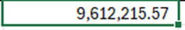Double click the box in the lower right corner to copy formula down
- For column C GL 1230 in cell beside location 1 do = click tab ‘Month YYYY 1230 GL balance’ and select total for location 1
  - Double click the box in the lower right corner to copy formula down
- Next you will pull the necessary information for column D Aging report by going to EOM adjusting entry spreadsheet F:\Accounting\Shared\Month End\EOM Entries 20XX\EOM entries\EOM Entry #4- Accounts Receivable.xlsx
  - Scroll to 1200&1230 section of the EOM adjusting entry spreadsheet
  - Take location 1 total (+) total beside Add Employee A/C’s (+) total beside Add other sales (Nat’ls a/c’s, etc to get the location 1 total on the reconciling spreadsheet
  - For all the other locations copy and paste the totals from the EOM adjusting entry spreadsheet to the reconciling spreadsheet
- Check all variance areas, if there is a variance investigate & escalate to controller
- Take snip its of the balances of both accounts off the Intranet and post them below the summary
- Make sure all the Months and dates are for the month you are reconciling on the below snip it.
  - Change the MM/YYYY to what fiscal period you are reconciling.
  - Change the month and year to current one reconciling.
  - In reconciled by put your name and date you reconciled.
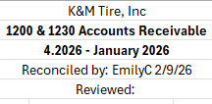

GL 1220 – Inventory In Transit, Inter-Co
G/L 1220 is used to record inter-company inventory transfers. Inventory that is in-transfer between K&M locations on the nightly transfer trucks. This includes both Stock & Sold transfers. This account is reconciled through an excel summary of the totals off our EOM reports by location showing "Inter-Co Rec," Inter-Company Receivers.
- To reconcile Monthly & Annually:
  - Open the EOM adjusting entry spreadsheet
    - F:\Accounting\Shared\Month End\EOM Entries 20XX\EOM entries\EOM Entry #11- Inter-Co Inventory.xlsx
  - Run an Intranet account balance total for current fiscal period, G/L 1220, K&M Only (R60), and click “Run Report”
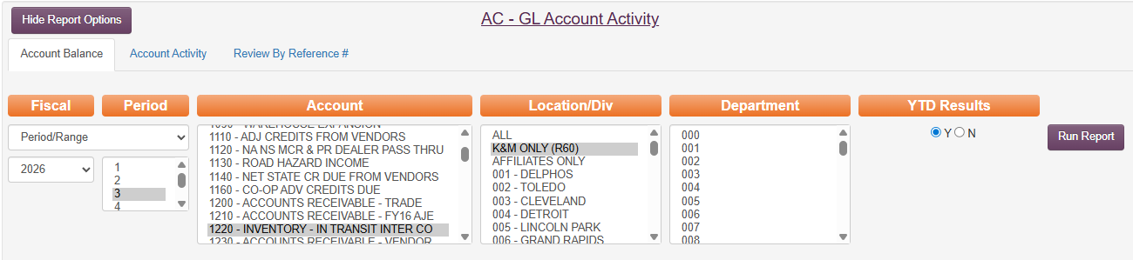
  - Compare total of Intranet report showing G/L balance to total of Monthly Receiver reports as summarized on EOM entry #11.
  - If the balances match, the account is reconciled.
Total from Intranet showing period G/L balance  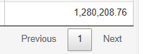 | Total from EOM #11 Summary of Reports, bottom of Column C
  - This procedure simply provides assurance that EOM#11 entry was posted correctly and the ending account balance matches what it was intended to.
  - Notate the account was verified on the reconciliation tracker and no further action is necessary.

GL 1290 – Reserve For Bad Debt

GL 1290 is our Bad debt reserve. We accrue for bad debts monthly based on amount set by Controller and approved by Pres & CFO at beginning of fiscal year. We true-up at year-end using a P13 entry. At year-end, this account is tied out to an excel calculation of required reserve based on AR aging.
Each month there is a recurring entry posted to 1290-1-1.
File path: ..\..\General Ledger\Balance Sheet Reconciliations 20XX\1290
- To reconcile monthly:
  - Open Intranet and run a G/L account detail, Most recent Fiscal month ended, G/L 1290, K&M Only (R60), and click “Run Report.”
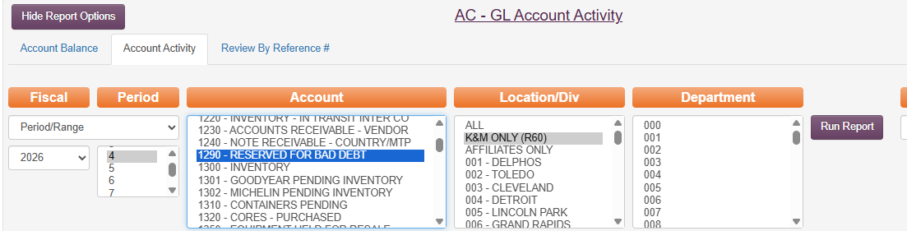
  - Review G/L activity to verify the monthly recurring entry posted as expected.
  - Review G/L activity to verify all other daily postings appear normal and expected. The debit postings coming through as AR adjustments are for accounts written off by K&M Tire which do not qualify for credit risk insurance reimbursement. A small credit posting is likely from an unexpected payment received by an account previously written off.
  - If there is anything posted that looks unusual or large in size
    - Research and escalate to controller.
    - Export report to excel, make notes beside row with item researched and any resolution if necessary
    - Save report to "F:\Accounting\Shared\General Ledger\Balance Sheet Reconciliations 20XX\1290\ naming it “GL 1290 Recon Detail [Period MM.YYYY].xls”
  - Once finished, notate the account was verified on the reconciliation tracker and no further action is necessary

GL 1300 – Inventory
This GL is used to record cost of inventory, including product cost & FET. In operations we verify daily through regular cycle counts. In G/L, we adjusted book to physical on a monthly basis through EOM entry. When reconciling monthly, we reconcile General Ledger inventory to our Computer cost. At year-end, we make a P13 entry to remove inventory padding and overstated amount, netting book inventory down to net cost for 9.30 YE financials.
- To reconcile Monthly:
  - Open the “ALL Locations Detailed Inventory” report that runs as an auto-report at end-of-month. This is saved during the month-end closing procedure and can be found at
    - "F:\Accounting\Shared\Month End\Monthly Reports\2026\January 2026\Inventory - Detailed\ALL LOCATIONS - DETAILED INVENTORY 1.31.26.txt"
    - Run an Intranet account balance total for most recent fiscal period, G/L 1300, K&M Only (R60), and click “Run Report”
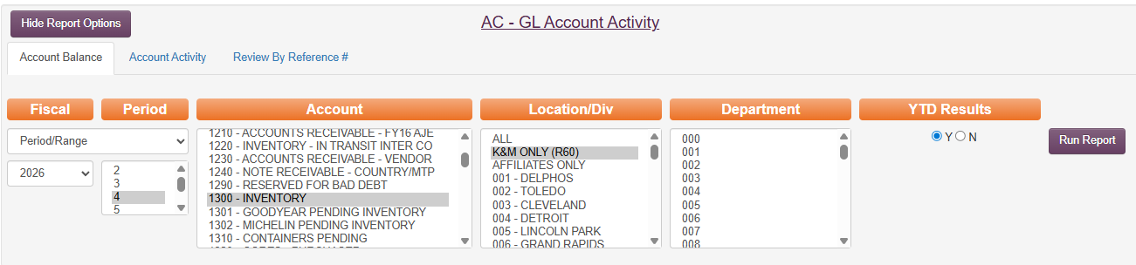
  - Compare total of Intranet report showing G/L balance to total of “ALL Locations – Detailed Inventory XX.XX.XXXX”
    - On the All Locations Inventory, you must add the middle to columns in the Grand Total row together. These columns are FET and Actual Cost.
  - If the balances match, the account is reconciled and everything has been recorded and posted correctly.
Total from Intranet showing period G/L balance  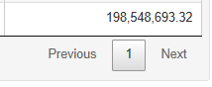 | Total from All Locations Detailed Inventory Report  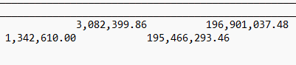  FET of $3,082,399.86 + Actual Cost $195,466,293.46 = $198,548,693.32
  - Notate the account was verified on the reconciliation tracker and no further action is necessary.
- To Reconcile Annually (done by Controller)
  - Email VP of Purchasing to request End-of-Year Physical Inventory Cost/Value report with Net downs.
  - Prepare entry to apply discounts by location.
  - Refer to the most recent Inventory Net Cost adjustment spreadsheet when making this entry
    - File path "F:\Accounting\Shared\Year End\Period 13\2025\Year End Inventory Net Cost adjustment 9.30.2025.xlsx"
    - In below example $24,527,724.19 was the amount we were carrying in Inventory Value Overstated going into year-end.
    - When VP of Purchasing ran analysis, $21,069,624.68 was the actual amount determined to be overstated at 9.30.2025.
    - The first entry zeros the 2370-1 Overstated account and applies the $21,069,624.68 discounts to each location, with the difference going to 4080-1-1.
    - The second entry reverses the discounts applied and moves them back into 2370-1 Inventory Value Overstated.
  - Send a copy of the spreadsheet to the CFO & President.
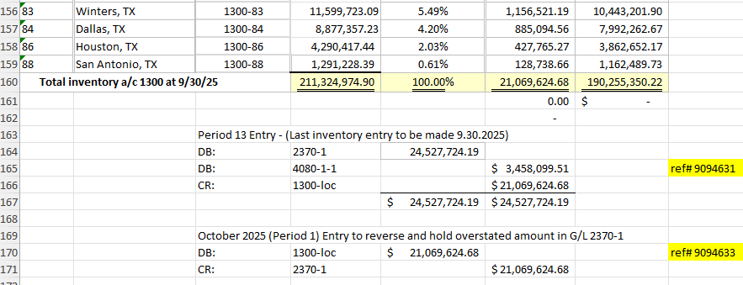

GL 1301 – Goodyear Pending Inventory
GL 1301 is used to record Goodyear invoices we are paying before we received the inventory. We pay all Goodyear invoices within 10 days to earn maximum cash & anticipation discounts. If we haven't received the tires, we will enter the invoice and pay it, with the debit going to 1301-Loc. When we receive the tires, we clear the receiver out against the related invoice that was posted to 1301-Loc.
This G/L is reconciled to an excel workpaper detailing any invoices paid before EOM where tires not yet received. There should not be anything aged in here, and if there is, it's likely an unresolved issue.
To Reconcile Monthly
- Open “1301 Reconciliation” excel spreadsheet at F:\Accounting\Shared\General Ledger\Balance Sheet Reconciliations YYYY\1301
  - This can be done once a month, it does not need to be done before the month is closed
- Start by updating tab “Month YYYY GL Detail”
  - Copy and Paste open line items from the same tab in the previous month
    - This should be items that are not highlighted grey, items that were used to tie out the “Month YYYY Summary” tab
  - Add all current monthly data
    - Intranet
    - Accounting
    - GL Account Activity
    - Tab “Account Activity”
    - Select the Fiscal Period reconciling
    - Select Account “1301 – Goodyear Pending Inventory”
    - Select Location/Div “K&M Only (R60)”
    - Do not select a Department or select “001” and “000”
    - Click Run Report
    - Export to Excel
  - Paste current data below previous open items
  - Highlight grey anything that washes with the previous month or in the current month
    - Leave items that do not wash unhighlighted to use to reconcile the “Month YYYY Summary” tab
- Update tab “Month YYYY GL Totals”
    - Intranet
    - Accounting
    - GL Account Activity
    - Tab “Account Balance”
    - Select the Fiscal Period reconciling
    - Select Account “1301 – Goodyear Pending Inventory”
    - Select Location/Div “K&M Only (R60)”
    - Do not select a Department or select “001” and “000”
    - Click Run Report
    - Export to Excel
    - Copy and paste all data from the downloaded file into the tab
- Update tab “Month YYYY Summary”
  - Update row 3 with the fiscal period and calendar month and year
  - Update row 4 with name or initials and date reconciled
  - Check that column B “GL 1301” is pulling correctly form the “Month YYYY GL Totals”
  - Update column C “Open Items”
    - Pull forward the sum of open items by location from tab “Month YYYY GL Detail”
    - If this tab is correct column B and C should wash
  - Check that column D “Variance” formulas are correct
  - Update the “GL Balance MM/DD/YYYY” from the Intranet- Accounting- GL Activity
    - Use the same criteria as step 3 of this procedure
    - Paste the total from all 1301 K&M accounts into cell B60
    - Also take a snippet of this balance to add to the bottom of the rec
  - If there is a variance start by checking formulas on this tab, work backwards through tabs checking all totals and formulas
- Review dates in “Month YYYY GL Detail” tab
  - No invoices or amounts should be aging. If any items are over 30 days old, email AP Manager & Team lead, and CC Controller to ask status.
    - If any items are over 60 days old, email to above group and also CC: CFO and EVP.
    - If any items are over 90 days old and still unresolved, email above individuals and also CC: President.
To reconcile at Year-End
- Follow above monthly reconciliation as of 9.30.XX.
- In October, trace and items that were open as-of Sept 30th, and notate the date tires were received into inventory and the pending item was relieved.
  - Everything should have cleared no later than October 31st

GL 1310 – Containers Pending
This GL functions similar to above GL 1301, except it’s used for BKT containers. We pay BKT in advance of receiving containers in order to receive a cash discount. Follow G/L 1301 reconciliation procedures when reconciling this account.

GL 1390 – Security Deposits
This G/L is used to hold Security deposits for utilities and landlords on the buildings we use in operations. It is reconciled to a detailed excel workpaper listing all security deposits. We review by location for changes. Pay specific attention to locations we've moved into or out of.
To reconcile Monthly
F:\Accounting\Shared\General Ledger\Balance Sheet Reconciliations 20XX\1390
- Open workbook 1390 and copy the summary tab from the previous month
- Run GL Account Activity for 1390 all locations with the YTD Results marked “Y”. Insert this information into a new tab on the 1390 workbook
  - Review the activity for the current reconciling month. Filter out all zeros in the YTD column. If there is no activity it means, there are no changes to the leases. If there is activity that location will need to be updated on the summary tab.
    - For new leases research what the amount is for (security deposit, utilities, etc..).
      - Document this with a description, and the year/period amount was added to Security Deposit schedule.
  - Total the YTD balance
- Add or remove any necessary leases to the summary tab
  - Update the total per location and update the GL balance formula to pull the correct month
- Review that there is no variance and update all dates and update Reviewed by information.

GL 1400 – Prepaids Insurance
There are four accounts in the 1400 that need to be reviewed and reconciled each month.
F:\Accounting\Shared\General Ledger\Balance Sheet Reconciliations 2026\1400
First reconcile 1400-1-1
- This should always be “0” with no activity
- To check this, we will go onto the Intranet, select accounting, then GL account activity.
  - Select the proper year and period we are reconciling.
  - Under “Account” select 1400.
  - Under “Location/Div” select Delphos, under “department” select “001”.
  - YTD results is always marked yes.
  - Once all of these have been selected run report and validate the balance
- On the spreadsheet just add a “0” on the current month reconciling.

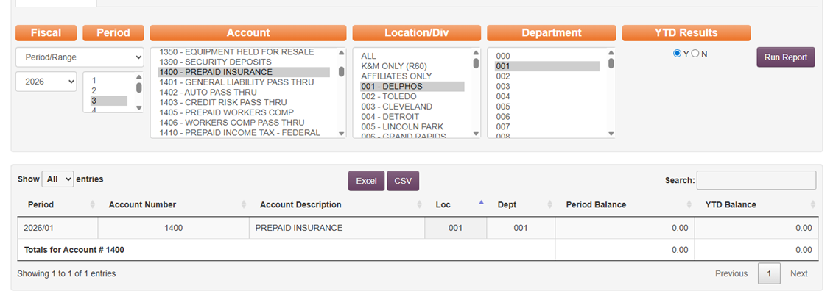

Next, reconcile: 1400-1-2, 1400-1-3, & 1400-1-4.
These 1400 accounts all follow the same exact process below, except substituted their account number.
- Run a GL Account Balance for 1400-1-2 with “Y” selected for YTD Results.
- If there is activity add the results under the detail tab from the account activity on the Intranet.
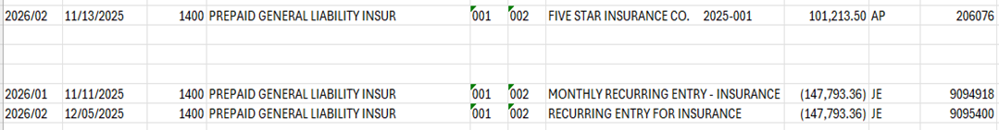

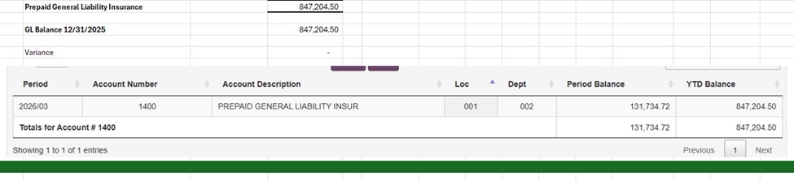
- On the Summary tab update the dates and then formulas from the detail tab with the updated values from the detail tab and add results from the Intranet to the bottom of the sheet.

This will show you what the balance should be for the month reconciling.
- Make sure your GL account total matches what your summary tab total equals. If there is a variance, make sure all detail is added and formulas are correct.
- Analyze the detail tab and verify there are no unusual or unexpected G/L postings.
- For G/L 1400 insurance accounts we would expect to see:
  - A monthly Credit entry for posting the monthly expense accrual
  - Monthly Debit entries for any payments made to insurance carries for each category.
  - If anything is unexpected, escalated to Controller.
See SOP 7.7 Recurring Entries for additional information on Prepaid Insurance

GL 1405 – Prepaid Workers Comp
The primary account is to be reviewed and reconciled is 1405-1-2. We also review the other 1405 accounts including 1405-1-1 to make sure there is no activity in them.
F:\Accounting\Shared\General Ledger\Balance Sheet Reconciliations 2026\1405
Verify No activity in 1405-1-1
- Run a GL Account Balance for 1405-1-1 with “Y” selected for YTD Results.
- There should be no activity on this account. If there is review item and find who posted it in the account for an explanation. It will need to be moved out of that account to another
- All that is needed is to plug in a “0” for the month reconciling.
Reconcile 1405-1-2
- Open the 1405-1-2 and copy both the Summary and detail tabs.
- Run a GL Account Balance for 1405-1-2 with “Y” selected for YTD Results.
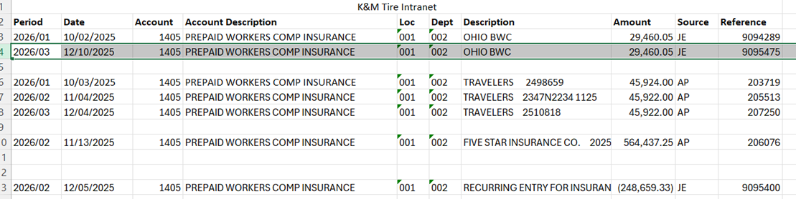
- If there is activity add the results under the detail tab from the account activity on the Intranet.

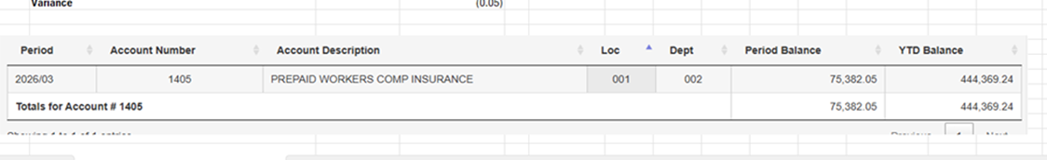
- On the Summary tab update the dates and then formulas from the detail tab with the updated values from the detail tab and add results from the Intranet to the bottom of the sheet.

- Make sure your GL account total matches what your summary tab total equals. If there is a variance, make sure all detail is added and formulas are correct.
- Review activity to make sure everything posted is expected and in-line
  - If anything unexpected, research and escalate to Controller.

GL 1410 – Prepaid Federal Income Tax
This G/L is used to track our required S-corporation tax deposits as reported on Form 8752.
See SOP 16.10 Form 8752 for details on purpose of the G/L
F:\Accounting\Shared\General Ledger\Balance Sheet Reconciliations 20XX\1410
- To reconcile Monthly:
  - Open general ledger balance inquiry for G/L 1410-1-0 and verify the balance has not changed from prior period.
  - Balance in G/L should agree with balance on line 9a of Form 8752.
    - Copy of Form 8752 saved in above 1410 recon folder
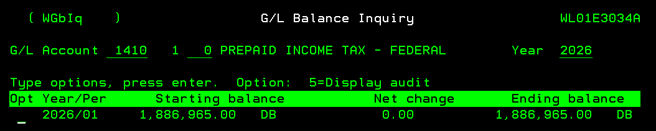
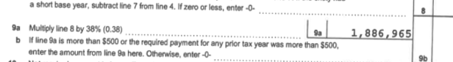
  - The only time these balances would not match would be if we filed Form 8752 on May 15th to receive a refund, and the US Treasury doesn’t mail us the check until August (as with last refund.)
  - If there are any unexpected entries, investigate and escalate to Controller.
- Once finished, notate the account was verified on the reconciliation tracker and no further action is necessary

GL 1420 – Prepaid Expense
This GL is used to record Prepaid Rent and other Prepaid Expenses. Prepaid Rent is posted by Location. Non-rent prepaid expenses are posted to 1420-1-1.
See SOP 10.2.1 Prepaid Expenses for additional details on non-rent prepaid expenses posted to 1420-1-1.
To reconcile Monthly
- Open the 1420 and copy both the Summary and detail tabs.
- Run a GL Account Balance for 1420, leave the location and department blank with “Y” selected for YTD Results, click run report.
- Export the report from Account balance to excel and move the spreadsheet to the 1420 reconciliation.
- If there is activity in the 1420 run an account activity and take a snippet of all the information and paste it into the detail tab for description.
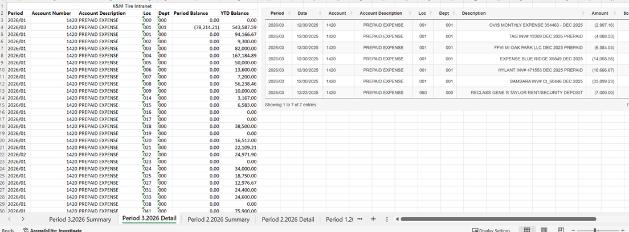
- Verify activity line by line to make sure it is correct.
  - Update the Summary tab to reflect any prepaids that have been added, refunded, or expensed.
- On the Summary tab update the dates and then formulas from the detail tab with the updated values from the detail tab. Make sure your GL account total matches what your summary tab total equals. If there is a variance, make sure all detail is added and formulas are correct.
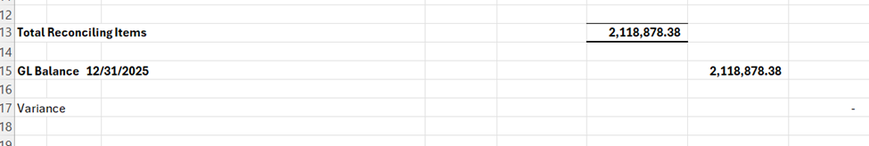
Search for changes in rent that could affect Prepaids
- Verify there were no changes in monthly rent that could affect prepaid acct
  - On the 1st or 2nd of month before the prior month financials are finalized, open Intranet and run a G/L detail for 5550 by location for the month that just ended.
  - Run the same GL 5550 detail by location for one month prior.
  - Compare the values side by side to see if any location rents have increased or decreased
  - This can also be done by running a financial statement and searching “5550/” and spot checking each location to verify no changes
- If there were any changes in rent, review change to see if a correction to prepaid G/L is needed.
  - For example, if the rent payment went up $2,000 then the first month we paid the higher dollar amount, the $2,000 incremental rent may likely need to be recorded as an addition to prepaid, since we typically pay rent before the 31st for the coming month.
To Reconcile Annually
- Verify all prepaid rent amounts match the current monthly rent expense
- Verify all amounts in G/L 1420-1-1 are supported and expensing matches term of contract or benefit.

GL 1440 – Tri-Energy Stock Payment
This GL is used to track Tri Energy Stock related to loc 53. We reconcile this account to the equity section at the bottom of our most recent payment remittance or 1099-PATR information return
GL 1440-53 Reconciliation:
F:\Accounting\Shared\General Ledger\Balance Sheet Reconciliations YYYY\1440
- This should be completed monthly.
- Open 1440 Reconciliation which can be found at
  - F:\Accounting\Shared\General Ledger\Balance Sheet Reconciliations YYYY\1440
- Create a copy of the previous period summary tab and rename for current period
- Run a GL Account Balance with YTD Results marked as “Y”
  - If there is any activity in this account add the activity to the 1440 Reconciliation as a GL Activity tab
- If there is a payment received
  - Add a screenshot of the statement that came with the check to the GL tab. Example:
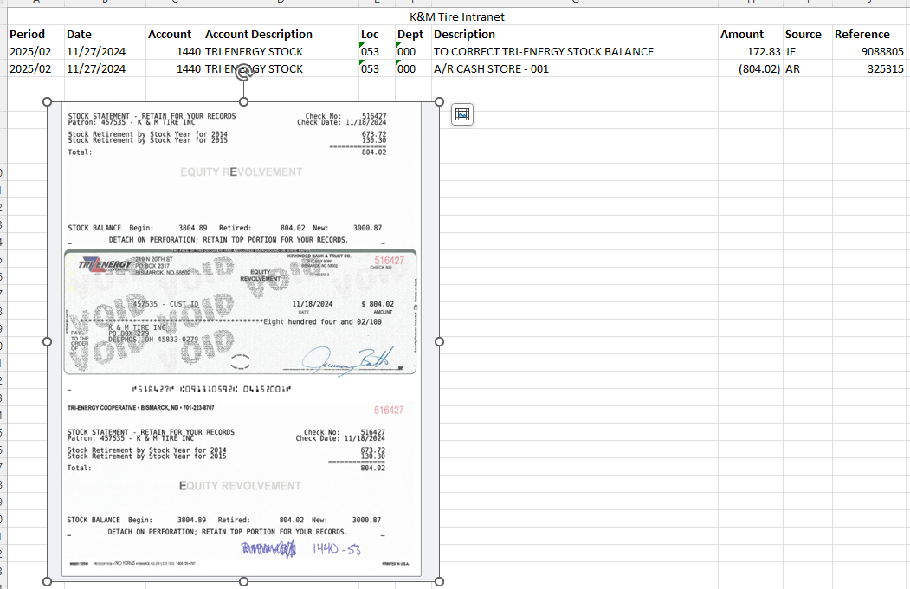
  - Update the summary tab
    - “Tri-Energy Statement” amount
    - “Tri-Energy Equity Payments” amount
    - Update GL Account Balance amount
- Compare the General Ledger balance in #1440-53 with the Equity Balance listed on the bottom of the payment remittance or 1099-PATR information return.
  - The difference should be the income that has not yet been recorded in our general ledger.
  - Accountants should review the two most recent remittances to confirm this,
    - If the G/L doesn’t match the Remittance or 1099-PATR, escalate to Controller and confirm need to post journal entry to record income.
    - Debit is to 1440-53 and Credit is to 3990-53.
- The 1440-53 Account is not considered reconciled until the G/L balance agrees with the Equity Balance listed on the payment remittance or 1099-PATR information return.
- If there is no activity no changes need to be made besides creating a copy of the previous month summary tab and updating dates.
G/L Coding and Filing of Tri-Energy Checks
Note: Tri-Energy Coop will periodically send a check and stub in the mail for a Patronage Dividend. When received:
- Scan and save the check and stub to the Tri-Energy folder - F:\Accounting\Shared\Tri-Energy
- Give the check to AR to post to1440-53
Example of check:
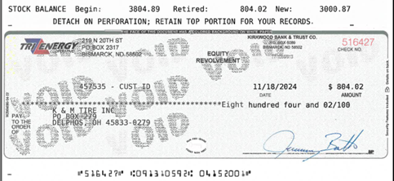

GL 1480 – FCSS Investment
This G/L is used to record K&M's investment in FCSS, tracked using the equity in earnings of affiliate accounting method. FCSS distributions are posted to this G/L as a debit, and periodically throughout the year we'll bring in K&M's portion of income as a credit.
F:\Accounting\Shared\General Ledger\Balance Sheet Reconciliations YYYY\1480
- Open the 1480 reconciliation and copy the prior month summary tab
- Run a GL Account Balance for 1480-1-1 with “Y” selected for YTD Results
- If there is activity save the results under the summary information on the summary tab
  - Update the “Investment” amount
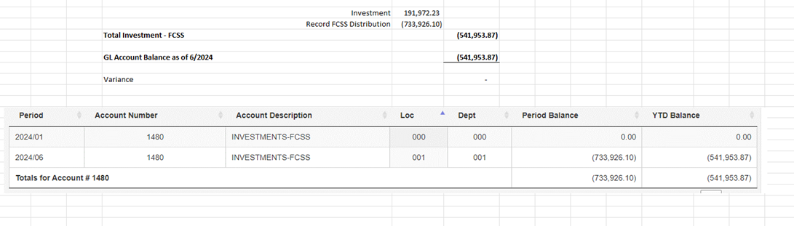
  - Update the GL Account Balance amount

  - Review the activity to make sure there is nothing unexpected or out of the ordinary.
    - Credits to this account should be Distributions paid by FCSS to K&M. Rebecca Hadley will generally send an email in advance to the Controller notifying K&M that a distribution is being paid
    - Debits to this account should represent K&M recording FCSS income (earnings) in our financials.
- If there is no activity no changes need to be made besides creating a copy of the previous summary tab.
- Update all dates and notate account has been verified
Year-End Reconciliation
- To reconcile this account at year-end, begin with the most recent FCSS K-1
  - If received, it should be saved in above recon folder.
  - Otherwise, request from Dave Estupinan at M&Z and save.
- Request the YTD Income Statement and Balance Sheet through 9.30.CY from Rebecca Hadley at FCSS.
  - At same time, request October through December financial statements from prior year, as FORVIS will need a complete 12 months ending 9.30.CY when they work on the our audit.
- Beginning with the 12.31.20XX reconciled balance on the K-1, add the YTD income from the period January 1st through September 30th, and Subtract the YTD Distributions received from FCSS for that same period
  - The result should be the current balance using the Equity in Earnings of Affiliates method of accounting.

GL 1510 Pending Nonstock/DS Banking
GL Purpose: To record all open non-stock items in Loc 1,48, & 58 month end reconciliations, to carry over pending nonstock (items sold that are not part of inventory) in which the AR sales invoice or AP product purchase invoice were not posted in the same period. Month end reversing entry from 3910.
Placeholder for SOP to be written

GL 1530 Returns to Vendor AP
Placeholder as pending being written

GL 1530-1-1 – Returns to Vendor-NAB
This G/L is used to track discrepancies in amounts vendors pass to K&M on individual NAB credits. Examples of items tracked in this account could include wrong billings, items waiting for corrections, duplications waiting on reversal, etc.
This G/L is reconciled to an excel list which tracks date, inv#, amount, and note on difference
- Open “1530-1-1 Reconciliation” excel spreadsheet at F:\Accounting\Shared\General Ledger\Balance Sheet Reconciliations YYYY\1530-1-1-NAB
- Start at tab “Month YYYY Summary” if not a tab for the month you are reconciling, right click and select move or copy, then copy, rename the tab to current month.
  - Pull GL balance from Intranet
    - Intranet
    - Scroll to Accounting
    - Select GL Account Activity
    - Make sure that Tab “Account Balance” is selected at the top
    - Select the Fiscal Period reconciling
    - Select Account “1530- Returns to vendor-NAB”
    - Select Location/Div “K&M Only (R60)”
    - Select Department “001”
    - Click Run Report
    - Put the YTD balance on the spreadsheet where it says GL Balance. Make sure the date beside the GL balance is the month you are reconciling
  - Go to F:\National Accounts\Shared\List\1530-1-1 Reconciliation.xlsx
    - Scroll to the bottom and look at the balance
    - Put that amount on the spreadsheet where it says reconciling items
    - Look at the variance, if there is a variance investigate by following the above steps for GL account activity but select Tab “Account Activity” from the top.
    - Highlight things that wash each other, what is on the list, or what has come off the list in the month you are reconciling
    - Once everything is highlighted it should tell you what is either in the GL and not on the list or vice versa.
    - Contact NAB Manager or Team Lead to see if it should be or not or any other questions you have about the account
    - Copy the 1530-1-1 excel sheet from national accounts and paste it below the variance on the reconciling spreadsheet.
  - Make sure all the Months and dates are for the month you are reconciling on the below snip it.
    - Change the MM/YYYY to what fiscal period you are reconciling.
    - Change the month and year to current one reconciling.
    - In reconciled by put your name and date you reconciled.
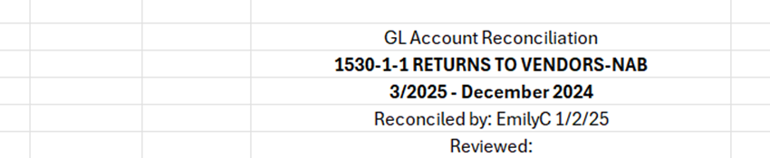
- Analyze Outstanding Items
  - Items in this account should clear within a reasonable period of time, typically less than 30 days
  - If any items appear on list >30 days, email screenshot of them to NAB Manager and Team Lead to inquire about status. CC: Controller
  - If any items appear on list >60 days, send email to above recipients and CC: CFO and VP of Accounting.

GL 1540 – Employee Loans Receivables
Employee Loans are tracked through individual AR customer accounts, with the exception of one EE’s loan which is tracked through 1540-1-1. Employee loan payroll withholdings are posted to 1540-1-1 weekly and washed against the AR payment on account, applying that withholding to EE's account.
This GL is reconciled through an excel workpaper, which lists out any end-of-period timing difference plus EE’s vehicle loan. This is also used for EE loans that are large amounts and take 6+ month to repay.
- Open “1540-1-1 Reconciliation” excel spreadsheet at F:\Accounting\Shared\General Ledger\Balance Sheet Reconciliations YYYY\1540
- Start at tab “Month YYYY GL Detail”
  - Add all monthly data (easiest if done weekly)
    - Intranet
    - Accounting
    - GL Account Activity
    - Tab “Account Activity”
    - Select the Fiscal Period reconciling
    - Select Account “1540- EE Loans Receivable”
    - Select Location/Div “K&M Only (R60)”
    - Select Department “001”
    - Click Run Report
    - Export to Excel
  - Before copying and pasting the data delete out the columns for Account, Account Description, Location, and Department
  - AR tracks employee loans by setting up the employee as they would a customer in Maddenco
    - This comes across as an AR Adjustment, normally for an amount such as $200, $400, $500
    - AR Adjustments are lumped together in the GL if they were made on the same day to the same GL account
  - Payroll withholds payments from the employees checks until the loan is paid off and AR treats these like normal payments on a customer account
    - The payroll entry comes across as one line item per location, not GL location as all go to 1-1, but the employee’s location set in Dayforce
    - The AR Adjustments for each payment will be smaller amounts, many will not be whole numbers
    - Payroll dept manages the spreadsheet “Employee Loans YYYY” at \\file-a.kmtire.local\File Server\Human Resources\Shared\Payroll Documents\Employee Loans and sends it to AR weekly to apply the AR Adjustments to the employees customer accounts
  - Both AR Adjustments and Payroll entries will need changed from lump sums to amounts by employee in order to tie them out and find the variances
    - There are almost always variances but if everything posted for the week does tie out to $0.00 the below steps do not need done, pick up at step 2.h.
  - To see what makes up the AR Adjustments
    - Intranet
    - Accounts Receivable
    - Adjustment Report
    - Select the start date and end date for day/week reconciling
    - Click “Run Report”
    - In the Search type “1540”
    - Export to excel
  - Ensure the total in column “Adj Amt” matches the total AR Adjustment you are trying to breakdown
  - Back in the “Month YYYY GL Detail” sheet replace the lump sum AR amount with the broke down amounts and add the employee names in column G
  - To see what makes up the payroll entries
    - **Replace below with Dayforce**
    - Access.paylocity.com
    - Login
    - Hover over “Tax & Finance” in the top menu bar
    - Select “General Ledger”
    - Choose the “Check Date From/To”
    - This should be one day off from the Date column B from the “Month YYYY GL Detail” tab
  - Add criteria “Display Employee Name”
  - Look to the right and go to the top “All (X) GL” box and select account “01540/001/001”, deselect the “All” option
  - Leave all other criteria as is
  - Click “Run Report and Go To Pickup”
    - This will take you under Reports & Analytics- Reports- Report Pickup
  - Open the file by clicking on the xlsx symbol under “Download”
  - Ensure the total in column Y matches the total Payroll entry you are trying to break down
  - Back in the “Month YYYY GL Detail” sheet replace the payroll entry amounts for the week with the broke down amounts and add the employee names in column G
- Format all names to match
  - take the “*” off the names from the AR Adjustments
  - Make the names from the Paylocity Report first then last name
- Sort column G by A-Z
- Highlight all amounts that tie out grey as they can now be ignored
- Open amounts can be given a week or so to ensure it is not just a timing issue
  - A common issue is an AR Adjustment being posted to 1560-1-1 or 1550-1-1 by mistake since they are similar GL’s
  - If this is a case a journal entry can be used to reclass the AR Adjustment to go to the same GL as the payroll side
    - Do not notify AR unless it is a reoccurring issue
  - If an item still remains open then send the details to AR and the HR Payroll Manager
- At the end of the month update tab “Month YYYY Detail”
  - Copy and paste any open items from the “Month YYYY GL Detail” tab
  - Check the previous month “Month YYYY Detail” tab to see if any open items were not cleared up and move forward if needed
  - Follow up with any emails or research needed to get these cleared up as soon as possible
  - At the end of the month update tab “Month YYYY Summary”
    - Update row 3 with the fiscal period and calendar month and year
    - Update row 4 with name or initials and date reconciled
    - Under “Reconciling Items” pull forward totals from tab “Month YYYY Detail”
    - Ensure they are totaling correctly
  - To the right of “GL Balance MM/DD/YYYY” add the total in the GL at month end
    - This can be found on the Intranet-GL Activity by following the steps above
    - Add a snippet of the total from the Intranet to the bottom of the “Month YYYY Summary” tab
  - If there is a variance, recheck all formulas first then work backwards through these steps rechecking formulas and totals

GL 1550-1-0 – AP Pass Thru
Placeholder for SOP to be written.
This G/L is used for any temporary AP pass thru items which will be reclassified out to the correct G/L acct as identified/determined. It is reconciled through an excel workpaper detailing open items in this account not yet reclassified or rebilled. Items should sit in this account no longer than 30 days.

GL 1550-1-1 – AR Pass Thru
This account is used as a pass-thru reconciling account for issuing checks to customers, typically for refunds arising from overpayment on account. If refund is due to a return, we typically encourage customer to use refund towards next purchase. Our Account Specialist will make a check request to C&C manager, who will either approve/deny or send to VP of Sales for approval. Once approved, Account Specialist will do an AR adjustment to debit the customers account and credit (negative debit) the 1550-1-1 AR pass thru account. When AP issues the check to the customer, they will post as a debit to 1550-1-1 netting transaction balance to zero.
- Open “1550-1-1 Reconciliation” excel spreadsheet at F:\Accounting\Shared\General Ledger\Balance Sheet Reconciliations YYYY\1550
- Start at tab “Month YYYY GL Detail” by adding all monthly data- easiest if done weekly
  - Intranet
  - Accounting
  - GL Account Activity
  - Tab “Account Activity”
  - Select the Fiscal Period reconciling
  - Select Account “1550- AP Pass Thru”
  - Select Location/Div “K&M Only (R60)”
  - Select Department “001”
  - Click Run Report
  - Export to Excel
- Before copying and pasting the data delete out the columns for Account, Account Description, Location, and Department
- The GL is made for when a customer has a credit on their AR account and they want it paid back to them by AP
  - The AP payments will say “Customer Name CK Req MMDDYY” with AP as the Source and a 6 digit reference number
  - To remove the customers’ credit off their account AR will make an AR Adjustment to the customer account
  - AR Adjustments issued on the same day to the same GL will sum together
  - To see what makes up the AR Adjustments
    - Intranet
    - Accounts Receivable
    - Adjustment Report
    - Select the start date and end date for day/week reconciling
    - Click “Run Report”
    - In the Search type “1550”
- The AP Check and AR Adjustment should wash out perfectly around the same day
  - Wait approx. 1 week if they do not wash to see if it is due to timing
  - Email AR Team Lead and AP Team Lead if they do not
- If something abnormal is posted to the GL research and see where it should be reclassed to or what it will wash with
  - First Financial Bank (Concur) AP entries should go to 1550-1 to wash, not 1550-1-1
- At the end of the month update tab “Month YYYY Detail”
  - Copy and paste any open items from the “Month YYYY GL Detail” tab
  - Check the previous month “Month YYYY Detail” tab to see if any open items were not cleared up and move forward if needed
  - Follow up with any emails or research needed to get these cleared up as soon as possible
- At the end of the month update tab “Month YYYY Summary”
  - Update row 3 with the fiscal period and calendar month and year
  - Update row 4 with name or initials and date reconciled
  - Under “Reconciling Items” pull forward totals from tab “Month YYYY Detail”
    - Ensure they are totaling correctly
  - To the right of “GL Balance MM/DD/YYYY” add the total in the GL at month end
    - This can be found on the Intranet-GL Activity by following the steps above
    - Add a snippet of the total from the Intranet to the bottom of the “Month YYYY Summary” tab
  - If there is a variance, recheck all formulas first then work backwards through these steps rechecking formulas and totals
- Review the “[Month Year] Detail” tab
  - Items in this account should clear in one to two weeks.
  - If any items remain on list >30 days, research and escalate to AR Manager and Controller for resolution .
    - Send email with screenshot of open items to AR Manager and Controller
  - If any items appear on list >60 days, send email to above recipients and CC: CFO and VP of Accounting.

GL 1560 – Employee Loan Pass Thru
GL 1560 is used as a pass-thru account for Employee Purchases for tires purchased on EE's account with a signed payroll deduction form in place. Receivable is tracked through AR customer accounts and payroll withholdings in Payroll system. Payroll withholding hits this account as a credit, AR Adjustments wash out those out as a debit when applied to the EE's A/R acct.
- Open “1560-1-1 Reconciliation” excel spreadsheet at F:\Accounting\Shared\General Ledger\Balance Sheet Reconciliations YYYY\1560
- Start at tab “Month YYYY GL Detail”
  - Add all monthly data (easiest if done weekly)
    - Intranet
    - Accounting
    - GL Account Activity
    - Tab “Account Activity”
    - Select the Fiscal Period reconciling
    - Select Account “1560- Employee Loan Pass Thru”
    - Select Location/Div “K&M Only (R60)”
    - Select Department “001”
    - Click Run Report
    - Export to Excel
  - Before copying and pasting the data delete out the columns for Account, Account Description, Location, and Department
  - AR tracks employee loans by setting up the employee as they would a customer in Maddenco
    - This comes across as an AR Adjustment, normally for an amount such as $200, $400, $500
    - AR Adjustments are lumped together in the GL if they were made on the same day to the same GL account
  - Payroll withholds payments from the employees checks until the loan is paid off and AR treats these like normal payments on a customer account
  - The payroll entry comes across as one line item per location
    - not GL location as all go to 1-1, but the employee’s location set in Dayforce
  - The AR Adjustments for each payment will be smaller amounts, many will not be whole numbers
  - Payroll manages spreadsheet “Employee Loans YYYY” at \\file-a.kmtire.local\File Server\Human Resources\Shared\Payroll Documents\Employee Loans and sends it to AR weekly to apply the AR Adjustments to the employees customer accounts
  - Both AR Adjustments and Payroll entries will need changed from lump sums to amounts by employee in order to tie them out and find the variances
  - There are almost always variances but if everything posted for the week does tie out to $0.00 the below steps do not need done, pick up at step 2.h.
  - To see what makes up the AR Adjustments
    - Intranet
    - Accounts Receivable
    - Adjustment Report
    - Select the start date and end date for day/week reconciling
    - Click “Run Report”
    - In the Search type “1560”
    - Export to excel
  - Ensure the total in column “Adj Amt” matches the total AR Adjustment you are trying to breakdown
  - Back in the “Month YYYY GL Detail” sheet replace the lump sum AR amount with the broke down amounts and add the employee names in column G
  - To see what makes up the payroll entries
    - **Replace below with Dayforce**
    - Access.paylocity.com
    - Login
    - Hover over “Tax & Finance” in the top menu bar
    - Select “General Ledger”
    - Choose the “Check Date From/To”
    - This should be one day off from the Date column B from the “Month YYYY GL Detail” tab
  - Add criteria “Display Employee Name”
  - Look to the right and go to the top “All (X) GL” box and select account “01560/001/001”, deselect the “All” option
  - Leave all other criteria as is
  - Click “Run Report and Go To Pickup”
    - This will take you under Reports & Analytics- Reports- Report Pickup
  - Open the file by clicking on the xlsx symbol under “Download”
  - Ensure the total in column Y matches the total Payroll entry you are trying to break down
  - Back in the “Month YYYY GL Detail” sheet replace the payroll entry amounts for the week with the broke down amounts and add the employee names in column G
  - Format all names to match
    - take the “*” off the names from the AR Adjustments
    - Make the names from the Paylocity Report first then last name
  - Sort column G by A-Z
  - Highlight all amounts that tie out grey as they can now be ignored
  - Open amounts can be given a week or so to ensure it is not just a timing issue
    - A common issue is an AR Adjustment being posted to 1540-1-1 or 1550-1-1 by mistake since they are similar GL’s
    - If this is a case a journal entry can be used to reclass the AR Adjustment to go to the same GL as the payroll side
    - Do not notify AR unless it is a reoccurring issue
    - If an item still remains open then send the details to AR and the HR Payroll Manager
- At the end of the month update tab “Month YYYY Detail”
  - Copy and paste any open items from the “Month YYYY GL Detail” tab
  - Check the previous month “Month YYYY Detail” tab to see if any open items were not cleared up and move forward if needed
  - Follow up with any emails or research needed to get these cleared up as soon as possible
- At the end of the month update tab “Month YYYY Summary”
  - Update row 3 with the fiscal period and calendar month and year
  - Update row 4 with name or initials and date reconciled
  - Under “Reconciling Items” pull forward totals from tab “Month YYYY Detail”
    - Ensure they are totaling correctly
  - To the right of “GL Balance MM/DD/YYYY” add the total in the GL at month end
    - This can be found on the Intranet-GL Activity by following the steps above
    - Add a snippet of the total from the Intranet to the bottom of the “Month YYYY Summary” tab
  - If there is a variance, recheck all formulas first then work backwards through these steps rechecking formulas and totals
- If there are any reconciliation differences remaining other than normal timing differences, research and notify department that needs to correct
  - If not corrected within 30 days, send email with screenshot to AR Manager (or) HR Manager, and Controller.
  - If not corrected within 60, send email to above recipients and CC: CFO and VP of Accounting

GL 1580 – Marketing Promo & Pass Thru

- Open “1580 Reconciliation Month” excel spreadsheet at F:\Accounting\Shared\General Ledger\Balance Sheet Reconciliations YYYY\1580
- Start at tab “Month YYYY Transactions” by adding all monthly data- easiest if done weekly
  - Intranet
  - Accounting
  - GL Account Activity
  - Tab “Account Activity”
  - Select the Fiscal Period reconciling
  - Select Account “1580- Marketing – Promo and Pass Thru”
  - Select Location/Div “K&M Only (R60)”
  - Do not select a Department or select “001” and “000”
  - Click Run Report
  - Export to Excel
- Add new data after deleting out the Account Description and cut and insert the Amounts to the end (move from column G to column I)
- Go to emails from Marketing (Marketing Coordinator, Director of Marketing)
  - They will have lists or individual invoices that need reclassed to a Volume Bonus GL.
- Reclass all activity using the “Month YYYY Transactions” tab.
  - AR Invoices posted on the same day to the same 1580 GL will lump together
    - They will need manually separated in excel in order to match up to the emails and find what invoices still need reclassed
  - If the amounts from emails do not tie out with total for the GL posting for the day look up what else makes up the line item
    - MaddenCo
    - General Ledger
    - Inquiry Menu
    - Balance Inquiry
    - All Stores 000- enter
    - Type in GL and Year
    - 5 on correct period
    - 6 on line that needs researched
    - Shift F2
    - 1 by Product History
    - Start at Product “PASSM”
    - 5 to View beside each PASSM item
    - Find the item(s) that do not match up to an email
  - Sometimes a credit to inventory is mistakenly applied to Product Code PICKUP instead of Inventory with PICKUP as a blank line below it.
    - These will post to 1580 and need reversed and recredited.
    - Email the Marketing contact with the invoice number (Dave Miller & Brian Goring)
    - If the credit says “Bridgestone Premium Ownership – Orig Inv ######### - PO #########” then see the next section on the BPTO Program.
    - Goodyear AR and AP credits will wash in the account
    - An email will come from Marketing but no entry needs made.
    - These may cause an open item at month end due to timing as both sides do not post on the same day.
  - Fill in column J “Notes” with the vendor/invoice number/any other helpful notes
  - Fill in column K “Account Moved to” with the new GL account
    - If it was a wash in the GL then use “wash”
  - Fill in column L “Status” with the reference number once the entry to reclass is made.
    - If it was a wash in the GL then use “Done”
    - If the entry itself is a reclass of prior entries then use its reference number from column H
    - This will allow column L to be sorted by a reference number to ensure the reclass was correct and ties out to $0.00
- Bridgestone/Firestone Premium Tire Ownership Program
  - Customers purchase tires and receive a credit (AR Invoice posted to 1580-location) then we receive a credit from Bridgestone to wash with it (posted by AP to 1580-location)
  - All need reclassed from 1580-location to 1580-1-1
  - Once reclassed add to listing on tab “Month YYYY Summary”
    - The “PO#” column D and “K&M Invoice #” column E are found when researching the line items above.
  - Using the PO# or K&M Invoice # go to the shortcut at F:\Accounting\Shared\General Ledger\Balance Sheet Reconciliations YYYY\1580 named “Premium Tire Ownership Tracking YYYY-Shortcut” to find the Date (column B) & Customer (column C)
    - This tracking managed by Marketing will also show if the BSFS credit has been issued yet (happens after the AR side) and the dollar amount of both credits.
  - Once we have received both credits and reclassed them to 1580-1-1, the difference can be wrote off to 4080-1-1 (always a debit)
    - Cut and paste complete lines from the “Month YYYY Summary” tab into the “Completed BPTO” tab
  - Every other month or if the list of AR credits missing the AP credit gets long or far behind email it to the Marketing contacts
    - Copy the list from the “Month YYYY Summary” tab and paste it into F:\Accounting\Shared\General Ledger\Balance Sheet Reconciliations YYYY\1580 “Open BPTO” spreadsheet to send.
  - We can also research them ourselves using Marketings tracking spreadsheet to see if the AP invoice info we are missing is filled in
    - If it is filled in we can search the AP invoice in Maddenco to see if it was posted, possible to the wrong GL
    - MaddenCo
    - 2 Accounts Payable
    - 3 Inquiry Menu
    - 8 A/P Invoice Inquiry
    - Leave it as all Stores 000 Enter
    - Type in the Bridgestone/Firestone invoice number from the tracking
    - 5 to Display Invoice
    - Reclass invoice if not posted to 1580-location for the amount noted on the tracking
- Complete tab “Open as of Month YYYY” if necessary
  - The goal is to reclass every item so nothing is left in a 1580 account at month end.
    - If it is not in an email, BPTOP, or Goodyear then research, most likely by reaching out to Marketing.
  - Copy and Paste items that were not reclassed from the “Month YYYY Transactions” tab to this tab
  - Check for any reconciling items from previous month that may still be open and copy and paste them to this tab
  - All locations can be summed up together
- Complete tab “Month YYYY Summary” after the month has ended
  - Update row 3 with the fiscal period and calendar month and year
  - Update row 4 with name or initials and date reconciled
  - Ensure all BPTOP has been reclassed and added to the listing
    - Check the formulas used to sum BPTOP in column F and G
  - Under “Other Reconciling Items” pull forward the total from the “Open as of Month YYYY” tab
  - Update the “GL Balance MM/DD/YY” from the Intranet- Accounting- GL Activity
    - Use the same criteria as step 1 of this procedure
    - Use the total from all 1580 K&M accounts
    - Also take a snippet of this balance to add to the bottom of the rec
  - If there is a variance start by checking formulas on this tab, work backwards through tabs checking totals and formulas.

Fixed Asset Accounts
See SOP 10.3 Fixed Assets

GL 2010 – Note Payable
This GL is used to record our Line of Credit balance. On a daily basis, the LOC sweep transaction is posted one day in arrears. At end of the month, the last sweep of the month is posted back into the month it occurred so the LOC balance agrees with the statement at EOM and the financial statements the true O/S LOC balance.
- Open “2010-1 Reconciliation” excel spreadsheet at F:\Accounting\Shared\General Ledger\Balance Sheet Reconciliations YYYY\2010\ 2010-1 Reconciliation
- Start at tab “Month YYYY Summary” if not a tab for the month you are reconciling, right click and select move or copy, then copy, rename the tab to current month.
  - Pull GL balance from Intranet
    - Intranet
    - Scroll to Accounting
    - Select GL Account Activity
    - Make sure that Tab “Account Balance” is selected at the top
    - Select the Fiscal Period reconciling
    - Select Account “2010 Note Payable”
    - Select Location/Div “1”
    - Click Run Report
    - Put the YTD balance on the spreadsheet where it says GL Balance. Make sure the date beside the GL balance is the month you are reconciling
- Open the consolidated daily bank balance sheet F:\Account\Shared\Banking \Consolidated Daily Bak Balances
  - Go to the last day of the month you are reconciling and in column line of credit balance grab the total in the cell without the subtraction of $7,149,000.00 for Travelers/Great American insurance and put it where it says PNC balance on the 2010-1 reconciliation spreadsheet. Always will be a credit
  - Ex. You would put the $61,902,311.56 amount (=61902311.56-I482)
  - Travelers/Great American Insurance – collateral will stay what it is unless we change the insurance letter of credit – collateral amount
- Total LOC will stay at what it is
- LOC Available @ MM/YY change the MM/YY to current one you are reconciling.
  - The Loc available amount will come from the consolidated daily bank balances sheet.
  - Use the last day of the month’s amount in Line of Credit Balance with the $7,149,000.00 Travelers/Great American insurance subtracted out. Ex. Will be the amount in the cell because it is a formula and already subtracts it out. (54,753,311.56)
- Balance on the reconciling spreadsheet will come from the consolidated daily bank balances sheet. It will be the total on the last day of the month’s cell under column Line of credit available.
- In the variance row on the reconciling spreadsheet look to see if there are variances if there are investigate.
- Go to PNC’s website (https://www.treasury.pncbank.com/idp/esec/login.ht) to get the 2010 balance to validate our information is correct
  - Click on the tab at the top that says Sweep Statements may have to click the right error at the top to get to this tab
  - Then click on the statement for the month you are reconciling
  - Scroll to the page that says Line of Credit with daily interest sweep statement with an ending outstanding balance.
  - Do a snip of that page’s information and paste it on the reconciling spreadsheet under the summary.
  - If that amount reconciles with the GL and there is no variance then the GL is reconciled.
- Make sure all the Months and dates are for the month you are reconciling on the below snip it.
  - Change the MM/YYYY to what fiscal period you are reconciling.
  - Change the month and year to current one reconciling.
  - In reconciled by put your name and date you reconciled.
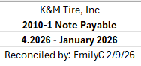

GL 2030 – Accrued Delivery Fees
Placeholder for future SOP

GL 2300 – Accounts Payable
The following steps 1-4 verify the General Ledger balance matches the AP Detail at end of previous month. We always expect these to match. If they don’t match, we should immediately research. See step 5 for possible causes.
- Open “2300 Reconciliation” excel spreadsheet at F:\Accounting\Shared\General Ledger\Balance Sheet Reconciliations YYYY\2300\2300 Reconciliation
- Need two tabs “Month YYYY Summary” and “Month YYYY GL Balance” if not a tab for the month you are reconciling, right click and select move or copy, then copy, rename the tab to current month.
  - Pull GL balance from Intranet
    - Intranet
    - Scroll to Accounting
    - Select GL Account Activity
    - Make sure that Tab “Account Balance” is selected at the top
    - Select the Fiscal Period reconciling
    - Select Account “2300 Accounts Payable”
    - Select Location/Div “K&M Only (R60)”
    - Click Run Report
    - Add the GL balance to tab “Month YYYY Summary” where it says GL balance under column B
    - Click Excel to convert the report to an excel file
    - Remove or add any locations that are on the reconciliation sheet and not the report
    - Copy and paste the report on the “Month YYYY GL Balance” tab
- Go to Month YYYY Summary tab in column B cell beside location 1 do = click ‘Month YYYY GL Balance’ and select the total beside location 1.
    - 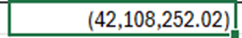Double click the box in the right-hand corner to copy the formula down
- Column C go to F: Accounting\Shared\Monthly Reports\YYYY\Month YYYY reconciling\AP Aging\AP Aging MM.DD.YY
    - The total due at the very bottom of the report furthest column to the right goes in column C.
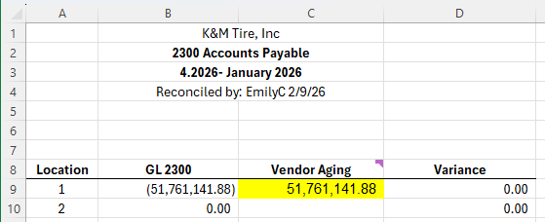
- Verify the GL balance in column B matches the AP Vendor Aging in column C.
  - We always expect these amounts to match to the penny
  - If they do not match, notify controller and research.
    - Begin by going into the General Ledger detail and looking for any items that may have posted into the General Ledger AP account after last day of month.
    - Once identified, Controller should determine if it is something that will reverse out the next month, or if it needs to be manually corrected.

GL 2320 Purchase Pending
GL Purpose: When we receive tires through receiver, GL entry is to debit inventory 1300 and credit 2320 purchase pending. When the invoice comes in and we match it to the receiver and enter the invoice into MaddenCo for payment, entry is to credit AP 2300 and debit 2320 purchase pending to enter the invoice and relieve the receiver. This is our AP receiver wash account. When matching AP invoice and receiver, any invoice differences are posted to G/L 4080 Invoice Differences.
Reconciliation: We reconcile GL to an excel workpaper which is summary of MaddenCo screenshots of each individual location's pending invoices
This needs done first thing in the morning on the first of the month. Accounts payable will not be able to process invoices until the 2320 is completed. Once this is completed, we will send an email to AP, NAB, and AP & AR manager.
F:\Accounting\Shared\General Ledger\Balance Sheet Reconciliations 2026\2320
- Open the “2320 Month FY20XX”
- Run a GL Account Balance for 2320, leave the location and department blank with “Y” selected for YTD Results, click run report.
- Export the report from Account balance to excel and copy the YTD values and paste them in column C. Next make the GL balances positive from negative.
- In Maddenco follow these steps
  - 2 for accounts payable - enter.
  - 2 for Invoice Input & update menu – enter
  - 1 for input vendor invoices - Enter
- Once here you will enter a store number, which will get you to this screen below. Every location will look the exact same but the invoices and amounts will vary per location
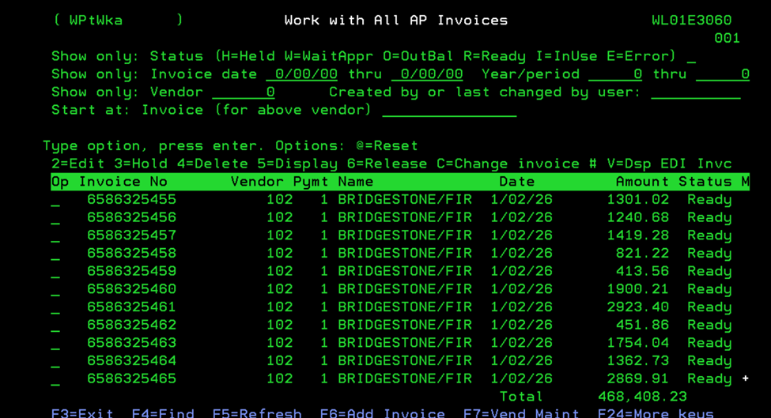

- From here we will look for any vendor number “111” Name – Postal service and place a “C” on the line next to that invoice number. Once the C is placed hit enter and update the vendor number to 1110. Enter again and that vendor should now be updated.
- Now we will place a “2” on every line for that location and hit enter. The screen should then look like below.
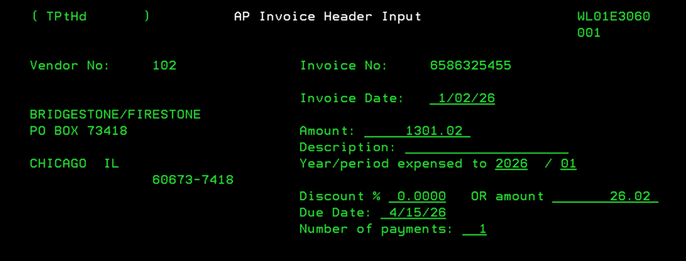

- We will then have to update the year/period expensed to, to the current calendar year and month we are in.
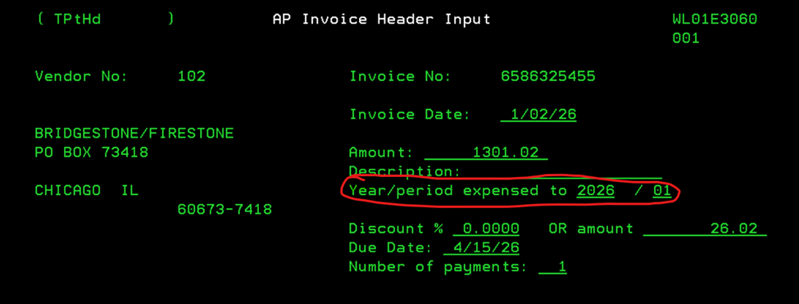

- Once that is completed, we will hit enter then press F3. This should now bring you to the next invoice for that location. You will repeat this process until all invoices are updated to the correct period.
- After everything is updated for that location, a 3 will need to be placed next to every invoice. This will place all items on hold for AP.
- Now we will take a snippet of the entire page and paste it into the “Month YR support” spreadsheet.
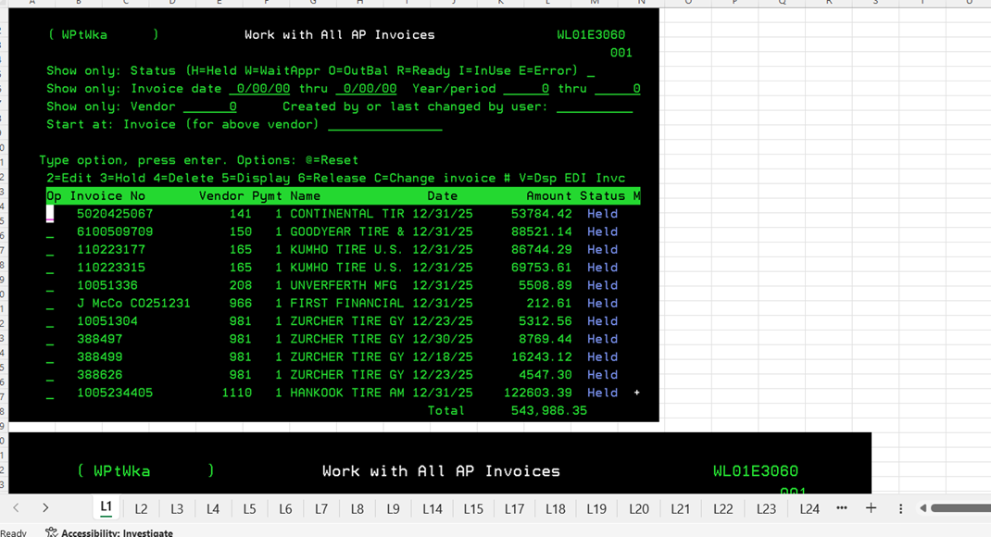

- After this step we will now take the total from Maddenco for that location and make that value negative when we add it to the “2320 month YR” spreadsheet in column D.
- This same process will be completed for every location we have. After all locations are added and all values are added to the “2320 Month Year” spreadsheet column B, C, D should all have totals at the bottom of the page. Column B shows the variance total among all locations
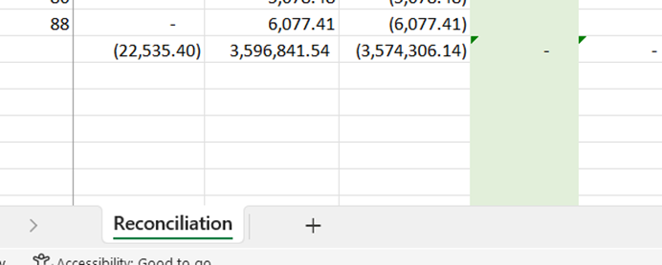
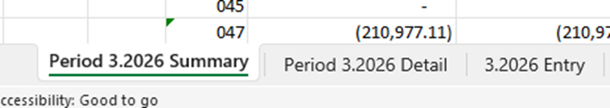
- Once these items are completed for every location we will open the “2320” spreadsheet. This spreadsheet will have an entry, detail, and summary tab.
- We will create a copy of the summary and entry tab and update the period and dates to the current month we are reconciling.
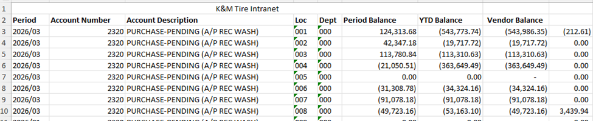
- The detail tab comes from when we run the “account balance” for the 2320 and export this to excel. Nothing is to be changed or deleted from the export. We will add “vendor balance” in column H and a formula in column I to get the different from out YTD and Vendor balances.

- Add a formula to sum column G, H, and I at the bottom of the detail sheet. You can compare these values to the “2320 Month Year” Spreadsheet all should match with Column C being the opposite of what is on the detail tab. That is okay if they are the same number.
- After all this is completed, we will now copy the detail sheet Column A-H and paste these values into the 2320 entry tab. It should now look like this.
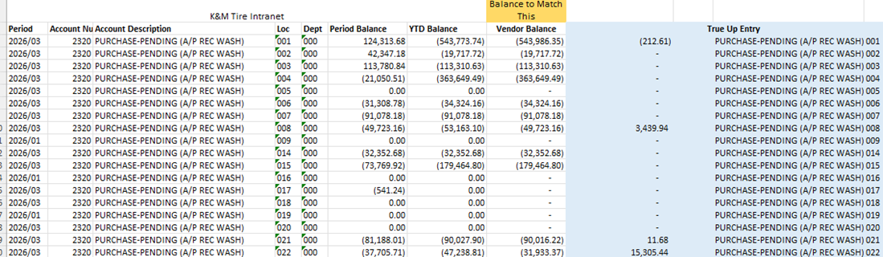

- The values in the blue column are what we will need to make our journal entry in Maddenco. If the value is negative then it is a credit. The variance to balance this entry will be posted the the 4080-1-1 This entry will always be posted back to the month we are reconciling.
- After the entry is posted we can now go to the summary tab on the 2320 run a GL account balance for the 2320 again for the period reconciling. We will take those values and paste them into column G on the summary tab. Next we will take the vendor balances from the detail tab column H and paste them in column F on the summary tab.
- Once both are added column H will show if there is any variance. If there is check your entry or if any amount was missed on the Entry tab. There should be no variance among the locations after the entry was made.

GL 2370 – Inventory Value Overstated
Purpose: This account is used to record the difference between K&M's lower net inventory cost after quarterly discounts and YE volume bonuses, and K&M's higher artificial invoice cost as listed in MaddenCo which does not reflect these discounts. VP of Purchasing calculates this amount the first week of October each year, based on the 9.30.XX MaddenCo Physical Inventory Report, by listing all vendor discounts by brand beside each inventory line, and subtracting them out. Any entry is made each year in Period 13, to apply this overstated balance against inventory which zero's out this account and nets the inventory down to net-cost, with any difference being posted to GL 4080-1-1 Invoice Differences. This entry is reversed in P1 the following year.
Reconciliation: This GL ties out to zero as of 9.30.XX. Every other period it ties out the most recent calculation performed by VP of Purchasing and approved by President or CFO. This is typically only calculated at Y/E, but may be updated at other points throughout year when warranted. An example of interim update was when we updated this to record a large invoice increase due to acquisition.
First go to F:\Accounting\Shared\General Ledger\Balance Sheet Reconciliations 2026\2370\2370 Reconciliation.xlsx
- "Create a copy" of the previous month’s summary tab
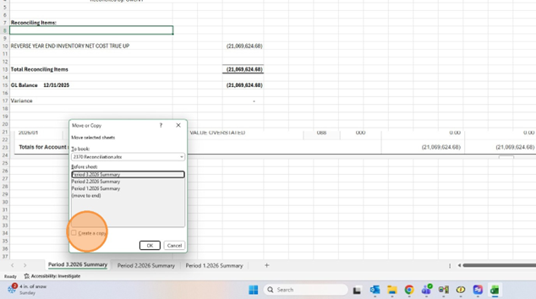
- Update the period and dates on the new tab
- In either MaddenCo or Intranet, go into General Ledger inquiry and verify the G/L balance has not changed from October 1st to present, and from prior period to present.
  - The balance in G/L 2370 in October should generally be carried throughout the year without change
    - Exceptions to this might arise from an acquisition, or other large swings in Inventory where President & CFO determine balance should be recalculated and updated.
  - If performing these steps in Intranet, go to the Intranet and select AC – GL Account activity. Select the period you are reconciling. Select G/L 2370, Select K&M Only (R60), & run report.
  - Take a screenshot of the balance and insert it into your excel tab for current month.
- If there were no changes, notate on the GL reconciliation tracker that the account was verified and no further action is necessary.

GL 2400 – FICA Payable ER
(balance in the GL should be zero and items should only be in location 1)
- To reconcile Monthly:
  - In the MaddenCo G/L Inquiry menu, open Trial Balance Inquiry (Option 3) for “000” all stores, and start at G/L 2400-0-0.
    - verify no G/L 2400 accounts have balances. If they have zero ending balances as we would expect, they will not appear
    - If you prefer to look specifically at G/L 2400-1-0, perform a MaddenCo general ledger balance inquiry (option 1) for G/L 2400-1-0 and that account with Zero balance will appear.
    - notate the account was verified on the reconciliation tracker and no further action is necessary.
  - If a balance is discovered, investigate reason and see if it was a posting in error which needs to be reclassed, or a timing difference that washed out the first week of the current month.

GL 2450 – 401K W/H
(balance in the GL should be zero and items should only be in location 1)
- To reconcile Monthly:
  - In the MaddenCo G/L Inquiry menu, open Trial Balance Inquiry (Option 3) for “000” all stores, and start at G/L 2450-0-0.
    - verify no G/L 2450 accounts have balances. If they have zero ending balances as we would expect, they will not appear
    - If you prefer to look specifically at G/L 2450-1-0, perform a MaddenCo general ledger balance inquiry (option 1) for G/L 2450-1-0 and that account with Zero balance will appear.
    - notate the account was verified on the reconciliation tracker and no further action is necessary.
  - If a balance is discovered, investigate reason and see if it was a posting in error which needs to be reclassed, or a timing difference that washed out the first week of the current month.
    - Document reason for balance and corrective action by following steps
If unexpected balance found
- Open “2450 Reconciliation” excel spreadsheet at F:\Accounting\Shared\General Ledger\Balance Sheet Reconciliations YYYY\2450\2450-1 Reconciliation
- Need two tabs “Month YYYY Summary” and “Month YYYY Detail” if not a tab for the month you are reconciling, right click and select move or copy, then copy, rename the tab to current month.
  - Pull GL balance from Intranet
    - Intranet
    - Scroll to Accounting
    - Select GL Account Activity
    - Make sure that Tab “Account Balance” is selected at the top
    - Select the Fiscal Period reconciling
    - Select Account “2450 401K W/H”
    - Select Location/Div “K&M Only (R60)”
    - Click Run Report
    - Add the GL balance to tab “Month YYYY Summary” where it says GL balance and change the date to the last day of the month you are reconciling
    - Click the account activity tab at the top on Intranet and click run report
    - Click Excel to convert the report to an excel file
    - Copy and paste the report on the “Month YYYY Detail” tab
- In “Month YYYY Detail” tab auto sum the total of column H
- Put the total of the auto sum from tab “Monthly YYYY detail” beside reconciling items on tab “Month YYYY Summary”
- Research and note the reason the balance in this G/L was not zero.
  - Include corrective action needed
  - Communicate issue and proposed correction with Controller, and get approval and alignment before making corrective entry.
- Make sure all the Months and dates are for the month you are reconciling on the below snip it.
    - Change the MM/YYYY to what fiscal period you are reconciling.
    - Change the month and year to current one reconciling.
    - In reconciled by put your name and date you reconciled.
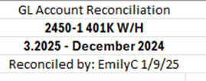

GL 2455 – 401K Employer Match
(balance in the GL should be zero and items should only be in location 1)
- To reconcile Monthly:
  - In the MaddenCo G/L Inquiry menu, open Trial Balance Inquiry (Option 3) for “000” all stores, and start at G/L 2455-0-0.
    - verify no G/L 2455 accounts have balances. If they have zero ending balances as we would expect, they will not appear
    - If you prefer to look specifically at G/L 2455-1-0, perform a MaddenCo general ledger balance inquiry (option 1) for G/L 2455-1-0 and that account with Zero balance will appear.
    - notate the account was verified on the reconciliation tracker and no further action is necessary.
  - If a balance is discovered, investigate reason and see if it was a posting in error which needs to be reclassed, or a timing difference that washed out the first week of the current month.
    - Document reason for balance and corrective action taken on the 2455 reconciation found at:
      - F:\Accounting\Shared\General Ledger\Balance Sheet Reconciliations YYYY\2455\2455 Reconciliation

GL 2460 – HSA
Placeholder for pending SOP

GL 2470 – Child Support W/H
(GL should have a zero balance)
- To reconcile Monthly:
  - In the MaddenCo G/L Inquiry menu, open Trial Balance Inquiry (Option 3) for “000” all stores and start at G/L 2470-0-0.
    - verify no G/L 2470 accounts have balances. If they have zero ending balances as we would expect, they will not appear
    - If you prefer to look specifically at G/L 2470-1-0, perform a MaddenCo general ledger balance inquiry (option 1) for G/L 2470-1-0 and that account with Zero balance will appear.
    - notate the account was verified on the reconciliation tracker and no further action is necessary.
  - If a balance is discovered, investigate reason and see if it was a posting in error which needs to be reclassed, or a timing difference that washed out the first week of the current month.
    - Document reason for balance and corrective action taken on the 2470 reconciliation found at:
      - F:\Accounting\Shared\General Ledger\Balance Sheet Reconciliations YYYY\2470\2470 Reconciliation

GL 2480 – Garnishment/Bankruptcy W/H
(GL should have a zero balance)
- To reconcile Monthly:
  - In the MaddenCo G/L Inquiry menu, open Trial Balance Inquiry (Option 3) for “000” all stores and start at G/L 2480-0-0.
    - verify no G/L 2480 accounts have balances. If they have zero ending balances as we would expect, they will not appear
    - If you prefer to look specifically at G/L 2480-1-0, perform a MaddenCo general ledger balance inquiry (option 1) for G/L 2480-1-0 and that account with Zero balance will appear.
    - notate the account was verified on the reconciliation tracker and no further action is necessary.
  - If a balance is discovered, investigate reason and see if it was a posting in error which needs to be reclassed, or a timing difference that washed out the first week of the current month.
    - Document reason for balance and corrective action taken on the 2480 reconciliation found at:
      - F:\Accounting\Shared\General Ledger\Balance Sheet Reconciliations YYYY\2480\2480 Reconciliation

General Ledger Account 2490 Union Dues
GL 2490 is used to record Employee Payroll withholdings and EE payments to Unions for location 33 and 42. Generally, the withholding and the payment will both be posted to this G/L in the same month. The payroll withholding is typically from the last payroll of the previous month, and posts the first week of the following month when it clears. The submission of this W/H to the union happens closer to the 20th of the month.
F:\Accounting\Shared\General Ledger\Balance Sheet Reconciliations 2026\2490
- Create a copy of both the detail and summary tab from previous month. Update the tab names to the current month/year reconciling.
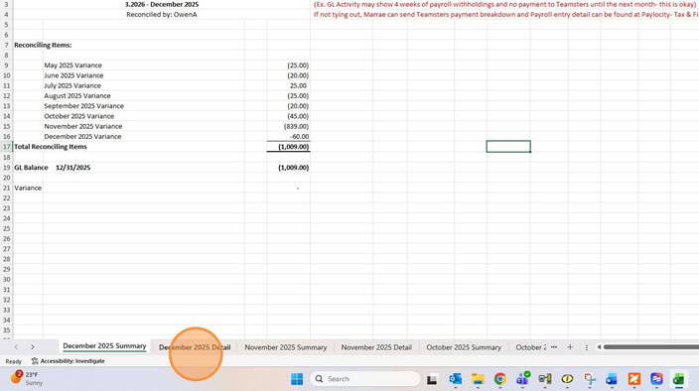
- On the Summary tab update all the dates from prior month to current month/period reconciling
- Next run an account balance for the 2490-33 with period reconciling selected.
- Click "2490 - UNION DUES"
- Click "033 - PORTAGE" then click run report
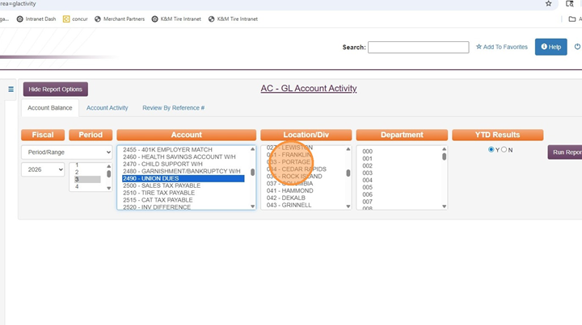
- Once ran update the total GL Balance with the total from the Intranet
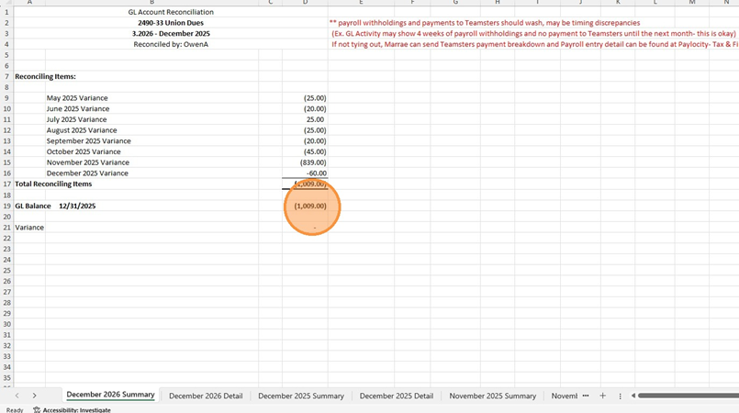
- Click "Account Activity" and click "Run Report" again. This will give us the detail that makes up the change in balance from prior vs current month.
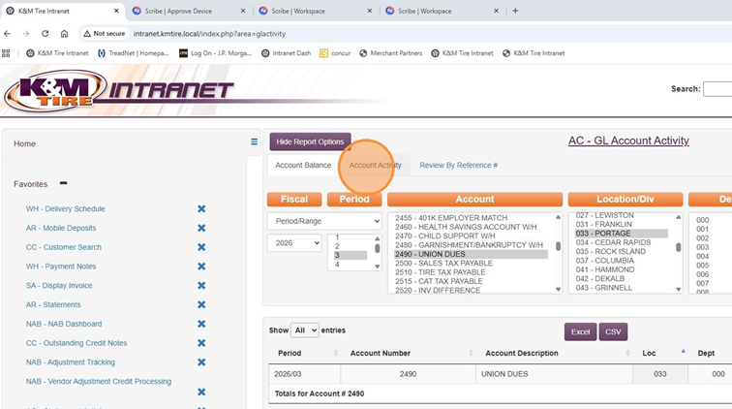

- Once this is ran export the detail to excel and click enable editing.

- Next delete columns from D-F
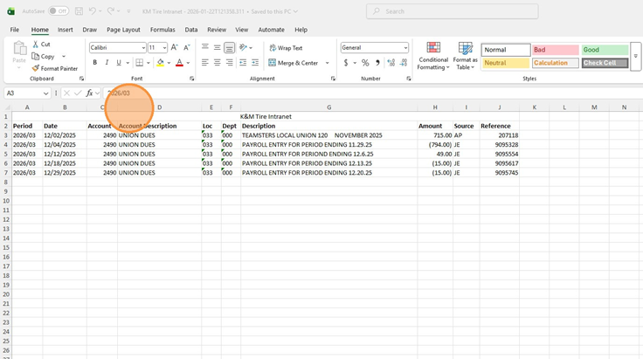
- Next copy all the detail and paste it in the 2490 Reconciliation detail tab for the current month reconciling below the previous month detail.
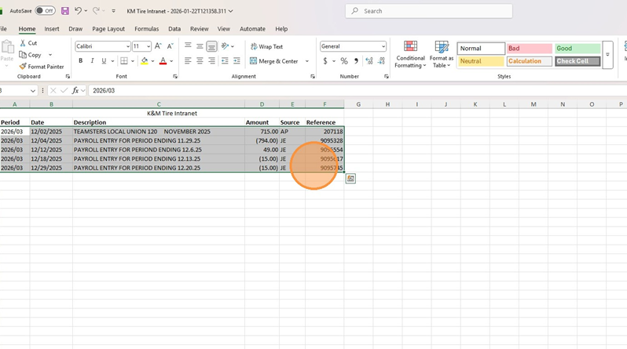

- Next copy anything that has to do with the previous month payroll and move it above to the prior month rows so the total reflects the entire month.
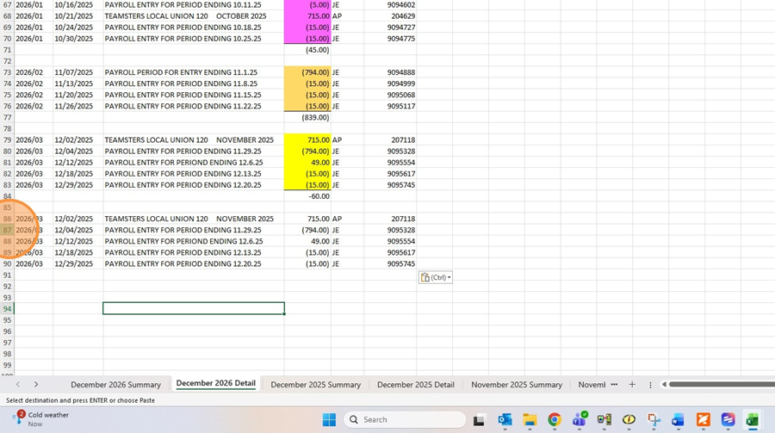
- After that is complete, we will need a formula to sum up the total for the current month.
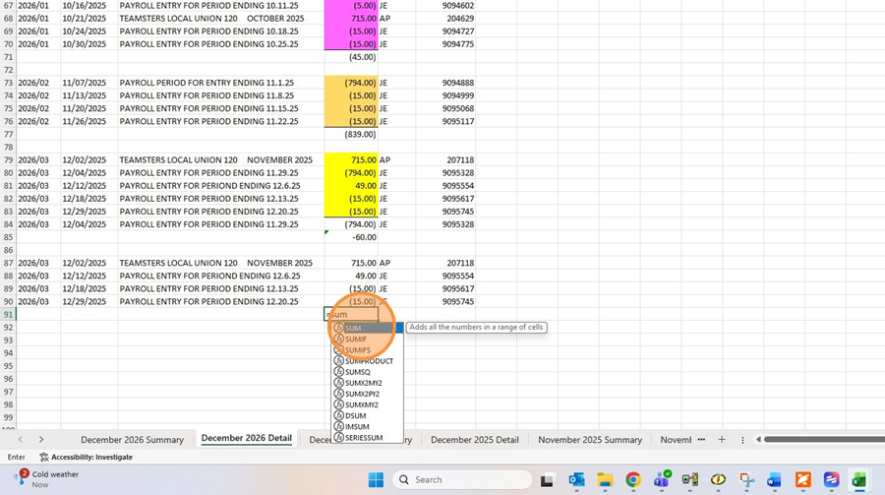

- Once that is complete, on the summary tab we will need to add a row to add in the new months total, with all the previous totals. This should add up to the same balance that the intranet total gave us. There should be no variance
This will be the same process for the 2490-42
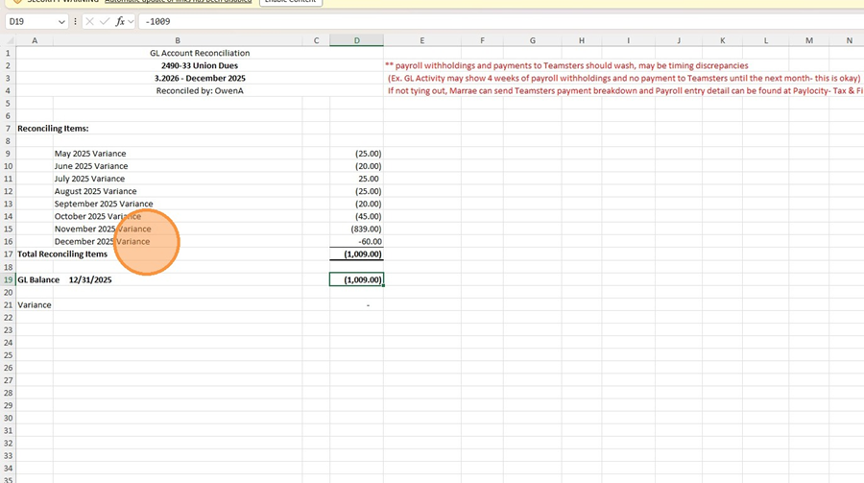

To reconcile at year-end
Match up Sept withholdings against Sept payments. If there are any remaining balances or amounts not cleared from prior periods, research and correct as necessary.
- Match up the September withholdings against September payments
- If there are any remaining balances or amounts not cleared from prior periods, research, present findings to controller, and correct as necessary
- Save reconciliation under following file path
F:\Accounting\Shared\General Ledger\Balance Sheet Reconciliations 2026\2490

General Ledger Account 2500 Sales Tax Payable
(needs to be done after sales tax has been filed for the month reconciling)
- Open “2500” excel spreadsheet at F:\Accounting\Shared\General Ledger\Balance Sheet Reconciliations YYYY\2500\MM.YYYY Sales Tax Calculator you are reconciling
- Click on the Period MM.YYYY Summary tab
  - Pull GL balance from Intranet
    - Intranet
    - Scroll to Accounting
    - Select GL Account Activity
    - Make sure that Tab “Account Balance” is selected at the top
    - Select the Fiscal Period reconciling
    - Select Account “2500 Sales Tax Payable”
    - Select Location/Div “K&M Only (R60)”
    - Click Run Report
    - Add the GL balance to tab “Period MM.YYYY Summary” where it says GL balance and change the date to the last day of the month you are reconciling
- All the totals for each state should be updated with the new totals when the tax tab is updated, calculating sales tax.
    - If there is a variance check the Quarterly states, you may have to add in previous months total because the portion it is pulling from on the tax tab is only for the month reconciling. (Ex of quarterly months New York, Maine, and Connecticut)
    - If there is still a variance investigate
- Make sure all the Months and dates are for the month you are reconciling on the below snip it.
    - Change the MM/YYYY to what fiscal period you are reconciling.
    - Change the month and year to current one reconciling.
    - In reconciled by put your name and date you reconciled.
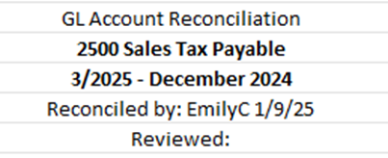
To Reconcile at Year-End
- Verify all amounts in G/L at September 30th that are accrued by State match what was remitted and paid to each state in October.

General Ledger Account 2510 Tire Tax Payable
To Reconcile Monthly
- Open “2510” excel spreadsheet at F:\Accounting\Shared\General Ledger\Balance Sheet Reconciliations YYYY\2510\2510 Reconciliation
- Need two tabs “Period MM.YYYY Summary” and “Period MM.YYYY Detail” if not a tab for the month you are reconciling, right click and select move or copy, then copy, rename the tab to period reconciling.
  - Pull GL balance from Intranet
    - Intranet
    - Scroll to Accounting
    - Select GL Account Activity
    - Make sure that Tab “Account Balance” is selected at the top
    - Select the Fiscal Period reconciling
    - Select Account “2510 Tire Tax Payable”
    - Select Location/Div “K&M Only (R60)”
    - Click Run Report
    - Add the GL balance to tab “Period MM.YYYY Summary” where it says GL balance and change the date to the last day of the month you are reconciling
    - Click Excel to convert the report to an excel file
    - Remove any rows with a zero amount in the YTD column
    - Copy and paste the report on the “Period MM.YYYY Detail” tab
- On the Period MM.YYYY Summary tab put all the necessary information
    - In column E cell beside the state do = click Period MM.YYYY Detail tab and select all the locations YTD total in that state and hit enter(Ex. Ohio would be location 1,2,3, and 15 YTD totals)
    - Repeat that step for every state
- Check the variance should be zero. If there is a variance investigate.
- Make sure all the Months and dates are for the month you are reconciling on the below snip it.
    - Change the MM/YYYY to what fiscal period you are reconciling.
    - Change the month and year to current one reconciling.
    - In reconciled by put your name and date you reconciled.
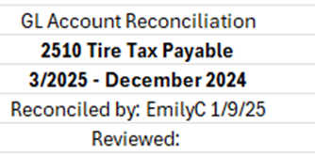
To Reconcile at Year-End
- Verify all amounts in G/L at September 30th that are accrued by State match what was remitted and paid to each state in October.

General Ledger Account 2515-1-1 CAT Tax
Ohio’s Commercial Activity Tax is paid quarterly and is due approximately 40 days after the closing of the quarter, however the filing and payment can be completed anytime after the quarter closes, up to that due date.
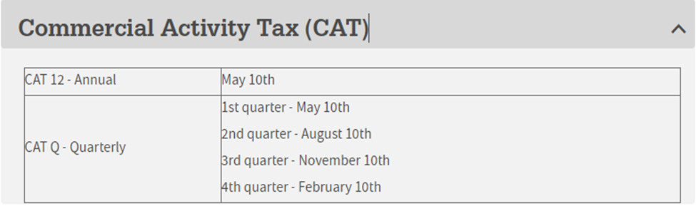
F:\Accounting\Shared\General Ledger\Balance Sheet Reconciliations YYYY\2515-1-1
- Open the CAT tax reconciliation workbook and copy the previous quarters summary tab and rename to the current quarter
- Update the Monthly Accrued Tax formula for the number of fiscal months (5 for February). If the monthly recurring entry ever changes you will also need to update the dollar amount.
- Leave the prior quarters payment amount listed since this calculation is based off of the fiscal year but the actual payments are based off of calendar year.
- Run a GL account Balance from the intranet and insert as a new tab titled Q # (month – Month) 20XX GL.
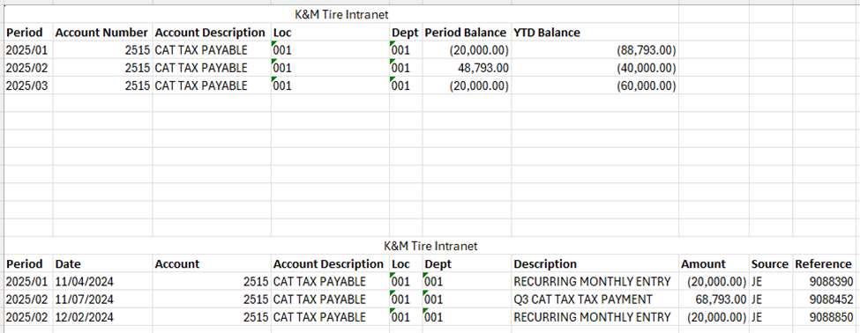
  - Paste each month of the quarter GL information on this tab

- Update the GL account balance on the summary tab to reflect the most recent balance
- Update all dates and clear Reviewed information
- To find the Taxable Gross Receipts run a Sales Summary Report using the below:
  - Tire Dealer System
  - Sales Menu
  - Monthly Sales Reports
  - Sales Summary
  - Store = R60
  - Year Period = 3 months for the quarter needed
  - Selections = CC & ST
  - Print Total Page? = Yes
  - Customer State = 34
  - Enter 3 times
  - A for Actual Cost
  - Place report on hold
- Save the CAT Worksheet as the year and quarter filing for
- Enter Total Sales amount from the Sales Summary Report in the Taxable Gross Receipts box (box 1)
  - All other amounts should autofill
  - When filing Q3, verify with Controller status of Job Creation Credit. If we qualify,
    - Complete credit schedule
    - Scan and Upload when filing both credit schedule and certificate for credit
- Login to OH Business Gateway to file and pay F:\Accounting\Shared\Tax\Sales, Use & Tire Tax\Sales and Estimate Logins.xlsx
  - Fill in account year, filing period, return type, and submit as (actual)
  - Total Taxable Gross Receipts = box 1 from excel
- Make entry to MaddenCo
  - Debit 2515-1-1 and Credit 1017-1
Input the Maddenco entry information on K&M Inc 1017 PNC spreadsheet.
**The following are placeholders for future SOPs **

General Ledger Account 2620 Accrued State & City Income Tax

General Ledger Account 2640 Accrued State & City Income Tax

General Ledger Account 2660 Accrued Property Tax

See property tax procedure for the process with the 2660 rec.

General Ledger Account 2710 Accrued Salaries

General Ledger Account 2740 Accrued Dividends

General Ledger Account 2750 Accrued PTO

General Ledger Account 2810 Federal & FICA W/H EE
(GL should have a zero balance)
- To reconcile Monthly:
  - In the MaddenCo G/L Inquiry menu, open Trial Balance Inquiry (Option 3) for “000” all stores and start at G/L 2810-0-0.
    - verify no G/L 2810 accounts have balances. If they have zero ending balances as we would expect, they will not appear
    - If you prefer to look specifically at G/L 2810-1-0, perform a MaddenCo general ledger balance inquiry (option 1) for G/L 2810-1-0 and that account with Zero balance will appear.
    - notate the account was verified on the reconciliation tracker and no further action is necessary.
  - If a balance is discovered, investigate reason and see if it was a posting in error which needs to be reclassed, or a timing difference that washed out the first week of the current month.
    - Document reason for balance and corrective action taken on the 2810 reconciliation found at:
      - F:\Accounting\Shared\General Ledger\Balance Sheet Reconciliations YYYY\2810\2810 Reconciliation

General Ledger Account 2860 United Way
Purpose: Payroll deduction withheld from employees weekly per signed payroll deduction form, and then paid to United Way quarterly. When K&M pays this to United Way, K&M matches what EE's contribute, doubling the contribution. K&M's portion of the contribution is posted as a charitable contribution, while remittance of the EE's portion is posted here washing out the amount withheld.

- Open “2860 Reconciliation” excel spreadsheet at F:\Accounting\Shared\General Ledger\Balance Sheet Reconciliations YYYY\2860\ 2860 Reconciliation 2025
- Start at tab “Month YYYY Summary” if not a tab for the month you are reconciling, right click and select move or copy, then copy, rename the tab to current month.
  - Pull GL balance from Intranet
    - Intranet
    - Scroll to Accounting
    - Select GL Account Activity
    - Make sure that Tab “Account Balance” is selected at the top
    - Select the Fiscal Period reconciling
    - Select Account “2860 United Way”
    - Select Location/Div “K&M Only (R60)”
    - Click Run Report
    - Should only be amounts in location 1
    - Put the YTD balance on the spreadsheet where it says GL Balance. Make sure the date beside the GL balance is the month you are reconciling
- Next put how much was withheld in the period your reconciling
    - To figure out the amount look at the period balance on the Intranet
    - Put that amount in the month line you are reconciling
    - When the three months are up you will have to rename the months to the next three months (ex. Jan-March, Apr-June, July-Sept., Oct-Dec)
- Check the variance. If there is a variance investigate.
- Make sure all the Months and dates are for the month you are reconciling on the below snip it.
    - Change the MM/YYYY to what fiscal period you are reconciling.
    - Change the month and year to current one reconciling.
    - In reconciled by put your name and date you reconciled.
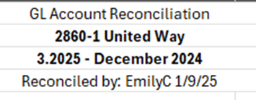
- Take a snip of the GL balance off the Intranet and paste it on the “Month YYYY Summary” tab under the summary.
To Reconcile Annually
- The year-end accrual at September 30th should be document in an excel WP, which shows July - Sept EE withholdings and is 50% of the amount paid to United Way in October.

GL 2950 - Capital Stock/Shares
Placeholder

GL - No Activity Reconciliations
Purpose here is to verify that there weren’t posting in error to an account that should have shown zero activity for the month.
- Open excel list of G/L accounts that should have Zero net activity each month
  - F:\Accounting\Shared\General Ledger\Balance Sheet Reconciliations 2026\No Activity GL Recs
    - Excel list to be created
- In MaddenCo, run a Trial balance report for the balance sheet period being reconciled
  - Go to: GL Start Menu
  - 4 Reports Menu
  - 2 Other Reports
  - 3 Trial Balance Report
  - Region is “R50” for all K&M locations
  - Sort by (1) GL account number
  - Enter period reconciling
  - Enter GL account range 1000 thru 29999 – this will pull entire balance sheet range
  - (N) Do not print consolidated
  - Do not Print. Place on Hold and email it to yourself.
- Scroll through report and review account that should have zero activity
  - There should be no postings in current period Debit/Credit columns
  - If there is a posting, research to see if it should be there or if it was done in error and should be corrected.

Miscellaneous GL Notes/Information

Direct Ship
- This is when product is shipped directly from the manufacturer to the customer.
- K&M is billed for the product. (Normally billed at our cost but not always)
  - Can bill the customer using the product # (Need to hit the F11 key when billing so the warehouse’s inventory is not changed)
  - Can use product # “DS”
- K&M bills the customer for the product. (Billed at customer’s cost)
- There is a difference left in the gl from K&M’s cost and the customer’s cost.
  - If the balance is a debit = loss.
    - (Shows as a negative (-) on the financial statement = EXPENSE)
  - If the balance is a credit = gain.
    - (Shows as a positive (+) on the financial statement sheet = INCOME)

End of Month Procedures- Day 1
The following standard operating procedures are to be completed monthly:
IF THE 1ST FALLS ON A SATURDAY OR SUNDAY – EMAIL OUT TO WAREHOUSE MANAGERS AND SUPERVISORS TO REFRAIN FROM RECEIVING IN RECEIVERS UNTIL MONDAY (WHEN AP CAN RECONCILE 2320 ACCOUNT)

Run Reports – make sure all updated
- Start between 3:30-5am the 1st day of the month.
  - Reports save to I-Navigator.
  - The following reports should be given to the Staff Accountants (will print automatically when the AR Supervisor releases the printer Day 1 of Close): A
    - AR Aging by store for Class 6 (Vendor Receivables)
    - AR Aging by store for Class 9 (Vendor Receivables)
    - Sales Summary – Store R060
    - Sales Summaries detailing sales sold in one location but delivered in another – from Intranet
- Put your printers on hold so the Service Charge doesn’t print. It is 500+ pages long.
  - Sign in to MaddenCo
  - Hit “Escape” then go under “Work with Printer Status” and find P273K0Z1 and PKONICA3. Put these printers on HOLD by placing a “3” in front of the printer line and enter.
  - F3 out of the Operations Window back to the main Starting Menu
- Service Charge Generation Process (DO NOT RUN MORE THAN ONCE)
  - This charges customers service charges on unpaid balance due in previous months
  - 1 Tire Dealer
  - 12 Update Menu
  - 3 SC Generation all stores (000)
    - Trans Date = last day of previous month (ex: 01/31/21 if today’s date is 02/01/21 – format of entering 013121 is acceptable)
    - Transaction Year/Period YRPR = last month (calendar year) (ex: 2021/01) <enter>
    - Due date = 10th of current month (ex: 02/10/21 if today’s date is 2/01/21 – format of entering 021021 is acceptable)
    - Next Screen, press (enter)

Closing Month | Trans Date | YRPR | Due Date
January | 1/31 | 20XX/01 | 2/10
February | 2/28 | 20XX/02 | 3/10
March | 3/31 | 20XX/03 | 4/10
April | 4/30 | 20XX/04 | 5/10
May | 5/31 | 20XX/05 | 6/10
June | 6/30 | 20XX/06 | 7/10
July | 7/31 | 20XX/07 | 8/10
August | 8/31 | 20XX/08 | 9/10
September | 9/30 | 20XX/09 | 10/10
October | 10/31 | 20XX/10 | 11/10
November | 11/30 | 20XX/11 | 12/10
December | 12/31 | 20XX/12 | 1/10
- Put Service Charge Report on Hold
  - Hit “Esc” and select “Display to be printed.”
  - Find the Service Charge Reports (PTARSRVG) on PKONICA3 – put a “3” in front of the file and hit enter.
  - Find the (TARUP) reports on P273K0Z1 printer (close to 33 total) to put on hold (could be in either printer but most of the time find on P273K0Z1). They should be at the top of the list when printer is on hold. Put a “3” in front of the files and hit enter.
    - If cannot locate P273K0Z1 go to “Work With Printer Status” and place an 8 “Work with output queue” on P273K0Z1. Scroll till you see TARUP and place all on hold.
  - DO NOT put TARUPBAL on hold. Do not take the P273K0Z1 off of hold – AR will release later. Work with printer status and you can release the PKONICA3 once both reports are on hold (Typically we just leave both on hold).
- A/R EOM Purge
  - Move paid invoices to history and only show unpaid invoices in Balance Inquiry and Cash Receipts
    - 1 Tire Dealer
    - 12 Update Menu
    - 6 A/R EOM Purge
    - all stores
    - all customers (enter past Customer Selection screen – 2x’s)
    - Purge date = last day of previous month (ex: 7/31/17 if today’s date is 8/01/17) – format 073117 format is acceptable to use
    - A = all customers (enter)
    - Next Screen (Enter)
- EOM A/R Aging Reports (set up under auto report)
  - 20 System Menu
  - 5 Auto Report Maintenance
  - 2 Run an Auto Report
  - Enter EOM AGING (or press F4 enter for a list and put a 1 in front of EOM AGING) (enter)
*To verify the report ran, Hit F3 to go back to one screen, pick option 1 to work with Auto Reports. Put a 2 on EOM Aging and it will show the last date the report ran.* (enter)
- (Emergency Cases Only-Manual Process) Instructions to Print if Necessary
  - 1 Tire Dealer System
  - 1 Accounts Receivable Menu
  - 10 A/R Report Menu
  - 3 Aging Report
  - 4 Extended One-Line Aging
  - Run Following Reports – All Stores (Sort by Customer #, Option 10) Vendor A/R
Loc # | Loc Name | Low | High
1 | Delphos | 100,000 | 139,999
2 | Toledo | 200,000 | 209,999
3 | Cleveland | 300,000 | 309,999
4 | Lincoln Park | 400,000 | 409,999
6 | Grandville | 600,000 | 609,999
7 | Cadillac | 700,000 | 709,999
8 | Kalamazoo | 800,000 | 819,999
14 | Chester | 140,000 | 149,999
15 | Columbus | 150,000 | 169,999
17 | Middletown | 170,000 | 179,999
18 | Hughesville | 180,000 | 209,999
20 | Beacon Falls | 2,000,000 | 2,099,999
21 | Rochester | 210,000 | 219,999
22 | Johnstown | 220,000 | 229,999
24 | Merrimack | 240,000 | 249,999
25 | Claremont | 250,000 | 269,999
27 | Lewiston | 270,000 | 309,999
31 | Franklin | 310,000 | 329,999
33 | Portage | 330,000 | 339,999
34 | Cedar Rapids | 340,000 | 349,999
35 | Rock Island | 350,000 | 369,999
37 | Columbia | 370,000 | 379,999
38 | Duluth | 380,000 | 409,999
41 | Hammond | 410,000 | 419,999
42 | Dekalb | 420,000 | 429,999
43 | Grinnell | 430,000 | 469,999
45 | Des Moines | 10,000 | 99,999
47 | Beresford | 470,000 | 479,999
48 | Tea | 480,000 | 489,999
49 | Rapid City | 490,000 | 499,999
51 | Minneapolis | 510,000 | 519,999
52 | Barnesville | 520,000 | 529,999
53 | Bismark | 530,000 | 549,999
55 | Omaha | 550,000 | 559,999
56 | Great Bend | 560,000 | 569,999
57 | Wichita | 570,000 | 579,999
59 | Lawrence | 590,000 | 599,999
60 | Carlsbad | 6,000,000 | 6,999,999
61 | Liberal | 610,000 | 639,999
64 | North Platte | 640,000 | 649,999
65 | Denver | 650,000 | 659,999
70 | Monroe | 7,000,000 | 7,999,999
71 | Fort Wayne | 710,000 | 719,999
72 | Sturgis | 720,000 | 729,999
73 | Indianapolis | 730,000 | 739,999
74 | Princeton | 740,000 | 749,999
75 | Watseka | 750,000 | 759,999
76 | Champaign | 760,000 | 769,999
77 | Vandalia | 770,000 | 799,999
80 | Mustang | 8,000,000 | 9,999,999
82 | Lubbock | 820,000 | 829,999
83 | Winters | 830,000 | 839,999
84 | Dallas | 840,000 | 859,999
86 | Houston | 860,000 | 879,999
88 | San Antonio | 880,000 | 889,999
N/A | Employee | 500,000 | 509,999
  - Send to Printer: P273K0Z1; On Hold: “N”
- A/R & Inventory Analysis – Run the Gather the Data Program
  - “Esc”
  - Page down until you see “K&M Tire Custom Menu” and select it with a 1
  - Menu Option #11
  - “Field Exit” – (+)
  - “Enter” – Only hit “enter” once – BE WATCHING – YOU SHOULD ONLY SEE A FLASH WHEN REPORT RUNS ‘OKAY’ (If didn’t run, red not authorized will display at the bottom)
  - F3 to exit
*Not necessary, but to check to see if the job is running:
  - “F3” back to the main window
  - Select “Work with batch jobs”
  - If “ARANDTA” is in the list, the program is running
To check to see if it is in the job queue:
  - Select “Work with jobs to be run”
To see if the job ran:
  - Select “Display Job Log”

- Statements on Intranet
  - “Esc”
  - Page down until you see “K&M Tire Custom Menu” and select it
  - Menu Option #12 “Statements”
  - “Field Exit” – (+)
  - “Enter” – Only hit “enter” once (BE WATCHING – YOU SHOULD ONLY SEE A FLASH WHEN THE REPORT RUNS ‘OKAY’
- To check to see if job is running:
  - “F3” back to the main window
  - Select “Work with batch jobs”
  - If “QDFTJOBD” is in the list, the program is running.
- To see if it is in the job queue:
  - Select “Work with Jobs to be Run”
- To see if the job ran: Select “Display Log”
- ONLY IF REQUESTED: To add or change the message on the statements:
  - Intranet
  - AR
  - Statements
  - Click on the button “Edit Message Line.”
  - For example, “Save a tree and have your statements e-mail to you. Simply log-in to Weblink 2.0 to go paperless.”
- Print receivers on hold (run the manual process below)
  - 1 Tire Dealer System
  - 3 Inventory Menu
  - 3 Inventory Receivers
Run one by one - Store # = 1, 2, 3, 4, 6, 7, 9, 15, 18, 20, 21, 22, 24, 27, 31, 33, 34, 35, 36, 37, 41, 42, 43, 17, 48, 49, 50, 51, 52, 53, 55, 57, 58, 59, 60, 61, 64, 65, 68, 70, 71, 72, 73, 74, 75, 76, 77, 80, 82, 83, 84, 86, 88
  - Print a report for each store individually by pressing enter, F9, on hold = Y. F3 to get to enter for next store
  - Print even if nothing on them.
  - Check I-Navigator to ensure reports ran (check under your username as well as user U273UPDATE (F11 to change users in I-Nav)
  - Copy and save the files to: F:/Accounting/Shared/MonthlyReports/year/month/create folder
named: Inventory – Intercompany Open Receivers.
(Copy and save (RTRcvReg) by using: System I Navigator)
  - After each report is saved on the F drive, you can delete reports off Maddenco Printer.
  - Email the warehouse managers and cc the ROM on any old receivers (15+ days old) so they can look into them and clean them up.
- Run EOM (only has 1 step – do not do unless you are ready)
Clears out the MTD sales in Balance Inquiry
  - 1 Tire Dealer System
  - 12 update menu
  - 7 End of Month
  - All Stores (enter)
- Run month auto reports - ► Have to be ran the first day of the month.
  - 20 System Menu
  - 5 Auto Report Maintenance
  - 2 Run an Auto Report (F4 to see list, hit enter)
    - MONTHLY (see bullet below for these three reports) <enter>
    - EOM REPORT (enter)
    - EOM CREDIT (enter)
    - COOP (enter)
    - VENDOR CR (enter)
- Email AR Manager, Team Lead, and AR email when ready – SUBJECT ‘STATEMENTS’ WITH BODY OF EMAIL THAT THEY ARE READY TO PRINT
  - The AR Supervisor will Release statements on PKONICA3 – AR responsibility – but here as a reference
  - Go to “Work with Printer Status”
  - Find PKONICA3 printer and put an 8 work with que, then Enter
  - Find “ARSTMT”
  - Put a 2 in front of the reports to Edit File Attributes
  - F10
  - Page down twice
  - Find “Source Drawer” and enter 3{Enter}
  - Enter a 6 to release the files
  - To change File Attributes on all files at once:
    - Tab to bottom line and enter:
    - Drawer (3) Save (*YES) Dev (PKONICA3)
- Change GL Control Keys (All Fiscal Year)
  - 3 General Ledger
  - 1 Maintenance
  - 1 Control File Maintenance
  - Type on the Start at YRPRHI (enter)
    - 2 on OPT line in front of the YRPRHI (Enter)
    - Change to current period (FY Period, Ex. if Jan 1st this will be changed to YYYY04) (Enter)
  - Go to YRPRLO
    - 2 on OPT line in front of the YRPRLO
    - Change to three periods prior to the current period (affiliate companies are on a calendar year) (Ex. if Jan 1st then change to YYYY01)
  - Also change individual users that make GL JE’s for YRPRLO to current fiscal month (Ex. if Jan 1st then change to YYYY04)
    - Start with whoever was changed last month
  - Ex. SHELIR, CREDIT USER, KATIER
  - If there are any new employees that make journal entries (AP, AR, C&C) then add:
    - F6
    - Control Key: YRPRLO +
    - User key: First name last initial (Ex. SAMANTHAB) + (Enter)
    - Data: YYYYMM (same as above users) + (Enter)
  - VALERIED or AP employee that does end of month reconciliations needs to be able to post to month closing (Ex. if Jan 1st then change to YYYY03)
  - Staff Accountants & GL Accounting Team should be left able to post in all months
- Change AP Control keys
  - 2 Accounts Payable
  - 1 Maintenance Menu
  - 1 Control File Maintenance
  - Type on the Start at YR (enter)
  - Change YRPRHI & YRPRLO to current month (actual month- Ex. if it is Jan 1st then the date should read YYYY01 for BOTH
    - *This limits postings from AP to one month to eliminate errors.
- Move the Service Charge report from Maddenco to the F Drive. (Want to make sure it gets moved and doesn’t print when they release the printer.)
  - File names: PTARSRVG, TARUP & TARUPBAL Drag from I-Series and put them in the appropriate month under Maddenco Reports under F:\Accounting\Shared\Monthly Reports\MONTH YEAR\SERVICE CHARGE (ANGIE)
  - Send these reports to Angie and Donna
  - If monthly file is open, can drag directly into the folder. (Ex. – Reports ran on 5/1 are filed in April)
    - (To find the Service Charge reports on the I-Series you need to change the user to U273XXXXX (username of person who ran beginning of month reports). To do hit F11 when you get to the “Printer Output” and type in U273Update in the users)
- Copy AR Aging, AP Aging as well as both Summary and Detail Inventory reports from System Navigator to appropriate folder on F:\ Drive:
  - AR Aging (under current user name) – Copy current month AR Aging files “RTAGOLRxxxxxxx” to new folder in the following location: F:\Accounting\Shared\Monthly Reports
  - AP Aging (under user U273UPDATE)– Copy current month AP Aging file “rPVIAgeR” to new folder in the following location: F:\Accounting\Shared\Monthly Reports
  - Summary and Detail Inventory Reports (under user U273UPDATE) – Copy current month “Rtpdcsv” files to new folders in the following location: F:\Accounting\Shared\Monthly Reports
  - If any of these reports are missing, you can run them manually the 1st day of the month and they should still be accurate as long as no updates were ran.
- Send Admin the Service Charge Reports
  - Report “PTARSRVG######” Service Charge Generation Register
  - Report “TARUPBAL######” Accounts Receivable Balance Register

- ONLY January 1st - In addition run these reports
  - Run the Tire Dealer System to close out sales for the year
    - 1 Tire Dealer System
    - 12 Update & EOM Menu
    - 15 End of the Year
    - All Stores
    - This option clears the YTD sales, discounts and service charges in the customer files; it sets the last year cost field to the current value of the actual cost in the product files; it clears the YTD units received field and the YTD cost of units field in the product file.
  - Run the year end for Accounts Payable
    - 2 Accounts Payable
    - 5 System Control Menu
    - 2 End of Year
    - This option moves YTD purchases to last year purchases and sets YTD purchases and discounts to zero. If you use 1099 processing, you have the option of choosing last years’ purchases or current year purchases.

- These reports run automatically the 1st day of the month under the auto report EOM. These are just procedures in case you need to reprint.
  - Inventory Reports
    - Run cost value for each store 1, 2, 3, 4, 6, 7, 9, 15, 18, 20, 21, 22, 24, 27, 31, 33, 34, 35, 36, 37, 41, 42, 43, 17, 48, 49, 50, 51, 52, 53, 55, 57, 58, 59, 60, 61, 64, 65, 68, 70, 71, 72, 73, 74, 75, 76, 77, 80, 82, 83, 84, 86, 88
    - 1 Tire Dealer System
    - 3 Inventory Menu
    - 7 Inventory Reports
    - 3 Cost/Value report
    - Enter Store #
    - Sort order 03: class/size
    - “U” = As of Last Night
    - All Product
    - Print Totals Only = Y (for condensed) / N (for detail)
    - Print to P273K0Z1 (this is zero)
    - If Detail – On Hold: “Y”
    - If Summary – On Hold: “Y”
  - A/P Aging (set up under auto report: EOM Aging)
    - 2 A/P
    - 4 reports
    - 6 vendor aging
    - Sort 02 vendor name
    - Dates 15th of next month following month etc.
    - Suppress = Y
    - Cut off = 1 year
    - Print = B

Saving Reports
- Multiple reports run automatically or as part of the Monthly Procedures (4:30 am on the 1st procedures). Save to F:\Accounting\Shared\Month End\Monthly Reports\YYYY. If ran automatically they will be in I-Nav U273Update (shift F11 to switch users)
  - The following reports are needed by the Staff Accountants (will print automatically in early AM on first day of month closing):
    - AR Aging by store for Class 6 (Vendor Receivables)
    - AR Aging by store for Class 9 (Vendor Receivables)
    - Sales Summary – Store R60

Correct GP
- Correct GP for K&M Tire Inc. (When a credit reason is used at the time credit is issued to the customer, it doesn’t post correctly to GL.) DO NOT DO THIS STEP FOR LOC 50 or 9.
- Run query sls.ntlact
  - ESC to get to the Operations Window
  - Place a 1 on Query
  - Beside Option place a 2 to Change
  - Beside Query type sls.ntlact and Enter
  - Place a 1 beside Select Records to change the date range to the ending month
  - F3 to the Exit this Quary screen
  - Enter
    - Go to F:\Accounting\Shared\Month End
    - Click on the National Account Download – Hit “Transfer data from System i” (This downloads the report to National Acct Credits.xls
    - 
    - Click “Open File” National Acct Credits.xls and sort by invoice #.
  - Check the date and make sure the date range on the query was changed. This may take some time. Make sure column ‘C’ has current period dates.
- Open previous months file: F:\Accounting\Shared\Month End\EOM Entries YYYY\ Report to correct GP \Report to correct GP Pivot – YYYY.MM and save copy as current month
  - In Sheet “National Acct Credits” Copy and paste columns A through L from current month downloaded file into new current month spreadsheet
  - Go to sheet “Pivot” right click and refresh, check totals
- Open File: Accounting/Shared/Month End/EOM Entries YYYY/Report to correct GP.xls
  - Create new tab copy for current month adjustment
  - Copy columns from “Report to correct GP Pivot – date” to “2026 Report to Correct GP” as noted
- Make the calculated entry to general ledger in the previous month. (remember GL period is off 3 months since the fiscal year starts in Oct) “EOM AJE to Correct GP”
  - Update the entry
- After the GL is updated compare the current month gross profit on the income statement (3, 4, 1, 4, Year & period income statement, INC30, xxxx,FP, Y to place on hold, enter, enter; bring up on screen to compare) to the gross profit by location on the R60 sales summary (Should be automatically printed out and on AR printer with first of the month reports) If the difference is less than $1,000 it is okay to leave as is – excluding loc 50.

Correcting Sales & Cost of Goods Sold (COGS) for Sold Transfers
This step is necessary to reclassify product billed out of one location and delivered by another.
Important: If new locations have been added or route changes have occurred, check with Logistics to confirm updates before proceeding. Any changes made in the system take effect immediately and apply retroactively. For example, a change made on March 25th will affect the entire month, potentially impacting reported figures.
- Steps to Correct Sales and COGS
  - Open the K&M Intranet: http://intranet.kmtire.local/
  - Navigate to "Accounting" → "Correct Sales and Cost of Goods Sold (COGS)"
  - Select the Year/Period using the calendar and click "Run Report"
  - Click "Export Report Data to Excel"
- Save and Review the Data
  - Save the exported file as a new tab in F:\Accounting\Shared\Month End\EOM Entries 2026\2026 EOM Correct 3010 and 4010.xlsx (Rename it for the current month.)
  - Compare the new data with the previous month’s file in the same location.
  - Identify any significant discrepancies (unexpected increases or decreases).
  - If everything looks correct, select "Create Journal Entry" on the intranet.
- Create the Journal Entry in MaddenCo
  - Open MaddenCo Tire Dealer System
  - Navigate to:
    - 3 – General Ledger
    - 2 – Input & Update Menu
    - 10 – Create Journal for Journal Upload
    - Press F2 to generate a Reference #
    - Enter the GL Year/Period (GL period is offset by 3 months. Example: If processing on March 1st, enter YYYY06.)
    - Enter the Description:
    - “EOM AJE to Correct Sales and COGS”
    - Use “JEUPLOAD” as the File Name to Post
    - Press Enter
- Final Review & Posting
  - The entry will be placed on Hold.
  - Review the entry by entering 2 on the line.
  - If correct, post manually.
  - Note: These journal entries will cause a variance for Profit between the
  - Sales Summaries and the Income Statement.

The following is an example of how to run a sales summary if it does not run with the auto reports – Sales summary for product billed out of Loc 4 but delivered in Loc 6 route codes 6A-6Z. You would need to do this for each location that sells out of there store to other location customers. This should never be necessary, but it helps the user understand the report parameters used to generate the correcting Sales & COGS entry.
  - 1=Tire Dealer System
  - 2=Sales Menu
  - 2=Monthly Sales Report
  - 1=Sales Summary
  - Store # = 4
  - Calendar Year/Period = Month Reconciling
  - Enter Route Codes = lo 6A / hi 6Z
  - Actual Cost = A
  - Open the following Excel file “2017 EOM Correct 3010 and 4010” located in F:\Accounts Payable\Shared\General Ledger\K&M\2017
  - Copy the “Blank” tab and rename for month reconciling
  - Enter the sales and profit from the respective sales summaries into the spreadsheet
  - Make the entries for sales for each store number as follows:
  - 3000-“Store #”
  - CR 3010-“Loc # of Route Code Delivered to”
  - Journal Entry Description – “Entry to Correct Sales & COGS”
  - Make the entries for COGS for each store number as follows:
  - DB 4010-“Loc # of Route Code Delivered to”
  - CR 4000-“Store #”
  - Journal Entry Description – “Entry to Correct Sales & COGS”

Post standard journal entries (recurring entries) for K&M Tire
NOTE: Changes to recurring entries are only made once a quarter, or when a new location is added. All recurring entry changes must be approved by the President. See SOP 7.7 Updating Recurring Entries for details.
- Open File Path "F:\Accounting\Shared\Month End\Recurring Entry"
- If it is the 1st month of a new quarter, contact controller for updated quarterly entry file with any updates that have been approved by President.
- If it is the 2nd or 3rd month of the quarter, simply roll forward the prior monthly file by Copy, Paste, and Renaming the spreadsheet from prior month recurring entry upload. DO NOT MAKE ANY CHANGES.
- Follow the JEUPLOAD process found in SOP 6.2 Upload Journal Entry, to upload the current month recurring entry.
It is possible to save a Standard JE within MaddenCo. Due to quarterly updates and the number of locations affected by a change, we use the JE Upload process so we can review that entry in Excel.

Reconcile Vendor Accounts Receivables
- Need AR Aging by Selling Store for Customer Class 6 (PR/National) & 9 (Vendor Billing for Shortages). These reports are programmed to auto run at EOM, they will be on the AR printer.
  - If need to run manually:
    - 1 Tire Dealer System
    - 1 Accounts Receivable Menu
    - 10 A/R Report Menu
    - 13 Aging Report by Selling Store
    - 3 One Line Aging Report
    - All Stores
  - Customer Class = 6 or 9 (need to run individually)
  - Print Customer’s Credit limit = N
  - Print Customer’s Available Credit = N
- Go to: F:\Accounting\Shared\Month End\EOM Entries 2026\2025 1230 - AR Vendor Reconcile.xls
  - Copy and create a new tab for the new month, copy and paste Acct 1230 GL Balances from Intranet into new monthly sheet on the 1230-AR Vendor Reconcile file.
  - Enter Class 6 and Class 9 Totals Due by location
  - Put all the totals from each item in the highlighted total area
  - Verify that all totals match
  - Make reconciling GL entry – “Reconcile Vendor AR”

Correct Direct Ship: difference should be what we paid verses what we charged
F:\Accounting\Shared\Month End\EOM Entries 2026\Correct Direct Shipments
- Save new spreadsheet as current calendar month “YYYY.MM Correct Direct Shipments”
- Run an Audit Report for the balance in 1300-50, 1300-9, 3960-50, 3960-9, 3000-50, 3000-9 and make the entry on the side of the spreadsheet after you researched and determined there is no other way to fix.
  - Maddenco 3, 4, 2 Other Reports, 1 Audit report
  - Run for location 50, run by 1 G/L account number, Fiscal Year to and thru. (ex. 2025/07 thru 2025/07) <enter>, run G/L account 1300 thru 1300, then run for all other accounts same way (one at a time).
  - (If Credit Reason 3 or Non-Stocks wasn’t used when K&M invoiced the customer, the sale will post to 3000-50 instead of 3060-50.)
- Journal Entry Description- “EOM AJE TO CORRECT DIRECT SHIPS”
- 4080-9 and 4080-50 should not be redistributed to all locations.

Allocate 4080-1-1. F:/Accounting/Shared/Month End/EOM Entries 2026/4080 Extension Changes_YYYY.
- Pull Audit Report for 4080-1-1 into Excel with tabs at 33, 84, 88, & 105. Sort by Column A, delete non-entry rows.
- Sort by Column B and copy and paste columns B - E below column headers under the blue line
- Copy formula in Column F & G down to bottom of list every time to cancel out overrides
- Manually add codes for the following:
  - American Omni 04080/001/760
  - American Pacific 04080/001/414
  - The Carlstar Group 04080/001/255 (should pull okay but double check)
  - There likely is more than just these now
- Verify a sample of N/A are valid
- Move the credits to negative debits for BKT and Speedway

Check for any inventory adjustments that are on hold
- Either release or delete (you must contact the VP of Ops and the ROM); If they are released later it will post to previous period and it will impact financials after they are completed.
- In Maddenco select option 1, 15, 5, 2 “Work with Inventory Adjustments”
- Change Status of to “H” for held

Check “Receivers on Hold”
- F:\Accounting\Shared\Month End\EOM Entries 2026\Old IC Receivers Email Template 2026.xlsx
  - 1, 15, 5, 1 in MaddenCo filter by 00/00/00 to 15th of month reconciling, status “H”
  - Enter data into email template and email appropriate ROM
    - “(Location) has the following I/C receivers on hold that are older than 2 weeks. Please investigate and clear if needed”

AR Analysis -- Duplicate?
F:\Accounting\Shared\Month End\Monthly Reports\YYYY\Month YYYY\AR AGING
- This can be done when time allows but C&C Manager prefers it at beginning of month, for Accounting it needs done before calculating the Wells Fargo Covenant Borrowing Base (step 28).
- Open previous and save as current month end
- Follow directions in red to open txt file into excel “All Locations – AR Aging Date” with column breaks
  - Select all column B and find and replace all = with ‘=
  - Highlight all data starting with "Cu" and then sort by Cu and remove all non-customer numbers rows
- Copy and paste special values only starting at “108” cell A11 on both spreadsheets.
- Go to bottom of copied data to make sure nothing left from prior month and that formulas are reaching last row of data
- Go to sheet “Pivot”
  - Right click refresh table
  - To fill in “All Accounts” column O and P for current month change drop down in cell A6 and B6 to “All”, copy paste values only J4x and K4x – blue total %’s
  - To fill in “Not Sent to Collections” column R and S for current month change drop down in cell A6 and B6 to “NO”, copy paste values only J41 and K41
  - To fill in the amount for “Sent to Collections” column U change drop down in cell A6 and B6 to “YES” and copy paste values only cell I41
- Send to C&C Supervisor “Attached is the AR Analysis for Month”

AR Analysis
- File Path: F:\Accounting\Shared\Month End\Monthly Reports\YYYY\Month YYYY\AR AGING
  - This can be done when time allows but C&C Manager prefers it at beginning of month.
  - Open previous and save as current month end
  - Follow directions in red to open txt file into excel “All Locations – AR Aging Date” with column breaks
    - Select all column B and find and replace all = with ‘=
    - Highlight all data starting with "Cu" and then sort by Cu and remove all non-customer numbers rows
    - Copy and paste special values only starting at “108” cell A11 on both spreadsheets.
    - Go to bottom of copied data to make sure nothing left from prior month and that formulas are reaching last row of data
  - Go to sheet “Pivot”
    - Right click refresh table
    - To fill in “All Accounts” column O and P for current month change drop down in cell A6 and B6 to “All”, copy paste values only J4x and K4x – blue total %’s
    - To fill in “Not Sent to Collections” column R and S for current month change drop down in cell A6 and B6 to “NO”, copy paste values only J41 and K41
    - To fill in the amount for “Sent to Collections” column U change drop down in cell A6 and B6 to “YES” and copy paste values only cell I41
- Send to C&C Manager “Attached is the AR Analysis for Month”

End of Month Procedures- Day 2
Note: The first two entries are moving balances from Loc 1 to Loc 1-1, so they can be reallocated across all locations through the 1-1 allocation entry.

Customer Cash Discounts EOM Entry#1
To move all customer cash discounts from 4070-1 to 4070-1-1 (entry can be done on day 1)
- Go to F:\Accounting\Shared\Month End\EOM Entries 2026\EOM entries\EOM Entry #1- Customer Cash Discounts.xlsx
  - Create new tabs for current month reconciling by right clicking on the tabs “Month YYYY GL 4070 Total” and “Month YYYY Entry” and selecting “Move or Copy”
  - Select “Create a Copy” and click “OK”
  - Rename the tabs to current month reconciling
- Pull GL activity and paste it in tab “Month YYYY GL 4070 Total”
  - Go to Intranet under Accounting and select “GL Activity”
  - Put in the year, period, GL, and K&M only for location and click “Run Report”
  - Click the excel button to convert it to excel
  - Copy and paste the GL balances to tab “Month YYYY GL 4070 Total”
- Look at column B to ensure all totals are pulling correctly from tab “Month YYYY GL 4070 Total” tab to “Month YYYY Entry” tab
- Check the formulas at the bottom of the spreadsheet beside “Total”
  - Ensure the formula in column D is zero
- Once everything is verified make the entry and put the reference number, initials, and date of entry in yellow highlighted area next to “Reference#”
  - See SOP 6.1 Input Journal Entry for steps on creating a JE
  - Description will be EOM AJE FOR CUSTOMER CASH DISCOUNTS

Vendor Cash Discounts EOM entry #2
To move all vendor cash discounts from 4055-1 to 4055-1-1 (can be done on day 1)
- Go to F:\Accounting\Shared\Month End\EOM Entries 2026\EOM entries\EOM Entry #2- Vendor Cash Discounts.xlsx and create new tabs for current month reconciling.
  - Create new tabs for current month reconciling by right clicking on the tabs “Month YYYY GL 4055 Total” and “Month YYYY Entry” and selecting “Move or Copy”
  - Select “Create a Copy” and click “OK”
  - Rename the tabs to current month reconciling
- Pull GL activity and paste it in tab “Month YYYY GL 4055 Total”
  - Go to Intranet under accounting and select GL activity
  - Put in the year, period, GL, and K&M only for location and click “Run Report”
  - Click the excel button to convert it to excel
  - Copy and paste the GL balances to tab “Month YYYY GL 4055 Total”
- Look at column B to ensure all totals are pulling correctly from tab “Month YYYY GL 4055 Total” tab to “Month YYYY Entry” tab.
  - Location 1 total should be a credit balance
- Check the formulas at the bottom of the spreadsheet beside “Total”
  - Ensure the formula in column D is zero
- Once everything is verified make the entry and put the reference number, initials, and date of entry in yellow highlighted area next to “Reference#”
  - See SOP 6.1 Input Journal Entry for steps on creating a JE
  - Description will be EOM AJE FOR VENDOR CASH DISCOUNTS

Adjustments EOM Entry#3
To reclass the difference between the Intranet Adjustment Tracking and GL 1110 balances by location to GL 4110 by location (entry can be done on day 1)
- Go to F:\Accounting\Shared\Month End\EOM Entries 2026\EOM entries\EOM Entry #3- Adjustments.xlsx
  - Create new tabs for current month reconciling by right clicking on the tabs “Month YYYY Entry” and “Month YYYY GL 1110 Total” and selecting “Move or Copy”
  - Select “Create a Copy” and click “OK”
  - Rename the tabs to current month reconciling
- Pull GL activity and paste it in tab “Month YYYY GL 1110 Total”
  - Go to Intranet under Accounting and select “GL Activity”
  - Put in the year, period, GL, and K&M only for location and click “Run Report”
  - Click the excel button to convert it to excel
  - Copy and paste the GL balances to tab “Month YYYY GL 1110 Total”
- Look at column B to ensure all totals are pulling correctly from tab “Month YYYY GL 1110 Total” to “Month YYYY Entry” tab
- The yellow highlighted columns you will get those numbers by going to F:\Accounting\Shared\General Ledger\Balance Sheet Reconciliations 2026\1110 All\Adjustment Reconciliation.xlsx
  - Look at the tab for the last day of the month you are reconciling.
  - Copy those totals and put them in column C in the yellow highlighted areas
- Once everything is verified make both entries and put the reference number, initials, and date of entry in yellow highlighted area next to “Reference#”
  - Description of entry will be EOM AJE FOR ADJUSTMENTS
  - To upload the entry, see SOP 6.2 Upload Journal Entry or follow the below:
    - Open F:\Accounting\Shared\General Ledger\Journal Entry Upload\JEUPLOAD.CSV and clear out all contents in the spreadsheet
    - Copy the journal entry upload format on the EOM spreadsheet and paste it into the JEUPLOAD spreadsheet
    - Delete out all negative numbers and save the excel sheet
    - Go to F:\Accounting\Shared\General Ledger\Journal Entry Upload\JOURNAL ENTRY UPLOAD.dtt and click transfer data to IBM (this will automatically send the entry to Madden Co)
  - Go to Madden Co to post the entry
    - 3 General ledger
    - 2 Input & Update Menu
    - 10 Create Journal from PC File
    - F2 to get a reference number
    - In year/period put three months out from month reconciling. (Example: reconciling 9/2025 you would be 2025/12)
    - Put it in the description of the entry (EOM AJE FOR ADJUSTMENTS)
    - In File Name to Post put JEUPLOAD and hit enter
    - Work with Outstanding JE’s
    - Locate entry and place a 2 on the entry to put into ready status
    - Ensure the entry is correct

Accounts Receivable – Accounts 1200 & 1230 EOM Entry#4
To reallocate AR from the 1200 &1230 GL’s by location to match the monthly AR Aging Reports SOP (entry cannot be done on day 1)
- Go to F:\Accounting\Shared\Month End\EOM Entries 2026\EOM entries\EOM Entry #4- Accounts Receivable.xlsx
  - Create new tabs for current month reconciling by right clicking on the tabs “Month YYYY GL 1200”, “Month YYYY GL 1230”, and “Month YYYY Entry” and selecting “Move or Copy”
  - Select “Create a Copy” and click “OK”
  - Rename the tabs to current month reconciling
- Pull GL activity for 1200 & 1230 and paste it in tab “Month YYYY GL 1200 Total” and “Month YYYY GL 1230 Total”
  - Go to Intranet under Accounting and select “GL Activity”
  - Put in the year, period, GL, and K&M only for Location and click “Run Report”
  - Click the excel button to convert it to excel
  - Copy and paste the GL balances to tab “Month YYYY GL 1200 Total” & “Month YYYY GL 1230 Total”
- Look at columns B & C to ensure all totals are pulling correctly from tab “Month YYYY GL 1200 Total” & “Month YYYY GL 1230 Total” tab to “Month YYYY Entry” tab
- Complete the yellow highlighted cells by going to F:\Accounting\Shared\Month End\Monthly Reports\2026\December 2025\AR Aging for the month reconciling. (this is the excel file we make for Credits and Collection)
  - The totals per location come from tab “Pivot” column I “Sum of Total Due”
  - The “Add Employee A/C’s” comes from the “Pivot” tab location 999
  - The “Grand Total” comes from the “Pivot” tab “Sum of Total Due” grand total
  - The yellow highlighted cells beside “Other Sales” customer numbers total should match location 0 “Sum of Total Due”
    - To find the breakdown by customer, control F to search the customer number on tab “ALL LOCATONS-AR AGING”
- Ensure everything is calculating correctly and there is no variance or amount being posted to 4080-1-1.
  - Notify Controller if there is a variance and research
  - Potential causes of variance include: NAB Voids (very infrequent) and unaddressed Error Log issues (should be addressed upfront)
- Once everything is verified make both entries and put the reference number, initials, and date of entry in yellow highlighted area next to “Reference#”
  - Follow SOP 6.2 Upload Journal Entry to upload
  - Description will be EOM AJE FOR ACCOUNTS RECEIVABLE

Inventory – Account 1300 EOM Entry#5
To reconcile the inventory subledger to the GL (entry cannot be done on Day 1)
- Go to F:\Accounting\Shared\Month End\EOM Entries 2026\EOM entries\EOM Entry #5- Inventory.xlsx
  - Create new tabs for current month reconciling by holding “CTRL” and right clicking on both tabs “Month YYYY Entry” and “Month YYYY GL 1300 Total” and selecting “Move or Copy”
  - Select “Create a Copy” and click “OK”
  - Rename the tabs to the current month’s reconciling
  - Clear out yellow highlighted cells
- Pull GL activity and paste it in tab “Month YYYY GL 1300 Total”
  - Go to Intranet under Accounting and select “GL Activity”
  - Put in the year, period, GL, and K&M only for Location and click “Run Report”
  - Click “Excel” to download and open the excel file
  - Copy and paste the GL balances to tab “Month YYYY GL 1300 Total”
- Look at column B to ensure all totals are pulling correctly from tab “Month YYYY GL 1300 Total” to “Month YYYY Entry”
- Complete the yellow highlighted columns by looking at following the below steps.
  - Intranet-Inventory-“End of Month Inventory Report”
  - Type in the Month and Year reconciling
  - Select Locations- All
  - Select Vendors- All
  - Select Class- All
  - Select View- Totals
  - Make the report into an excel file by clicking Excel
  - Copy and paste the FET column into the EOM spreadsheet column C
  - Copy and paste the Value column into the EOM spreadsheet column D
- The highlighted cells C56 and D56 can be found at the bottom of the excel sheet you pulled from Intranet.
- Number for highlighted cell in Column F immediately below the column sum total can be found F:\Accounting\Shared\Month End\EOM Entries 2026\Inventory Cost Change
  - This figure is the inventory adjustment due to total cost changes made during the month
  - We compare the total G/L adjustment to the total expected adjustment stemming from cost changes. The cell below shows the difference.
  - Compare the difference to previous months, and if it is larger than normal range, research and notify Controller. Add the amount if larger than X, notify the Controller and CFO.
- Once everything is verified make the entry and put the reference number, initials, and date of entry in yellow highlighted area next to reference# on the EOM entry spreadsheet.
  - Follow SOP 6.2 Upload Journal Entry to upload
  - Description will be EOM AJE FOR INVENTORY

Accounts Payable- Account 2300 EOM Entry#6
To ensure that GL 2300 account balance matches the AP Aging monthly report (entry can be done on day 1)
- Go to F:\Accounting\Shared\Month End\EOM Entries 2026\EOM entries\EOM Entry #6- Accounts Payable.xlsx
  - Create new tabs for current month reconciling by right clicking on the tabs “Month YYYY Entry” and “Month YYYY GL 2300 Total” and selecting “Move or Copy”
  - Select “Create a Copy” and click “OK”
  - Rename the tabs to current month reconciling
- Pull GL activity and paste it in tab “Month YYYY GL 2300 Total"
  - Go to Intranet under Accounting and select GL Activity
  - Put in the year, period, GL, and K&M only for location and click “Run Report”
  - Click the excel button to convert it to excel
  - Copy and paste the GL balances to tab “Month YYYY GL 2300 Total”
- Look at column B to ensure all totals are pulling correctly from tab “Month YYYY GL 2300 Total” tab to “Month YYYY Entry” tab
- Look at yellow highlighted cell C4 and input the grand total under total due found in F:\Accounting\Shared\Month End\Monthly Reports\2026\December 2025\AP Aging for month reconciling.
- Once everything is verified make sure the amount next to 4080-1-1 is zero.
  - If not zero then investigate and notify Controller
  - There should be no Entry because this is expected to match.

Inside/Outside Sales Wage Allocation EOM Entry#7
This entry is done to reallocate monthly inside & outside sales wages to the warehouse locations (entry can be done on day 1)
- Go to F:\Accounting\Shared\Month End\EOM Entries 2026\EOM entries\EOM Entry #7- Inside & Outside Sales.xlsx
  - Create new tabs for current month reconciling by right clicking on all the tabs labeled “Month YYYY Entry” or “GL #### Total” from prior month
  - Select “Create a Copy” and click “OK”
  - Rename the tabs to current month reconciling
- Pull GL activity for all GL tabs and paste it in all GL tabs labeled “Month YYYY GL #### Total”
  - Go to Intranet under Accounting and select GL Activity
  - Put in the year, period, GL, and K&M only for location and click “Run Report”
  - Click the excel button to convert it to excel.
  - Copy and paste into each GL tab “Month YYYY GL #### Total”
- Look at column B to ensure all totals are pulling correctly from each tab labeled “Month YYYY GL #### Total” to the calculation tab “Month YYYY Entry”
- The yellow highlighted cell D3 amount comes from the total sales wages on the pdf located at F:\Accounting\Shared\Month End\EOM Entries 2026\Sales Wages for month reconciling.
  - If the report is not saved ask the Controller or Staff Accountant Level 2.
- In the yellow highlighted cell E3 put the dates of the report
- Once everything is verified make both entries and put the reference number, initials, and date of entry in yellow highlighted area next to “Reference#”
  - Follow SOP 6.2 Upload Journal Entry to upload
  - Description will be EOM AJE FOR SALES WAGE ALLOCATION

Freight Billed to Vendors EOM Entry#8
To move invoices billed to the vendors for K&M picking up product at their warehouses
- Vendors invoices needing moved
  - Excel (Continental Tire – acct # 100593)
  - MNA (Michelin Tire – acct # 100652)
  - Williams & Assocs (Bridgestone/Firestone – acct # 514349)
  - Goodyear (acct # 101167)
- These are billed in loc 1 by the A/P Administrative Assistant. However, the income created is not Loc 1’s income; it is company income. We move the billings to 3920-1-1 at the end of each month
- Go to F:\Accounting\Shared\Month End\EOM Entries 2026 “EOM Entry #8- Freight Billed To Vendors”
  - Update tab “Month YYYY GL 3920 Totals” with account# 3920 totals by location from Intranet-Accounting-Asset Activity for period reconciling
  - Update tab “Month YYYY Entry” yellow highlighted cells and ensure totals in column B are pulling correctly
- Update the yellow highlighted cells for Freight totals billed to Vendors
  - Invoice registers for all 4 companies are ran with the EOM reports on the 1st.
    - Input the total amount billed into the yellow cell
    - Be sure to include ALL charges including fuel surcharges, lumber fees, dispatch fees, etc.
  - If an invoice register doesn’t print, notify controller and follow below steps to retrieve total from MaddenCo
    - 1 Tire Dealer System
    - 1 Accounts Receivable Menu
    - 8 Customer Inquiries Menu
    - 10 Customer Sales Inquiry
    - Look at Store 1
    - Enter the calendar Year and Period reconciling in format YYYYMM
    - Look up each customer number from column J
    - Sum all amounts in “$ Sales” column
    - Including Freight, Lumper Fees, and Fuel Surcharges
- Input Journal Entry
  - The total is a Debit to 3920-1 and Credit to 3920-1-1 (Original was a credit when billed to the vendor)
- Description will be EOM AJE FOR FREIGHT BILLED TO VENDORS
- Reprint Invoice Register if needed:
  - 1 Tire Dealer System (enter)
  - 5 Invoice History Menu (enter)
  - 2 Reprint Invoice Register (enter)
  - Loc
  - (Enter)
  - Order to print report = 01 Invoice Number
  - Enter Invoice Date
  - (Enter)
  - Date to use = U (Invoice Date)
  - (Enter) (Enter)
  - Enter Product Class (If you want to include only one or a range of product classes instead of running everything for that day.)
  - (Enter)
  - Print only products that meet criteria? = Yes
  - Put on hold

Freight EOM Entry#9
To reclass account balances from account 4920 to 3920 (entry can be done on day 1)
- Go to F:\Accounting\Shared\Month End\EOM Entries 2026\EOM entries\EOM Entry #9- Freight.xlsx
  - Create new tabs for current month reconciling by right clicking on the tabs “Month YYYY GL 4920 Total” and “Month YYYY Entry” and selecting move or copy
  - Select “Create a Copy” and click “OK”
  - Rename the tabs to current month reconciling
- Pull GL activity and paste it in tab “Month YYYY GL 4920 Total”
  - Go to Intranet under Accounting and select “GL Activity”
  - Put in the year, period, GL, and K&M only for and click “Run Report”
  - Click the excel button to convert it to excel
  - Copy and paste the GL balances to tab “Month YYYY GL 4920 Total”
- Look at column B to ensure all totals are pulling correctly from tab “Month YYYY GL 4920 Total” tab to “Month YYYY Entry” tab
- Ensure the entry is pulling into the “JEUPLOAD FORMAT” by dragging down formulas and deleting any negative amounts
- Once everything is verified make the entry and put the reference number, initials, and date of entry in yellow highlighted area next to “Reference#”
  - Follow SOP 6.2 Upload Journal Entry to upload
  - Description will be EOM AJE FOR FREIGHT

PR (Purchase Resale) – accounts 1120 & 4120 EOM Entry#10
To reclass account balances from 1120 to 4120 (entry can be done on day 1)
- Go to F:\Accounting\Shared\Month End\EOM Entries 2026\EOM entries\EOM Entry #10- PR.xlsx
  - Create new tabs for current month reconciling by right clicking on the tabs “Month YYYY Entry” and “Month YYYY GL 1120 Total” and selecting “Move or Copy”
  - Select “Create a Copy” and click “OK”
  - Rename the tabs to current month reconciling
- Pull GL activity and paste it in tab “Month YYYY GL 1220 Total”
  - Go to Intranet under “Accounting” and select “GL Account Activity”
  - Make sure Account balance tab is selected
  - Put in the year, period, GL, and K&M only for location and click “Run Report”
  - Click the excel button to convert it to excel
  - Copy and paste the GL balances to tab “Month YYYY GL 1220 Total”
- Look at column B to ensure all totals are pulling correctly from tab “Month YYYY GL 1220 Total” total tab to “Month YYYY Entry” tab
- Ensure the journal entry is calculating correctly across the locations and into the “JEUPLOAD FORMAT”
- Once everything is verified make both entries and put the reference number, initials, and date of entry in yellow highlighted area next to “Reference#”
  - Follow SOP 6.2 Upload Journal Entry to upload
  - Description will be EOM AJE FOR PR

Inter-Co Inventory – account 1220 EOM Entry#11
To allocate inventory in transit at the end of the month to the correct location (entry can be done on day 1)
- Go to F:\Accounting\Shared\Month End\EOM Entries 2026\EOM entries\EOM Entry #11- Inter-Co Inventory.xlsx
  - Create new tabs for current month reconciling by holding “CTRL” and right clicking on both tabs “Month YYYY Entry” and “Month YYYY GL 1220 Total” and selecting “Move or Copy”
  - Select “Create a Copy” and click “OK”
  - Rename the tabs to the current month’s reconciling
  - Clear out yellow highlighted cells
- Pull GL activity and paste it in tab MMYYYY GL 1220 Total
  - Go to Intranet under Accounting and select “GL Activity”
  - Put in the year, period, GL, and K&M only for Location and click “Run Report”
  - Click “Excel” to download and open the excel file
  - Copy and paste the GL balances to tab “Month YYYY GL 1220 Total”
- Look at column B to ensure all totals are pulling correctly from tab “Month YYYY GL 1220 Total” to “Month YYYY Entry”
- Complete the yellow highlighted column by looking at each locations Intercompany Receiver report at F:\Accounting\Shared\Month End\Monthly Reports\20XX\December 20XX\Inventory - Intercompany Receivers for month reconciling.
  - Open report for each location and pull the total
    - located at the end of the report, furthest number to the right
  - Ensure the amount going to 4080-1-1 is zero
    - If not verify that vendor AR does not appear on the reports.
    - If there is a transfer listed as coming from Bridgestone deduct that total from the report total
    - If there is no vendor AR on the report or you have already backed that amount out and there is still a small variance, ($200 or less) this will get moved to 4080-1-1.
      - Notify Controller of amount variance
      - We expect variance to be Zero
- Once everything is verified make the entry and put the reference number, initials, and date of entry in yellow highlighted area next to reference# on the EOM entry spreadsheet.
  - Follow SOP 6.2 Upload Journal Entry to upload
  - Description will be EOM AJE FOR INTER-CO AR

Intercompany Transfer Calculation
- Intranet- Accounting - AC Transfer Redistribution Credit
- Put in the Calendar Date – then click on Run Report (example for April 2021):
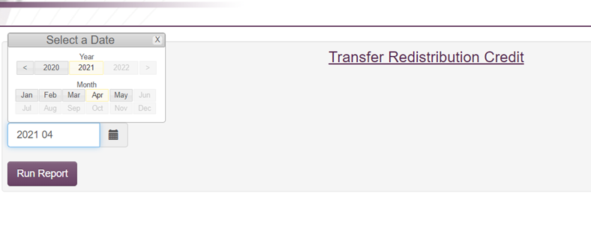

- Click “IC Transfer Analysis” tab- click “Loc-Totals”- click “Save IC Totals”- Print Report to pdf
- Save at F:\Accounting\Shared\Month End\EOM Entries 2026\Transfer Redistribution Credit XXXX.XX (year.calendar month)
- Inventory and Accounts Receivable Analysis (** Needs done by the 15th of the month)
  - Intranet http://intranet.kmtire.local/ Accounting
  - Accounting - Click on “AC - Inventory and Accounts Receivable Analysis”
  - Enter Calendar Year/Period
  - Select Store #1 (only need to do it for 1 store and it will write it for all stores)
  - Click “Run Report”
  - Verify the accuracy of the Inv & AR Analysis against the latest income statement
- Compare a sample of accounts for an exact match (Total Sales should match Sales, Total COGS should match Cost of Sales, etc.)
  - Inventory – F:\Accounting\Shared\Monthly Reports\YYYY\Month YYYY\INVENTORY – SUMMARY
- Loc 1 Inventory actual plus FET should be close to “Total Inventory”
  - AR Aging- found in F:\Accounting\Shared\Monthly Reports\YYYY\Month YYYY\AR AGING
- Location 1 AR Aging total should be an exact match with “Total A/R”
  - When comfortable with the data, click “Write Sales Data for All Stores”
  - Once back to “Store Select” shift- select each location, “Run Report” (this may take a few minutes)
    - Export to excel and save as current month at F:\Accounting\Shared\Month End\EOM Entries\Inventory & AR Analysis
  - Go back to “Store Select”, select “All”, Run Report, Export to excel and add as first sheet in above spreadsheet
  - Shift-select all sheets to format column and rows to size
  - Copy & paste check columns BU and BV from previous months excel, sheet “All Stores”
  - Email to President, CFO, VP of Accounting, and Controller as an attachment when complete.

Non-Stock Adjustment Entry
Needs completed before balance sheet and income statements are run for Controller/VP review

The purpose of posting the Non-Stock Entry is to reconcile the AP invoices where we purchased non-stock items with the AR invoices where we invoice back to customers. The following entries ensure AP & AR invoices are matched in the same period on the income statement, and freight is reclassed.

Path: F:\Accounting\Shared\Month End\EOM Entries 2026\Non Stocks\month you are reconciling

- Make sure all AR/AP invoices are on the non-stock spreadsheet for the month. Refer to SOP 9.1 to do this.
  - Variances of a few cents are okay, these will be written off each month
- EOM Posting (All entries will be made in the month that just ended since this is and end of the month entry)
  - Carryover non-stock entry– This is everything that is still open for the month for each location. Needs reconciled for anything over 30 days old, and needs a reason why is was not washed. Normally, this indicates an issue that needs to be resolved.
  - Filter the AR side by color and select red. This will show everything that is still open.
  - All red items will be moved to the 1510 location each month
- 3910-location will be a debit (only make entry if balances are over $1000.00)
- 1510-location will be a credit (only make entry if balances are over $1000.00)
  - You will put the totals in the below area on the non-stock spreadsheet. Once entry is made put the reference#, initials, and date.
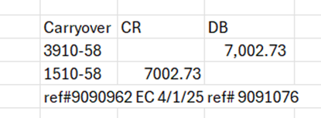

  - Unfilter the sheet this will show everything again.
  - All the red items delete the amount out of column J so it is only showing the amounts for the other entries.
- Non-stock reclass entry
  - There is a running formula on the non-stock spreadsheet that will tell you what your entry should be. See below.
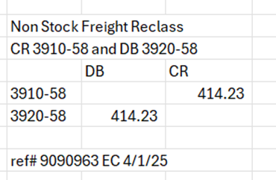
  - Once the entry is made put the reference#, initials, and date.

- Non-Stock Freight write off entry
  - There is a running formula on the non-stock spreadsheet that will tell you what your entry should be. See below
  - Once the entry is made put the reference#, initials, and date
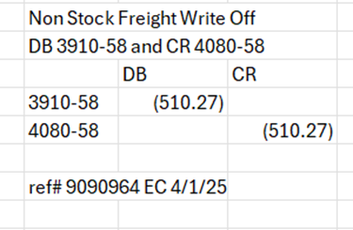
- Helpful Tips
  - Unverferth is usually intercompany transfers
  - If product code NSUSED was used on the invoice it should hit the 3905-1 GL. You can look into this by going to that GL activity on the Intranet or Madden Co.

Service Charges – Account 3980 EOM Entry#12
To allocate service charges from location 1 to the correct locations according to the AR Aging’s (entry can be done on day 1)
- Go to F:\Accounting\Shared\Month End\EOM Entries 2026\EOM entries\EOM Entry #12- Current Service Charges.xlsx
  - Create a new tab for current month reconciling by right clicking on the tab “Month YYYY Entry” and selecting “Move or Copy”
  - Select “Create a Copy” and click “OK”
  - Rename the tab to current month reconciling
  - Clear out yellow highlighted cells
- Complete the yellow highlighted column B using Current Service Charges from the AR Aging Reports by location F:\Accounting\Shared\Month End\Monthly Reports\2026\December 2025\AR Aging for month reconciling
  - Open each locations AR Aging one at a time
  - Locate the column “Current” and pull the “Grand Total of Service Charges Due” into column B
  - In the yellow highlighted cell beside “All Locations Report” open All Locations AR Aging report and pull the same current grand total of service charges amount
  - In yellow highlighted cell beside “Employee Service Charges” open “Employee# AR Aging” report and pull the same current grand total of service charges due
- Ensure the journal entry is calculating correctly across the locations and into the “JEUPLOAD FORMAT”
- Once everything is verified make both entries and put the reference number, initials, and date of entry in yellow highlighted area next to “Reference#”
  - Follow SOP 6.2 Upload Journal Entry to upload
  - Description will be EOM AJE FOR SERVICE CHARGES

EOM Net Income Entry Location 50 (complete after loc 50 has been reviewed)
- Go to F:\Accounting\Shared\Month End\EOM Entries 2026\EOM entries\2026 EOM Net Income Entry Loc. 9 & 50.xlsx
- Copy last periods tab and rename it to current period
- Change the “month ending” in yellow to month reconciling
- Open EOM entry# 7 – Inside & Outside Sales F:\Accounting\Shared\Month End\EOM Entries 2026\EOM entries\EOM Entry #7- Inside & Outside Sales.xlsx
- Take totals by location from EOM entry #7 from column B and paste them into column B in the EOM entry New Income Entry location 9 & 50
- Run a Year & period income statement following the below steps out of Madden CO.
  - 3- General Ledger
  - 4- Reports Menu
  - Financial Reports
  - 4- Year & Period income statement
  - Enter through date screen
  - INC30 (could change if we add new locations, check with Controller)
  - Year/Period = fiscal year reconciling
  - Place report on hold = Y
  - Open in System I Navigator or F4 to email to yourself
- We are currently excluding Loc 9 from this entry unless otherwise told by the controller
- Go to Loc 50’s income statement and find the total net income for current month (can CTRL+F enter 0092 until you get to L50)
- Record Loc 50 current month net income in the highlighted yellow field on your excel spreadsheet for allocation
- Make the entry using the JE upload
  - Follow SOP 6.2 Upload Journal Entry to upload
  - Description will be EOM AJE FOR LOC 50 NI ALLOCATION

Corporate Income & Expense Allocation EOM Entry
To allocate monthly Corporate Income and Expense 1-1 accounts based on Sales by location. We allocate out using G/L 5840-1-1 and 3990-1-1 (This entry is listed with Day 2 as it is the final entry, but is not made until the after financials have been reviewed by Controller and VP of Accounting, and before submitting to President)
- Go to F:\Accounting\Shared\Month End\EOM Entries 2026\EOM entries\EOM Entry Corporate Income & Expense Allocation.xlsx
  - Create a new tab for current month reconciling by right clicking on the tab “Month YYYY Entry” and selecting “Move or Copy”
  - Select “Create a Copy” and click “OK”
  - Rename the tab to current month reconciling
  - Clear out yellow highlighted cells
- Update Column B “Sales” for both entries
  - Open the Inside and Outside Sales EOM entry per location and copy the calculated Sales by Location
  - Paste into Corporate Income & Expense Allocation column B ensuring the locations line up and all amounts are correct
- Update the yellow highlighted cells in column D using the Income Statement
- Pull the Income Statement by going to Madden Co and following the below steps
  - 3- General ledger
  - 4- Reports Menu
  - Financial Reports
  - 4- Year & period Income Statement
  - Enter through date screen
  - Enter report format = INC30 (or whichever INC we are on)
  - Enter in year/period for what month reconciling (example September 2025 would be 2025/12)
  - Y to place report on hold and hit enter
  - Go to I System Navigator to view the report or have it sent to your email by hitting F4 and putting in your email
- Look at the Income Statement and search code 00092/000/000 under corporate expense 1-1. Type the amount as a negative into the yellow highlighted cell for the Corporate Expense Allocation
- Look at the Income Statement and search code 00087/000/000 under corporate expense 1-1. Type the amount into the yellow highlighted cell for the Other Income (Expense) Allocation
- Ensure the journal entry is calculating correctly across the locations and into the “JEUPLOAD FORMAT”
- Once everything is verified make both entries and put the reference number, initials, and date of entry in yellow highlighted area next to “Reference#”
- Follow SOP 6.2 Upload Journal Entry to upload both JEs
- Descriptions for the two entries are as follows:
  - EOM AJE FOR CORPORATE EXPENSE ALLOCATION
  - EOM AJE FOR OTHER INCOME (EXPENSE) ALLOCATION
- NOTE: If any changes are identified during President’s review which affect 1-1, this entry will need to be ran again to allocate those adjustments so ending 1-1 net income is Zero when financials are finalized

Run & Review Financial Statements
Before the next steps can occur – be sure the Non-Stock Adjustment Entry is posted – 13.5 and the daily and monthly bank reconciliations needs completed and posted as necessary.
- Print a Consolidated Balance Sheet (this will print all locations to I-Nav, only print hard copy of Consolidated)
  - 3 General Ledger
  - 4 Reports Menu
  - 1 Financial Reports
  - 1 Balance Sheet year to yr, yr, yr
  - BAL30
  - Year 1 = Current fiscal year (ex. 2026 for October 2025)
- Year 2 = prior fiscal (2025), Year 3 (2024), Year 4 (2023)
  - Period = current fiscal (ex. 1)
  - Place Report on Hold Y
  - This will print all locations, only print hard copy of consolidated
- Print a 6 column Income Statement
  - 3 General Ledger
  - 4 Reports Menu
  - 1 Financial Reports
  - 9 Six Column Income Statement
  - Report Format = Income Statement (INC30)

Example for March 2026 (be sure to use fiscal month):
March March February January YTD YTD
2025 2026 2026 2026 2026 2025
2025 06 2026 06 2026 05 2026 04 2026 01 2025 01
2025 06 2026 06 2026 05 2026 04 2026 06 2025 06
(see example)- Be sure to include both month and year on every heading of six column report
Use “Balance” B
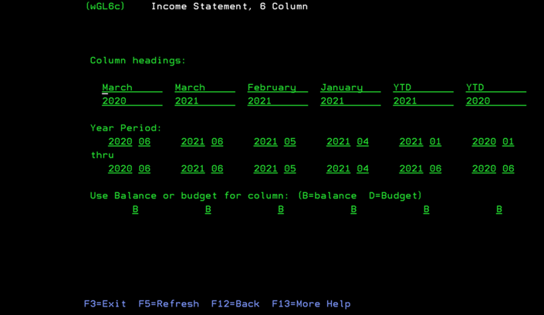
If changes are made (moving expenses from one period to another, for example), reports will need to be re-ran after updating the journal entries.
- Review and discuss Income Statement & Balance Sheet accounts that are questionable or need further review.
- Save Financial Statement Review notes for the month in F:\Accounting\Shared\Month End\Monthly Financial Statements
  - Open “Financial Statement Review - Notes YYYY”
  - Review electronic copies of Income Statement and Balance Sheet from EOM procedures
  - Check to ensure any accounts added throughout the month are pulling correctly by location and on the Consolidated pages
  - Send out inquiry emails based on the below notes and anything else that has changed significantly or looks odd
  - Accounts that may need extra review:
    - Any expense that is over $20K for a single location, or over $150,K for total company needs reviewed to see if it should remain in current period or be reclassed to 1420-1-1 Prepaid and expensed monthly.
      - See SOP titled “Prepaid Expenses”
    - 3900 Inventory Difference: research large changes in MaddenCo
      - 3 General Ledger
      - 3 Inquiry Menu
      - 1 Balance Inquiry
      - Enter (000 All Stores)
      - Go to Account 3900 and find the location and transaction that are abnormal
      - Place a 6 beside the line
      - Shift F2
      - 1 Product History
      - Locate the reference numbers to research elsewhere in Maddenco
      - F3 back to 1 Tire Dealer System
      - 15 More Options Menu
      - 5 Headquarters Menu
      - 2 Inventory Adjustments
      - Status of P Processed
      - Exclude Processed Adjustments N
      - Type in Reference number found in previous Maddenco screen
    - 3880 Waive SC: email C&C Manager.
    - 3920 Freight
    - 3970 Road Hazard
      - ROAD HAZARD credits / debits are from the adjustment department issuing road hazard credits to customers, or the marketing department billing said customers a monthly fee for the service. They are both using the part number RH.
      - Product Code is RH 23
      - If need further assistance contact Director of Marketing
    - 4080 Invoice Difference
      - To view cost corrections, place a 6 on the entry you would like to review. Do a shift F2 and then a 1 on product history
      - After you are on the product history screen enter CST on the product line. This will show you all invoices with a cost correction.
      - Review the largest corrections and if associated invoices are on the main invoice review to see what vendors and dollar amounts make up the total dollar amount. See below for example
      - 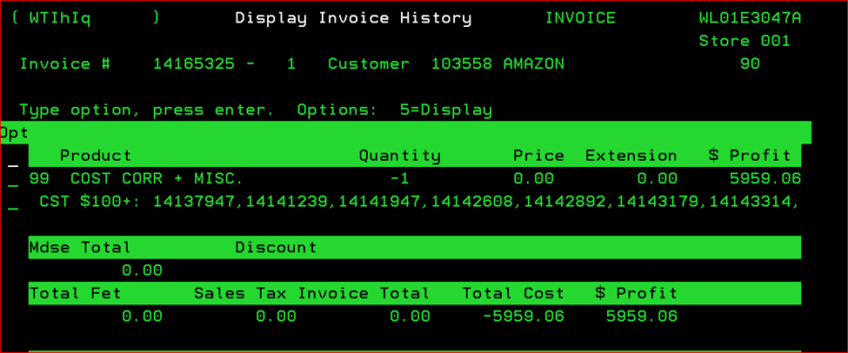
    - 4110 Adjustment Difference
    - 5030/5070 Truck Fuel & Sales Vehicle Fuel
      - Changes most likely WEX fuel bill fluctuating due to sales quantity or gas price changes
      - Make sure three WEX bills and the monthly allocation were posted in month reviewing
    - 5040 Truck Leases
      - Intranet
      - Warehouse
      - Truck Rental Notice
      - Search by location
      - Make note of what vehicles were out of order and why
    - 5050 Truck Repairs
    - 5050 Truck Accidents (only if month to month change is over $10,000)
      - Research invoices over $7,000.00, spot check other invoices and make note if there are no other large invoices or anything that looks abnormal
    - AR Adjustments in 5050 accounts: any own use account that has a balance is adjusted off to 5050-location by month per Katie.
    - 5930 Cash Over/Short: If greater than $50.00 reach out to Katie for explanation. All balances in location G/L 5930 cash over/short should have an explanation in the F/S Notes.
- Send Notes, Consolidated portion of Balance Sheet and all Income Statement (front and back) to next reviewer.
- Controller and then VP of Accounting to add their notes or review if any adjustments need

FINAL PROCEDURES To Do by 15th (After Cheryl’s Review):
- Six Column Income Statement for Warehouse Bonus
  - 3 General Ledger
  - 4 Reports Menu
  - 1 Financial Reports
  - 9 Six Column Income Statement
    - Enter
    - INC##
    - Year Period (First Column Only) Example: (2026 04 thru 2017 04 would be for January 2026)
    - Balance = B
    - Place Report on Hold = Y (Enter)
  - Do you want to create a File for Client Server Use? Y (this and k.(File Name) are necessary to do for warehouse bonus to run properly on the intranet).
  - File Name: type in HRAY202601 **(MUST BE ACTUAL CALENDAR YEAR AND MONTH)** <enter>
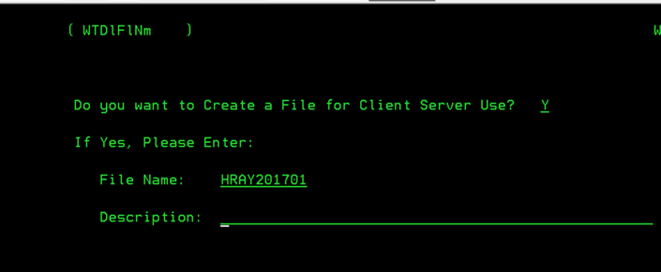
  - Go to System I Navigator – find the file under your name
  - Save as a text file :\Accounting\Shared\Month End\EOM Entries 2026\Transfer Redistribution Credit\Income Statement xxxx.xx

Summary Financials
- Monthly Summary Bank Financials
  - Open previous months “KM Tire – Summary Financials as of xxxx-xx-xx” file located in the following path: F:\Accounting\Shared\Month End\Monthly Financial Statements\Summary Financials and save as the current month.
  - Print to I-Nav, BAL30 & INC30 for current fiscal year current fiscal period, and previous fiscal year current fiscal period. 3-4-1-4
  - Save in same location as txt files with similar name as previous (Ex. “INC P4 2026”)
  - Start on sheet “Summary Financials” changing cell E1 to current ending date
  - Go next to sheets INC 25, BAL 25, INC 26, BAL 26
    - File, Open, find correlating text file, may have to change drop down box from Excel to “All Files”
    - Use column breaks in red to format the text file into excel
    - Copy & paste Consolidated portion into Summary Financials.
  - Review to make sure summary financials are correct
    - Verify amounts flowing across tabs as expected
    - Verify the Total Assets = Total Liabilities & Equity
    - Verify Net Income on Income Stmt is correct
  - Email to President, CFO, EVP, VP of Accounting, and Controller

Operations Income Statement
Open previous month’s excel version and save as current month: F:\Accounting\Shared\Month End\Monthly Financial Statements\Summary Financials “KM Tire – Operations Income Statement – YYYY.MM.DD”
- Create current month sheet by creating copy of previous
- Go to sheet “INC_STMT” and follow directions in red to open txt file “6 column – YYYY P00” as excel.
- On Master tab – follow directions in red
- Copy and paste values only from sheet “Master” into monthly sheet
- Print or publish to pdf. Current month’s tab
- This needs sent to all ROM’s, copying VP of Ops, Director of Real Estate & Facilities, & Director of Operations
Subject “Month Year Operations Income Statements”
“All: Please see attached the Month Year Operations Income Statements.”

Warehouse Bonus Analysis

Warehouse Reports
The Warehouse Bonus Reports are used as part of the calculations for the Warehouse Bonus Payouts. To access all the reports that are needed follow the below steps:
***NEED TO UPDATE THE FOLLOWING FOR DAYFORCE***
- Log onto your Paylocity account
- Select Data Insights from the Main Dashboard
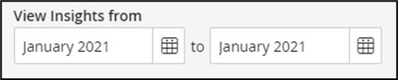
- Once you are logged into Data Insights, select the month you are working on at the top of the page. Ex: if it is for the month of January, select from January 2025 to January 2025

- Select the cost centers that need to be used

  - Click on

  - Click on Cost Center 2
  - Select the following cost centers:
    - Night Shift
    - Route Drivers
    - Semi Drivers/Transfer Drivers
    - Transfer Shift
    - Warehouse
    - Warehouse/Drivers
  - Click Apply
- Active Employees Report
  - Select the option Headcount, on the left side of the screen
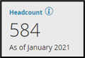
    - Click on the box titled Headcount

    - This will open a pop-up box, select Export to Excel
    - This will open the information in Excel Spreadsheet. Save this spreadsheet to send to the Staff Accountant.
- Turnover Report
  - Select the option Turnover, on the left side of the screen
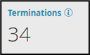
  - Click on the box titled Terminations

    - This will open a pop-up box, select Export to Excel
    - This will open the information in Excel Spreadsheet. Save this spreadsheet to send to the Staff Accountant.
      - File path to save file F:\Accounting\Shared\Payroll\Warehouse Bonus Analysis\20XX\Terminations
- Overtime Report
  - Select the option Labor Costs, on the left side of the screen
  - From the drop down, select Overtime
  - Click on the box titled Overtime Hours
  - This will open a pop-up box, select Export to Excel
  - This will open the information in Excel Spreadsheet. Save this spreadsheet to send to the Staff Accountant.
- Monthly Wage Report
  - Select the option Labor Costs, on the left side of the screen
  - From the drop down, select Trends
  - Click on the box titled Labor Costs
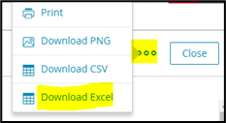
  - This will open a pop-up box, click on the three dots in the left-hand corner and select Download Excel

  - This will open the information in Excel Spreadsheet. Save this spreadsheet to send to the Staff Accountant.
- Prepare Spreadsheet for Current Month
  - Open previous month and save as current month F:\Accounting\Shared\Payroll\Warehouse Bonus Analysis\2025\December 2025.xlsx
  - For each location tab add a new column to the right of the grey bar. Follow these steps carefully.
    - Select all location tabs
    - Add Column
    - Copy last month to added column
    - Past Values NOT formulas
    - Format column by clicking the paintbrush select column you are copying and then select column you pasted.
  - This should make the columns to the left and right of the gray bar the same, change the column to the left to the current month.

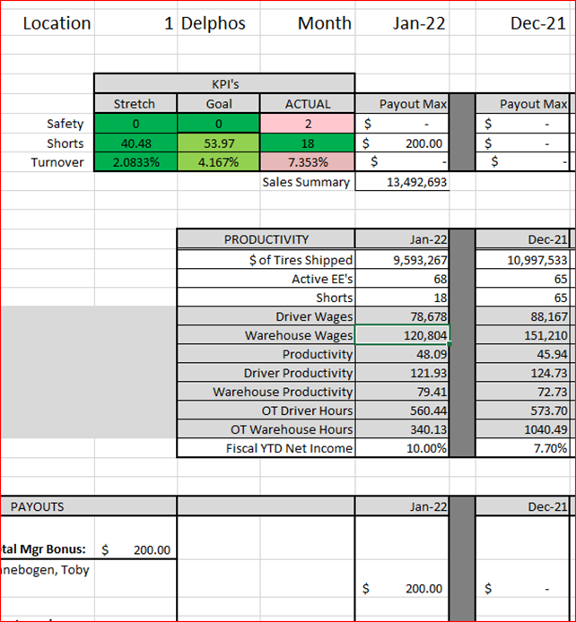

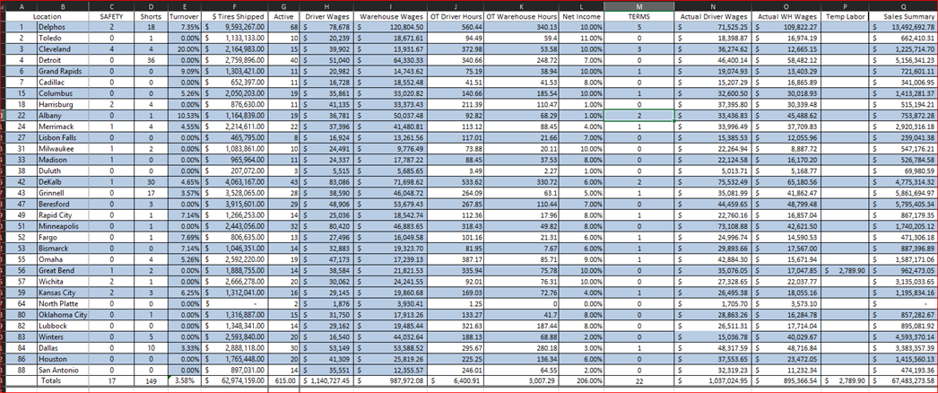
Complete the current month data tab

- Clear all of the previous months data from “background” tab so that no information is missed getting updated. Do not delete columns E, I, and J from “MM tab” as these are formulas and will calculate as information is added. Clear contents from columns F, G, and O

  - Workers’ Compensation Claims – HR (Becky) will send an email after the first of the month, review all claims for the current month you are working on. Copy and paste the current month data to the Background Tab and add all instances to each location on the (Month) Data tab under the SAFETY column. Save file from HR under F:\Accounting\Shared\Payroll\Warehouse Bonus Analysis\20XX\Workers Comp
  - Shorts –Operations Project Manager or VP of Operations will send this report during the first week of the month, record all shorts to their appropriate locations on the (background) Data tab under the SHORTS column. The (background tab info will calculate to the (month) data tab. Save the short file under F:\Accounting\Shared\Payroll\Warehouse Bonus Analysis\20XX\Shorts
  - Accidents – Review the Logistics’ accident spreadsheet. You will need to get with the Logistics Supervisor so they can share the file with you. Select all accidents for the month you are working on and sort by Fault (Y) claims. Copy and paste the current month data to the (Background) tab. Enter accidents by location on the (Month) Data Tab under the SAFETY column.
    - If the fault is not completed email Jennifer or Sam in logistics
  - OSHA visits – watch for emails regarding OSHA fines.

Calculating Terms
  - Open the Terminations file previously downloaded and saved in:
    - F:\Accounting\Shared\Payroll\Warehouse Bonus Analysis\20XX\Terminations
  - Review column header “Cost Center 2” make sure there are no inside or outside sales, delete if any listed
  - Review column header “Termination reason”, delete all employees with the reasoning of “Returned to School”, “Retired”, or “Deceased”
  - If an employee terminates due to a warehouse move send to VP of Operations to see if it should be counted or not in the term total.
  - Filter by column header “Tenure” to only show those who have worked 0 months, review those whose reason is “3 day no call no show” and delete if they worked less than 7 working days, taking into account the 3 days of no call no show. Ex. Hire 11/2/25 Term 11/11/25, this is 8 working days but after removing the 3 days of no call no show his actual term date would be 11/8/25. This would now put the terminated employee at 5 working days. All other reasons if worked less then 7 working days delete.
  - Select all remaining data and format to a pivot table
  - Use “Cost Center 1” as the Rows and “Preferred/First Name” as the Values (count)
  - Copy and paste pivot table to Background tab, this will filter to (Month) data tab in column header terms
  - Save spreadsheet to F:\Accounting\Shared\Payroll\Warehouse Bonus Analysis\2025\Terminations making sure file type is excel

Calculating Active Employees
  - Open file F:\Accounting\Shared\Payroll\Warehouse Bonus Analysis\20XX\Active
  - Review column header “Position Title” and delete any sales or office employees
  - Update all employees to either Warehouse or Route Driver. Do a CTRL+F and click replace. 21-Warehouse/Driver, 20-Warehouse, 24-Transfer Shift, 22-Night Shift, and 31-Executive Multi-Location replace with Warehouse. 23-Route Drivers replace with Route Drivers
  - Select all remaining data and format to a pivot table
  - Use “Cost Center 1” as the Rows, “Preferred/First Name” as Values (count), and “Cost Center 2” as columns
  - Copy and paste pivot table to Background tab, this will filter to (month) data tab in column header Active
  - Save spreadsheet to F:\Accounting\Shared\Payroll\Warehouse Bonus Analysis\20XX\Active making sure file type is excel

Calculating Wages
  - Open file F:\Accounting\Shared\Payroll\Warehouse Bonus Analysis\20XX\Wages
  - Review column header “Position Title” and delete any sales or office employees
  - Update all employees to either Warehouse or Route Driver. Do a CTRL+F and click replace. 21-Warehouse/Driver, 20-Warehouse, 24-Transfer Shift, 22-Night Shift, and 31-Executive Multi-Location replace with Warehouse. 23-Route Drivers replace with Route Drivers
  - Select all values in column header “Earnings” a green triangle in the top left corner of each cell indicates that there is an issue and a small yellow diamond will appear when the cells are selected.
  - 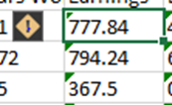
  - Click the dropdown on the diamond and select “Convert to Number”
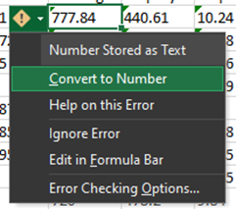
  - Select all remaining data and format to a pivot table
  - Use “Cost Center 1” (location) as the Rows, “Cost Center 2” (warehouse and route drivers) as the Columns and Earnings as the Values (sum).
  - Copy and paste the pivot table onto the Background Tab, this will filter into (month) data tab column header “Actual driver wages” and “Actual WH wages”.

Calculating Hours
  - NOTE: Use same spreadsheet that was used for wages
  - Take the original wages spreadsheet, select all data and format to a pivot table
  - Use “Cost Center 1” (locations) as the Rows, “Cost Center 2” (warehouse and route drivers) as the Columns and Hours Worked as the Values (sum)
  - Copy and paste the pivot table onto the Background Tab, this will filter into (month) data tab column header “Total Driver Hours” and “Total Warehouse Hours”
  - Save file F:\Accounting\Shared\Payroll\Warehouse Bonus Analysis\20XX\Wages

Calculating OT Wages
  - Open file path F:\Accounting\Shared\Payroll\Warehouse Bonus Analysis\20XX\Overtime
  - Open Overtime report
  - Review column header “Job Assignment” and delete any sales or office employees
  - Update all employees to either Warehouse or Route Driver. Do a CTRL+F and click replace. 21-Warehouse/Driver, 20-Warehouse, 24-Transfer Shift, 22-Night Shift, and 31-Executive Multi-Location replace with Warehouse. 23-Route Drivers replace with Route Drivers
  - Select all remaining data and format to a pivot table
  - Use “Cost Center 1” (location) as the Rows, “Cost Center 2” (warehouse and route drivers) as the Columns and OT Hours Worked as the Values (sum).
  - Copy and paste the pivot table onto the Background Tab, this will filter into (month) data tab column header “OT Driver Hours” and “OT Warehouse Hours”
  - Save spreadsheet to F:\Accounting\Shared\Payroll\Warehouse Bonus Analysis\2025\Overtime

Net Income & Temp Labor
- Pull report from Madden Co using the below steps
  - 3 General Ledger
  - 4 Reports Menu
  - 1 Financial Reports
  - 4 Year & period income statement
  - Enter through date screen
  - INC30 (could be different if we added locations ask Controller)
  - Enter Year Period using fiscal year
  - Place report on hold = Y
  - Pull report from System I- Navigator or F4 to have it emailed to you
- Open report and use the Current Year YTD percentage for each location to fill in the Net Income on the (Month) Data tab column header “Net Income” on the warehouse bonus analysis spreadsheet.
  - CTRL + F to search 0095 and enter that amount for each location (if the amount is a negative so is the percentage)
- Fill in the Temp Wages
  - Go to Intranet and run a G/L balance report for 5590, for all K&M locations, for month.

Total Tires Shipped
Can’t do this step until financials for month doing warehouse bonus has been finalized
- Go to Madden Co and follow the below steps
  - 1 Tire Dealer System
  - 2 Sales Menu
  - 2 Monthly Sales Reports
  - 1 Sales Summary
  - Enter through date screen
  - Year/period put in month reconciling
  - In line under “First” put ST
  - Y for print total page only
  - Exclude Non-Merc and Exclude Inter-Co = N
  - Enter through next 3 screens
  - Cost page use A for Actual cost
  - Place report on hold = Y
  - Open System I-Navigator or F4 to have it emailed to you, but your email will need set up
- Add all the units totals for each location on the (month) data tab

To review $ Tires Shipped on the Intranet:
Can’t do this step until financials for month doing warehouse bonus has been finalized
- Pull report from Intranet
  - Log onto the Intranet
  - Select Human Resources
  - Select HR – Analysis Report
  - Select Review HR Report Month tab
  - In the Year/Month box, select month in which you are preparing the analysis for
  - Select Click to Review
  - Select each Locations Tab to determine their $ Tires Shipped
  - Enter $ Tires Shipped total in the $ Tires Shipped column per locations on tab (month) data
- To view if the $ Tires Shipped equation is correct, hover over $ Tires Shipped in the Category column (Intranet) and match the numbers against the documents Accounting sent to you (Income Statement, Transfer Redistribution Credit and EOM Correct 3010 and 4010). Please see equation below for more details.
- If calculation is needing done manually, follow below

$ Tires Shipped Manual Equation
$ Tires Shipped = (Sales from Income Statement) + (PR National Accounts from Income Statement) + (Total Transfer Redistribution Credit for Location) + Sales for Location from EOM Correct 3010 and 4010 based on the following:
  - (40% of Sales for Location in Sold From Column) +
  - (85% of Sales for Location in Delivered To Column) +
  - (30% of Sales for Location in Transferred Through Column (details on Transfer Through tab of spreadsheet))

Sales Summary
  - Log onto the intranet
  - Select WH – Units Sold Report
  - Run the report from the first day of the month to the last day
  - View option = Web View
  - Download as excel
  - Copy total sales column and paste values into column header Sales Summary on the current (months) data tab
    - This information should flow to each locations tab in cell E11
  - Save Report to: F:\Accounting\Shared\Payroll\Warehouse Bonus Analysis\20XX\Sales Summary - WH Units Sold

Finalizing the Bonus
  - Verify the formula for the Short Goal. This should be updated at the beginning of each fiscal year to reflect the new KPI #
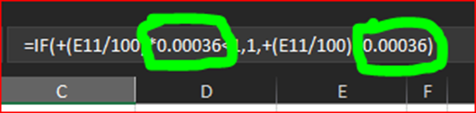
    - Confirm with VP of Ops & Controller

  - Verify colors are correct on the KPI Score card. Update the ACTUAL column only to reflect the below.
    - Payout Max = $200 should be green
    - Payout Max = $100 should be light green
    - Payout Max = $0 should be light red
  - Review warehouse bonus 20XX, fill in bonus amount and add any employees to the month spreadsheet
  - Check and Double Check numbers
  - The combined tab total paid amount should match the warehouse bonus spreadsheet total amount
  - Send to HR & Payroll Manager and HR Payroll Generalist to review all employees are correct
  - Once approved by HR send to VP of Ops
  - Once approved by VP of Ops send to President
  - Once approved send to Managers
  - Fill out Warehouse Bonus sheet under HR in F drive.
    - If you don’t have access, ask for it.
    - Make sure the total matches your total on “combined” tab.
    - Send this to HR & Payroll Manager letting her know warehouse bonus has been approved and can be paid out

Sending to Managers
  - For each tab export and save as PDF, exporting will guarantee that all info is captured save F:\Accounting\Shared\Payroll\Warehouse Bonus Analysis\20XX\PDFs\[Month] 20XX
  - Send to Warehouse managers and ROMS
  - Answer any questions that come back

Adding a new location to Workbook
  - Copy the most recent location tab
  - Rename new tab with new location
  - Change column B3 to correct location number
  - Insert a row for the new location on the Month Data tab
  - Correct all formulas on the location tab to pull from the new location row on the month data tab
INFORMATION ONLY
Formulas are as follows:
Safety
Stretch:0; Goal:0; Actual:=VLOOKUP($B$3,'September data'!A:P,3,FALSE); Payout:= IF(D8=0,200,IF(D8>=1,0))
Short
Stretch:=+E15*0.00017; Goal:=+E15*0.00023; Actual:=VLOOKUP($B$3,'September data'!A:P,4,FALSE);
Payout: = D9<=(C9*0.75),200,IF(D9<=C9,100,0))
Turnover
Stretch:=(0.4/12); Goal:=(0.5/12); Actual:=VLOOKUP($B$3,'September data'!A:P,5,FALSE);
Payout: =IF(D10<=(B10),200,IF(D10>=(B10),IF(D10<=C10,100,0),0))
Manager Bonus: = IF(E8+E9+E10=600, 900, E8+E9+E10)
ASST Manager Bonus: =B32/2

Property Tax Procedures
On an as needed basis, at least annually, property tax invoices are received from various sources. Property taxes are can be due on Real Property (building & land) or Personal Property (equipment such as racking and pickers.) All states charge tax on real property, while only some charge personal property tax and those invoices are much smaller. Property Taxes can be due on one or multiple invoices, such as Summer/Winter or Spring/Fall.
Some final payments might be scheduled to be paid after our fiscal year ends. If this happens make sure to update it on the new year spreadsheet. Review each invoice as follows:
- Check Maddenco to ensure the invoice has not already been paid.
  - 2 Accounts Payable
  - 3 Inquiry Menu
  - 4 Vendor Name
  - Enter to include all stores 000
  - Type Name in the field provided.
  - Find the correct Vendor, mark 7 beside Vendor Name to Display Invoices
  - Press Enter
  - Press Enter again to load invoices for the Vendor.
  - Search for the invoice to see if it has been paid or not. If not present on the list, it needs to be reviewed/approved. If present, no further action is required.
- Verify the tax assessment is being correctly calculated and approve.
- Scan and save the approved invoice/assessment F:\Accounting\Shared\Tax\RE and Property Tax\Property Tax Assessments. Save under the specific location.
  - Send an email to “AP invoices” with the account and GL for AP to post it properly.
  - Send all Texas assessments to TAG for review.
- Once Invoice is approved, update the Property tax spreadsheet 20XX.
F:\Accounting\Shared\Tax\RE and Property Tax\Property tax spreadsheet
  - Update the Location tab by whichever location the invoice is, then find the parcel number on the invoice and input the amount due and the due date. The Maddenco Ref# column will be updated once AP makes the journal entry. Once the entry is made put their reference number in the spreadsheet. Check as needed.
  - Next update the “Property % Change” tab. Find the location and parcel number and input the amount of tax bill due and the total assessment value.
  - After the reference number is added in the location tab, make sure the 20XX tab updates as well. It is formulated to pull from the location tabs.
  - Each year the spreadsheet will need to be updated with current dates. As needed, if we acquire or sell other properties the spreadsheet will need updated.

ASSESMENTS/APPEALS:
- Throughout the year, often annually by location, property tax assessments are received from various sources.
- Scan and save the Assessments under F:\Accounting\Shared\Tax\RE and Property Tax\Property Tax Assessments
- Compare the current year assessment vs prior year value. If the assessment has increased by more than 3% from the prior year, notify Controller and see if we need to file an appeal or see if there have been any improvements to the property over the year that might explain the assessment.
- If any land/ building improvement was made, verify that the change in assessment is reasonable and not unproportional to the improvement.
- If we do need to file an appeal
  - Check the Appeals folder at F:\Accounting\Shared\Tax\RE and Property Tax\Property Tax Assessments\Appeals to what documents have been previously saved for that location.
  - Review that location’s information on the property tax spreadsheet at F:\Accounting\Shared\Tax\RE and Property Tax\Property tax spreadsheet and will be located on the locations tab.
  - Verify if we have any recent real estate appraisals for that location. If so, review the appraised value as that would help support our position.
  - Verify appeal deadlines and due date.
  - Complete appeal form and have Controller and VP of Accounting review prior to submission.

Five Star Insurance Reimbursements
To understand Five Star Insurance Reimbursements, it is important to understand key parties involved in K&M’s insurance structure. Hylant is K&M Tire’s insurance agent. Travelers Insurance is our primary insurance carrier for Property, General Liability, Workers Comp, and other categories of insurance. Five Star Insurance is K&M Tire’s affiliate captive, providing deductible reimbursement insurance as well as direct issue insurance in several categories. K&M Tire posts qualifying charges (expenses) to the following pass-thru accounts as they arise, and quarterly we submit the totals and postings of these accounts to Five Star Insurance for reimbursement.
Monthly, G/L accounts 1401-1-1, 1402-1-1, 1403-1-1 and 1406-1-1 are reviewed and balanced to supporting schedules. Quarterly, a reimbursement claim is filed with Five Star Insurance according to our captive agreement. Only claims incurred after 10/1/2021 qualify as a Five Star Insurance claim. For credit risk only b debt from sales qualify. The reconciliation file can be found at: F\:Accounting\Shared\Insurance Costs\Account Reconciliations\XXX (Month) 20XX Insurance Pass Thru Account Recon.

GL 1401-1-1 General Liability – Pass Thru
No transactions should post to this general ledger account. General Liability claims are covered only by the Traveler’s Insurance policy. This general ledger account is balanced monthly to ensure that the balance remains at zero.

GL 1402-1-1 Auto – Pass Thru
Transactions posting to this general ledger account are for auto accidents incurred on or after 10/1/2021 and paid directly by K&M Tire Inc.
- These transactions should be matched to the detailed file maintained by the Logistics department to ensure all transactions have been validated.
  - The detailed transaction file can be found at: F:\Logistics\Public\Trucks & Trailers\Accidents\20XX-CurrentAccidents on the Payment Breakdown tab. Once reconciled, these transactions are reported on the quarterly Five Star Loss Run report as an APD – Auto Paid claim.
- The Auto Liability portion of the monthly Travelers Billing is also recorded to this general ledger account.
  - Only claims incurred on or after 10/1/2021 included on the monthly Travelers invoice should be posted to this account. Any costs for claims incurred prior to 10/1/2021 should be expensed to general ledger account 5050 for the location where the claim was incurred.
  - Once reconciled, these transactions are reported on the quarterly Five Star Loss Run report as an AL – Auto Liability claim.
To Reconcile 1402-1-1
- Pull all new entries from the accident spreadsheet to the 1402-1-1 detail tab.
- Add all new MaddenCo entries for the month to the same detail tab.
- Review the entries added from MaddenCo and match them to the entries taken from the accident spreadsheet.
- Once matched highlight in the appropriate quarter color.
- If there are any entries that are listed in MaddenCo but are not listed on the accident sheet send them back to be reviewed by the Logistics department to determine if they are valid.

GL 1403-1-1 Credit Risk – Pass Thru
Accounts Receivable balances arising from sales made by K&M Tire that are determined to be uncollectible after 10/1/2021 are written off to general ledger 1403-1-1. The Credit and Collections manager tracks all accounts that are determined to be uncollectible.
- To qualify for credit risk insurance reimbursement the tires must be
  - Sold by K&M Tire. When we purchase accounts receivable invoices during an acquisition, if any of those receivables later become uncollectible, they are not eligible to be turned in for Credit Risk reimbursement because K&M did not make the sale. Those invoices will be written off by C&C Manager to G/L 1290-1-1. To the extent there are invoices on the same bad debt account sold by K&M after the acquisition, those can be posted to 1403-1-1 and turned in for credit risk reimbursement.
  - The loss is a direct result of customers’ failure to pay K&M Tire
  - Loss must be caused by financial insolvency of the customer
  - K&M must exhaust all reasonable steps to seek payment from customer
- Monthly, a detailed file is obtained and the general ledger transactions are matched to ensure all transactions posting to this general ledger account are validated.
  - The monthly file received from Credit and collections is called BAD DEBT XX-XX (Calendar Year of the file).
- To assist in the reconciliation of the general ledger entries to the BAD Debt file, daily A/R adjustment files that tie to the general ledger entries can be found at F:\Accounts Receivable\Shared\Adjustment Reports\20XX (year)\XX.20XX (month/year).
- Once reconciled, the quarterly total of these transactions are reported on the quarterly Five Star Loss Run report as a Credit Risk claim with supporting details provided.
To Reconcile 1403-1-1
- Save a copy of the Bad Debt report from Credit and Collections each quarter.
- Any entries that are in MaddenCo but not listed on the Bad Debt report need to be reviewed by the AR & Credit managers.
- Add all entries from MaddenCo to the 1403-1-1 detail tab.
- Once all information is added, balance this tab to the Bad Debt excel file.
  - If an amount is tied to the Bad Debt sheet, color the cell with the corresponding color for the quarter.
- Information for AR Adjustment Store – 001 entries can be found on the adjustment report for the corresponding day, month, and year as the MaddenCo entry.
- Search for account 1403, this will find any entry made to the account and will allow the correct customer information to be found.
- Information for AR Cash Store – 001 entries can be found on the Cash Deposit Slip Report for the corresponding day, month, and year as the MaddenCo entry.
  - Search for the amount that information is needed for, once located you will be able to find the needed customer information.
  - If there is more than one transaction for the same amount send all entries to AR in order for them to look at each customer and determine which has been written off to Bad Debt.
  - Send any credit card entries to AR to get the correct customer information.
- Add any MaddenCo entries that are missing to the Bad Debt excel file that has been saved for the quarter and the excel file that C&C Manager uses titled BAD DEBT PY-CY. This excel file is saved under F:\Credit & Collections\Shared\BadDebt\BDEBT.
- Keeping a separate excel file for each quarter to ensure all information is organized for each reconciliation.

GL 1406-1-1 Workers Comp – Pass Thru
The Workers Comp Liability portion of the monthly Travelers Billing is recorded to this general ledger account. Again, only claims incurred on or after 10/1/2021 included on the monthly Travelers invoice should be posted to this account. Any costs for claims incurred prior to 10/1/2021 should be expensed to general ledger account 5710 for the location where the claim was incurred. Once reconciled, these transactions are reported on the quarterly Five Star Loss Run report as a WC –Workers Compensation claim.
To Reconcile 1406-1-1
- Copy all entries for the month from MaddenCo to the 1604-1-1 Detail tab.
- Once all entries are copied this amount should tie out to the current account ending balance..

Quarterly Five Star Loss Run Report
At the close of each quarter (March, June, September, December), a loss run report must be filed with Five Star to be reimbursed for qualifying Auto Claims Paid (APD), Auto Liability claims (AL), Bad Debt Write Offs (Credit Risk) and Workers Compensation Claims (WC). The claims are summarized in the XXX (Month) 20XX Insurance Pass Thru Account Recon file on the Loss Run XX.XX.XX tab.
Files are located in the below folder:
F:\Accounting\Shared\Insurance\Five Star Reimbursements\5Star Insurance Reimbursements
The quarterly loss run report is a cumulative report. To assist in completing this report, Travelers will send a Claim Listing report within the first 10 days following the end of the quarter. The report lists all filed claims for Workers Compensation (WC) and Auto Liability (AL) using the following criteria:
Date Selection: 10/1/2021 to End of current quarter
Valued as of: Last date of quarter (3/31, 6/30, 9/30 or 12/31)
Indemnity Breakout: Selected
Each specific claim should be reported on a separate line on a cumulative basis. Instructions for specific columns of the Loss Run XX.XX.XX tab are as follows:
- Column A – Line Business
Credit Risk = Bad Debt Write Offs (GL 1403-1-1)
APD = Auto Claims Paid (GL 1402-1-1)
AL = Auto Liability (GL 1402-1-1)
WC = Workers Compensation (GL 1406-1-1)
- Column D – Policy Number
- The 2nd portion of the policy number corresponds to the Line of Business reported in Column A above
- Column E - Claim Number
  - Credit Risk Claims – assigned by K&M
    - KM-CR-BD-MM-DD-YYYY (MM-DD-YYYY = date of quarter end)
  - APD Claims – assigned by K&M
    - KM-APD-XX-MM-DD-YYYY
    - XX = Initials of Claimant / Insured
    - MM-DD-YYYY = date of accident
  - AL Claims – assigned by Travelers (see Claim Listing)
  - WC Claims – assigned by Travelers (see Claim Listing)
- Column F – N Claim details
  - Credit Risk Claims = See Prior Quarter
  - APD Claims – See detailed file from Logistics
  - AL Claims – See Claim Listing
  - WC Claims – See Claim Listing
- Column O – R
  - Summarizes amounts paid into various categories. For Credit Risk and APD claims, reimbursement values are recorded as an Indemnity Paid only. For AL and WC claims – details are included on the Claim Listing report.
- Column S – total amount of Reimbursement Request
- Column T – AA – used only for AL and WC claims – details are included on the Claim Listing report.

Supporting details for Loss Run report
- Supporting details must be provided for all items listed on the Loss Run report.
- All support for Credit Risk and APD claims should be scanned into one PDF file organized in the same order as the Loss Run report.
  - File name = XX.XX.20XX Claim Support (XX.XX.20XX = Quarter End Date).
  - The Claim number should be referenced on each individual invoice.
  - The Bad Debt Summary file should be printed and scanned for the Credit Risk Support.
  - Accounts payable invoices for the APD claims can be found at: F:\Accounts Payable\Shared\Lists\Accidents - 1402-1-1.
- The monthly Travelers Tracer Bill excel file will be used for support for the AL and WC claim payments. These excel files will be sent as separate files with the Quarterly Loss Run Report.
- The Claim Listing report received from Travelers will also be sent with the Quarterly Loss Run Report.
- Once the Loss Run XX.XX.XX tab has been updated and balanced to the individual GL accounts, save a copy of that tab only.
  - File name = 5 Star Insurance Company Loss Run XX.XX.20XX (XX.XX.20XX = Quarter End Date)
- All the above files should be saved at: F:\Accounting\Shared\Five Star Reimbursements\5Star Insurance Reimbursements\QX FY 20XX\X.XX.2X Claim Support\
- Send to President with summary to request approval for submission to Five Star
- Once approved, the following reports are submitted via email to Five Star for reimbursement:
  - The following reports are submitted via email to Five Star for reimbursement to: Nicole Wulf, Nicole.Wulf@Hylant.com and cc: Danielle Brown, Danielle.brown@hylant.com; Piper Crockett, Piper.Crockett@Hylant.com; Courtney Doherty, Courtney.Doherty@Hylant.com; Urvi Jakharia, Urvi.Jakharia@Hylant.com; and Cheryl Gossard, Cheryl.gossard@kmtire.com
  - [Quarter][Year] Insurance reimbursement Request
  - K&M Quarterly Claim Listing - $1m Cap
  - K&M Quarterly Claim Listing – Financial Breakout
It is the Controller's responsibility to make sure all amounts reported on the Quarterly Five Star Loss report are correct and qualify for reimbursement.
To review current year policy limits F:\Accounting\Shared\Insurance\Insurance Costs\20XX policies.
Credit Risk: $500,000 in aggregate
Auto Liability: $1,000,000 per occurrence
Worker’s Comp: $500,000 per occurrence

Quarterly Closing Procedures

Bank Covenants

Bank Covenant Calculations
Placeholder for SOP to be written

Bank Covenant Tracking
The purpose of bank covenant tracking SOP is to ensure that K&M Tire and its affiliates comply with all bank covenant requirements by tracking, preparing, and submitting necessary financial information and certifications by required deadlines.
Scope: This SOP applies to K&M Tire’s Accounting Department and affiliated entities responsible for managing and submitting covenant requirements to banking institutions. This SOP is written to be followed by the VP of Accounting or Controller
- Bank Compliance Tracking Spreadsheet:
  - Ensure the “Bank Compliance Tracking” spreadsheet remains up to date at all times and includes the following information:
    - Bank Covenant Requirements, listed by Entity
    - Submission Deadlines
    - Contact information for bank representatives and loan guarantors
File location F:\Langhals Companies\Bank Reporting
- Bank Covenant Submissions:
  - Maintain historical bank covenant submissions to ensure accurate recordkeeping and accessibility.
    - Includes all past covenant submissions by entity
    - Organized by fiscal year and submission quarter
    - Used for reference in preparing future submissions
- Loan Document Storage:
  - Ensure loan documents for K&M Tire and its affiliates are properly maintained and accessible.
    - K&M Tire Loan Documents: Stored under the designated bank folder.
  - File location: F:\Langhals Companies\AFFILIATE NAME\Assets & Financing (Loans)
- Review of New or Updated Loan Covenants:
  - Review new or updated covenant requirements for K&M Tire and identify all necessary financial statements, certifications and calculations that are required to be submitted.
  - Real Estate Accounting Manager reviews new or updated covenant requirements for affiliated entities and identifies necessary financial statements, certifications and calculations for affiliates, communicating these to the VP of Accounting
  - Update “Bank Compliance Tracking” spreadsheet with any new or updated requirements identified above.
- Monthly Covenant Compliance Tracking:
  - Between the 1st and 3rd business day of each month, review the bank compliance tracking spreadsheet to identify covenants due within the coming 45 days.
- Preparation of Calculations and Financial Statements:
  - K&M Tire Accounting Department prepares financial statements and completes all required financial calculations to meet covenant requirements for K&M Tire.
  - Affiliate Accountant completes financial calculations, prepares financial statements, and completes certifications for each affiliate.
- Submission of Documentation to VP of Accounting:
  - K&M Tire Accounting Department sends completed financial statements and calculations for K&M to the VP of Accounting as soon as available but never less than five business days before bank due date.
  - Real Estate Accounting Manager sends completed calculations, certifications, and financial statements for each affiliate to the VP of Accounting as soon as available but never less than five business days before bank due date.
  - Review and organize the above submissions. Coordinate with both the Accounting Department and the Real Estate Accounting Manager to address any discrepancies or missing information.
- Certification and Submission to Banks:
  - Ensure that all documents for K&M Tire and its affiliates are completed, obtain signatures where required, and submit to each bank before the deadline.
    - When emailing documents to appropriate bank contacts, CC:
    - President & CFO
    - Real Estate Accounting Manager (if covenant pertains to an affiliate)
  - Financial Statements and certifications are sent to banks as soon as available in order to prevent unnecessary advanced reminder emails from banks.
- Update Tracking Spreadsheet:
  - Log submission dates for all covenants.
    - F:\Langhals Companies\Bank Reporting
  - Ensure annual covenant communication and status updates are accurately tracked using the RED/GREEN shading system.
- Annual Individual Guarantor Documentation:
  - During the first quarter of each calendar year, email all individual guarantors to provide them with a detailed list of required documents they must submit directly to banks.
  - This email should include
    - Bank Requiring documentation & Banker’s email address.
    - What specific documents bank requires such as Guarantor’s Personal Financial Statements (PFS) and/or Federal Tax Return.
  - Once the loan guarantor confirms that the documents have been sent to the bank, update the spreadsheet with the date the guarantor communicated this and change the cell shade to GREEN.

Create Equipment & Parts Income Statement
Purpose: To prepare accurate and consistent quarterly Equipment Location Financials by compiling sales data, income statements, and expense details from various sources.
- Open previous quarter Equipment Location Financials F:\Accounting\Shared\Quarter End\Equipment Financials\YYYY “KM Tire – Equipment Location Financials – Q YYYY”
- Roll forward spreadsheet and save as new quarter dates
- Create a blank tab separating Quarter End – example 2nd Qtr.
  - color code tab to Green as a visual
- Copy previous quarter’s ‘Sales thru xxx’ tab into a new tab for the now reporting quarter
- Log into the intranet
  - Go to Sales – inside and click on ‘Sales Summary (3 period comparison)
  - Pick dates for the current quarter you are completing
  - Track sales by Store (Grouped By)
  - Under Class highlight 31-40
  - Run report
- Copy in the Units / Sales / GP for Class 31-40 into columns A-D (being sure the Totals match the report from the intranet).
- Complete steps 5-6 for class 52 and include its Unit / Sales / GP into columns F-I starting in row 3 (validating that the totals starting in column F match the intranet report)
- Complete steps 5-6 for class 28 and include its Unit / Sales / GP into columns F-I (validating that the totals starting in column F match the intranet report).
- Go to the ‘QTD Comp’ tab (yellow highlighted tab) and expand the columns to include the quarter you are working on.
- Copy the previous quarters ‘Total Sales’ and Total Cost of Sales’ equations, but update to your new created Qtr Sales tab.
- Copy previous ‘INC30 xxx’ tab into a new tab for the now reporting quarter
- Open the final income statement file for that quarter and copy in income statement data for only 48, 58, 68
- Copy previous ‘xx.xx.xx FS’ tab into a new tab for the now reporting quarter
- Update the ‘TOTAL SALES’, ‘TOTAL COST OF SALES’, ‘TOTAL OTHER INCOME & EXPENSE’, and the YTD ‘EXPENSES’ (these start on line 24) for the current quarter reporting.
- Go to the ‘QTD Comp’ tab (yellow highlighted tab) and copy from the previous quarter the column equations for ‘TOTAL EXPENSES’, TOTAL OTHER INCOME & EXPENSE’ and ‘EXPENSES’ – BE SURE TO UPDATE THE CALCULATIONS TO INCLUDE YOUR MOST UP-TO-DATE QUARTER TABS YOU ARE WORKING ON.
- Make sure the dates in A3 are correct, and all calculating checks are good.
- Send to the President, EVP, CFO, VP of Accounting, and Controller

Key Performance Indicators (KPI’s) – Company Playbook
KPIs should be updated quarterly immediately after the month-end financials are approved by President. Because KPIs are presented at the manager meeting, it is critical that they are updated in a timely manner to allow those presenting to prepare.
To update, open previous quarter excel file and save as current fiscal year quarter #. Located at: F:\Accounting\Shared\Quarter End\KPI Calculations\Quarterly KPI’s for Playbook QX XXXX (Year)
- Go to “Monthly Inventory Turns” tab and insert columns for the next 3 months’ worth of data.
  - Copy the previous month’s calculations, update the month ending dates in the calculations that correspond to each month
- Go to the “Income Statements” Tab and enter a column after the previous FYTDxx and also FYXX Qtr column.
  - Copy the previous month’s calculations, update the month ending dates in the calculations that correspond to the proper quarter end data.
  - Insurance for this fiscal year will need to be manually input
- Go to the “Balance Sheets” tab and insert a column after the previous quarter’s column.
  - Copy the previous month’s calculations, update the month ending dates in the calculations that correspond to the proper quarter end data.
  - Cash will have to be manually input until FYE and calculations can be updated to include all Cash Accounts.
  - Volume Bonus - Pending will also need to be manually entered (both in red font).
- Go to the “Profile” tab and insert a column for the next YTD FYXX.
  - Copy and paste over calculations from the prior YTD column.
- Go to “Quarterly KPI’s” tab and insert a column after the previous YTD FYXX.
  - Copy the previous month’s calculations, update the month ending dates in the calculations corresponding to the proper quarter end data.
Go to F:\Adminstrators\Shared\Playbook\XXXX (Year) and open the previous quarter playbook 20XX Playbook QX
- Save the file as the current fiscal year quarter #.
- Update the Total Sales $’s with the quarter end sales $’s from above.
- Update the Sales Growth % from above
- Update the Gross Profit Margin from above
- Update the Net Income (% of Sales) from above
- Update the inventory turns from above
- Update the inventory shorts
  - Shorts information comes from the VP of Operations and can also be found on the Manager Bonus documents.
  - To calculate shorts based on % of tires moved
    - Numerator is total shorts for that period
    - Denominator is total units excluding non-merchandise
      - We include total units even though transfers are counted twice, because warehouses are graded on shorts based on tires touched which includes transfers
      - We exclude non-merchandise items, so we don’t include TIRE FEE and other non-merchandise invoice items
- Update Auto Claims
  - Auto claims should be updated for current year and all prior years on playbook.
  - Auto Claims KPI includes both Auto Liability and Auto Physical Damage claims
  - This can be pulled through multiple methods. The most reliable is pull this off the Five Star Insurance running total spreadsheet which is updated quarterly
- Update 80% of Reserve for Outstanding Auto Claims
  - Open K&M Quarterly Claims Listing for most recent quarter ended
  - Sort by accident date
  - Insert two rows between each fiscal year
  - For each fiscal year, sort by Claims type
  - Add Column immediately to right of Outstanding claims and insert formula to multiply Outstanding Claims Dollars by 80%
  - Save File to following path "F:\Accounting\Shared\Quarter End\KPI Calculations\Auto Claims"
- Update the expenses (% of sales)
- Update Employee Engagement – annually in either April or May.
  - Get this information from the VP of Human Resources
- Update Sales & Office Turn
  - Get this information from the VP of Human Resources
- Update Warehouse Turn
  - Get this information from the VP of Human Resources
- Update Workers Comp Claims
  - Get this information from the VP of Human Resources
- Update 80% of Reserve for Outstanding Workers Comp Claims
  - Request this figure from HR (Becky)
  - If calculating this number off the quarterly claims listing, you must also add in the Ohio BWC claims as the Travelers quarterly claim listing does not include those
  - Once completed email the updated KPI’s to the President, CFO, and VP of Accounting.

End of Year Closing Procedures

Update Year End

Update Year End – Balance Sheet roll forward
This procedure rolls forward the balance sheet account balances. It can be done numerous times. Balances won’t roll automatically if they are not completed. Each time this is done, it will be listed on the daily error log.
- 3 General Ledger
- 5 System Control Menu
- 4 End of Year
- Year Ending = previous fiscal year
- Year Beginning = current fiscal year
- Company = All companies

Close Prior Year Net Income & Distributions
When rolling the balance sheet forward, a manual journal entry will need to be made to close out the prior year’s net income and distributions to retained earnings.
The year-end may be rolled forward at any time, and this entry does not have to be made when updating the year-end. It does need to be made before the October financial statements are printed because they will be out of balance until this entry is posted. Best practice is to have all P13 entries posted and Year End financials reviewed before making this entry, to avoid multiple postings.
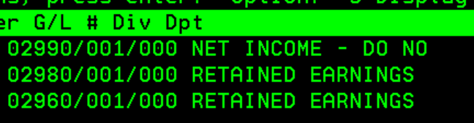
- Debit G/L 2990-1-0 for the total Net Income of the prior year
- Credit G/L 2980-1-0 for the total balance showing in this account at the end of period 13 (PY)
  - This zero’s the balance in G/L 2980-1-0 as of Oct 1st, the beginning of current fiscal year
- Credit G/L 2960-1-0 for the difference
  - G/L 2960-1-0 is our primary retained earnings account

Calendar Year Update
- Do on 1/2/YY
- From Starting Menu:
  - Accounts Payable
    - Maintenance Menu
    - Control File (Enter)
    - YRPRHI - Edit – Increase the YR by one
    - YRPRLO – Edit – Increase the YR by one

Reconcile All Balance Sheet Accounts
All balance sheet accounts need to be reviewed and approved and cleaned up. It is best to stay on top of this throughout year and do a deep dive into each in July through September, so the year-end close process can proceed seamlessly.
There is a list of balance sheet GL saved here, that list is of who provides information for year-end reconciliation of accounts. (ex. 2370 & 1070 purchasing; 1160 marketing)

Profit Sharing
Annually, net income of the company is reviewed to determine if a Profit Sharing bonus will be paid. This procedure outlines the process to determine if a bonus will be paid, how it is calculated, when it is paid and how the bonus is distributed to eligible employees.
- Profit Sharing Calculation
  - The bonus will be paid if the company’s annual net income is 3.75% or greater for the fiscal year based on the preliminary audited financial statements.
  - The amount is 1% of Net Income before taxes
    - Taxes is defined as state & local income taxes listed on the face of the P&L in the Other Income/(Expense) grouping right after Income from operations and before Net Income.
- Post Accrual to Period 13 (If the 3.75% NI Goal is met)
  - The estimated profit-sharing bonus should be accrued to period 13 prior to sending preliminary financial statements to the audit team
  - The entry should be recorded as follows:

Account Number Debit/Credit
5680-1-1 Debit
2710-1-0 Credit
- Calculate distributions to eligible employees (To be completed by the controller and sent to the UP, CFO, President for approval)
  - HR will provide a list of employees who are eligible to receive the profit-sharing bonus. The listing should include the following:
    - Employee #
    - Employee Name
    - Pay Type – Salary or Hourly
    - Regular Hours worked
    - OT Hours Worked
  - Sort the file based on Pay Type. This is important because hourly employees will receive a portion of the distribution based on OT hours worked during the year.
  - Add a column to total Regular hours and OT hours. This is calculated for Hourly paid employees only.
  - Salary employee distribution (Column K in Example)
    - Total Profit Sharing amount (cell J2 in example) divided by total eligible employees
  - Hourly employee distribution

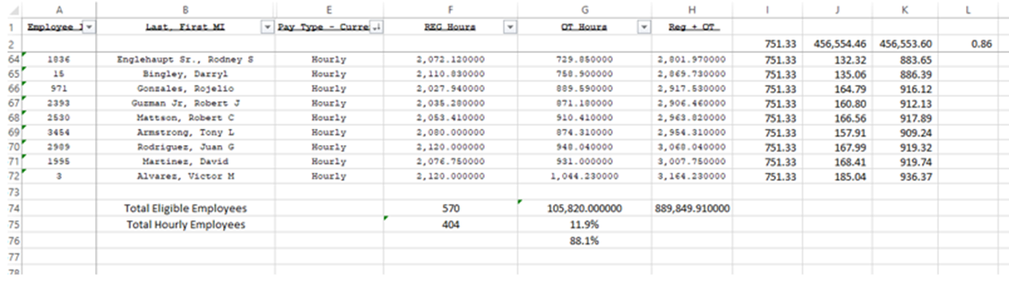

  - Calculate the total % Regular Hours of total Hours paid for hourly employees for the period
    - Total Column F (hourly employees only) divided by Total Column H (hourly employees only)
  - Regular bonus payment (Column I in example)
    - Initial value=% of Salary Value calculated in step i
    - The initial value will be adjusted based on the calculated OT payments. The adjustment will be made to balance the total payment to the total profit sharing to be paid in step #1.
  - OT bonus payment (Column J in example)
    - Regular Hourly bonus divided by total Reg hours
    - Result of #1 multiplied by OT hours
    - Result of #2 multiplied by 0.5
    - Round the result of #3 to 2 decimal places
    - Formula per below example is (row 69)
=ROUND(I69/F69*0.5),2)
    - Copy this formula to all hour employees
  - Total bonus payment (Column K in Example)
    - Regular bonus + OT Bonus
  - Total all bonus payments – salary & hourly (Cell K2 in example)
    - Calculate the difference between Calculated bonus payments (step iv) and Total Profit sharing amount (step #1)
    - In example – Cell L2 calculation is J2-K2
    - Take the value calculated in step v and divide by the number of eligible hourly employees
    - Adjust the Regular bonus payment (step i) by the value calculated in step vi.
    - Continue to make adjustments to the Hourly Regular Bonus until the variance between the Calculated bonus and Total Profit Sharing amount in minimal (step v – cell L2 in example)
    - Final formula for the Hourly Reg Bonus in example is:
=ROUND(+K3*G576,2)+48.6-2.99
- Example

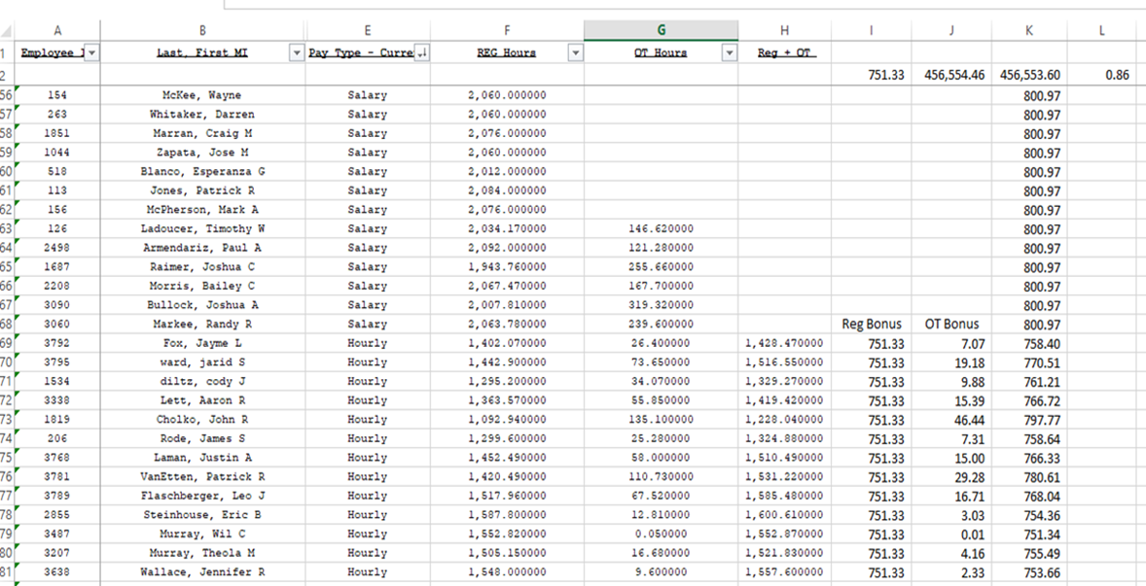

- Once approved, CFO will submit to Human Resources for December payout.
- Once the profit sharing has been calculated for each employee, send the file to the President for review and approval.
- After the file has been approved by the President, send the file to HR/Payroll to be paid. Payment must be issued before December 15th for tax purposes.
- Send the Hourly Reg bonus amount to the VP of HR and Director of HR so the Profit-Sharing letters can be updated and sent out.

Tax Filings and Compliances

Sales Tax Reports
- Open F:\Accounting\Shared\Tax\Sales, Use & Tire Tax\20xx This is where all information is be saved.
  - To determine the amount of sales tax collected per location. Prepare after the 1st; file and pay by the 15th of each month.
  - 1 Tire Dealer System
  - 2 Sales Menu
  - 8 Sales Tax Due/Collected Report
  - Enter Store = enter for all stores
  - Enter through date screen
  - Order = ‘02’
  - Enter State = ‘00’ for all states
  - Use history from Sales or Invoice = ‘S’
  - Period low and high = calendar month being filed
  - Place Report on Hold
- Save and convert this file to excel each month under current month reconciling. Rename as Sales Tax Collected by Location xx-xx-xx
  - When converting place breaks at 50, 72, and 105
  - Place a filter on row 10 “Code Description Excise Tax Sales Tax Due”
  - Select only the “Store Number” rows in column A and highlight
  - Unfilter A and filter column C to only show “Total Collected Tax” and “Store Total Collected Tax”
  - Filter column D to remove all zeros
  - Highlight remaining rows in a different color.
  - Unfilter all columns, the worksheet now shows where each location starts and ends, along with each states total per location
  - File save as “Sales Tax Collected per State XX.XX.XX)
    - Make sure to change the file type from Unicode to Excel
- To determine monthly sales:
  - 1 Tire Dealer System
  - 2 Sales Menu
  - 2 Monthly Sales Reports.
  - 1 Sales Summary
  - “Enter Store or Region Number to be Used” = ‘000’ for all stores
  - “Year/Period” = YYYY/MM calendar month being reconciled
  - Character code for group to be viewed = ‘ST’ (only)
  - Print total page only? = Y
  - Tab to the field labeled ‘Customer State’ = enter 12 (for Illinois)
  - Enter through the next three screens.
  - Use replacement or actual cost? = ‘A’
  - Place Report on Hold
- Repeat steps for all state codes.
  - Colorado = 5
  - Connecticut = 6
  - Illinois = 12
  - Indiana = 13
  - Iowa = 14
  - Kansas = 15
  - Kentucky = 16
  - Maine = 18
  - Massachusetts = 20
  - Michigan = 21
  - Minnesota = 22
  - Missouri = 24
  - Nebraska = 26
  - New Hampshire = 28
  - New Mexico = 30
  - New York = 31
  - North Dakota = 33
  - Ohio = 34
  - Oklahoma = 35
  - Pennsylvania = 37
  - South Dakota = 40
  - Texas = 42
  - Wisconsin = 48
  - Add additional reports as we expand into new States
Save and rename each file “State abv Sales Summary xx-xx-xx) to current month.
- To retrieve General Ledger balances
  - 3 General Ledger
  - 4 Reports Menu
  - 2 Other Reports
  - 3 Trial Balance Report
  - Enter the Store Number to be Used = 000 for all stores.
  - Enter through date screen.
  - Order = ‘01’ G/L account number / division / department.
  - Include Year Period = fiscal month for which payment is being calculated.
  - G/L Account = 2500 thru 2500.
  - Print the Trial Balance consolidated? N
  - Place report on hold and print
- Save and rename as GL Trial Balance xx-xx-xx.
- To find each instance of the use of ‘99SLTAX’ Open MaddenCo:
  - 1 Tire Dealer System
  - 5 Invoice History Menu
  - 17 Invoice History Reports
  - 2 Invoice History Salesman Report
  - Enter Store or Region Number to be Used = ‘000’ for all stores.
  - Enter through date screen.
  - Order = 01 Salesman, Invoice #.
  - Salesman Type = ‘S’
  - Product Class = ‘98’ (low and high columns)
  - Year/Period = current calendar month reconciling
  - Place report on Hold = Y
- Save and convert this file to excel each month under current month reconciling. Rename as 99SLTAx Report xx-xx-xx
  - When converting leave breaks where they are and add a break 80
  - Place a filter on row 11 “Invoice Date Product Description Qty Price Extension Profit”
  - Look for instances of 99SLTAX (This is where sales tax has been refunded)
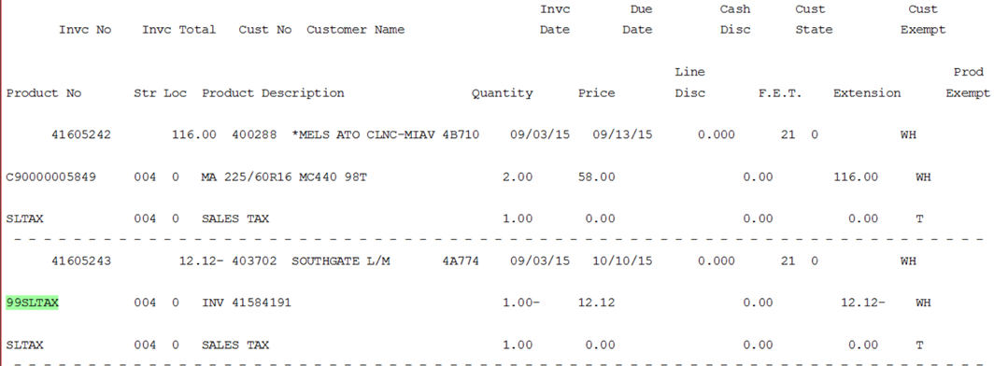

Calculating Sales Tax
- Tax Tab
  - Using the sales tax collected by location report, fill in the appropriate month with the “Total Collected Tax” dollar amounts per store, per locality, per state.
  - Fill in the GL 2500 row using the GL trial balance (Debit balances are entered as negative
  - If after all information is entered and there is a variance for any location review the 99SLTAX Report file
    - Print these invoices from MaddenCo and save in the Support Docs folder renaming them with the invoice number.
    - When entering the adjustment from the invoice use the invoice number to determine the store location and the customer city to determine the city location.
    - Ex. Inv#13782228 with the customer address of Lebanon PA would be Loc 1 and the adjustment made to Pennsylvania
    - If there is still a variance for a location after all 99SLTAX instances have been added, there is a chance that a refund was not coded with the 99SLTAX. If this is the case filter the report so that you only see invoices for the location that is out of balance.
    - Look in column G “Extension”, if there was a refund, the dollar amount will show an “N” at the end. The N lets you know that the invoice was for a refund of sales tax.
    - The invoices in green are those that have been refunded but they were not coded using the 99SLTAX product code.
    - If there are still variances review all formulas and previous month entries
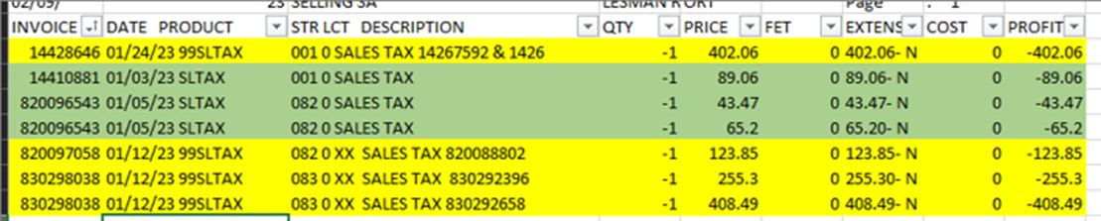

- IMPORTANT- DO NOT MISS THIS STEP OR YOU WILL PAY THE SAME MONTH TWICE
  - Copy from the OH 1 Illinois cell to include all location columns down to the GL 2500 row and paste up top in the unmarked grid.
  - This is where all other tabs pull the months information for different formulas
- Each state with multiple stores has a main store. Below are all states with main and additional stores
  - Ohio
    - Allen 3400000 (main store)
    - Lucas 3400002
    - Portage 3400003
    - Columbus 3400004
  - Wisconsin
    - WI State 4800000
    - Madison 4800001
    - Milwaukee 4800002 (main store)
  - Iowa
    - IA State 1400000
    - Des Moines 1400001
    - Carter Lake 1400002
    - Grinnell 1400003 (main store)
    - Cedar Rapids (adding)
  - South Dakota
    - Tea 4000000
    - Beresford 4000047 (main store)
    - Box Elder 4000049
    - Occasionally there will be sales tax for Wyoming State, this is to be added to Beresford
  - Texas
    - TX State 4200000
    - Arlington 4200001
    - Houston 4200002
    - San Antonio 4200003
    - Lubbock 4200004
    - Each City/Town that we warehouse products in Texas uses the same sales tax rate. Arlington was picked because it’s the first city on the Madden Co sales tax report.
- Sales Tab
  - Using the sales summary reports for each state fill in the sales tab per state, per store.
  - For the states that have multiple stores (Iowa, Kansas, Minnesota, Ohio, & Texas) subtract the additional store’s sales total from the State’s total. If there is a state amount this is added to the main store.
  - Ex. Franklin receives WI total sales minus the amount that is listed for Portage
- State tabs
  - Light blue tabs are paid monthly, dark blue quarterly, and yellow is paid on the odd quarter
  - Each states tab should pull all needed information from the current month tax tab section and current month sales tab section.
  - Review each state and clear out any use tax from the prior month
  - Update formulas on the quarter and odd quarter tabs as needed
  - All yellow cells
  - Follow each tab to know what amount needs to go where on each state’s website
  - The amount shown as crediting the 1014 account is what each amount due should be
  - Below the General Ledger Entry is a balancing formula, be sure to review as each state should show balances. If it says check entry be sure to review all formulas
  - Check the discount calculation off to the side to be sure that the proper discount is being taken, this will need reviewed and updated each month.

Sales Tax Payment and Posting (Must complete use tax section. Next, prior to making payment)
- To file, pay and post sales tax payments prior to the 20th of each month for the following States:
- Ohio
- Michigan
- Illinois
- Minnesota
- Nebraska
- Kansas
- Oklahoma
- Pennsylvania
- Texas
- Indiana
- South Dakota
- North Dakota
- Iowa
- New Mexico
- Connecticut
- To file, pay and post sales tax payments prior to the 15th of each quarter for Maine
- To file, pay and post sales tax payments prior to the 20th of the odd quarter dates for New York.
  - Each State is filed and paid via ACH Debit on their respective websites.
  - Use amounts calculated per state in F:\Accounts Payable\Shared\Forms\Sales Tax\Sales Tax Calculator 20xx to fill in the returns of each respective state’s website listed below.
- Logins can be found at:
  - F:\Accounting\Shared\Tax\Sales, Use & Tire Tax\Sales and Estimate Logins.xlsx
- Follow each states tab on the Sales Tax Calculator spreadsheet to file and pay
- Each state website is different, follow all prompts while filing and paying
- Review previous month filings as needed to make sure filing is done correctly
- Print all receipts, confirmations, returns, and excel calculator sheets
- Ohio: https://ohiobusinessgateway.ohio.gov/OBG/Membership/Security.mvc/Login#MainContainer
  - Create own OH|ID
  - Request Access to K&M
- Illinois: https://mytax.illinois.gov/
  - Account Master will have to create login
  - Settings
  - Additional Logons
  - Add
  - Fill in info
    - Must call 217-785-3707 in order to change Account Master info
- Minnesota: https://www.mndor.state.mn.us/tp/eservices/_/#1
  - Account Master can create login
  - Manage My Profile
  - I want to….
  - Other Users
    - Manage Internal access to my accounts
- Nebraska: https://ndr-efs.ne.gov/revefs/allPages/login.faces (Sales and Use) & https://revenue.nebraska.gov/businesses/nebraska-e-pay (Waste)
  - Unable to have separate logins
  - Sales and Use: NebFile
    - User ID = 10847391
    - Pin = 24017
  - Waste Tax: E-Pay
    - User ID = 10847391
    - Password = Delphos^22
  - E-pay forgot password questions: City of 1st job? = Delphos, On what street did you grow up? = Elida, Authorization code? = 5683
  - Only allowed one login per ID
- Kansas: https://www.kdor.ks.gov/apps/kcsc/login.aspx
  - Account Master will give access
  - Register for new account
  - Acct Master Manage Acct
  - Manage access to this account
  - Add User
  - Fill in new email
  - Enter 7-digit access code from below
- Oklahoma https://oktap.tax.ok.gov/OkTAP/Web/_/#2
  - Account master will have to create login
  - Settings
  - Additional logons
  - Add
- Texas: https://mycpa.cpa.state.tx.us/securitymp1portal/displayLoginUser.do
  - Create own WebFile ID
  - File and Pay Taxes
  - Enter 11 Digit Tax ID from below
  - Click Assign on desired taxes
  - Enter Webfile number from below
    - Annual Franchise Tax only file payment actual return is sent via mail
- South Dakota: http://dor.sd.gov/epath
  - Administrator has to add account
  - Add User Account
  - Complete username and accounts
- Indiana: https://intime.dor.in.gov/eServices/_/
  - Account Master will have to create login
  - All Actions
  - Manage Account Access
  - Add Additional Logon
- Iowa: https://govconnect.iowa.gov/tap/_/
  - Switching accounts working to get new account setup
- Wisconsin: https://tap.revenue.wi.gov/mta/_/#1
  - Create New Username
  - Enter all required info
  - Login using security code
  - Add Access to an Account
  - Select Specific Tax
  - Enter Required Info
- North Dakota: https://apps.nd.gov/tax/sales/webfile/login.htm
  - Sign up for Access
  - Access Type = Employee
  - Enter all required info
  - Once letter is received follow prompts to gain access
- Michigan: https://mto.treasury.michigan.gov/eai/mtologin/authenticate?URL=/
  - Create Login
  - After first logging in add Relationship
  - Provide all requested info
  - Enter Access Code
- Maine: https://portal.maine.gov/salestax/
  - Username: 1187877
  - Password: Delphos^2021
  - Only one login allowed per ID
- New York: https://my.ny.gov/sreg/Login/
  - Master Administrator must create login
    - Must file Annual Tax Return for Sales Tax. Payroll company will file it with the withholding information. K&M must file with the sales and use tax portion.
- Connecticut: https://drs.ct.gov/eservices/_/#10
  - Single login due to only filing estimates and zero dollar sales tax returns
  - Username: KMTire
  - Password: Delphos^23
- New Mexico: Accounting SOP Binder12.27.2022.docx
  - Create Logon
  - Provide all requested info
- Pennsylvania: https://mypath.pa.gov/_/
  - Sign Up
  - Enter all required info
- Print a copy of: payment confirmation, return, return confirmation, and excel calculation.
- Make journal entries for each state following the excel print off and record the reference number.
  - Description ex. = April OH Sales Tax Payment, April OH Tire Tax Payment, Q2 NY Sales Tax Payment
- Post payments to the Bank Ledger (Chase AP) @ F:\Accounts Receivable\Shared\Bank Ledgers\K&M Inc.
  - Use the same description as the GL entry but drop the month and payment, ex. Q2 NY Sales Tax, OH Sales Tax.
  - Illinois, Minnesota, Texas and Nebraska’s debits may need to be adjusted by a few cents in order to make the entry balance since these state’s round all or portions of their returns.
- Scan and save each State to appropriate month and year folder: F:\Accounting\Shared\Tax\Sales, Use & Tire Tax\Year\Month\Filing
- State tax account #’s:
- OH 02-038764
- MI ME-0172702
- IL 3564-0642
- MN 1841307
- NE 001-0/10847391
- KS 004-341212834-F01 / 0238691
- OK STS-10127206-06
- TX 1-34-1212834-3 / RT371422
- IN 0123823412
- IA 1-77-116839
- WI 456-102652 0163-04
- ND 26508400
- SD 1030-1494-STMC
- PA 0123823412
- NM 03-604844-00-5
- CT 076543982-0001

Use Tax
NOTE: This must be done before filing sales tax
The purpose of Use Tax SOP is to outline our process for identifying and reporting use tax due by K&M to state taxing authorities. Use tax is a compensating sales tax payable when certain taxable items are purchased by K&M Tire and sales tax was not collected by seller on invoice when we made the purchase.
- Review accounts 5440, 5570, 5050, and 1630 for instances of use tax.
  - Note,
- When reviewing each location, look for amounts larger than $300, if a vendor is over $300 then review the Sales Tax Customer list to see if they charge us sales tax or not
- If a vendor does not charge us sales tax, then pull the invoice to scan and save as backup
- Record the amount of the sale on the appropriate states tab so that use tax will be paid
- Make sure any use tax amount is posted to the appropriate GL when making sales tax entries
  - Ex. Truck repairs in Great Bend should be posted to 5050-56 on the General Ledger Entry
- Be sure to only update the additional amounts for Allen County and not the entire formula
- Review the General Ledger Entry to be sure all accounts are listed correctly
- Ohio Use tax account is 97-808509 paid quarterly on form UST1
  - cleaning payments for Emily Coil or Susan Hall should always be 13 weeks.
- Use tax is reported on the sales tax form for all other states
- Controller must review the list of invoices pulled by vendor and approve before they are included/add on sales tax return.

NOTE: This must be done before filing sales tax

The purpose of Use Tax SOP is to outline our process for identifying and reporting use tax due by K&M to state taxing authorities. Use tax is a compensating sales tax payable when certain taxable items are purchased by K&M Tire and sales tax was not collected by seller on invoice when we made the purchase.

- Retrieve GL account activity for review
- This can be done through MaddenCo or Intranet.
- If pulling from Intranet, go to Accounting, then GL Account Activity
- Select the period you are doing sales tax for (for NY, OH, ME, and CT you will have to select three months at a time because these are quarterly filings and for Colorado you would select the whole year because they are annual)
- Select accounts 1630, 5050, 5440, 5450, and 5570
- Select the in-state locations needed for each state tab on the sales tax spreadsheet which is saved "F:\Accounting\Shared\General Ledger\Balance Sheet Reconciliations 2026\2500"
For example, if you are doing OH you would select locations 1,2,3, and 15 because they are all located in Ohio
- After selecting date range, GL accounts, and locations, select Account Activity tab
- Click run report to retrieve the GL activity for analysis
- Once the report is done, turn it into an excel file
- Put a filter on the second row and sort the description column by A-Z
- Save the file at “F:\Accounting\Shared\Tax\Sales, Use & Tire Tax\20XX\[Month Year]\Filings” with a name that identifies both state and period.
  - File name example: OH 3.31.25 use tax spreadsheet
- Repeat these steps for each state
- Open the use tax spreadsheets you just created and delete any A/R Adjustment Store- 001, A/R cash store- 001, and First Financial Bank lines
- Next open the Sales and Use Tax vendor list spreadsheet F:\Accounting\Shared\Tax\Sales, Use & Tire Tax\Sales and Use Tax customer list.xlsx
  - This list contains G/L account, Vendors, and Notes for each. Notes include: Check for tax, Charges Tax, Needs Taxed, Service Not Taxable, etc.
  - NOTE: This spreadsheet should be reviewed annually by the Controller and updated on an interim basis with any changes identified during state sales & use tax audits.
- When reviewing truck repair invoices, note that in several states we now qualify for tax exempt status on repair parts and labor
  - This is because Tribune is the operator and is a “For-Hire” motor carrier
  - Refer to Tribune’s sales-tax exempt schedule by state for qualifying tax exempt status
- Go through what is left on the use tax spreadsheet and look for the names of the companies on the sales and use tax customer list to identify what may be subject to use tax.
- If they are on the list and beside their name it says charges tax, you can remove them from the use tax spreadsheet
- If they are on the list and beside their name it says needs taxed, look for the invoice in the Ap invoices inbox either under invoice box deletes or Approved for Payment. Once you find the invoice see if sales tax was charged and if not leave it on the use tax spreadsheet.
- If sales tax was charged then you can remove them from the list and change the needs taxed to charges tax.
- If they are not on the list at all you need to look for the invoice and see if they charged sales tax and if not, then you need to google if whatever the invoice is for should be charging sales tax. Confirm your findings with the Controller.
For example, if the invoice is for snow removal google is snow removal taxable in OH or whatever state the service was provided in.
- Make sure to save the use tax spreadsheet with the updates after you have reviewed all the items on the list.
- Compare use tax invoices identified for current month with total of those identified in previous month and what would be normally expected.
  - If there are any material increases or decreases, confirm current month amounts with Controller before proceeding.
- Once you have figured out what needs to stay on the use tax spreadsheet because use tax is due, go to your sales tax spreadsheet and under the tab for the state you will enter the total amount in the field “Use Tax Purchases”
- OH, has its own use tax tab and you will have to filter the use tax spreadsheet to figure out how much goes to each location and then put those amounts in “taxable purchases” field beside each location
- In the General ledger entry table on each state tab, you will click on the number beside each location under the formula column for the GL’s we run use tax for and change the amount in the formula to what it needs to be for each GL and location. This creates the G/L entry to post the use tax to the correct G/L account where the original invoice was posted.
- All other use taxes are built within the state tab. Some will say amount of purchases, taxable sale, or use tax purchases
- Some tabs will have either where you put the whole total in one spot, or it is split out at the top or you must input it on a table.
- In the General Ledger entry table make sure to look at the GL’s for the ones we run use tax for. If the use tax is input as a lump sum put the GL that the highest amount goes to
- If it’s split, make sure to look at what GL is used most for that location.
For example, WI is split between 31 and 33. If 31 most goes to 5570-33 change it to that and if most goes to 5050-31 change it to that
- If the state has use tax, make sure to select the box at the bottom of the general ledger entry table that says use tax. If it doesn’t have use tax, select no use tax.
Tip- if last month it was selected use tax and this month it isn’t you have to unselect use tax first then select no use tax.
- Once completed, forward spreadsheet showing Use tax to Controller for review, before reporting in on Sales & Use tax return.

*WHEN POSTING USE TAX, POST THE TAX TO THE SAME GL ACCOUNT AS THE INVOICE IS POSTED*

State Tire Fee Report

Summary
OH, NY, PA, IL, NE, and KS all have tire fees
OH = Monthly
NY, PA, IL, and NE = Quarterly (NY & PA are always zero)
KS = Annually
NY, PA, NE are all exempt from filing as we are not a retailer, we are a wholesaler.

OH, NY, & PA Report
OH, NY and PA use the below report. However, all PA & NY tires are exempt.
- Open MaddenCo
  - 1 MaddenCo Tire Dealer System
  - 1 Tire Dealer System
  - 2 Sales Menu
  - 2 Monthly Sales Reports
  - 10 10-Column Sales Report
- “Enter Store or Region Number to be Used” = ‘000’ for all stores
- Enter through date screen
- “Report Period” = calendar month, for which, payment is being calculated.
- Monthly 10 Column Sales Report
  - “Report Format Name” = ‘TIREFE’
  - “Which category” = ‘1’ to print by store number totals
  - “Create a file” = ‘N’
  - Enter twice to print.
- Cross reference report totals with GL 2510 balance.
- F3 to Starting Menu
  - 3 General Ledger
  - 3 Inquiry Menu
  - 1 Balance Inquiry
- “Enter the Store Number to be Used” = ‘000’ for all stores
- G/L Balance Inquiry
  - “G/L Account” = ‘2510-xx’ where ‘xx’ is the store number
    - Store 1, 2, 3 and 15 from the report. See below for an example.
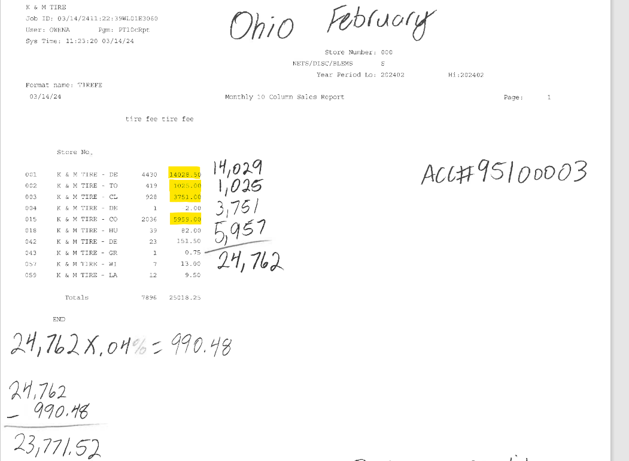
  - Tab to fiscal year/month that corresponds to step 5 above.
  - Ending balance = payment amount.
  - Calculate (currently 4%) cash discount that posts to 4055-1-1
  - File and Pay on Ohio Business Gateway

NE & IL Tire Fee
NE and IL Tire Fee calculation. All NE tires are exempt.
Both states use the same report but are calculated differently
- Tire Dealer
- Sales
- Daily Sales
- Sales Summary
- Enter
- Date (3 months)
- Enter
- Two character order = VN
- Enter
- Print total only = Y
- Pro class = low – 01 high – 03
- Customer state = 12 (IL) or 26 (NE)
- Exclude non-merch = N
- Enter x 3
- Actual
For NE
- We file the paper return mailed to the corporate office. See the example below.
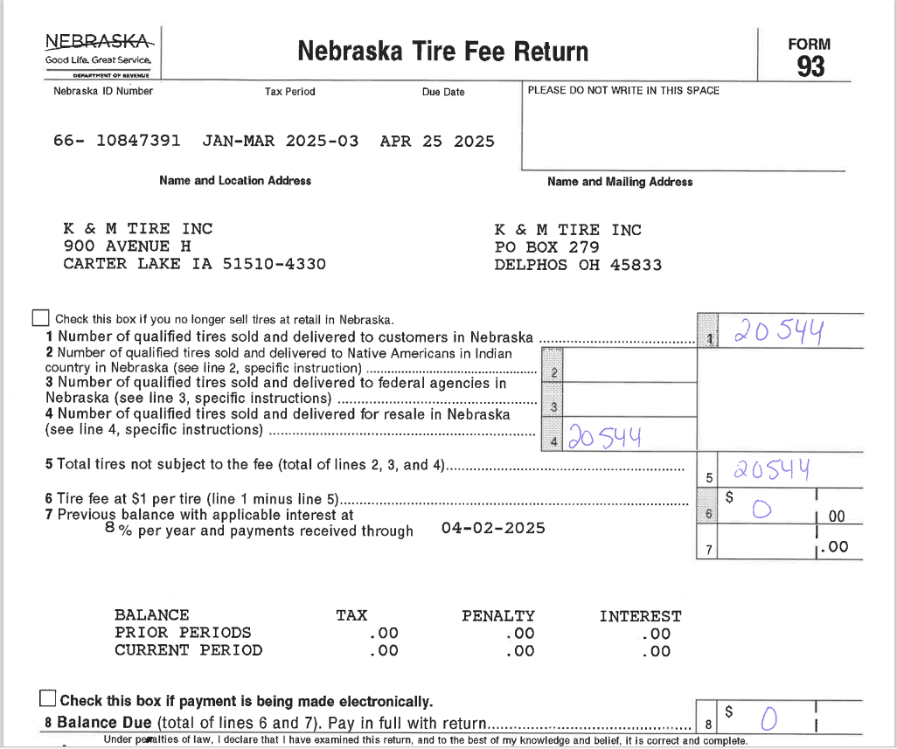
For IL
- Take total tires in MaddenCo 2510-42 at the end of the quarter divided by 2.50 (fee per tire)
- Multiply this amount by .10 (10%)
- Exempt tire total comes from the total tires on the Sales Summary report ran before minus the amount determined in step 1
- Debit the 2510 with the number of tires in MaddenCo, credit the percentage amount to the 4055 and the 1014 account for amount due. See example below
- File online via https://mytax.illinois.gov/_/
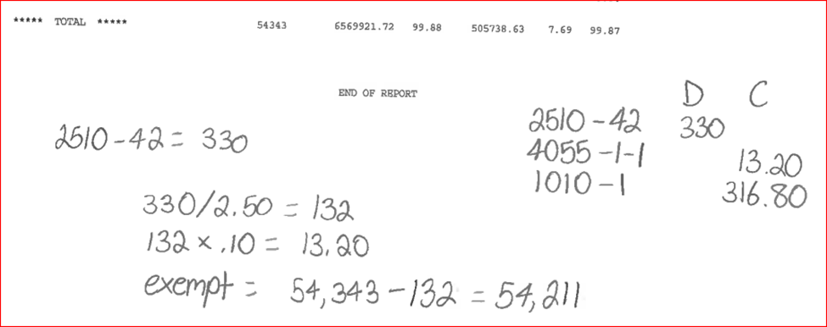

KS Tire Fee
KS Tire Tax Filing must be submitted via mail
- Number of tires in 2510-57 and 2510-59
- Multiply line 1 by .25
- Zero as long as paid on time
- No credits
- Total should match line 2
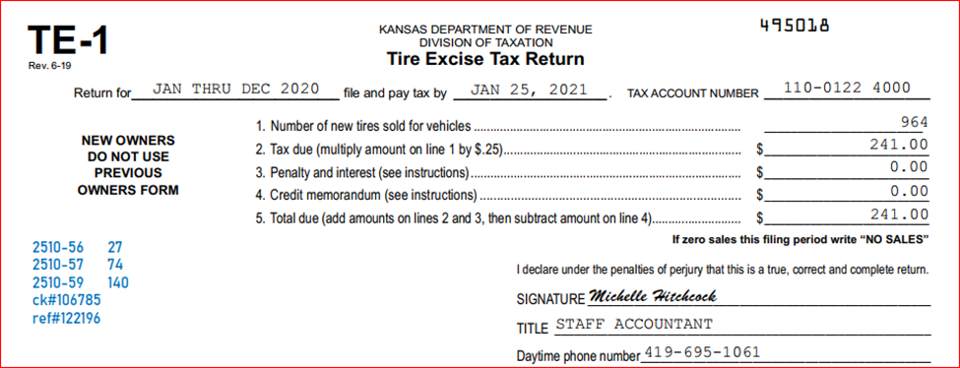
- Debit number of tires in each location and credit 1014-1

CAT TAX – Commercial Activity Tax – Quarterly Return
The Commercial Activity Tax (CAT) is a business privilege tax imposed on the gross receipts of businesses doing business in Ohio and Texas.
- To find the Taxable Gross Receipts run a Sales Summary Report using the below:
  - 1 Tire Dealer System
  - 2 Sales Menu
  - 2 Monthly Sales Reports
  - 1 Sales Summary
  - Store = R60
  - Year Period = 3 months for the quarter needed
  - Selections = CC & ST
  - Print Total Page? = Yes
  - Customer State = 34
  - Enter 3 times
  - A for Actual Cost
  - Place report on hold
- Save the CAT Worksheet as the year and quarter filing for
- Enter Total Sales amount from the Sales Summary Report in the Taxable Gross Receipts box (box 1)
  - All other amounts should autofill
  - When filing Q3 with Job Creation Credit do the following
    - Complete credit schedule
    - Scan and Upload when filing both credit schedule and certificate for credit
- Login to OH Business Gateway to file and pay
  - Fill in account year, filing period, return type, and submit as (actual)
  - Total Taxable Gross Receipts = box 1 from excel
- Make entry to MaddenCo
  - Debit 2515-1-1 and Credit 1017-1
- Enter on K&M Inc PNC AP tab

Unclaimed Funds
Due to the type of business K&M does we are exempt from having to report any unclaimed funds.
- The only action that must be taken by November 1st of each year is filing a “Negative Unclaimed Funds Report” on the Ohio Business Gateway site. https://ohid.ohio.gov/wps/portal/gov/ohid/login .
- Save each report under F:\Accounting\Shared\Unclaimed Funds Reporting

Income Tax Payments

Quarterly Income Tax Estimate Payments
Dave Estupinan from M&Z will file extensions and calculate Quarterly Income Tax Estimated payments. The accountant is then to make payments for each filing if necessary. Filing instructions will be sent from M&Z stating the amount that needs paid and any other important information.
- Create a copy of Estimated Tax Payment instructions and Save to
  - F:\Accounting\Shared\Tax\Taxes\Income Tax\Current Year
  - Select appropriate year, Estimated Payments, Appropriate Quarter
- All instruction payments forms have been listed on the workbook “All annual and estimate payments FY 20XX”. F:\Accounting\Shared\Tax\Taxes\Income Tax\Estimated Payment spreadsheet
- Depending on the taxing authority, we will either make a payment online or pay by check.
- When making estimated tax payments, post the Debit to G/L 2980-1-0
  - We post here when making payment, and Dave Estupinan from M&Z will separate out and give us a reclassifying entry at Y/E.
  - He separates these out based on nature: some are for state & local income taxes while others are for non-resident shareholder withholding.
- If paying by check, you will need to provide AP with a copy of the payment instructions and approval to pay.
  - AP will run a check before each payment’s due date, and hand the check back to the accounting department.
  - Accounting is responsible for mailing the check with the payment voucher, ensuring each payment is mailed and postmarked before due date.
- If the estimated payment requires an Electronic Funds Transfer (EFT) or Online payment/filing, please see instructions provided by M&Z and refer to the specific taxing authority’s tab on the excel spreadsheet. F:\Accounting\Shared\Tax\Taxes\Income Tax\Estimated Payment spreadsheet
  - Due to the nature of state websites constantly changing, individual state and local payment instructions are saved on this spreadsheet rather than in the SOP.
  - Not all states require a login for submitting payment. If the state does require a login, it can be found at F:\Accounting\Shared\Tax\Sales, Use & Tire Tax\Sales and Estimate Logins.xlsx
- BE AWARE: When making payments online, it is IMPARITIVE that you select the correct tax period for which the payment is to be applied.
  - The tax period that the estimated payment is for can be found on the filing instructions provided by M&Z.
  - If there are any questions, please stop and ask the Controller. If you select the wrong tax period, this can result in penalties and interest, plus 1-2 hours of the Controller’s time waiting on hold with the Taxing Authority trying to correct the mistake!
- Record the payment on the Estimated Payment spreadsheet
Example:
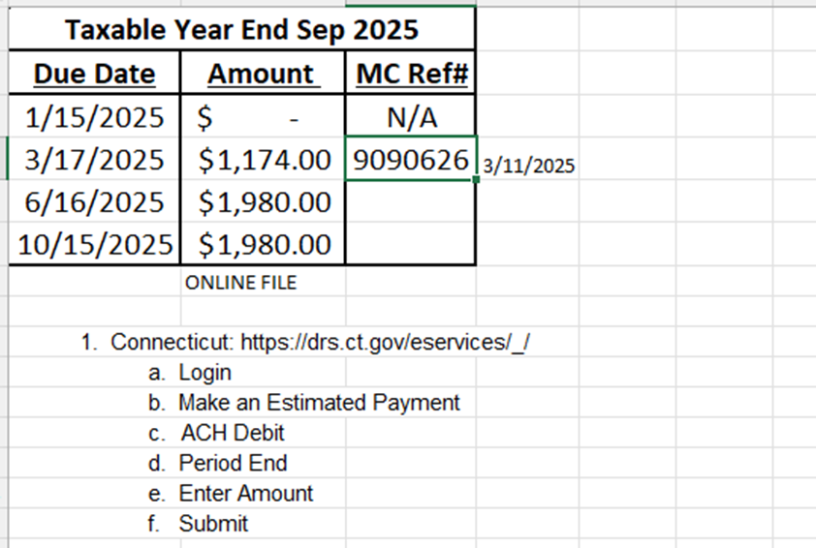
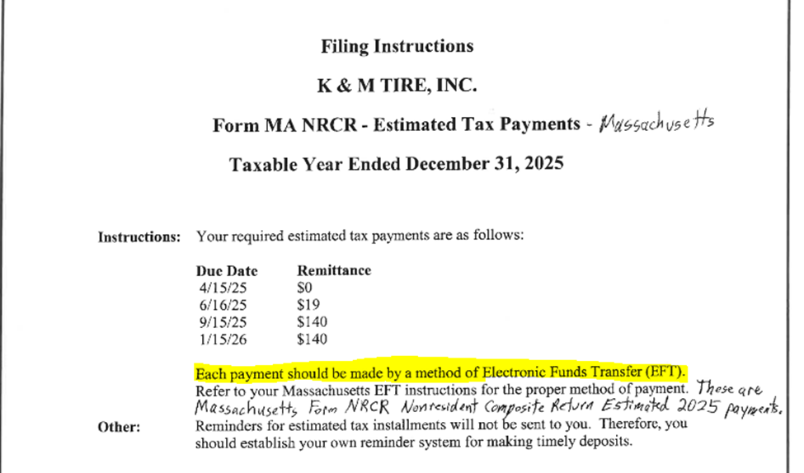
- Online payment filing form example:

- AP check form example:
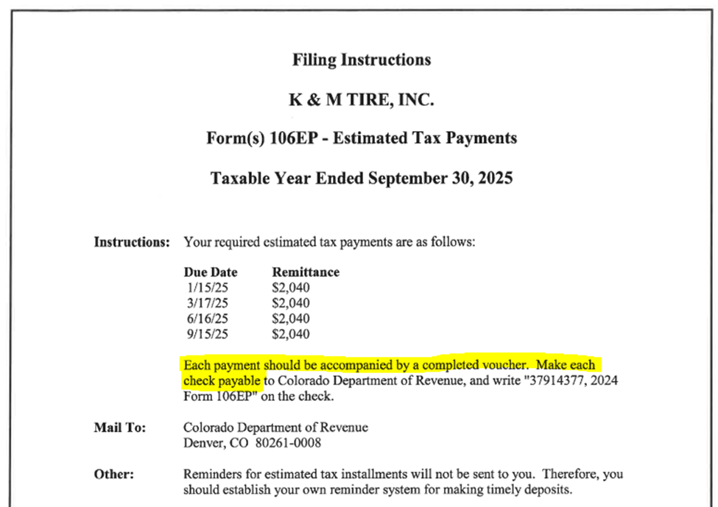

Annual Income Tax Extension Filing
Dave from M&Z will file all extensions, the staff accountant is then to make payments for each filing if necessary. Filing instructions will be sent over from M&Z stating the amount that needs paid and any other important information.
- When paying online, JE will be:
  - Debit – 2980 & Credit – 1017
- Print and Save to F:\Accounting\Shared\Tax\Taxes\Income Tax
  - Select appropriate year and save in Extension Payments
- New York: https://my.ny.gov/sreg/Login/
  - Normal login
  - Top left click on “Services”
  - Corporation Tax
  - Make Estimate or MFI (Mandatory First Installment) Payment
  - Form CT3
  - Fiscal Date Filing
  - “Yes” for mandatory first installment payment

  - New York State MFI Payment Amount = amount instructed by M&Z on instructions
  - Submit
- Minnesota: https://www.mndor.state.mn.us/tp/eservices/_/#1
  - Normal login
  - S Corporation Tax
  - Make a Payment
  - Payment Type = Extension
  - Period = Fiscal Year End
  - Payment amount = amount listed in instructions
  - Submit
- Massachusetts: https://mtc.dor.state.ma.us/mtc/_/
  - Login
  - Corporate Excise Tax
  - Make a Payment
  - EFT Payment
  - Extension Payment
  - Filing Period
  - Payment amount listed in M&Z instructions
  - Submit
- Illinois: https://mytax.illinois.gov/
  - Normal Login
  - Account Type = Business
  - Taxable Year End
  - Make a Payment
  - Bank Account Debit
  - IL-1120 ST Payment
  - Submit
- Wisconsin: https://tap.revenue.wi.gov/mta/_/#1
  - Normal Login
  - Pass-Through
  - Pass-Through Account
  - Taxable Year End
  - Make a Payment
  - Estimated Payment
  - Submit
  - Corporation
  - Corporation Account
  - Taxable Year End
  - Make a Payment
  - Estimated Payment
  - Submit
- Nebraska: https://revenue.nebraska.gov/businesses/nebraska-e-pay
  - Normal Waste login
  - 02300 – Corporation Income Tax-Extension
  - Submit
- Connecticut: https://drsbustax.ct.gov/SBR/PSC/formCT1065CT1120SIReg.aspx?TXPYRTYP=B&fromwelcome=yes
  - No login
  - Form CT-1120SI
  - File an Extension
  - Taxable Period
  - Submit
  - Validate Info
  - Enter Amount
  - Submit
- Rhode Island: https://taxportal.ri.gov/rptp/portal/!ut/p/z1/04_Sj9CPykssy0xPLMnMz0vMAfIjo8zifQLcPQ2NvQ28DZx8DQwcnX39grwCTI3d3U31w8EKDIx8zAw9LQy8LSzcQQoMHMNczTyMDQyM9KNA0jiAowFUPx4LCOqPIqSkIDc0wiBdUREA9YVxmw!!/dz/d5/L2dBISEvZ0FBIS9nQSEh/
  - Login
  - RI-4868PT
  - Personal Income
  - Make a Payment
  - Type of Payment = Extension
  - Account = Personal Income
  - Form = RI 4868 EXT
  - Noted Filing Period
  - Reported Due = Payment amount
  - Reported Payments = Zero
  - Amount Due = Payment amount
  - RI-4868C
  - Composite
  - Make a Payment
  - Type of Payment = Extension
  - Account = Composite Income
  - Form RI 4868 C
    - Noted Filing Period
    - Reported Due = Payment amount
    - Reported Payments = Zero
    - Amount Due = Payment amount
    - Calculate
    - Submit
  - RI-7004
    - Corporate
    - Make a Payment
    - Type of Payment = Extension
    - Account = Corporate
    - Form RI 7004 Ext
    - Noted Filing Period
    - Ownership Type = Corporation
    - Reported Due = Payment amount
    - Reported Payments = Zero
    - Amount Due = Payment amount
    - Calculate
    - Submit
- Maine:
  - No payment is typically made
  - Automatically Extended
- Vermont
  - No login
  - Returns
  - File an extension
  - Complete information
  - Account type = Corporate Income
  - Filing period listed
  - Also make an extension payment
  - Amount Due
  - Payment information
  - Submit

Property Tax Abatements
Placeholder for SOP to be written

Business License Filings/Renewals

Annual CSC Worksheets
F:\Accounting\Shared\Compliance & Leases\CSC Global\Annual CSC fillings
All information comes from the Balance Sheet and State Income Filing
- Balance Sheet
  - F:\Accounting\Shared\Audit\Forvis Audit\
  - Applicable Fiscal Year Audit
  - K&M Tire, Inc Final Financial Statement
- State Income Filing
  - F:\Accounting\Shared\Tax\Taxes\Income Tax\State Income Taxes
  - Applicable Year
  - Choose Wisconsin not Wisconsin Withholding

Wisconsin – Due March every year.
This is emailed to members on the accounting team yearly two months prior to the due date from the CSC team.
Completing the form
- Stock information – Balance Sheet, Stockholders’ Equity
  - Class - Common
  - Series - Class A and B
  - Authorized Shares – A=, B=
  - Issued Shares – A=, B=
  - Outstanding Shares – A=, B=
  - Par Value per share - $0.00
- Gross Business – Wisconsin Income Statement, schedule A-01, Balance Sheet
  - Gross Business – line 10, Total company column
  - Gross Assets – Form 5S, line 24
  - Total liabilities other than capital and surplus – Final Audited Financials, Total current liabilities
- Wisconsin Business – Wisconsin Income Statement, schedule A-01, Form 5S
  - Wisconsin Business – line 10, Wisconsin column
  - Wisconsin Assets – Form 5S, line G1
- Paid in Capital
  - Paid in Capital, in excess of par – Class A $ amount + Class B $ amount
- General information I
  - Entered into any contract, combination in the form of trust or otherwise, or conspiracy in restraint of trade or commerce – No

Arkansas
Completing the form
- Stock information – Balance Sheet, Stockholders’ Equity
  - Class A and B
  - Number of shares usually does not change
  - Value is usually $0
- Issued and Outstanding
  - Class A and B
  - Number of shares usually does not change
  - Value is usually $0
- Property Information – State Income Filing
  - Schedule A section B line 1d. Total Property

Kansas
Completing provided excel sheet
- Total number of shares of capital stock issued: total number from the balance sheet both issued and outstanding
- Does the corporation own or lease any land in Kansas that is suitable for use in agriculture? [You do not need to indicate yes if any of the following apply: (1) tracts of land are fewer than 10 acres; (2) contiguous tracts of land are fewer than 10 acres in aggregate; (3) state-assessed railroad operating property.] Yes or no. Answer is no
- If Yes, please provide the name of the entity as it is listed with the Kansas Secretary of State: N/A

Michigan
Completing provided excel sheet
- Is this entity required to file taxes in the state of Michigan? Yes or No
- If yes, please provide both items below:
The most recent apportionment percentage: find on most recent MI tax return
- The year-end through which the percentage is valid: fiscal year of return

Texas
Completing provided excel sheet and also M&Z filing Public Information Report and Franchise Tax Return
- The annual filing in Texas is a two-step process with the Comptroller's Office: the Public Information Report (PIR) and the Franchise Tax Return (FTR). Oftentimes, your tax department or CPA files both documents because of the financial information required and the fact that they are both filed with the same office.
  - Is your tax department or CPA filing the PIR and FTR? Yes or no

New York
- Number of directors constituting the board of directors (minimum one required): Look at distribution members
- Number of directors on the board of directors that are women: Look at distribution members
Once excel is completed save one copy per state and send back to CSC

Form 8752
Each year we make a payment to or receive a refund from the US Treasury to maintain our S-Corporation required tax deposit. The amount of the deposit or refund is calculated by M&Z and filed on Form 8752, based on prior year taxable income. If we have a balance due, M&Z will provide payment voucher and payment is due by May 15th each year. If we have a refund, we typically receive the refund from the US Treasury sometime in August. Previous year filings are saved in F:\Accounting\Shared\Tax\Taxes\Income Tax\Form 8752
- When taxable income increases, we will have a balance due.
- When taxable income decreases, we will receive a refund.
- When there is a balance due, a check request needs to be completed for AP to enter payment
  - Code to G/L 1410-1 “PrePaid Income Tax - Federal”
  - Do not expense at the time of payment, as this is not an expense and will be refunded in full to the extent there is no taxable income to report

Form 05-158 Texas Franchise Tax Report
Texas Franchise Tax Report – completed by M&Z Partnership and sent to the President of K&M to be signed. Accounting receives and mails the form by due date required. Accounting also issues EFT payment via Texas Franchise Tax Portal. Previous year filings are saved in F:\Accounting\Shared\Tax\Taxes\Income Tax\20XX\Texas
To pay the annual Texas Franchise Tax, login with the normal Texas payment portal: https://security.app.cpa.state.tx.us/Dashboard/
Franchise Tax
- File and Pay
- Make a payment only
- Continue
- Report Type = Annual
  - There should only be one option
- Electronic Check
- Amount to Pay = amount listed in M&Z instruction sheet
- Enter banking information and effective date
- Submit Payment
- Print and save with tax filing report to F:/Accounting/Shared/Tax/Taxes/Income Tax/State Franchise Taxes/YEAR FORM 05-158 TX Franchise Tax Report
- Make a journal entry to debit account 2640 “Accrued State & City Income Tax” and credit cash
- The total amount paid should be allocated between all Texas locations
- Add the entry to K&M inc 20XX

Form 8802 Application for United States Residency Certification
Annual Process for Completing Form 8802
Purpose: To obtain the United States Residency Certification necessary for BKT to issue our credits and annual volume bonus.
Frequency: Annually. Can begin January 1st, but file no later than January 20th to avoid delays in receiving our BKT annual VB.
Reference: Prior year forms are saved at: F:\Accounting\Shared\Tax\Taxes\Income Tax\US Residency Certification\XXXX (year) Ensure to use the most current form from the IRS website.

Steps:
- Pay the US Residency Form 8802 Filing Fee:
  - Access the payment portal at https://www.irs.gov/payments/electronic-payment-of-user-fees.
  - Select & pay the US Residency Form 8802 filing fee
  - Obtain a confirmation code required to file for Form 8802.
  - Note: The IRS will not process the form without prior payment.
- Complete Form 8802:
  - Download fillable PFD Form 8802 from IRS website.
  - When completing, refer to prior year forms to ensure consistency in information.
  - Make adjustments only if the form has changed.
  - Submit to President for signature
- Complete Form 8821:
  - Download fillable PFD Form 8821 from IRS website.
  - When completing, refer to prior year forms to ensure consistency in information
  - Required for Cheryl and Ken (verify if need to add Jon in the future).
  - This form is necessary for the release of information listed in Box 10 of Form 8802.
- Fax Forms 8802 & 8821 to the IRS:
  - Fax both forms to IRS at 877-824-9110 after verifying fax number on form has not changed.
  - After submission, expect a receipt confirmation letter from the IRS within two to three months.
- Receive the United States Residency Certification:
  - After their review, IRS will mail K&M Tire the US Residency Certification.
  - Once received, scan and save a copy in the designated file location.
  - Email a copy to Mark Knippen (VP of Purchasing).
- Proceed with Filing 10F:
  - Access the 10F form via the India Income Tax portal at https://www.incometax.gov.in/iec/foportal.
  - Log in using the Accounting Department credentials.
    - "F:\Accounting\Shared\Tax\Sales, Use & Tire Tax\Sales and Estimate Logins.xlsx"
  - Complete in same manner as prior year
    - Reference previous filings saved in the designated location.
  - Upload the Tax Residency Certificate:
    - Required when filing the 10F.
- Submit Documentation to BKT:
  - Forward the Tax Residency Certificate, filed 10F, and a letter on K&M letterhead (template saved in prior year) to VP of Purchasing (Mark Knippen)
  - The VP of Purchasing will forward these documents to the appropriate BKT contact.
Important Notes:
- Ensure all forms are the latest versions from the IRS and relevant websites.
- Maintain consistency with prior year filings unless there are form changes.
- Securely store all login credentials and scanned documents in the designated file locations.

Form 200 – Oklahoma Annual Franchise Tax Return
Form 200 – Oklahoma Annual Franchise Tax Return – completed by M&Z Partnership and sent to the President of K&M to be signed. Accounting receives and mails the form by due date required. Accounting will provide check request to Accounts Payable Lead for a check to be made payable to Oklahoma Tax Commission. Scan and save in F:/Accounting/Shared/Tax/Taxes/Income Tax/20XX Oklahoma Annual Franchise Tax Return for Period Ending Month Day, Year
Send tax return and check payment to Vendor 1429 – and post to G/L 2640-80
Oklahoma Tax Commission
Franchise Tax
Post Office Box 26920
Oklahoma City, OK 73126-0920

Miscellaneous Additional Responsibilities

S-Corporation Distribution Payments
S-Corporation Distributions are paid out quarterly to provide shareholders funds for paying their quarterly estimated taxes on K&M Tire’s K-1 income. They are generally processed before the 10th day of the quarter, so funds can clear recipients’ bank accounts before they each mail checks out for their quarterly estimates.
- Receive quarterly distribution request from President, CFO, or EVP
- Process as an ACH for all shareholders (unless instructed to handle differently)
- If a manual check is requested by any shareholder, get blank check from AP (with Cheryl’s stamp) or have AP process the check and return to accounting
- Update K&M Inc bank ledger – for ACHs and AP checks to the specific date F:/Accounting/Shared/Bank Ledgers/
- Make entry for totals: Debit 2980-1; credit 1017-1
- Notify Cheryl, Ken, and each shareholder by email when ACH has been sent to them, include the amount.

US Census Bureau Quarterly Financial Report
- Previous submission and worksheet located at F:\Accounting\Shared\Compliance & Leases\US Census Bureau\Quarterly Financial Reports
- Go to: econhelp.census.gov/qfr
  - Username (only for this reporting): 7770032129
  - Password: a22df4f4
- Use Summary Financials pdf’s F:\Accounting\Shared\Month End\Monthly Financial Statements\Summary Financials
- Copy company and contact info. from previous quarter
- Income Statement (*Monthly Summary Financials Income Statement is YTD, so need to subtract previous quarter from current to get just the correct 3 months (except for Q4\ Fiscal Q1)
  - 8.A. Sales
  - 8.B. Depr plus Amort
  - 8.C. Operating Expenses minus Depr & Amort plus Cost of Sales
  - 8.D. Formula
  - 8.E. Interest Expense
  - 8.G. Interest Income
  - 8.H. Gain/Loss on Assets
  - 8.I. Gain/Loss on Affiliates (only Fiscal YE)
  - 8.J. Formula
  - 8.K.2. Provision for Taxes (only Fiscal YE)
  - 8.P. Retained Earnings
  - 8.Q. Distributions
  - 8.S. Formula
- Balance Sheet
  - 9.A.1. Cash
  - 9.D.2. AR Trade plus AR Vendor minus AR NR minus Reserve
for Bad Debt
  - 9.E. Inventory plus Inventory in Transit
  - 9.F. Prepaid Expenses plus Volume Bonus plus Co-op Adv
  - 9.G.1. Add all Property & Equip excluding Acc Depr
  - 9.G.3. Accumulated Depr (enter as positive)
  - 9.I. Total Other Assets
  - 10.C. AP Trade
  - 10.F. Total current Liab minus AP Trade minus Note Payable
  - 10.G.1. Note Payable
  - 10.I.1. Capital Stock/Shares
  - 10.I.2. Ending Retained Earnings from Income Statement
  - 10.I.6. Should match Total Members' Equity plus Net Income- YTD
  - 10.J. Should match Total Liabilites & Members' Equity
- Review and Submit
  - Save confirmation of submission and copy of entire submission at above location

Preparing 1099’s
Form 1099’s are required to be sent to qualifying recipients of payments of $2,000.00 (as of 2026) or more for items such as Rents, Non-Employee compensation paid to contractors and service providers, etc. There are multiple due dates depending on the type of Form 1099. Form 1099-NEC (Non-Employee Compensation) is the earliest due date and this form is due to recipients by January 31st, so we run this process annually in January and complete all 1099’s by January 31st to avoid any issues. We file 1099’s electronically because the IRS is now requiring all companies who file more than ten (10) Form 1099’s annually to file and submit them to the IRS electronically.
When setting up new vendors, AP will request a Form W-9. If any of the three following boxes are checked (Individual/Sole Proprietor, Partnership, LLC taxed as a Partnership,) AP will check the 1099 flag in MaddenCo so the vendor name and amount will print when we run our report for 1099s.
The following SOP is intended to provide a clear process for retrieving and uploading 1099 payee information using Yearli's template feature for efficient and compliant 1099 filing.
- Log-in and Access Yearli
  - Pull up the following website - https://yearliapp.greatland.com/home
  - Log into the Yearli platform using your authorized credentials.
  - Login credentials can be found at the following path - F:\Accounting\Shared\Tax\Sales, Use & Tire Tax\Sales and Estimates Logins excel sheet
- Download 1099 Form Templates
  - Navigate to the “1099 Forms” section. This will be the Import Forms / Templates tab under the Getting Started section.
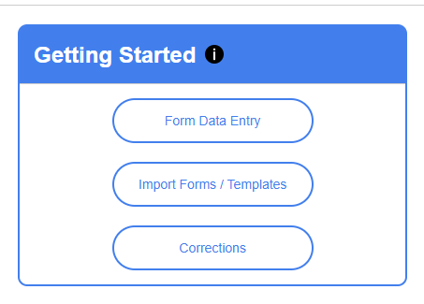
  - You will need to select the Yearli Excel Import as your preferred file formatting as there is no integration for MaddenCo.
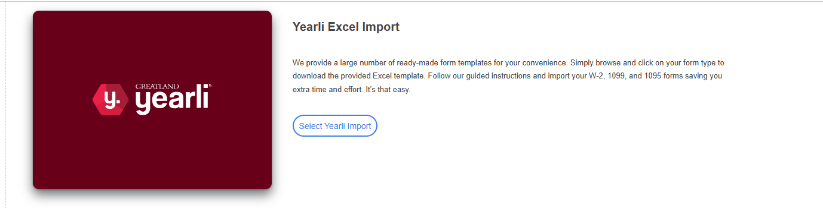
  - Locate and download the appropriate 1099 templates (e.g., 1099-MISC, 1099-NEC).
  - 1099-MISC and 1099-NEC should typically be the only templates we would use most years, but others are available if the controller determines payments were made needing reported on another 1099 form.
  - We will also pull down all the appropriate templates required for the affiliates and send them to the Real Estate Accounting Manager. She will fill them out appropriately and send them back to Accounting to upload. Accounting can file all 1099’s for both K&M Tire, Inc and K&M’s affiliates under one license. These are all uploaded into the system on separate templates to ensure proper FEIN’s are associated with the right company.
- Pulling Vendor Payment Detail from Madden Co
  - 2. Accounts Payable, ENTER
  - 4. Reports Menu, ENTER
  - 12. 1099 Menu, ENTER
  - 1. 1099 Report, ENTER
  - All stores, ENTER, ENTER
  - 01
  - Change Payable Code to ‘10’, ENTER
  - ‘L’ for Last Year’s purchases, ENTER
  - B, ENTER
  - Repeat all steps, changing only the payable code to ‘20’ for all Vendors paid by ACH as well.
- Trade Show Winnings
  - Contact the Director of Marketing to request all the necessary information for any 1099s that will need to be filed from the Trade Show Winnings. We will need the same information as listed in step 5 below to process their 1099’s appropriately. Marketing collects this W-9 information from recipients at time of winning during the K&M trade show. Cross check this list by name and amount against the Vendor Detail list for any duplications, as we may have paid them through AP.
  - Cash is sometimes applied directly to the customer’s account and therefore would not require a 1099 to be filed.
- Gather Required Information
  - Verify we have the necessary W-9 field information for all payees.
  - Verify our 1099 information is complete and accurate including:
    - Name
    - Address
    - Tax Identification Number (TIN)
    - Amount paid during the tax year
- Verify Information is Correct
  - Verify all information listed appears reasonable based on what would be expected
  - Specifically review any new or final Payees such as new landlords receiving 1099’s for rent for the first or last time
    - Amounts paid for security deposits should not be included in the 1099 in the year paid. These need to be removed from the total so the 1099 only includes rent, since security deposits are considered to be held in escrow. If the landlord later keeps all or part of the deposit, in the year it’s determined to be transferred to the landlord it should be added to the 1099 along with rent paid in that calendar year.
- Complete the Template
  - Open the downloaded template file
  - Input the collected information for each payee in the designated columns
  - Verify that all required fields are filled out correctly
- Save the Completed Template
  - Save the completed template in an appropriate format (e.g., .csv or .xlsx)
  - Use a clear naming convention (e.g., "YYYY 1099MISC.xlsx") for easy identification
- Upload the Template to Yearli
  - Return to the Yearli platform

  - Navigate to the “Import Forms / Templates”
  - Select Yearli Import
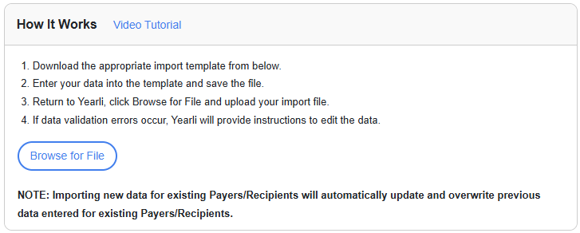
  - Browse for File and choose the saved file from your computer and confirm the upload
- Review Uploaded Data
  - After uploading, Yearli will process the data
  - Review the uploaded information for any errors or discrepancies by clicking the Forms List
  - Check mark all, and click the Edit button to begin reviewing the forms 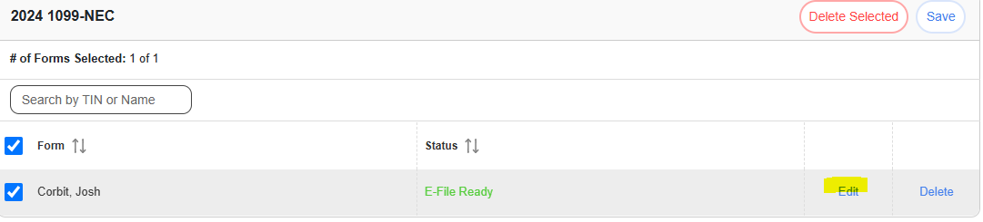
  - Correct any issues as needed by following the prompts in Yearli
  - While reviewing the uploaded data, reference the state where the recipient earned and received the income for the 1099 they are receiving. Review the State Compliance Help in Yearli to determine whether we are required to file any 1099 forms with specific states. Selecting the individual state will outline scenarios where we may be required to file form 1099 with states. This state filing is done automatically through Yearli and is driven by state selection below
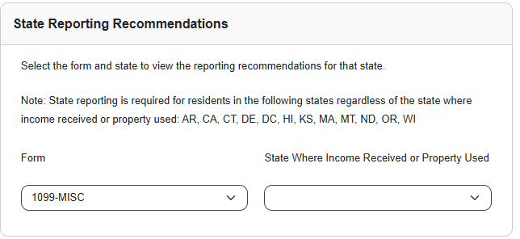
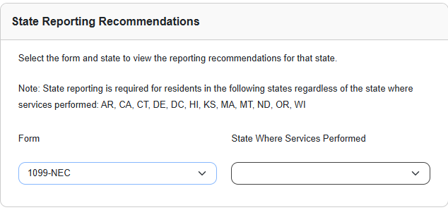
- Generate 1099 Forms
  - Once the data is verified, proceed to generate the 1099 forms based on the uploaded information
  - Review each generated form for accuracy
  - Edit the form to review accuracy
- Submit Forms
  - Submit the reviewed forms electronically via Yearli
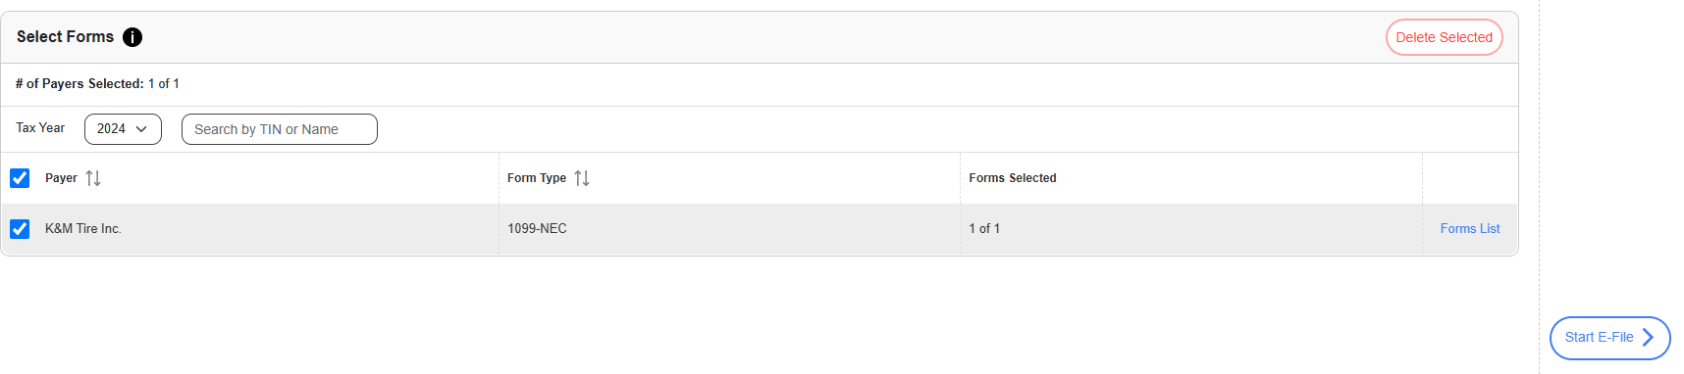
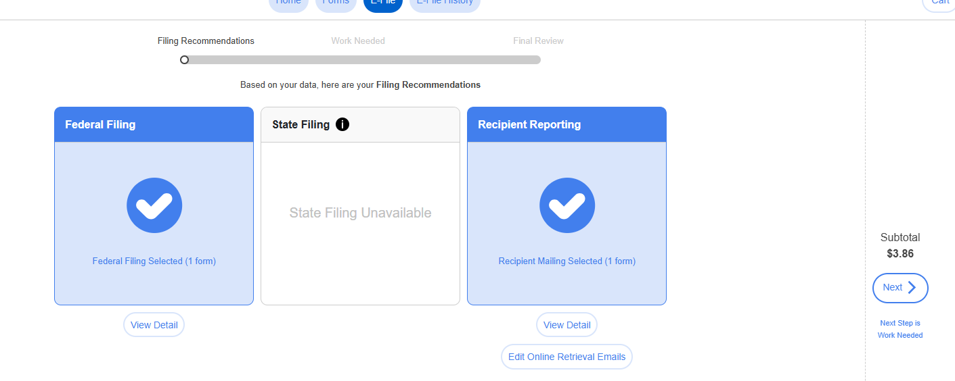
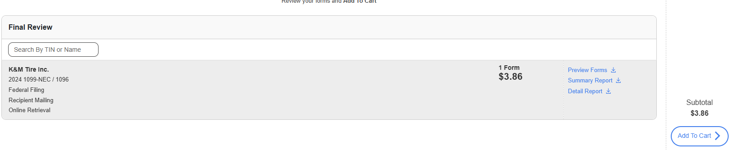
  - Confirm submission and save any confirmation receipts under following pathway: "F:\Accounting\Shared\Year End\1099's"
  - Confirm payment information with the Director of Finance to ensure payment methods are up to date with the card on file
- Provide Copies to Payees
  - Yearli will manage distribution of copies to payees, but verify this process by checking to make sure we receive 1099’s sent to K&M affiliates
  - If we have email addresses for 1099 recipients, add them into the system as this allows for Yearli to securely send a link to their emails to provide an emailed copy of the 1099 in addition to the mailed version
  - Recipient copies must be mailed by Yearli to recipients on or before January 31st. We complete this process in early January to allow plenty of time for distribution
- Maintain Records
  - Keep a digital or physical copy of the uploaded template and submitted forms at the following pathway: F:\Accounting\Shared\Year End\1099's. These will be put into the appropriate year-end folder, i.e. 2025 1099s.
  - Maintain digital copies for at least four years for audit purposes
- Compliance Check
  - Ensure all forms are submitted before the IRS deadline. The IRS has various due dates for Form 1099s dependent on type, but the earliest due date is January 31st. By completing this in early January, we will meet all deadlines
  - Verify that all data complies with IRS regulations
- Review and Update SOP
  - Periodically review this SOP for updates or changes in Yearli’s processes or IRS regulations
  - Make necessary adjustments to maintain compliance and efficiency

Energy Benchmarking Compliance Review
This SOP was removed, because in 2025 the City of St Paul discontinued its local ordinance in order to align with a new Minnesota Energy Benchmarking Program. Going forward, building owners will be contacted directly by state as part of a new state initiative in energy benchmarking.

Supply Suppliers with Audited Financial Reports
- Only send upon request
- Only send to large vendors who should need these for credit purposes
  - Do not send to vendor who could be a competitor
  - If in question, ask President or CFO
- F:\Accounting\Shared\Year End\Year End Financials\20XX\

Trademark Registration Maintenance – currently managed by the President
Scott Federoff – partner at the law firm Snyder, Morgan, Federoff & Kuch will reach out regarding authorization to proceed with any renewal filings.
- Review expiration dates annually
- On any expiring check with Marketing department, and President to be sure the Trademark is valid.
- Provide authorization to law office to proceed as necessary to renew or let expire
- All active Trademarks registrations (including renewal dates) processed by Scott Federoff can be found at - F:\Administrators\Shared\Legal\Trademarks\Trademark Registration

Attorney Invoice Approvals
The law firm McAfee & Taft are the attorneys working on the Doolin case. CFO or VP of Accounting will review these invoices prior to approving. Regular updates should be provided to President.

Annual Capital Expenditures Survey
Complete if receive the questionnaire
The website for the survey is: https://portal.census.gov
Password is: DelphosOhio1!
The guide to complete the survey can be found at: F:\Accounting\Shared\Compliance & Leases\US Census Bureau\Annual Capital Expenditures Survey\20XX"

GL Reclass Entries
Every GL entry should have a clearly documented purpose, and non-routine entries should be approved by the controller.
- If an entry needs made that does not fall under a daily/monthly procedure such as balance sheet rec, bank ledger, tax filing, etc.
  - Confirm with Controller that entry is needed, providing reason and entry
  - Post GL Reclass entry
  - Save backup starting with reference number at F:\Accounting\Shared\Month End\EOM Entries YYYY\EOM entries\Month YYYY Ad Hoc Entries

Annual Business Survey
This is generally received around the end of July and is usually due around the end of August.
Section A
Direct questions to VP of Accounting
A.8. Total W2s
- When reporting W2s, be sure to subtract the number of owners since they are added in separately
A.9. Total 1099s
A.10. Total Sales
- Run a year and period income statement
  - 3 General Ledger
  - 4 Reports Menu
  - 1 Financial Reports
  - 4 Year & Period Income Statement
    - Format = INC30 (or most current)
    - Year = reporting
    - Period = 13
A.11. Domestic Ops
- Same as A.10
A.13. Types of customers = Other businesses
Section E
Direct Questions to Director of IT and VP of Operations
Section F
Direct Questions to Controller and VP of Finance
F.8. Outstanding Debt
- Total current Line of Credit used
Section G
Direct All Questions to VP of Sales and Director of Training
Section H
Direct Questions to VP of Operations

Annual Zurcher Best One Analysis – Benchmarking
Purpose: We fill out the Best One Analysis excel worksheet in order to track K&M Tire’s year over year performance in key categories related to revenue, expense, net income, productivity, and asset utilization. This information is used by management to identify trends and shifts within our financial statement numbers. This BestOne Analysis spreadsheet should be updated using the September 30th year-end figures once completed and no additional entries are expected.
File path for this project: F:\Accounting\Shared\Year End\Best One Analysis
- Run the Sales Summary Report By Class, an Intranet Report, to complete the tab “Best One Sales Data”.
  - Login to Intranet
  - Scroll down to SA-Sales Summary (3 period comparison) – only fill out first period (this uses actual months, not fiscal year & months)
  - Change settings to match the below
  - Run Report
  - Export Report Date to excel
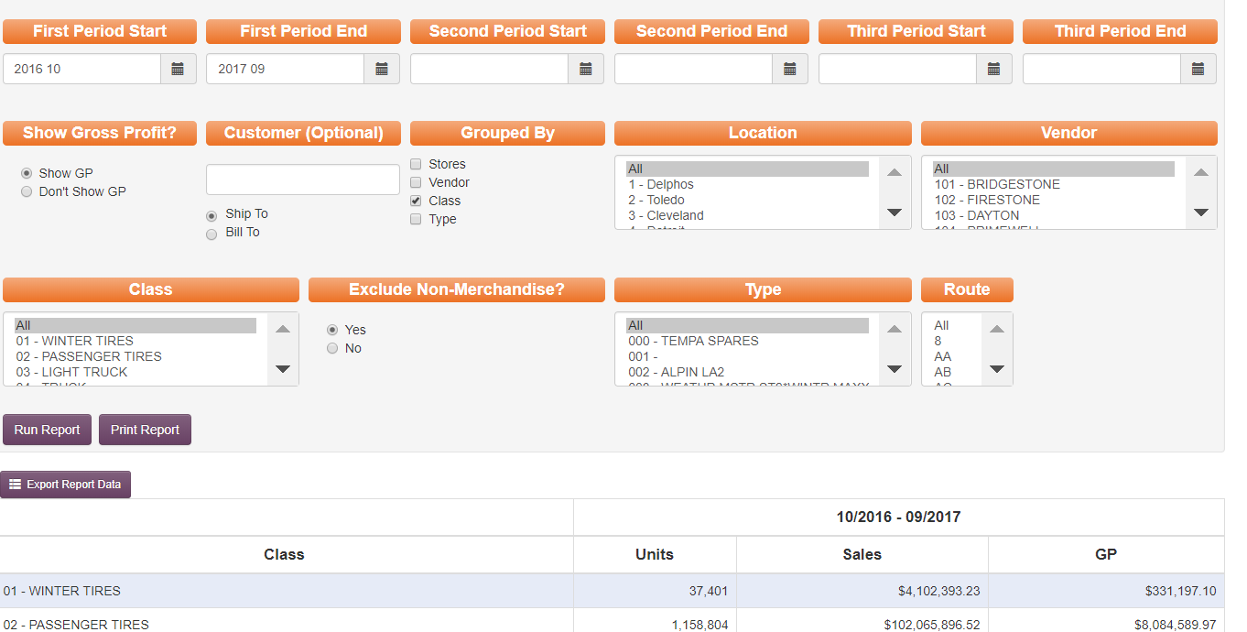
- Update the Best One Analysis working file saved at F:\Accounting\Shared\Year End\Best One Analysis tab “Financial Statements” with the below:
  - The Audited Financial Statements from the external auditors, presently Forvis. Use DRAFT report once available and no additional entries are expected.
  - The final internal financial statements saved on the network in the following location: F:\Accounting\Shared\Month End\Monthly Financial Statements\Summary Financials
- Pull Reports to complete Best One Analysis-tab “Best One Payroll Data”
  - Paylocity (*replace this with Dayforce report paths in 2026)
    - Data Insights
    - Set Fiscal Year Date Range (10/YYYY-9/YYYY)
    - Go to Labor Costs- Trends
    - Click Labor Costs box and export to excel
    - Click Labor Hours box and export to excel
  - Sort by Position Code
    - Drivers:
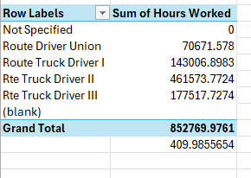 | 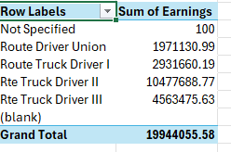
*Pull both Sum of Hours worked & Sum of Earnings as in first example. Screenshots excluded from below examples to protect confidential payroll information.
    - IT:
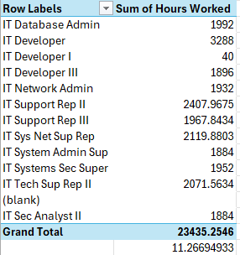

    - Managers – Do Sell:
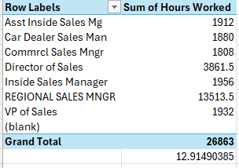
    - Managers – Do Not Sell:
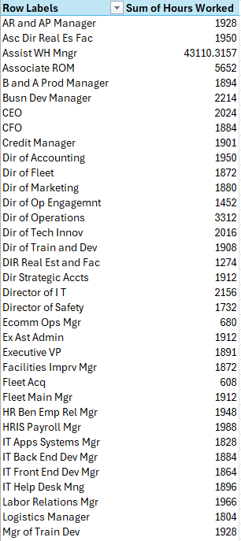 | 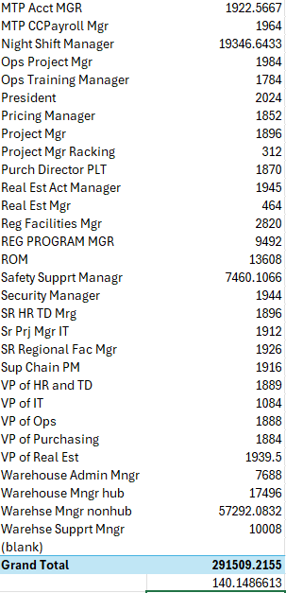
    - Sales:
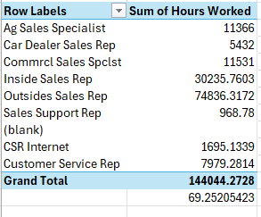
    - Warehouse:
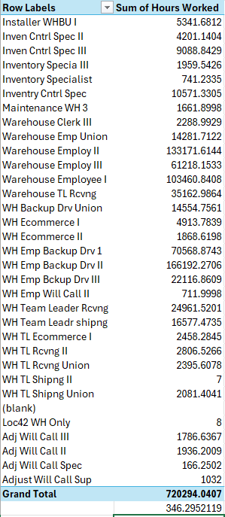
    - Office:

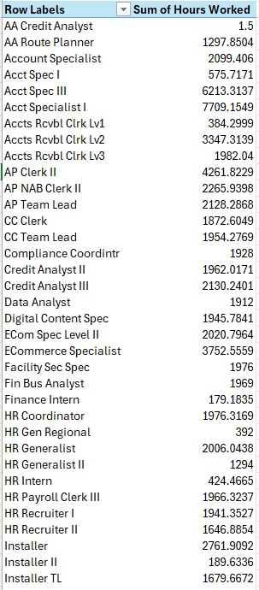 | 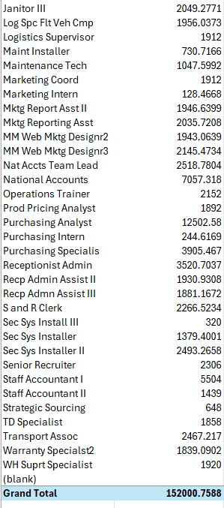
- Controller or VP to review then forward to CFO or President

ACH/Wire Approvals
This SOP outlines the approval process for ACH and wire transfers within the Accounting Department and Affiliate Companies.
- ACH/Wires for Accounting
  - ACH and wire transfers for accounting must be approved by the Controller.
  - If the Controller is absent or unavailable, the following individuals, in order of priority, are authorized to approve:
    - VP of Accounting
    - Director of Accounting
    - Sr Project Manager IT & Accounting
    - CFO
    - President
- ACH/Wires for Accounts Payable
  - ACH and wire transfers for Accounts Payable must be approved by the AP/AR/NAB Manager.
  - If the AP/AR/NAB Manager is absent or unavailable, the following individuals, in order of priority, are authorized to approve:
    - Director of Accounting
    - VP of Accounting
    - Sr Project Manager IT & Accounting
    - CFO
    - President
- ACH/Wires for Any Affiliate
  - ACH and wire transfers for any affiliate must be approved by the Real Estate Accounting Manager.
  - If the Real Estate Accounting Manager is absent or unavailable, the following individuals, in order of priority, are authorized to approve:
    - VP of Accounting
    - Director of Accounting
    - Sr Project Manager IT & Accounting
    - CFO
    - President
- Role of the Approver
  - This approver role is effective for K&M Tire wires and ACHs as well as for any affiliate wire or ACH requests.
  - The approver plays a critical role in ensuring the accuracy and security of ACH and wire transfers. The approver must:
    - Confirm the Payee and the dollar amount of the transaction.
    - For wires or ACH transfers not using a template, the initiator must provide the wire instructions to the approver, including the routing number and account number, for validation.
    - The approver must thoroughly review and validate these details before approving the transaction.

New Location Procedures
Important Notes:
Only the controller or level 3 accountants should complete these tasks.
When adding a new location, a series of items need to be set up or added.
Everything should be set up 2 weeks prior to the 1st day it will be used
Once everything is set up there needs to be testing to confirm all is working properly.

GENERAL LEDGER:
- GL – (Add new location in GL)
  - 3 General Ledger (enter)
  - 5 System Control Menu (enter)
  - 5 Duplicate Chart of Accounts (enter)
  - Hit (Enter)
  - “Duplicate GL account from division” is the location you want to copy (never use loc 1, because loc 1 has extra account numbers)
    - Below example is using Loc 57.
  - “As accounts for division” is the location you want to set up.
    - Below example is setting up Loc 56.
  - “Copy Heading” = N; Copy Subtotal accounts” = Y; “Copy Unit accounts” = N; Overlay Existing Acct” = Y
  - IT will need to be contacted in order to open access to post to new LOC GLs
    - Email IT Help Desk – Help@kmtire.com with subject MaddenCo Access.
    - Message should be: Hi, I just set up Loc 56 in GL; would you please add access for (whomever needs) for GL access.
(This is example of duplicating Loc. 57 accounts for new Loc. 56)
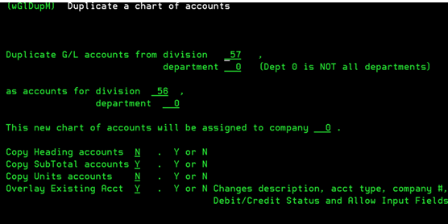
- Balance Sheet & Income Statement (INC & BAL), edit to add new location.
  - 3 General Ledger (enter)
  - Maintenance Menu
  - Report Format Maintenance
  - Enter store or region = 000
  - Put a 2 to edit on the correct BAL and INC report. (enter) (enter)
  - Write down the beginning and ending sequence number. (you will need this in step L).
  - F3 to exit the report.
    - Next, we will start a new report and copy the current report to the new report. When editing these reports, make a copy before starting so you always as the previous report as a backup copy.
    - For example, if the current income statement is INC30, you will copy this and create Inc 31.
  - F6 (to add new report)
  - Format Name = BAL## or INC## (## should be the next sequence number); Description = Balance Sheet - K&M or Income Statement - K&M; Assign to Store/Region = leave blank. (enter)
    - It will bring you to the screen where you can manually enter/add what GL# you want included in the report. We want to copy everything from the previous report.
  - F3 to exit the area where you manual add one line at a time.
  - F2 to copy another report.
  - Copy report format = Bal__ or Inc__ (the report you looked at in step e&f); from sequence number ______= enter the beginning sequence number from step f thru ________= enter the ending sequence number from step f; into report format at sequence number ______= 10. (It doesn’t have to be 10 this is just a best practice.) (enter)
  - It will copy the report and it’s normal for the sequence numbers to be really long. Pressing F8 will re-sequence the report. Start at 10 and re-sequence by 10.
  - Page down to the area in the report where you need to insert the new location.
  - Write down the beginning and ending sequence numbers of the location you wish to copy in the report. Make sure to double check the numbers to make sure you don’t miss any lines.
Below example is to copy LOC 22 BAL and INC
  - Start of BAL to copy = Sequence # 2790
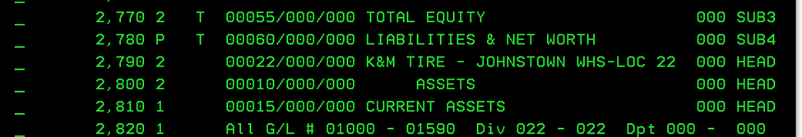
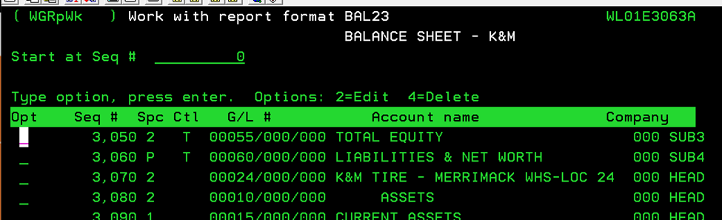
  - Ending BAL to copy = Sequence #3060

  - Start of INC to copy = Sequence # 11430
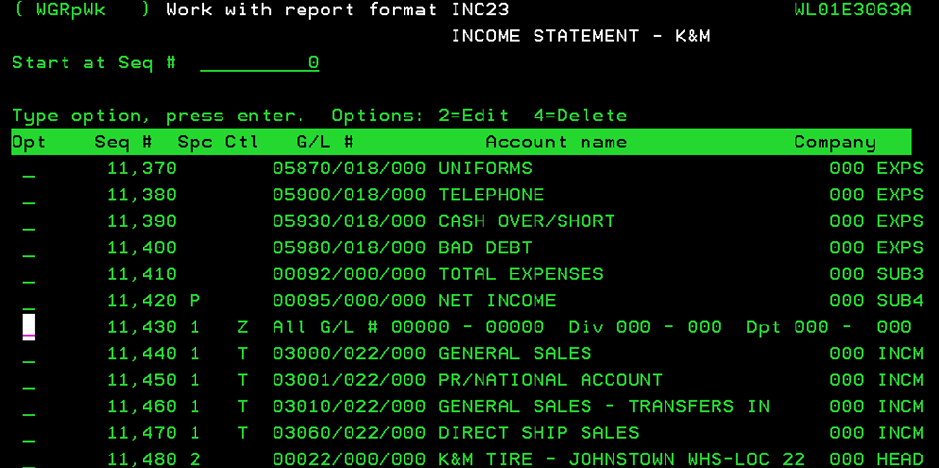
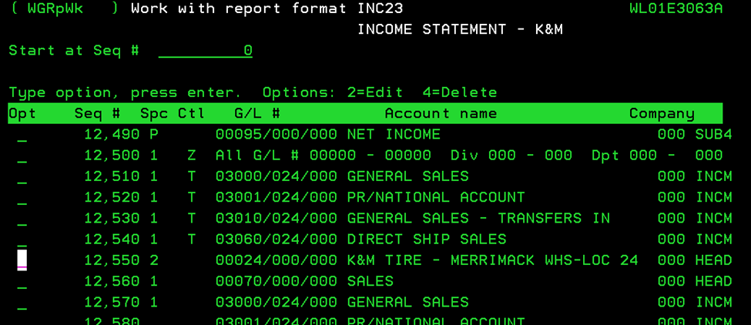
  - Ending INC to copy = Sequence # 12490

  - F2 to Copy a report.
  - Enter the current report you are in, enter the beginning sequence number for the location you wish to copy, enter the ending sequence number for the location you wish to copy, enter the sequence number where you want the information copied into (see below example). (enter)

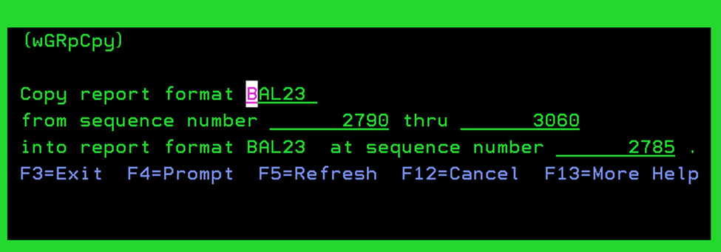

  - Need to update the location heading line, which would always be the 1st new line inserted.
  - Go to the lines that were copied in and put a 2 on them to edit. On the GL number field, change the location to the new location you are adding. Do this until you updated all lines that were copied in for the new location.
  - Scroll to the bottom of the report where it has the consolidated. Review the GL ranges to ensure the new location falls within the range. If it doesn’t you will need to edit the range or make a change so it would be included. (If you need to do this step, please see your supervisor for assistance.)
  - F8 to re-sequence, because when you copied the new lines into the report, it made the sequence numbers for the rest of the report really long numbers. (Start at 10 and re-sequence by 10.)
  - Repeat these same steps for both the BAL report and the INC report.

Auto Reports:
Auto reports are scheduled reports that run either daily, weekly or monthly for various people and departments.
Important Note: Avoid setting up reports on the 1st day of each month, the 15th day of each month and the last day of each month.
- Add new or Update Reports Auto Reports
  - 20 System Menu (enter)
  - 5 Auto Report Maintenance (enter)
  - Work with Auto Report
  - 2 to edit EOM (enter) (enter)
    - **note** be very cautious and never edit an existing report unless 100% necessary and approved by the CFO. Once you go into a report, all the settings are wiped out and lost, including the printer, if the report is put on hold and anyone it is emailed to.
  - Page down to the Product Cost Value report. Add one detail report and one summary report for the new LOC.
  - F6 add
  - Sequence = select an available number trying to keep the reports in order by location with like reports being the same.
  - Be as detailed and consistent as possible on the description, because there isn’t a way to “look” to see how a report is set up after it’s done.
    - Copy exactly how other locations are described.
  - Product Cost Value – Detail
    - Enter new sequence number
    - Enter description exactly as below except Loc number
    - Enter front end, libriary & back end program
    - Enter Store # (enter) (enter)
    - Enter order to print report = 03 Class; Size (enter) (enter) (enter)
    - Inventory Quantity = U (enter)
    - Totals only = N (enter)
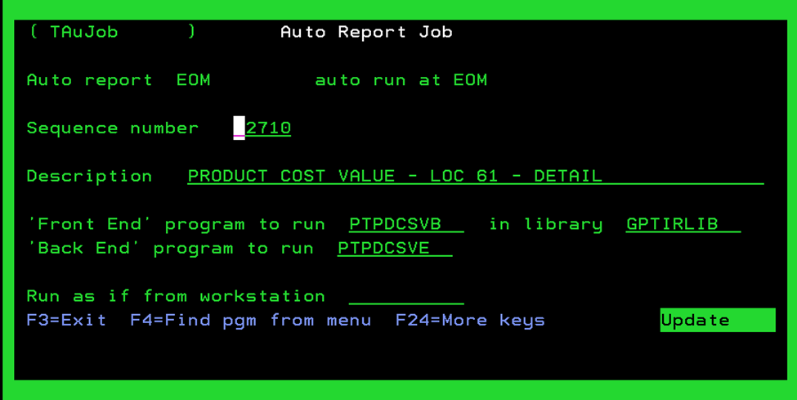
    - Put printer on Hold (enter) (enter)

  - Product Cost Value – Summary
    - Enter new sequence number
    - Enter description exactly as below except Loc number
    - Enter Front End, Library and Back End program
    - Enter Store # (enter) (enter)
    - Enter order to print report = 03 Class; Size (enter) (enter) (enter)
    - Inventory Quantity = U (enter)
    - Totals only = Y (enter)
    - Put printer on Hold (enter) (enter)

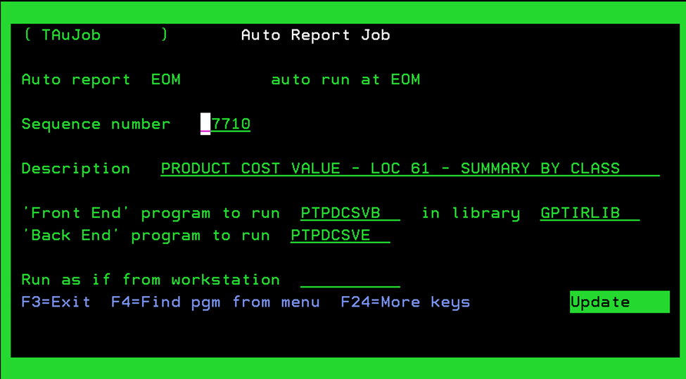

  - Invoice History
    - Page down to Invoice History and add one for the new location.
    - Enter new Sequence number
    - Enter description exactly as below except location number.
    - Enter Front End, Library and Back End
    - Enter Store # (enter) (enter)
    - Enter order to print report = 01 Invoice Number (enter)
    - Enter Year/Pr (current year/pr) and customer class = 7 (enter) (enter) (enter) (enter)
    - Put printer on Hold (enter) (enter)
    - F3 to exit EOM when you are done adding both product cost value reports and the Invoice History.

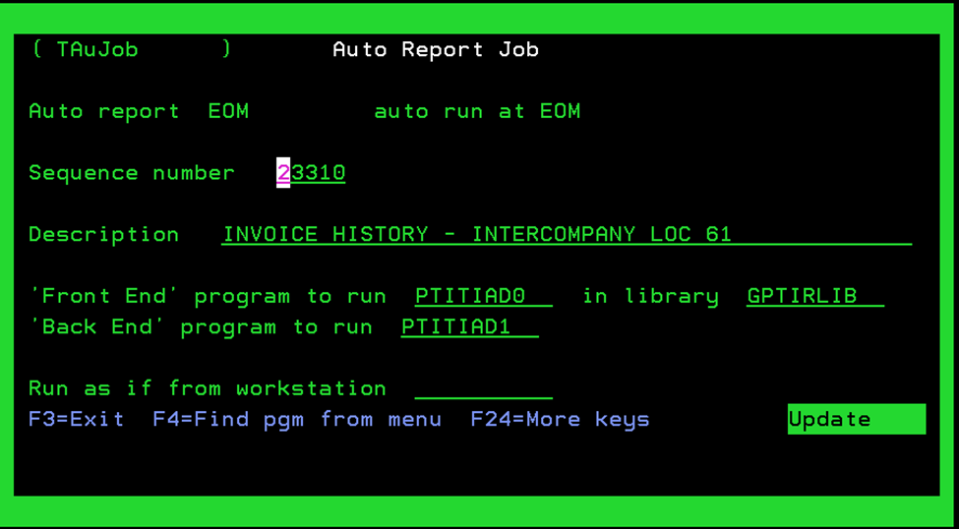

Edit Existing Auto Reports:
Important Note: Prior to updating auto reports make sure there are no overlaps and/or gaps in customer number ranges.
- EOM Aging auto report (2 to edit)
- These reports are run by customer ranges. If customer number ranges for a location are altered, you must edit the A/R Aging report for those locations that report and re-set it up for the correct customer number range, then you need to add a new report for the new location with the new customer number range. Review instruction under Tire Dealer Menu & Misc in order to update the Customer Number Range on the Intranet for Report purposes
    - It is important to note that customer number range changes and additions must be approved by the CFO.
- F6 to add the new location/customer range.
Important Note: There should never be an opening in the range even if we don’t plan on having customers in part of the range it must be included. It will create issues if there are gaps in ranges. For example, lowest range is 10,000-999,9999. When setting up the report start with 1-999,999 so there isn’t an ‘opening in 1-9,999’.

    - Enter sequence number
    - Enter description as below except location #
    - Enter Front end, Library and Back end program as listed below
    - Type of Aging to Print = 3 One Line Aging Report (enter)
    - Store XX (enter) (enter) – Must be 0
    - Order = 2 Customer Name (enter)
    - Enter Customer Range (enter) (enter) (enter) – as desc/determined
    - Print Credit Limit = N
    - Print Available Credit = N (enter)
    - Put printer on Hold (enter) (enter) = Y

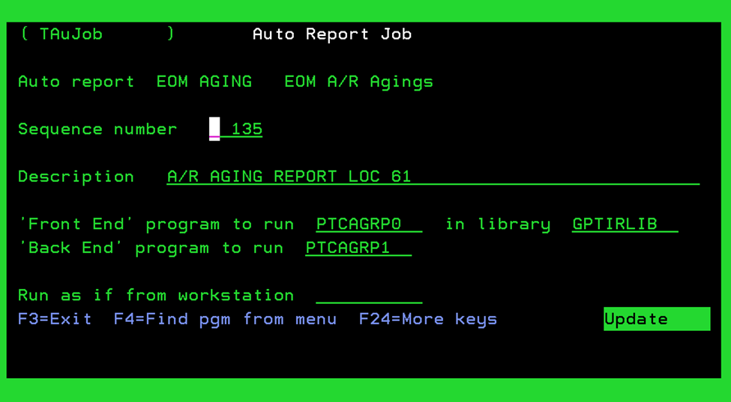

Tire Dealer Menu & Misc:
- Customer Number Range on Intranet for Report purposes
  - Intranet » Credits and Collections » Customer Number Range Maintenance
    - Completed only after CFO approval has been provided on adjusting the ranges.
  - Edit any existing locations where you need to make the range smaller to make room for the new location. Add the new location and customer range.
    - Make sure there are no overlaps and no gaps in customer number ranges. Every number should be accounted for in one of the ranges. (If not it can make it hard to balance GL 1200 because we balance to the AR report which is ran by customer ranges. If a customer appears on two different AR aging reports or if a customer doesn’t appear on a report, then GL won’t make the reports and we have to figure out why.)
- Several reports will automatically include the new location, if the new location is not already added to region60 you will need to add to region60 (sometimes updates occur to locations in region60 without communication).
  - 1 Tire Dealer System (enter)
  - 6 File Maintenance Menu (enter)
  - 1 Control File Maintenance (enter)
  - Start at “RGIONR60”
  - Region 60 continues to R61, which continues to R64, which continues to R67. The new location needs to be included, by having it listed in R60, R61, R64 or R67. Then when reports run for R60, it will include the new location for the updated company totals.
    - The sequence should be putting the store number in order by location number. For example, if the new store is location 35 and we already have 34 and 37 it will be placed in the middle to be 34, 35, 37 in sequence.
- Sales Tax
  - Research on line to find the Sales Tax Rate (find form or apply online) is for the county in which the new warehouse is located, this Sales Tax Rate will need to be updated in MaddenCo.
  - Only update after the Controller has reviewed and approved the rate.
    - 1 Tire Dealer System (enter)
    - 6 File Maintenance (enter)
    - 7 Sales Tax File Maintenance (enter)
    - Find state and update with Sales Tax Rate, if more than one warehouse in a state it will be necessary to set up more than one tax rate- see either Ohio (Delphos, Toledo) or Michigan (Grandville, Lincoln Park)
    - If this happens, you must notify the Credit manager on what that location tax code will be so they can assign the correct code to that locations customers.
    - Refer to section 8.6 for more information on sales tax.
- Research to find out if that state which the new warehouse is in has a tire disposal tax for wholesale tire sales. If so, the Controller will need to set up:
  - Control File Maintenance code: DP9988x = 99 is the state code; 88 is the disposal code; x is the customer class. Copy codes: DP34011, DP34013, and DP34015 which are for Ohio and customer classes 1, 3 & 5.
  - State Codes are as follows:
Alabama = 1 Montana = 25
Alaska = 50 Nebraska = 26
Arizona = 2 Nevada = 27
Arkansas = 3 New Hampshire = 28
California = 4 New Jersey = 29
Colorado = 5 New Mexico = 30
Connecticut = 6 New York = 31
Delaware = 7 North Carolina = 32
D.C = 8 (not used) North Dakota = 33
Florida = 9 Ohio = 34
Georgia = 10 Oklahoma = 35
Hawaii = 51 Oregon = 3
Idaho = 11 Pennsylvania = 37
Illinois = 12 Rhode Island = 38
Indiana = 13 South Carolina = 39
Iowa = 14 South Dakota = 40
Kansas = 15 Tennessee = 41
Kentucky = 16 Texas = 42
Louisiana = 17 Utah = 43
Maine = 18 Vermont = 44
Maryland = 19 Virginia = 45
Massachusetts = 20 Washington = 46
Michigan = 21 West Virginia = 47
Minnesota = 22 Wisconsin = 48
Mississippi = 23 Wyoming = 49
Missouri = 24
- Register to do business in the state (Secretary of State website. We normally use CSC.)
  - First step is to review if needed.
  - If needed, work with CFO and Controller to decide on next steps.
  - If we engage CSC we will reach out to our contact kyle.jenkins@cscglobal.com and request to begin registering in the new state.
- Register for Withholding Tax (Done by Dayforce & request initiated by HR)
- Determine whether a Certificate of Authority Application is needed and send application if necessary. (Secretary of State website)
  - Consult with the CFO and Controller to determine if K&M is “doing business” in the state in question. Some states have different requirements for this but if we have standard delivery routes in the state, we will typically consider this “doing business”.
- Assign registered agent, a registered agent is needed in every state (CSC).
- Set up/arrange for Petty Cash, if needed
  - Request approval from CFO and Controller on need for petty cash.
  - If approved, we will work with operations and admin on method of delivery to the location.
  - The GL entry will then need to be made to receive petty cash into GL 1000 (cash on hand) and the correct location number.
- Complete Store Tender Master Maintenance (See print screen document in procedures)
  - 1 Tire Dealer System (enter)
  - 6 File Maintenance Menu (enter)
  - 10 Store Tender Master Maintenance (enter)
  - Go into another store location that this location would be similar to, when it asks whether to copy to other stores make sure you type “N” for no. Do a print screen to have a guide as to all tenders that will need to be set up in new store location. You can place a “2” on line to edit each tender maintenance, print screen so you know how to set up and then F3 so no changes are made. Once you have all of your guides you will need to go into new store location and set up all Tenders.
Below is a list of all available Tender Types and how each are set up:
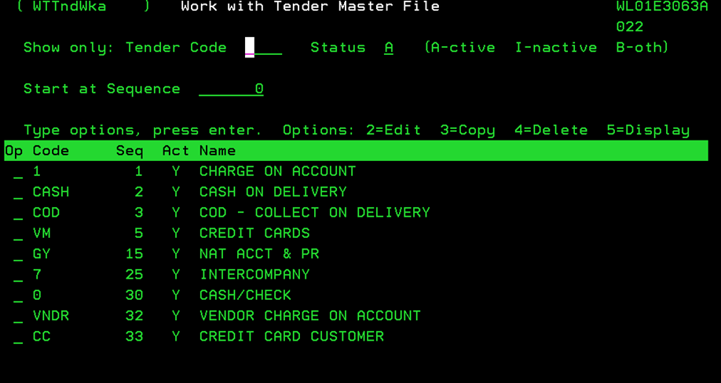
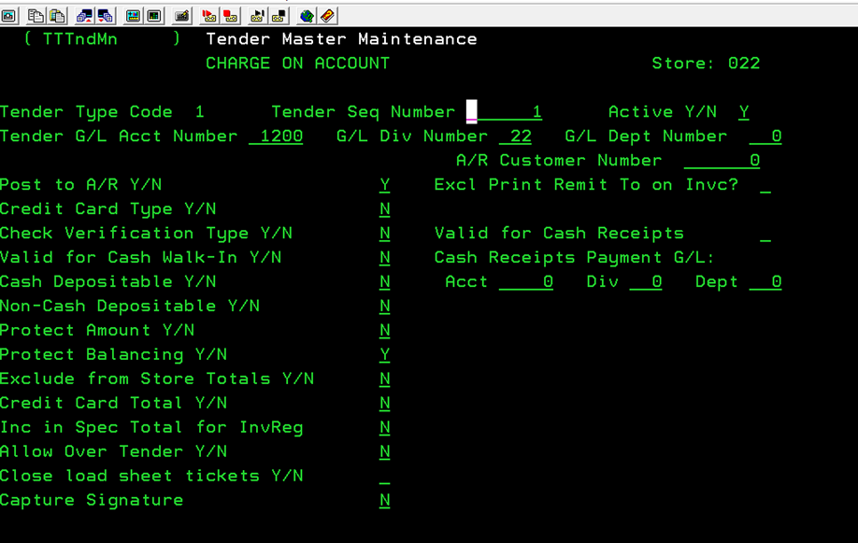
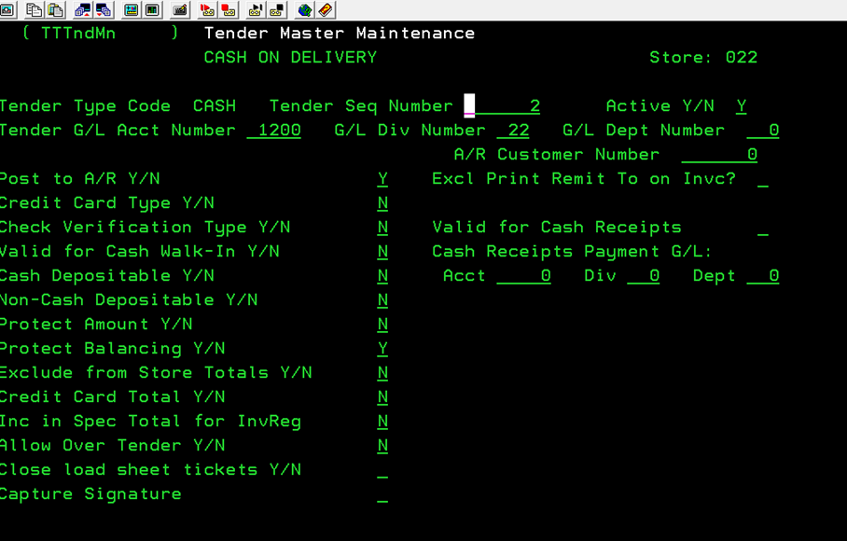
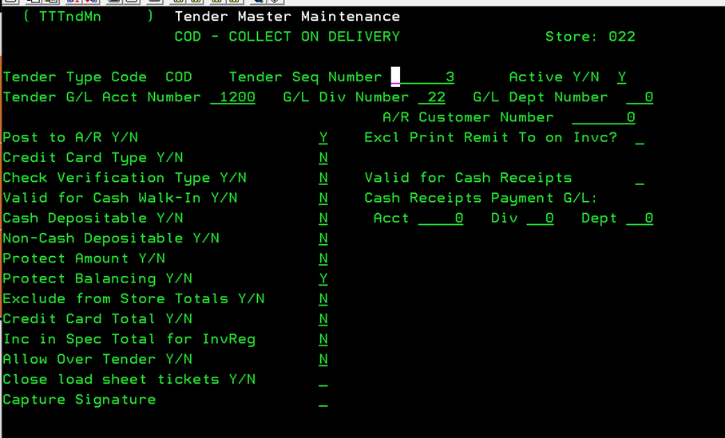

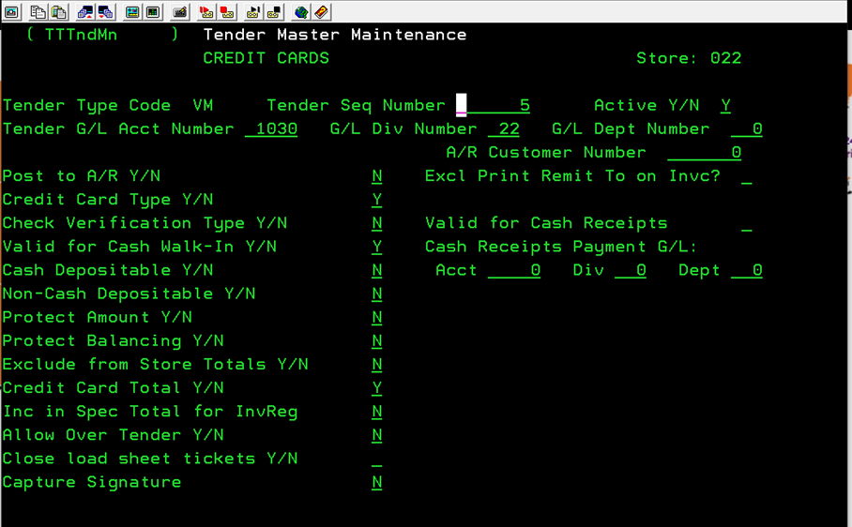
  - For GY – be sure to include Nat A/C # 108.

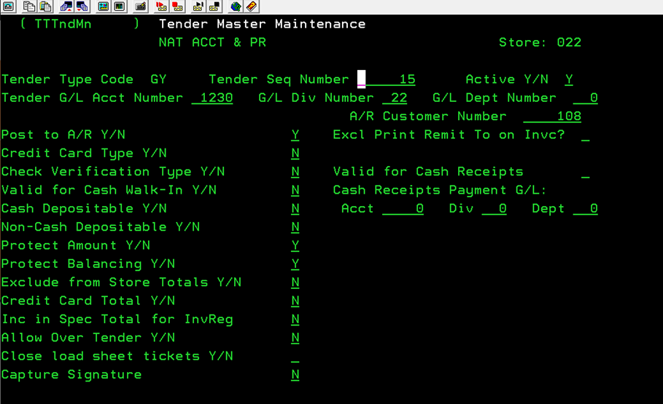
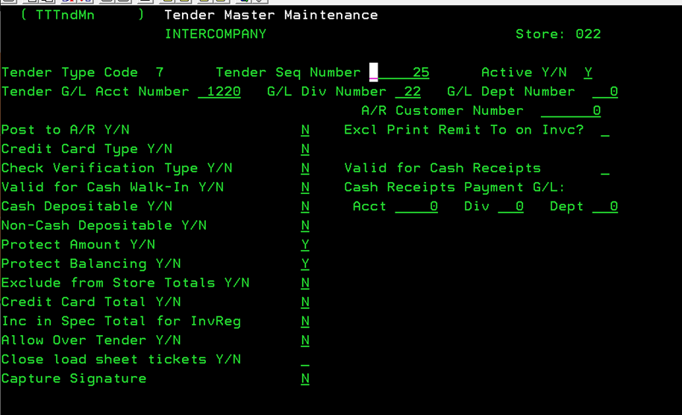

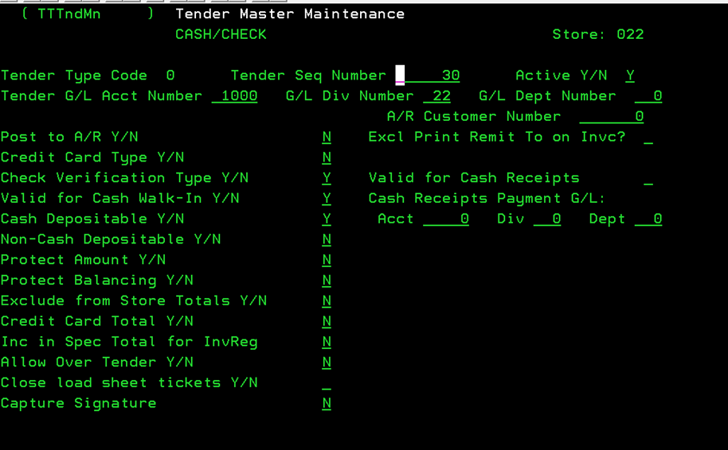
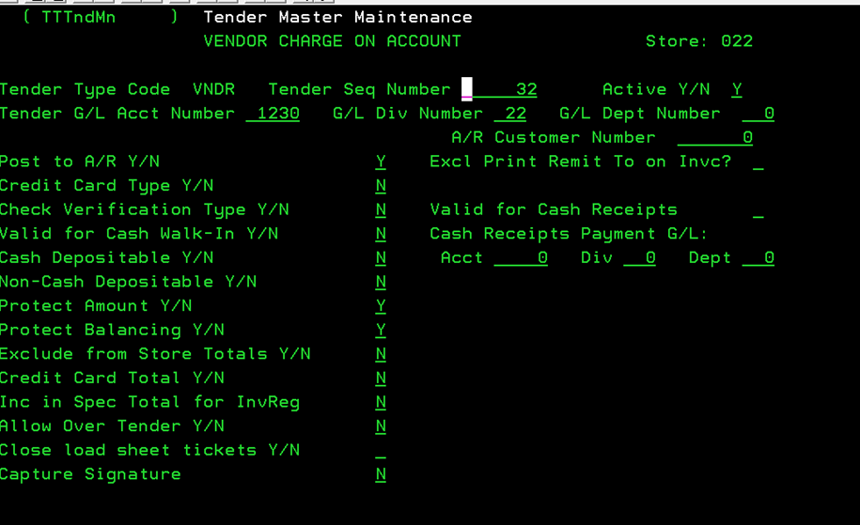

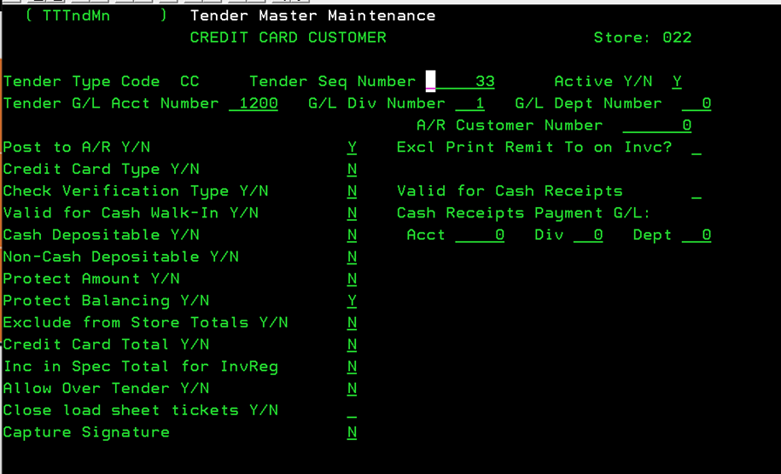

Transfer Hops: Location to Location Transfer Grid
Purpose: The Transfer Hops are a necessary part of K&M operations. This controls how we show movement of tires between locations and determines the amount of redistribution credit a store receives from transferring tires across our network. This is required to ensure accurate accounting of location profitability is maintained.
Anytime a new location is added or when changes are made to our transfer paths the distribution transfer must be added or adjusted in the K&M Intranet to maintain accuracy.
Important Note: Timing on when you update this is important because however the information is set at the time the GL pulls the report for end of month is how the entire prior month will show for the correcting GL entries.
The VP of Operations will provide General Ledger with a spreadsheet containing necessary updates. When a new location is added many other locations are affected so every location must be reviewed.

Operations will send Accounting an updated excel file with all updated transfer routes. Save this file at:
F:\Accounting\Shared\Transfer Hop Updates\
- Update Each Location Tab
  - Navigate to the Intranet
  - Accounting
  - AC - Transfer Redistribution Credit
    - Select the current month and year
    - Run Report
    - Transfer Hops tab
    - Tires Delivered To, Tires Sold From, and Transferred Through should not be changed.
    - Start location should always be the same as the location tab that you are on (Loc 1 tab will have Delphos as the starting location for each row, Loc 2 tab will have Toledo, and so on). Always start with LOC 1.
    - If the excel file is different than the Intranet, update the intranet
    - If the location does not have any transfer stops just add start and end location and leave transfer location blank and select Add
  - To add a new route with multiple transfer locations or with only one transfer location - update the Start, End and Transfer Location. See below for using N & Y for stop at location
    - Stop at Location = N when the transfer location in the excel spreadsheet from operations is blue, there is no inventory transferred.
    - Stop at Location = Y when the transfer location in the excel spreadsheet from operations is orange, there is inventory transferred.
    - Select Add
The below example is for Location 1 – to update / add routes for an existing location – select the location tab (see below). If this was a New Location, a new tab will be added when you select the Start LOC = New LOC and End LOC = Delphos. After Add is selected, you will be taken to the new LOC tab. It will automatically generate (example if Loc. 88 was a new location it would look like the screen below Loc 1 where 88 – Loc screen pops up).
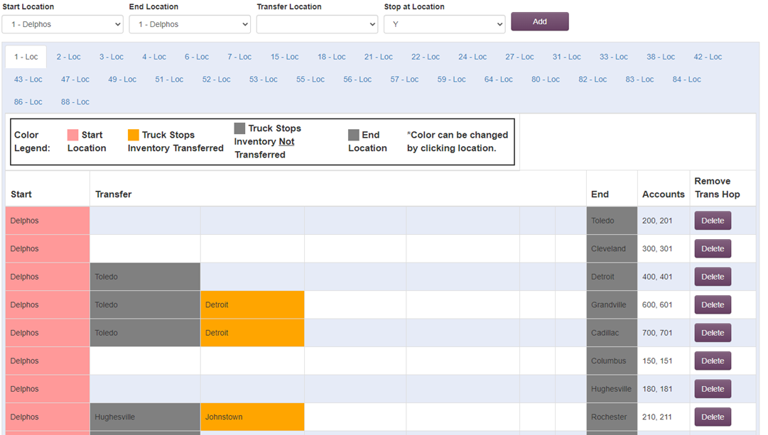
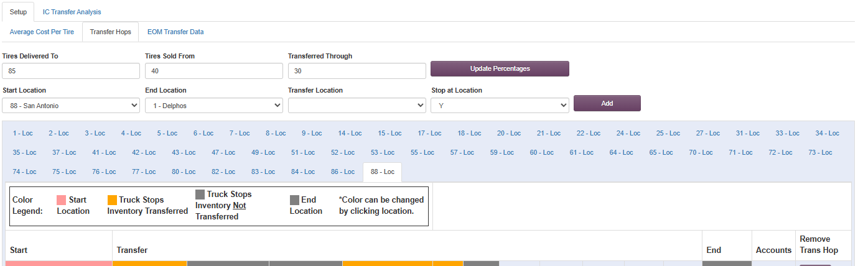

- Edit Current Transfer Route
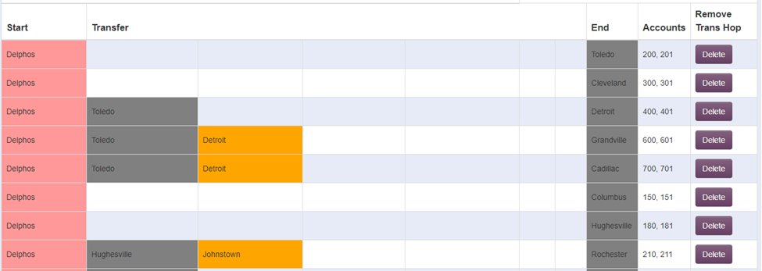
  - Select the Transfer Location by clicking the cell

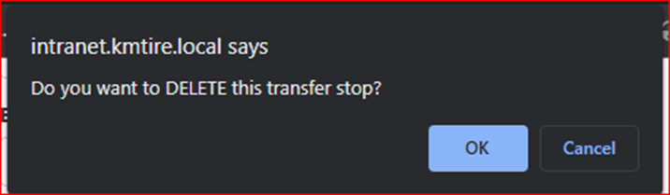
  - The below box appears, select OK to Delete, or Cancel if you wish to Edit Location

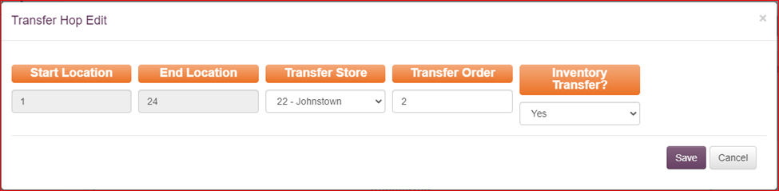
  - If Edit (Cancel) is selected you can change the transfer store, transfer order, or inventory transfer. Hit save once complete

  - Once all updates are made, each LOC tab on the Intranet and corresponding excel file tab in the file received from Operations should match.

Frequently Asked Questions
K&M instructions: Provide information on how the Warehouse Manager can get emergency assistance and system support (e.g., help desk support, inventory support, etc.). Include the names of the responsible personnel and organization(s), telephone numbers, and email addresses of the staff who serve as points of contact for system support.
Table 1 - Support Points of Contact
Contact / | Department | Phone | Email | Role
K&M Corporate Line | Corporate | 419-695-1061 | n/a

Other

Appendix A: Miscellaneous
Add links here

Appendix B: Supportive Department Summaries
How we can help at the field level?
Inventory Specialist:
Sales Department:
Purchasing Department:
Credit Department:
Instructions: Provide a list of acronyms and associated literal translations used within the document. List the acronyms in alphabetical order using a tabular format as depicted below.
Table 2 – Acronyms

Appendix C: Glossary
Instructions: Provide clear and concise definitions for terms used in this document that may be unfamiliar to readers of the document. Terms are to be listed in alphabetical order.
Table 3 - Glossary
Term | Acronym | Definition

Appendix D: Referenced Documents
Table 4 - Referenced Documents
Document Name | Document Location and/or URL | Issuance Date

Appendix G: Notes to the Author/Template Instructions
This document is a template for creating a User Manual for a given investment or project. The final document should be delivered in an electronically searchable format. The User Manual should stand on its own with all elements explained and acronyms spelled out for reader/reviewers, including reviewers outside CMS who may not be familiar with CMS projects and investments.
This template includes instructions, boilerplate text, and fields. The developer should note that:
Each section provides instructions or describes the intent, assumptions, and context for content included in that section. Instructional text appears in blue italicized font throughout this template.
Instructional text in each section should be replaced with information specific to the particular investment.
Some text and tables are provided as boilerplate examples of wording and formats that may be used or modified as appropriate.
When using this template, follow these steps:
- Table captions and descriptions are to be placed left-aligned, above the table.
- Modify any boilerplate text, as appropriate, to your specific investment.
- Do not delete any headings. If the heading is not applicable to the investment, enter “Not Applicable” under the heading.
- All documents must be compliant with Section 508 requirements.
- Figure captions and descriptions are to be placed left-aligned, below the figure. All figures must have an associated tag providing appropriate alternative text for Section 508 compliance.
- Delete this “Notes to the Author/Template Instructions” page and all instructions to the author before finalizing the initial draft of the document.

Appendix H: Revision History Tracking
The following table records information regarding changes made to the Operations Binder.
Table 6 - Revision History Tracking
Date | Author/Owner | Description of Change
4/4/2022 | Joni Zerkel | move Section 13.6 Annual CSC Worksheets to Section 14 – Tax Filings and Compliance. All items that CSC helps with are Tax items and though they are all annual filings, they are not necessarily part of our Year End procedures
4/4/2022 | Joni Zerkel | Section 15.4 – Unclaimed Funds Annual Filing
4/4/2022 | Joni Zerkel | Section 15.9 – AP ACH Wire – please remove this section. This is no longer done by the accounting team, this should be part of the AP SOP Binder
4/4/2022 | Joni Zerkel | Section 15.10 Employee Loan Reconciliation – please remove this section. This should be part of the AR or Credit and Collections SOP Binder.
9/23/2022 | Shaina Johnson | Edited/update section 6 & 7
10/31/2022 | Shaina Johnson | Updated 6.2,7.3,9.1,11.1-15.16
11/18/2022 | Shaina Johnson | Update changes from Mindy’s email 11/17
12/14/2022 | Angie Prichard | Updated changes from Mindy 8.1 pgs. 38-47
12/27/22 | Donna Burgei | 13.6 Added the Profit-Sharing SOP
03/28/2023 | Jody Keller | Added updates to SOP
4/6/23 | Kayla Perrine | Added to section 7.8 Error Log Missing or invalid Control Key
4/18/23 | Donna Burgei | Added Director of Ops to the Operations Income Statement email list
05/09/2023 | Jody Keller | Added update to Five star Ins. reimbursements
05/11/2023 | Jody Keller | Changes to WH Bonus section
6/23/23 | Kayla Perrine | Updating Section 14
8/23/23 | Kayla Perrine | Updated 11.6 Property Tax Procedures
6/6/2024 | Kayla Perrine | Added 15.17 ACH Wire Approval
7/15/2024 | Angie Prichard | Updated 14.14 Form 8802 Application for United States Residency Certification
10-21-24 | Barb Suever | Updated 10.4 Travelers Tracer Payment and 9.2 Weekly Payroll Journal Entry Updates
10/21/2024 | Barb Suever | Added 6.9 System I Navigator
10/22/2024 | Barb Suever | Added 11.2.15 PR Allocation
2/13/2025 | Shaina Johnson | Add section 14.6 Bank Covenant Tracking
3/7/2025 | Barb Suever | Updated 15.17 ACH/Wire Approvals
3/18/2025 | Jody Keller | Removed 14.5 Ohio Job creation Tax Credit
3/31/2025 | Jody Keller | Update 8.2 Inventory Cost Change
4/3/2025 | Jody Keller | Update 9.1 Non-Stock Balancing
4/11/2025 | Jody Keller | Update 8.1 Daily Banking Reconciling/First Financial-Cash
4/25/2025 | Jody Keller | Small changes 6.0 to MaddenCo Gen.Ledger Basics/ removed System Navigator
4-30-25 | Barb Suever | Updated 10.2 Best One Health Insurance Billing Allocation
5/6/2025 | Angie Prichard | Added Section 7.4 Transfer Hops
5/7/2025 | Angie Prichard | Added 11.2 4. Correcting Sales & Cost of Goods Sold (COGS) for Sold Transfers
5/7/2025 | Angie Prichard | Added 10.5 Send GL 3900 Balances to VP of Operations
10/14/2025 | Angie Prichard | Verified 6.3 GL Re-Class (Moves) is current
10/23/2025 | Angie Prichard | Updated 6.1 Input Journal Entry/** Making Unbalanced Journal Entry
10/23/2024 | Angie Prichard | Updated 6.2 Upload Journal Entry – GL binder
10/23/2025 | Angie Prichard | Updated 7.6 Changing or Adding Sales Tax Rates
10/23/2025 | Angie Prichard | Updated 14.7 quarterly Income Tax Estimate Payments
10/23/2025 | Angie Prichard | Updated 15.14 – GL 1440-53 Tri-Energy Stock

